

Class: CIS-3365 (Fall 2020)

Date: 11/18/2020

Instructor: Dr. Xuqing Wu, Ph.D.

University of Houston

|  |  |
| --- | --- |
| Team Members | Roles |
| Duy Truong | Project Manager |
| Travis Ho | Systems Analyst |
| Sunny Sembhi | Systems Analyst |
| Julia Byrne | Systems Analyst |
| Muhammad Tahir | Systems Analyst |
| Carlos Moya | Systems Analyst |
| Ashley Pinto | Systems Analyst |
| Robert Smith | Systems Analyst |
| Kevin Tao | Systems Analyst |
| Kayla Harris | Systems Analyst |

Table of Contents

Executive Summary 3

Client Information 5

Cost and Benefits 7

Project Approach 8

Solution 9

Testing Process 10

Project Improvement 11

Project database Maintenance Issues 12

Lessons Learned 13

Project Summary 15

Complete Lists of Reference 16

Entity Relationship Diagram 17

Data Dictionary 18

Final Updated Problems and requirements List with Results 30

Final Summary of Project Hours 31

Ashely Pinto Report 36

Carlos Moya Report 73

Duy Truong Report 128

Travis Ho Report 160

Kevin Tao Report 240

Kayla Harris Report 275

Muhammad Tahir Report 301

Robert Smith Report 331

Sunny Sembhi Report 366

Julia Byrne Report 425

**Executive Summary**

The Swift Database proposed to design a more effective and efficient database system for Yun Global LLC. Our Client, Yun Global is a real estate agency that offers a wide variety of residential services which include advice on housing market trends, the negotiation in the purchase of a new home, listing and renting properties.

Initially, Yun Global was dealing with a lot of challenges because of using inefficient, complicated, and non-systematic methods to handle their client information which includes paper-based records and web-based documents to store data, that consist of Google docs, Microsoft excel, paper documents stored in file cabinets and Google drive, which oftentimes is hard to manage and find when needed.

These Problems let Yun Global think about improving their current system and it gave us an opportunity or learn about their business practices and design a new system for them which would significantly improve their business by giving them ease of use in managing client’s information. The needs of this proposed database solution are as follows:

* The current system is difficult to work with, inefficient and non-systematic
* The current system is complicated, non-intuitive and requires the user to spend significant time with it to be able to use it efficiently
* No automatic timestamp feature for client profiles and no progress information about real estate deals
* No information regarding when the client was last contacted and what was being discussed

After careful discussion with Yun Global’s team regarding the method by which their routine client information would be stored and managed, several crucial design objectives were identified and are listed below in order of necessity and importance:

* Minimalistic and easy to navigate interface
* Filter feature to sort clients by area, price range, and cool or warm clients
* Ability to add notes about what was discussed during last client interaction
* Ability to view and manage the progress of real estate deal

It is of the utmost concern of any real estate agency to provide exemplary service to their clients and having an inefficient client information management system was preventing Yun Global from providing the top-quality service that they are capable of. Swift Database designed a new system by use of SQL Server, Java as a programming language, and HTML/CSS. This new system would work as a singular data storing entity and would provide all the proposed required features, ease of use, and efficiency, which Yun Global was lacking. Once the new system is implemented, it will solve all the issues that Yun Global was facing. Swift Database’s new proposed solution consists of multiple features that will greatly aid in streamlining the overall process by which the agent interacts with clients every day.

### **Client Information**

Our Client, Yun Global is a real estate agency that offers a wide variety of residential services which includes advice on housing market trends, the negotiation in the purchase of a new home, listing and renting properties. Steven Yun, the owner of Yun Global established this company in 2016, intending to provide their clients with exemplary service in quality home improvement and real estate. They’re located in Southwest of Houston and their team consists of several agents with top agents to guide them.

Initially, Yun Global was dealing with a lot of challenges because of using inefficient, complicated, and non-systematic methods to handle their client information, which includes paper-based records and web-based documents to store data, that consist of Google docs, Microsoft excel, paper documents stored in file cabinets and Google drive. Often it was very hard to manage and find data when needed because of having data stored in different places.

Some of the main issues that Yun global was dealing with include difficulty in finding data when needed. Similarly, another problem is, not having the ability to store notes regarding the customer’s last contact. The system was hard to navigate and browse for a new agent because of having data files in different places such as google docs and excel sheets. All these problems let Yun Global think about improving their current system and it gave us an opportunity or learn about their business practices and design a new system for them which would significantly improve their business by giving them ease of use in managing client’s information.

After careful discussion with Yun Global’s team regarding the current system issues how a new system can make their work environment efficient and effective, several crucial requirements were identified which includes: A system that would be easy to navigate, have the ability to store client conversation notes, provides the ability to filter the clients based on their types, area, price range and should be able to display real estate deal progress. Swift Database took this opportunity to learn more about Yun Global and develop an application based on their needs, which can improve their business greatly aid in streamlining the overall process by which the agent interacts with clients.

### **Cost and Benefits**

Yung Global currently does not have or use a proper database system to store information on their clientele. Since the start of the company, Yung Global has been using Microsoft Excel and Google Drive and has come across several issues such as a lack of a good organization system, user not so friendly interface, as well as difficult navigation for novice system users. Swift Database has built a database system that Yung Global can implement into their business to increase productivity.

Some benefits that come with the system we’ve built for Yung Global are an intuitive system to use, an excellent organization for agent clients which will provide information for the agent, such as a buyer/seller and property information, and much more. Originally our client does not have any expenses with the system they currently using but for our system, to be fully functional our client would have to pay a monthly subscription anywhere from $2.00 to $14.00 a month for a relatively cheap server host. The cost may vary depending on how much storage space is needed to store information.

### **Project Approach**

Whilst creating our database for Yung Global we approached the project by following the 3 levels of normalization, this was done to prevent redundant information. When we created the tables for our database, we made sure that each row and column intersection had 1 value. We also designed the database to have a primary key and a foreign key. All nonprime attributes in each table are linked and dependent on the designated primary key of that given table. We also gave each table in the database its UUID for the primary key.

With the unique primary key for an attribute of each table, it can also be linked to other tables with the same attribute as a foreign key. For example, in our database Floor Plan table has a primary key of Floor Plan ID and in another table, the room table, it contains the same attribute Floor Plan ID but this time as a foreign key. The reason for structuring our database this way is so it would be normalized.

### **Solution**

Yun Global faced many issues with its system of storing real estate information. Our solution was able to fix these issues including ones such as filtering clients and being able to record the date, time, topic, and notes of discussions between the agent and client. To create our solution, we created a SQL Server database into which we loaded the tables that we created and then bulk inserting the test data for our tables. After completing our SQL database, we built a web application using the Spring MVC framework. The IDE which we used to build the web application was IntelliJ. The java web application would then be connected to our SQL database. To finish off our web application, we would work on the front end by tidying up the graphical interface with custom formatting and styling using HTML and CSS.

### **Testing Process**

For database testing, the testing process begins with the team loading the CSV data files into the database. If a file is not successfully loaded into the database, we went back into the SQL script and the data we put into the CSV to find out what the problem is. There were several times when we either had to change the data type on the SQL script or edit the data on the CSV file. Common errors such as spacing issues in the CSV, wrong data type, and the wrong data order sequence to load data are fixed during this stage of the testing process.

After all the data successfully load into the database, we begin to test its usability by creating multiple queries that utilize four or more tables. If the query rows in SQL Management Studio populate with the right data, then the database is working as intended. If the result does not come out as intended, we went back to the SQL code and checked for the way we implemented the foreign keys, the data types, and further investigate the data files. Most of the time, the wrong output from the query is due to the spacing issues within the CSV file. In order to fix it, we fixed the CSV file, then proceed to recreate and reload the database.

The testing of the database continued during the process of developing the application. We tested the code using multiple Java IDE and JDK plugins because we were having an issue with connecting to the database. We ran into some Firewall and antivirus related issues that were blocking the server access on both local the remote servers and found the firewall must be disabled in order for the database to connect to the Java application. After disabling both the firewall and making a connection using the full VPN, we were successfully able to load data from the database.

### **Project Improvement**

**Feature: Secure Login System**

* **Priority: High**
* During the development of the project, we thought about having a secure login system for our application as it would make sense to have the application accessible to the only employee of Yun Global. However, none of the team members knew how to properly code a secure login system utilizing a username and password to code a login system. Without having a login screen the application just wouldn’t be secure. None of our prior CIS classes taught us about developing a secure login system yet. So, in the end, we decided to scrap the feature. However, a secure login system would be a must-have feature to include in a future release of this application.

**Feature: Privilege access level based on position in the company**

* **Priority: Medium**
* There is no rule against a real estate agent to look at each other’s progress in a deal. In fact, after conducting multiple interviews with our client, we learned that the real estate agent would sometimes ask each other for help when stuck with a deal or any related issues. However, it would be so much better for the application to only show the contract and clients to the agent that is responsible for the deal. The only person that would be allowed to see everything in the database is the owner of the company, Mr. Yun. The only thing that stopped us from developing this feature is because this feature would need the login feature for each agent to be functional first. This feature would be the second feature to be included right after the initial release of the application.

### **Project database Maintenance Issues**

Project Maintenance Issues

* Regular testing should be conducted on the database to ensure the security of the database.

Data Cleanup

* Incomplete entries
  + Identified entries that were had incomplete fields, such as missing client types, if they were interested in buying, selling, or renting a property.
* Inaccurate entries
  + We also discovered inaccurate entries such as incorrect business and home addresses
  + For example, some businesses no longer exist so we had to adjust our “Nearby Business” table to ensure that all businesses were still operating.
* Identify duplicates
  + We discovered that some clients had duplicate entries, so we had to decipher which entry was the current up to date information.

Backup and Recovery

* Backup
  + Consistent backup of the database is vital
  + Data such as client information, client selling plan, property information, agent information, and contract information contains the most crucial data.
* Recovery
  + In order to start properly recovery of the database, the admin must locate the latest and correct copy of the database.

Maintenance of Lookup Tables

* The user has full control to add, edit, and delete an entry but that entry will not be deleted in the corresponding tables. The admin would have to go into SQL Server Management Studio and do a full delete of all the corresponding information in the other tables.

Data Archival

* Archiving information of inactive clients
  + These clients would be clients whose contract status is “closed” or clients who are no longer looking for a property. In the future, they may be interested in looking for a new property or interested in selling their current property.

### **Lessons Learned**

**What Work:**

* The decision to develop the application using Spring boot instead of JavaFX. Initially, the team decided to develop the application using Spring boot because it is what our programmers are comfortable with. That decision turned out to be greatly beneficial to us in the long run. Since the team is already familiar with Spring Boot, the team was able to implement many CSS features into the application using what we already learned from Java 2 class.
* The decision to use UUID instead of the traditional ID system for our database. Since each UUID is unique. It made the process of coding so much easier. For example, The Garage table is connected to the Floor Plan table but not to the Property table. However, The Floor Plan is connected to the Property table. By using UUID, we can correctly pull the property address that belongs to the right garage.

**What Did Not Work:**

* Unusual Situation: Certain datatype such as “date” in SQL does translate well to Java. During the process of developing our application, multiple team members reported errors, when trying to pull up any data that had “date” as a datatype. After spending many hours trying to fix this issue with no resolution, we decided to change the SQL data type from “date” to “varchar” and that made the application to work fine. We still do not know what caused the error even after the project completion.
* Unusual Situation: During the development of the database. We used parenthesis for certain attributes that contain length. For example, the column for bathtub length would be named as “Bathtub_Length(ft)” in the SQL database. This is not a problem in SQL. But whenever we called on the data from that column using the get and set method from Java, it would cause an error in the application. The team had to go back into the CREATE script section to remove the parenthesis in the table column. After removing all parenthesis, the application work as intended.

**What we would do differently next time:**

* During the development of the application. Each of the team members was in charge of creating 3 GUI using Spring boot Java. We did not come up with a coherent naming schematic when it came to the request mapping of each part in the application. For example, one person would name their page as “AgentData” while the other would name it as “Agent_Data”. This caused us an issue when we put everyone’s code together. For the next time, we would have a better naming schematic when it comes to each part of the application before we start coding it.
* For the next time, we would avoid using parenthesis altogether when coding the CREATE script for the SQL database. This will save us many hours by avoiding having to go back and fix the database.
* For the next time, we would learn how to utilize the “date” datatype better, so we will not have to go back and change the database.

### **Project Summary**

Swift Database set out to design and implement a user-friendly GUI application for the client, Yun Global LLC. Swift Database assessed Yun Global's current system and determined that their system was complicated, difficult to work with, and inefficient. The group then established some requirements for a new system and determined that the new system needed the ability to add notes for customer interactions, minimalistic, and easy to navigate.

The project was split up into two parts, the first part being Swift Database analyzed, design, and loaded a SQL Server 2019 Developer database which is rooted from the System Analysis and Design project. Part two of the project consisted of each group member creating multiple create table scripts as well as insert, update, and delete scripts. Once the tables were created, each user then had to write and execute bulk insert scripts to insert data into the created tables.

Once the SQL server and database were established, a connection was needed to form from IntelliJ IDEA and the server. This connection allowed the data from the SQL server to be retrieved when the Java application was executed. The Java application was created using spring boot and maven features to allow for a sustainable web server application. The front end of the application required some CSS and HTML code to make up the user-friendly layout and button features. This new web application system for the client Yun Global should be minimalistic for customer interactions, as well as quick and easy to navigate.

### **Complete Lists of Reference**

|  |
| --- |
| [**https://www.har.com/andres-sanchez/agent_sanchezaa**](https://www.har.com/andres-sanchez/agent_sanchezaa) |
| [**https://www.yunglobalrealty.com/**](https://www.yunglobalrealty.com/) |
| Digital buyers and sellers packet from Yun Global LLC (Can be found inside the appendices folder) |

### **Entity Relationship Diagram**

* **ERD with all attributes and relationship:**

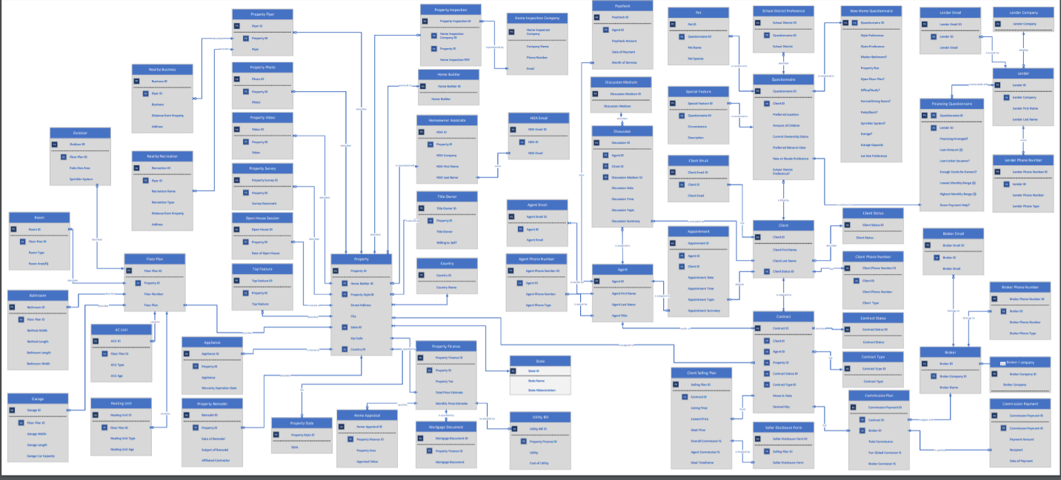

* **ERD with just the primaries key and the relationship:**

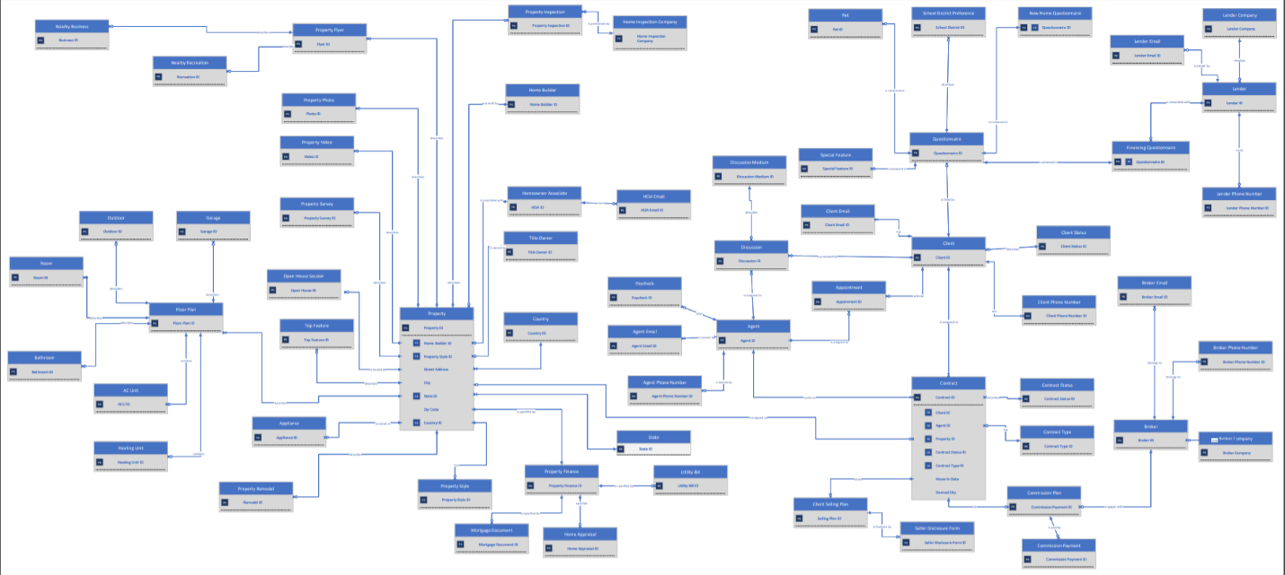

* **Note: Higher quality pdf of both the ERD can be found inside the Appendices folder**
* **On the second ERD, there are two tables (Property and Agent) that cannot be condensed due to having too many relationships.**

### **Data Dictionary**

|  |  |  |  |  |
| --- | --- | --- | --- | --- |
| Table Name | Field Name | Data Type | Constraint | Description |
| Country | Country ID | Varchar(36) | Primary Key |  |
| Country | Country Name | Varchar(100) | Not Null | Country name |
| State | State ID | Varchar(36) | Primary Key |  |
| State | State Name | Varchar(100) | Not Null | State name |
| State | State Abbreviation | Varchar(2) | Not Null | State shortcut name |
| Login | Login ID | Varchar(36) | Primary key |  |
| Login | Username | Varchar(100) | Not Null |  |
| Login | Password | Varchar(100) | Not Null |  |
| Login | Agent ID | Varchar(36) | Foreign key |  |
| New Home Questionnaire | Questionnaire ID | varchar(36) | Primary Key & Foreign Key |  |
| New Home Questionnaire | Style Preference | varchar(255) | Not Null | Style of property in search |
| New Home Questionnaire | Stairs Preference | Varchar(5) | Not Null | Yes/no field |
| New Home Questionnaire | Master Bathroom | Varchar(5) | Not Null | Yes/no field |
| New Home Questionnaire | Property Area | int | Not Null | Example Input:  2,000 sq. ft |
| New Home Questionnaire | Open Floor Plan | Varchar(5) | Not Null | Yes/no field |
| New Home Questionnaire | Office/Study | Varchar(5) | Not Null | Yes/no field |
| New Home Questionnaire | Formal Dining Room | Varchar(5) | Not Null | Yes/no field |
| New Home Questionnaire | Patio/Deck | Varchar(5) | Not Null | Yes/no field |
| New Home Questionnaire | Sprinkler System | Varchar(5) | Not Null | Yes/no field |
| New Home Questionnaire | Garage | Varchar(5) | Not Null | Yes/no field |
| New Home Questionnaire | Garage Car Capacity | tinyint | Not Null | Desired cars fitting in the garage |
| New Home Questionnaire | Lot Size Preference | int | Not Null | Example Input:  7,000 sq. ft |
| Questionnaire | Questionnaire ID | varchar(36) | Primary Key |  |
| Questionnaire | Client ID | varchar(36) | Foreign Key |  |
| Questionnaire | Preferred Location | varchar(35) | Not Null | City or Zip Code |
| Questionnaire | Amount of Children | tinyint | Not Null |  |
| Questionnaire | Current Ownership Status | Varchar(100) | Not Null | Does client already rent/own property? |
| Questionnaire | Preferred Move-In Date | Varchar(36) | Not Null | YYYY-MM-DD |
| Questionnaire | New or Resale Preference | Varchar(10) | Not Null | Yes/no field |
| Financing Questionnaire | Questionnaire ID | varchar(36) | Primary Key & Foreign Key |  |
| Financing Questionnaire | Financing Arranged | Varchar(5) | Not Null | Yes/no field |
| Financing Questionnaire | Loan Amount | money | Not Null |  |
| Financing Questionnaire | Loan Letter Issuance | Varchar(max) | Not Null | Yes/no field |
| Financing Questionnaire | Enough Funds for Earnest | Varchar(5) | Not Null | Yes/no field |
| Financing Questionnaire | Lowest Monthly Range | money | Not Null | Example Input:  $1,200 - $1,400 |
| Financing Questionnaire | Highest Monthly Range | Money | Not Null | Example Input:  $2,000 - $3,400 |
| Financing Questionnaire | Lender ID | Varchar(36) | Foreign Key | Yes/no field |
| Pet | Pet ID | varchar(36) | Primary Key |  |
| Pet | Questionnaire ID | varchar(36) | Foreign Key |  |
| Pet | Pet Name | varchar(25) | Not Null | Name of pet |
| Pet | Pet Species | varchar(25) | Not Null | Species of pet |
| School District Preference | School District ID | varchar(36) | Primary Key |  |
| School District Preference | Questionnaire ID | varchar(36) | Foreign Key |  |
| School District Preference | School District | varchar(100) | Not Null | Desired school district to live |
| Client | Client ID | varchar(36) | Primary Key |  |
| Client | Client First Name | varchar(35) | Not Null |  |
| Client | Client Last Name | varchar(35) | Not Null |  |
| Client | Client Status ID | varchar(36) | Foreign Key | Pending, Under Contract, Closed |
| Client | Client Type | varchar(30) | Not Null | Buying, Selling, Renting, Investing |
| Client Email | Client Email ID | varchar(36) | Primary Key |  |
| Client Email | Client Email | nvarchar(255) | Not Null |  |
| Client Email | Client ID | varchar(36) | Foreign Key |  |
| Client Phone Number | Client Phone Number ID | varchar(36) | Primary Key |  |
| Client Phone Number | Client ID | varchar(36) | Foreign Key |  |
| Client Phone Number | Client Phone Number | varchar(15) | Not Null |  |
| Client Phone Number | Client Phone Type | varchar(10) | Not Null | Home, Cell, Work, Other |
| Client Status | Client Status ID | varchar(36) | Primary Key |  |
| Client Status | Client Status | Varchar(50) | Not Null |  |
| Agent | Agent ID | varchar(36) | Primary Key |  |
| Agent | Agent First Name | varchar(35) | Not Null |  |
| Agent | Agent Last Name | varchar(35) | Not Null |  |
| Agent | Title | varchar(100) | Not Null | Lead agent or working under lead agent |
| Discussion | Discussion ID | varchar(36) | Primary Key |  |
| Discussion | Agent ID | varchar(36) | Foreign Key |  |
| Discussion | Client ID | varchar(36) | Foreign Key |  |
| Discussion | Discussion Medium ID | varchar(36) | Foreign Key | Phone, Email, Text |
| Discussion | Discussion Time | Varchar(36) | Not Null | Time of discussion |
| Discussion | Discussion Topic | varchar(255) | Not Null | Reason for discussion |
| Discussion | Discussion Summary | varchar(255) | Not Null | Description of discussion |
| Discussion Medium | Discussion Medium | varchar(20) | Not Null | Email, Call, Text |
| Discussion Medium | Discussion Medium ID | Varchar(36) | Primary Key |  |
| Paycheck | Paycheck ID | varchar(36) | Primary Key |  |
| Paycheck | Agent ID | varchar(36) | Foreign Key |  |
| Paycheck | Paycheck Amount | money | Not Null |  |
| Paycheck | Date of Payment | Varchar(36) | Not Null |  |
| Paycheck | Month of Services | varchar(25) | Not Null |  |
| Appointment | Appointment ID | varchar(36) | Primary Key |  |
| Appointment | Agent ID | varchar(36) | Foreign Key |  |
| Appointment | Client ID | varchar(36) | Foreign Key |  |
| Appointment | Appointment Date | Varchar(36) | Not Null | Date of appointment |
| Appointment | Appointment Time | Varchar(36) | Not Null | Time of appointment |
| Appointment | Appointment Topic | varchar(50) | Not Null | Reason for appointment |
| Appointment | Appointment Summary | varchar(350) | Not Null | Description of appointment |
| Contract | Contract ID | varchar(36) | Primary Key |  |
| Contract | Client ID | varchar(36) | Foreign Key |  |
| Contract | Agent ID | varchar(36) | Foreign Key |  |
| Contract | Property ID | varchar(36) | Foreign Key |  |
| Contract | Contract Status | varchar(36) | Foreign Key | Pending, Closed, Waiting etc |
| Contract | Contract Type ID | varchar(36) | Foreign Key | Buying, Selling, Investing |
| Contract | Move-in Date | Varchar(36) | Not Null | Official Date of Move-In |
| Contract | Desired City | varchar(100) | Not Null | City the client wants to move to |
| Client Selling Plan | Selling Plan ID | varchar(36) | Primary Key |  |
| Client Selling Plan | Contract ID | varchar(36) | Foreign Key |  |
| Client Selling Plan | Listing Price | money | Not Null | Original sale price advertised |
| Client Selling Plan | Lowest Price | money | Not Null | Lowest price seller is willing go |
| Client Selling Plan | Ideal Price | money | Not Null | Price the seller prefers to sell for |
| Client Selling Plan | Overall Commission % | Decimal(4,2) | Not Null | Example: 6.25 |
| Client Selling Plan | Agent Commission % | Decimal(4,2) | Not Null | Example: 50.99 |
| Client Selling Plan | Starting Ideal Timeframe | Date | Not Null | Seller’s desired sell-by date |
| Client Selling Plan | Ending Ideal Timeframe | Date | Not Null |  |
| Seller Disclosure Form | Seller Disclosure Form ID | varchar(36) | Primary Key |  |
| Seller Disclosure Form | Selling Plan ID | varchar(36) | Foreign Key |  |
| Seller Disclosure Form | Seller Disclosure Form | varchar(max) | Not Null | PDF of form filled out by seller |
| Commission Plan | Commission Plan ID | varchar(36) | Primary Key |  |
| Commission Plan | Contract ID | varchar(36) | Foreign Key |  |
| Commission Plan | Broker ID | varchar(36) | Foreign Key |  |
| Commission Plan | Total Commission | money | Not Null | Value of commission from the sale |
| Commission Plan | Yun Global Commission % | decimal(4,2) | Not Null | Percentage of commission to agent |
| Commission Plan | Broker Commission % | decimal(4,2) | Not Null | Percentage of commission to broker |
| Commission Payment | Commission Payment ID | varchar(36) | Primary Key |  |
| Commission Payment | Commission Plan ID | varchar(36) | Foreign Key |  |
| Commission Payment | Payment Amount | smallmoney | Not Null |  |
| Commission Payment | Recipient | varchar(50) | Not Null | Agent or Broker |
| Commission Payment | Date of Payment | Varchar(36) | Not Null |  |
| Broker | Broker ID | varchar(36) | Primary Key |  |
| Broker | Broker Company ID | Varchar(36) | Foreign Key |  |
| Broker | Broker Name | varchar(70) | Not Null | First and Last Name of Broker |
| Broker Company | Broker Company ID | Varchar(36) | Primary key |  |
| Broker Company | Broker Company | varchar(200) | not null | Company Broker works for |
| Broker Phone Number | Broker Phone Number ID | varchar(36) | Primary Key |  |
| Broker Phone Number | Broker ID | varchar(36) | Foreign Key |  |
| Broker Phone Number | Broker Phone Number | varchar(15) | Not Null | Phone Number of Broker |
| Broker Phone Number | Broker Phone Type | varchar(9) | Not Null |  |
| Broker Email | Broker Email ID | varchar(36) | Primary Key |  |
| Broker Email | Broker ID | varchar(36) | Foreign Key |  |
| Broker Email | Broker Email | nvarchar(255) | Not Null | Email address of Broker |
| Utility Bill | Utility Bill ID | varchar(36) | Primary Key |  |
| Utility Bill | Property Finance ID | varchar(36) | Foreign Key |  |
| Utility Bill | Utility | varchar(20) | Not Null | Utility name sold with the house |
| Utility Bill | Cost of Utility | money | Not Null | Avg cost of utilities for home records |
| Top Feature | Top Feature ID | varchar(36) | Primary Key |  |
| Top Feature | Property ID | varchar(36) | Foreign Key |  |
| Top Feature | Top Feature | varchar(100) | Not Null | Agent highlights this feature in description of property |
| Contract Status | Contract Status | varchar(30) | Not Null |  |
| Contract Status | Contract Status ID | Varchar(36) | Primary key |  |
| Contract Type | Contract Type | varchar(30) | Not Null |  |
| Contract Type | Contract Type ID | Varchar(36) | Primary key |  |
| Outdoor | Outdoor ID | varchar (36) | Primary Key |  |
| Outdoor | Floor Plan ID | varchar(36) | Foreign Key |  |
| Outdoor | Patio Size Area | int | Not Null | In Sq. Ft. Or can be NA |
| Outdoor | Sprinkler System | Varchar(5) | Not Null | Yes/no field |
| Room | Room ID | varchar(36) | Primary Key |  |
| Room | Floor Plan ID | varchar(36) | Foreign Key |  |
| Room | Room Type | varchar(35) | Not Null | Bedroom, Bathroom, Game Room etc. |
| Room | Room Area ft | int | Not Null | Example Input:  12ft L X 10ft W |
| Bathroom | Bathroom ID | varchar(36) | Primary Key |  |
| Bathroom | Floor Plan ID | varchar(36) | Foreign Key |  |
| Bathroom | Bathtub Width | int | Not Null | Example Input:  60in. L X 30in. W |
| Bathroom | Bathtub length | int | Not Null | Example Input: |
| Bathroom | Bathroom width | int | Not Null |  |
| Bathroom | Bathroom length | int | Not Null |  |
| Garage | Garage ID | varchar(36) | Primary Key |  |
| Garage | Floor Plan ID | varchar(36) | Foreign Key |  |
| Garage | Garage width | int | Not Null | Example Input:  12ft L X 10ft W |
| Garage | Garage length | int | Not null |  |
| Garage | Garage car Capacity | int | Not Null | Amount of cars that fit inside |
| Nearby School District | School District ID | varchar(9) | Primary Key |  |
| Nearby School District | Flyer ID | varchar(9) | Foreign Key |  |
| Nearby School District | School District | nvarchar(255) | Not Null | District in which property is zoned |
| Nearby Business | Nearby Businesses ID | varchar(36) | Primary key |  |
| Nearby Business | Flyer ID | varchar(36) | Foreign Key |  |
| Nearby Business | Business | nvarchar(255) | Not Null | Name of business near property |
| Nearby Business | Distance from Property | varchar(255) | Not Null | Distance from property to business |
| Nearby Business | Address | nvarchar(255) | Not Null | Address of business |
| Nearby Recreation | Recreation ID | varchar(36) | Primary Key |  |
| Nearby Recreation | Flyer ID | varchar(36) | Foreign Key |  |
| Nearby Recreation | Recreation | varchar(35) | Not Null | Name of recreation near property |
| Nearby Recreation | Distance from Property | varchar(50) | Not Null | Distance from property to recreation |
| Nearby Recreation | Address | nvarchar(255) | Not Null | Address of recreation |
| Floor Plan | Floor Plan ID | varchar(36) | Primary Key |  |
| Floor Plan | Property ID | varchar(36) | Foreign Key |  |
| Floor Plan | Floor Number | tinyint | Not Null | Floor Number the client prefers |
| Floor Plan | Floor Plan | Varchar(max) | Not Null | File containing image of floor plan |
| Air Conditioning Unit | ACU ID | varchar(36) | Primary Key |  |
| Air Conditioning Unit | Floor Plan ID | varchar(36) | Foreign Key |  |
| Air Conditioning Unit | ACU Type | varchar(9) | Not Null |  |
| Air Conditioning Unit | ACU Age | int | Not Null |  |
| Heating Unit | Heating Unit ID | varchar(36) | Primary Key |  |
| Heating Unit | Floor Plan ID | varchar(36) | Foreign Key |  |
| Heating Unit | Heating Unit Type | varchar(9) | Not Null |  |
| Heating Unit | Heating Unit Age | int | Not Null |  |
| Appliance | Appliance ID | varchar(36) | Primary Key |  |
| Appliance | Property ID | varchar(36) | Foreign Key |  |
| Appliance | Appliance | varchar(20) | Not Null | Name of appliance |
| Appliance | Warranty Expiration Date | varchar(35) | Not Null | Will be either the warranty date or ‘NO WARRANTY’ |
| Open House Session | Open House ID | varchar(36) | Primary Key |  |
| Open House Session | Property ID | varchar(36) | Foreign Key |  |
| Open House Session | Date of Open House | Varchar(36) | Not Null |  |
| Property Flyer | Flyer ID | varchar(36) | Primary Key |  |
| Property Flyer | Property ID | varchar(36) | Foreign Key |  |
| Property Flyer | Flyer | Varchar(max) | Not Null |  |
| Property Photo | Photo ID | varchar(36) | Primary Key |  |
| Property Photo | Property ID | varchar(36) | Foreign Key |  |
| Property Photo | Photo | Varchar(max) | Not Null |  |
| Property Video | Video ID | varchar(36) | Primary Key |  |
| Property Video | Property ID | varchar(36) | Foreign Key |  |
| Property Video | Video | Varchar(max) | Not Null |  |
| Property Survey | Property Survey ID | varchar(36) | Primary Key |  |
| Property Survey | Property ID | varchar(36) | Foreign Key |  |
| Property Survey | Survey document | varchar(max) | Not Null |  |
| Property Remodel | Remodel ID | varchar(36) | Primary Key |  |
| Property Remodel | Property ID | varchar(36) | Foreign Key |  |
| Property Remodel | Date of Remodel | Varchar(36) | Not Null |  |
| Property | Property ID | varchar(36) | Primary Key |  |
| Property | Home Builder ID | varchar(36) | Foreign Key |  |
| Property | Property Style ID | Varchar(36) | Foreign key |  |
| Property | Street Address | nvarchar(255) | Not Null |  |
| Property | City | varchar(35) | Not Null |  |
| Property | State ID | varchar(36) | Foreign key |  |
| Property | Zip Code | varchar(9) | Not Null |  |
| Property | Country ID | varchar(36) | Foreign key |  |
| Property Style | Property Style ID | varchar(36) | Primary Key |  |
| Property Style | Style | varchar(35) | Not Null | Style of property |
| Home Appraisal | Home Appraisal ID | Varchar(36) | Primary Key |  |
| Home Appraisal | Property Finance ID | varchar(36) | Foreign Key |  |
| Home Appraisal | Property Area | Varchar(50) | Not Null |  |
| Home Appraisal | Appraisal Value | money | Not Null |  |
| Mortage Document | Mortgage Document ID | varchar(36) | Primary Key |  |
| Mortage Document | Property Finance ID | varchar(36) | Foreign Key |  |
| Mortage Document | Mortage Document | varchar(max) | Not Null | Pdf of Mortage document |
| Property Finance | Property Finance ID | varchar(36) | Primary Key |  |
| Property Finance | Property Tax | money | Not Null | Property tax |
| Property Finance | Property ID | varchar(36) | Foreign Key |  |
| Property Finance | Total Price Estimate | money | Not Null | Overall price estimate |
| Property Finance | Monthly Price Estimate | money | Not Null | Monthly estimate |
| Agent Phone Number | Agent Phone Number ID | varchar(36) | Primary Key |  |
| Agent Phone Number | Agent ID | varchar(36) | Foreign Key |  |
| Agent Phone Number | Agent Phone Number | varchar(15) | Not Null | Agent's number |
| Agent Phone Number | Agent Phone Type | varchar(15) | Not Null | Home, Work, Cell, Other |
| Agent Email | Agent Email ID | varchar(36) | Primary Key | Agent's email |
| Agent Email | Agent Email | nvarchar(255) | Not Null |  |
| Agent Email | Agent ID | varchar(36) | Foreign Key |  |
| HOA Associate | HOA ID | varchar(9) | Primary Key |  |
| HOA Associate | Property ID | varchar(9) | Foreign Key |  |
| HOA Associate | HOA First Name | varchar(35) | Not Null | HOA Associate’s First Name |
| HOA Associate | HOA Last Name | varchar(35) | Not Null | HOA Associate’s Last Name |
| HOA Phone Number | HOA Phone Number ID | varchar(9) | Primary Key |  |
| HOA Phone Number | HOA ID | varchar(9) | Foreign Key |  |
| HOA Phone Number | HOA Phone Number | varchar(15) | Not Null | HOA Associate’s Phone Number |
| HOA Phone Number | HOA Phone Type | varchar(15) | Not Null | HOA Associate’s Phone Type |
| HOA Email | HOA Email ID | varchar(36) | Primary Key |  |
| HOA Email | HOA ID | varchar(36) | Foreign Key |  |
| HOA Email | HOA Email | nvarchar(255) | Not Null | HOA Associate’s Email |
| Title Owner | Title Owner ID | varchar(36) | Primary Key |  |
| Title Owner | Property ID | varchar(36) | Foreign Key |  |
| Title Owner | Title Owner | varchar(150) | Not Null | Many names can be on a single title |
| Home Builder | Home Builder ID | varchar(36) | Primary Key | Home Building Company |
| Home Builder | Home Builder | Varchar(100) | Not Null | Home builder associated |
| Home Inspection Company | Home Inspection company ID | Varchar(36) | Primary key |  |
| Home Inspection Company | Property ID | Varchar(36) | Foreign key |  |
| Home Inspection Company | Company Name | Varchar(200) | Not Null |  |
| Home Inspection Company | Phone Number | Varchar(15) | Not Null |  |
| Home Inspection  Company | Email | nvarchar(255) | Not Null |  |
| HOA Company | HOA Company | Varchar(9) | Primary Key |  |
| Homeowner Associate | HOA ID | Varchar(36) | Primary key |  |
| Homeowner Associate | Property ID | Varchar(36) | Foreign key |  |
| Homeowner Associate | HOA First name | varchar(35) | Not Null |  |
| Homeowner Associate | HOA Last name | varchar(35) | Not Null |  |
| Homeowner Associate | HOA Company | Varchar(100) | Foreign key |  |
| Lender Company | Lender Company ID | varchar(36) | Primary Key |  |
| Lender Company | Lender company | Varchar(50) | Not Null |  |
| Lender | Lender ID | varchar(36) | Primary Key |  |
| Lender | Lender Company ID | varchar(36) | Foreign Key |  |
| Lender | Lender First Name | varchar(35) | Not Null |  |
| Lender | Lender Last Name | varchar(35) | Not Null |  |
| Lender Email | Lender Email ID | varchar(36) | Primary Key |  |
| Lender Email | Lender Email | nvarchar(255) | Not Null |  |
| Lender Email | Lender ID | varchar(36) | Foreign Key |  |
| Lender Phone Number | Lender Phone Number ID | varchar(36) | Primary Key |  |
| Lender Phone Number | Lender ID | varchar(36) | Foreign Key |  |
| Lender Phone Number | Lender Phone Number | varchar(15) | Not Null |  |
| Property Inspection | Property Inspection ID | varchar(36) | Primary Key |  |
| Property Inspection | Property ID | varchar(36) | Foreign Key |  |
| Property Inspection | Home Inspection Company ID | varchar(36) | Foreign Key |  |
| Property Inspection | Home Inspection PDF | varchar(max) | Not Null |  |

### **Final Updated Problems and requirements List with Results**

**Problems:**

* The current system is difficult to work with, inefficient, and not systematic.
* The current system is complicated, and it takes time to figure out how it works.
* No automatic time stamp feature for client profiles and no progress information about real estate deals.
* No information regarding when the client was last contacted, date, time, and what was discussed on the last contact.

**Requirements:**

* Ability to see Real estate deal progress.
* Ability to have customer last contact date, time, and a summary of what was discussed.
* Filter feature to sort what client wants by Area, price range.
* Ability to store clients, agents, and property details.
* Sort property base on zip code, price, or a certain type of attribute.
* Sort clients by status.

**Results:**

* Ability to see Real estate deal progression can be seen.
* Ability to see customer last contact data, time, and summary of the discussion.
* Filer features for clients by area, price range, and more are created.
* Storing property zip code, price, and other attributes achieved.
* Sorting clients by status achieve.

### **Final Summary of Project Hours**

|  |  |  |  |  |
| --- | --- | --- | --- | --- |
| Team Swift Database | Deliverable Description | Start Date/Time | Hours Worked | Est. Hours Remaining |
| Duy Truong |  |  |  |  |
|  | Meeting | 09/17/2020 15:40 | 1 | N/A |
|  | Meeting | 09/20/2020 14:05 | 2 | N/A |
|  | Meeting | 10/04/2020 14:00 | 1 | N/A |
|  | Meeting | 10/11/2020 14:00 | 1 | N/A |
|  | Meeting | 10/18/2020 14:05 | 1 | N/A |
|  | Meeting | 10/25/2020 14:00 | 1 | N/A |
|  | Meeting | 11/01/2020 14:00 | 1 | N/A |
|  | Meeting | 11/08/2020 14:00 | 1 | N/A |
|  | Meeting | 11/15/2020 14:00 | 1 | N/A |
|  | Meeting | 11/16/2020 14:00 | 1 | N/A |
|  | Meeting | 11/17/2020 14:00 | 1 | N/A |
|  | Meeting | 09/27/2020 14:10 | 1 | N/A |
|  | SQL General Programming | 09/20/2020 19:00 | 52 | 0 |
|  | Java | 10/29/2020 15:00 | 27 | 0 |
|  | Report | 11/16/2020 10:00 | 20 | 0 |
|  | CSV | 10/08/2020 16:00 | 15 | 0 |
|  | ERD polish | 11/05/2020 09:00 | 2 |  |
|  | **Total** |  | **129** |  |
|  |
|  |
| Robert Smith |  |  |  |  |
|  | Meeting | 09/17/2020 15:40 | 1 | N/A |
|  | Meeting | 10/04/2020 14:00 | 1 | N/A |
|  | Meeting | 10/11/2020 14:00 | 1 | N/A |
|  | Meeting | 10/18/2020 14:05 | 1 | N/A |
|  | Meeting | 10/25/2020 14:00 | 1 | N/A |
|  | Meeting | 11/01/2020 14:00 | 1 | N/A |
|  | Meeting | 11/08/2020 14:00 | 1 | N/A |
|  | Meeting | 11/15/2020 14:00 | 1 | N/A |
|  | Meeting | 11/16/2020 14:00 | 1 | N/A |
|  | Meeting | 11/17/2020 14:00 | 1 | N/A |
|  | Meeting | 09/27/2020 14:10 | 1 | N/A |
|  | SQL General Programming | 09/21/2020 18:00 | 28.5 | 0 |
|  | Java | 10/29/2020 15:00 | 30 | 0 |
|  | Report | 11/16/2020 10:00 | 8 | 0 |
|  | CSV | 10/08/2020 16:00 | 4 | 0 |
|  | **Total** |  | **81.5** |  |
|  |
| Ashley Pinto |  |  |  |  |
|  | Meeting | 09/17/2020 15:40 | 1 | N/A |
|  | Meeting | 09/27/2020 14:10 | 1 | N/A |
|  | Meeting | 10/04/2020 14:00 | 1 | N/A |
|  | Meeting | 10/11/2020 14:00 | 1 | N/A |
|  | Meeting | 10/18/2020 14:05 | 1 | N/A |
|  | Meeting | 10/25/2020 14:00 | 1 | N/A |
|  | Meeting | 11/01/2020 14:00 | 1 | N/A |
|  | Meeting | 11/08/2020 14:00 | 1 | N/A |
|  | Meeting | 11/15/2020 14:00 | 1 | N/A |
|  | Meeting | 11/16/2020 14:00 | 1 | N/A |
|  | Meeting | 11/17/2020 14:00 | 1 | N/A |
|  | Data Dictionary | 10/01/2020 | 30 | 0 |
|  | SQL General Programming | 09/21/2020 18:00 | 25 | 0 |
|  |  |  |  |  |
|  | Java | 10/29/2020 15:00 | 20 | 0 |
|  | Report | 11/16/2020 10:00 | 10 | 0 |
|  | CSV | 10/08/2020 16:00 | 5 | 0 |
|  | **Total** |  | **101** |  |
|  |
| Travis Ho |  |  |  |  |
|  | Meeting | 09/17/2020 15:40 | 1 | N/A |
|  | Meeting | 09/27/2020 14:10 | 1 | N/A |
|  | Meeting | 10/04/2020 14:00 | 1 | N/A |
|  | Meeting | 10/11/2020 14:00 | 1 | N/A |
|  | Meeting | 10/18/2020 14:05 | 1 | N/A |
|  | Meeting | 10/25/2020 14:00 | 1 | N/A |
|  | Meeting | 11/01/2020 14:00 | 1 | N/A |
|  | Meeting | 11/08/2020 14:00 | 1 | N/A |
|  | Meeting | 11/15/2020 14:00 | 1 | N/A |
|  | Meeting | 11/16/2020 14:00 | 1 | N/A |
|  | Meeting | 11/17/2020 14:00 | 1 | N/A |
|  | Finalizing ERD | 09/22/2020 18:05 | 1 | 0 |
|  | SQL General Programming | 09/22/2020 20:00 | 68 | 0 |
|  | Java | 10/29/2020 15:00 | 87 | 0 |
|  | Report | 11/16/2020 10:00 | 3 | 0 |
|  | CSV | 10/08/2020 16:00 | 15 | 0 |
|  | **Total** |  | **193** |  |
| Julia Byrne |  |  |  |  |
|  | Meeting | 09/17/2020 15:40 | 1 | N/A |
|  | Meeting | 09/20/2020 14:05 | 2 | N/A |
|  | Meeting | 10/04/2020 14:00 | 1 | N/A |
|  | Meeting | 10/11/2020 14:00 | 1 | N/A |
|  | Meeting | 10/18/2020 14:05 | 1 | N/A |
|  | Meeting | 10/25/2020 14:00 | 1 | N/A |
|  | Meeting | 11/01/2020 14:00 | 1 | N/A |
|  | Meeting | 11/08/2020 14:00 | 1 | N/A |
|  | Meeting | 11/15/2020 14:00 | 1 | N/A |
|  | Meeting | 11/16/2020 14:00 | 1 | N/A |
|  | Meeting | 11/17/2020 14:00 | 1 | N/A |
|  | SQL General Programming | 09/21/2020 19:00 | 32.25 | 0 |
|  | Editing ERD | 09/29/2020 23:00 | 1.5 | 0 |
|  | Java | 10/29/2020 15:00 | 37 | 0 |
|  | CSS | 10/30/2020 14:00 | 53 | 0 |
|  | Report | 11/16/2020 10:00 | 10 | 0 |
|  | CSV | 10/08/2020 16:00 | 5 | 0 |
|  | Data Dictionary | 09/20/2020 | 3 | 0 |
|  | **Total** |  | **153.75** |  |
|  |
| Carlos Moya |  |  |  |  |
|  | Meeting | 09/17/2020 15:40 | 1 | N/A |
|  | Meeting | 10/04/2020 14:00 | 1 | N/A |
|  | Meeting | 10/11/2020 14:00 | 1 | N/A |
|  | Meeting | 10/18/2020 14:05 | 1 | N/A |
|  | Meeting | 10/25/2020 14:00 | 1 | N/A |
|  | Meeting | 11/01/2020 14:00 | 1 | N/A |
|  | Meeting | 11/08/2020 14:00 | 1 | N/A |
|  | Meeting | 11/15/2020 14:00 | 1 | N/A |
|  | Meeting | 11/16/2020 14:00 | 1 | N/A |
|  | Meeting | 11/17/2020 14:00 | 1 | N/A |
|  | Java | 10/29/2020 15:00 | 25 | 0 |
|  | Report | 11/16/2020 10:00 | 25 | 0 |
|  | CSV | 10/08/2020 16:00 | 10 | 0 |
|  | SQL General Programming | 09/21/2020 17:00 | 27 | 0 |
|  | **Total** |  | **97** |  |
| Kayla Harris |  |  |  |  |
|  | Meeting | 09/17/2020 15:40 | 1 | N/A |
|  | Meeting | 10/04/2020 14:00 | 1 | N/A |
|  | Meeting | 10/11/2020 14:00 | 1 | N/A |
|  | Meeting | 10/18/2020 14:05 | 1 | N/A |
|  | Meeting | 10/25/2020 14:00 | 1 | N/A |
|  | Meeting | 11/01/2020 14:00 | 1 | N/A |
|  | Meeting | 11/08/2020 14:00 | 1 | N/A |
|  | Meeting | 11/15/2020 14:00 | 1 | N/A |
|  | Meeting | 11/16/2020 14:00 | 1 | N/A |
|  | Meeting | 11/17/2020 14:00 | 1 | N/A |
|  | SQL General Programming | 09/21/2020 19:30 | 28 | 0 |
|  | Java | 10/29/2020 15:00 | 30 | 0 |
|  | Report | 11/16/2020 10:00 | 7 | 0 |
|  | CSV | 10/08/2020 16:00 | 6 | 0 |
|  | **Total** |  | **81** |  |
| Kevin Tao |  |  |  |  |
|  | Meeting | 09/17/2020 15:40 | 1 | N/A |
|  | Meeting | 09/20/2020 14:05 | 2 | N/A |
|  | Meeting | 10/04/2020 14:00 | 1 | N/A |
|  | Meeting | 10/11/2020 14:00 | 1 | N/A |
|  | Meeting | 10/18/2020 14:05 | 1 | N/A |
|  | Meeting | 10/25/2020 14:00 | 1 | N/A |
|  | Meeting | 11/01/2020 14:00 | 1 | N/A |
|  | Meeting | 11/08/2020 14:00 | 1 | N/A |
|  | Meeting | 11/15/2020 14:00 | 1 | N/A |
|  | Meeting | 11/16/2020 14:00 | 1 | N/A |
|  | Meeting | 11/17/2020 14:00 | 1 | N/A |
|  | Meeting | 09/27/2020 14:10 | 1 | N/A |
|  | Java | 10/29/2020 15:00 | 30 | 0 |
|  | Report | 11/16/2020 10:00 | 15 | 0 |
|  | CSV | 10/08/2020 16:00 | 4 | 0 |
|  | CSS | 10/30/2020 14:00 | 46 | 0 |
|  | SQL General Programming | 09/21/2020 14:00 | 20 | 0 |
|  | **Total** |  | **128** |  |
| Muhammad Tahir |  |  |  |  |
|  | Meeting | 09/17/2020 15:40 | 1 | N/A |
|  | Meeting | 09/20/2020 14:05 | 2 | N/A |
|  | Meeting | 09/27/2020 14:10 | 1 | N/A |
|  | Meeting | 10/04/2020 14:00 | 1 | N/A |
|  | Meeting | 10/11/2020 14:00 | 1 | N/A |
|  | Meeting | 10/18/2020 14:05 | 1 | N/A |
|  | Meeting | 10/25/2020 14:00 | 1 | N/A |
|  | Meeting | 11/01/2020 14:00 | 1 | N/A |
|  | Meeting | 11/08/2020 14:00 | 1 | N/A |
|  | Meeting | 11/15/2020 14:00 | 1 | N/A |
|  | Meeting | 11/16/2020 14:00 | 1 | N/A |
|  | Meeting | 11/17/2020 14:00 | 1 | N/A |
|  | SQL General Programming | 09/21/2020 14:00 | 40 | 0 |
|  | Java | 10/29/2020 15:00 | 25 | 0 |
|  | Report | 11/16/2020 10:00 | 25 | 0 |
|  | CSV | 10/08/2020 16:00 | 5 | 0 |
|  | **Total** |  | **118** |  |
| Sharanjit Sembhi |  |  |  |  |
|  | Meeting | 09/17/2020 15:40 | 1 | N/A |
|  | Meeting | 09/20/2020 14:05 | 2 | N/A |
|  | Meeting | 10/04/2020 14:00 | 1 | N/A |
|  | Meeting | 10/11/2020 14:00 | 1 | N/A |
|  | Meeting | 10/18/2020 14:05 | 1 | N/A |
|  | Meeting | 10/25/2020 14:00 | 1 | N/A |
|  | Meeting | 11/01/2020 14:00 | 1 | N/A |
|  | Meeting | 11/08/2020 14:00 | 1 | N/A |
|  | Meeting | 11/15/2020 14:00 | 1 | N/A |
|  | Meeting | 11/16/2020 14:00 | 1 | N/A |
|  | Meeting | 11/17/2020 14:00 | 1 | N/A |
|  | SQL General Programming | 09/21/2020 14:00 | 30 | 0 |
|  | Java | 10/29/2020 15:00 | 40 | 0 |
|  | Report | 11/16/2020 10:00 | 10 | 0 |
|  | CSV | 10/08/2020 16:00 | 4 | 0 |
|  | **Total** |  | **96** |  |

### **Ashely Pinto Report**

**Create Scripts:**

CREATE TABLE [Outdoor](

[Outdoor_ID] varchar(36) NOT NULL,

Floor_Plan_ID] varchar(36) NOT NULL FOREIGN KEY REFERENCES Floor_Plan(Floor_Plan_ID),

[Patio_Size_Area] int NOT NULL,

[Sprinkler_System] varchar(5) NOT NULL,

CONSTRAINT [PK_Outdoor_ID] PRIMARY KEY ([Outdoor_ID])

);

CREATE TABLE [Room](

[Room_ID] varchar(36) NOT NULL,

[Floor_Plan_ID] varchar(36) NOT NULL FOREIGN KEY REFERENCES Floor_Plan(Floor_Plan_ID),

[Room_Type] varchar(35) NOT NULL,

[Room_Area_ft] int NOT NULL,

CONSTRAINT [PK_Room_ID] PRIMARY KEY ([Room_ID])

);

CREATE TABLE [Property](

[Property_ID] varchar(36) NOT NULL,

[Home_Builder_ID] varchar(36) NOT NULL FOREIGN KEY REFERENCES Home_Builder(Home_Builder_ID),

[Property_Style_ID] varchar(36) NOT NULL FOREIGN KEY REFERENCES Property_Style(Property_Style_ID),

[Street_Address] nvarchar(255) NOT NULL,

[City] varchar(35) NOT NULL,

[State_ID] varchar(36) NOT NULL FOREIGN KEY REFERENCES State(State_ID),

[Zip_Code] varchar(9) NOT NULL,

[Country_ID] varchar(36) NOT NULL FOREIGN KEY REFERENCES Country(Country_ID),

CONSTRAINT [PK_Property_ID] PRIMARY KEY ([Property_ID])

);

CREATE TABLE [Questionnaire](

[Questionnaire_ID] varchar(36) NOT NULL,

[Client_ID] varchar(36) NOT NULL FOREIGN KEY REFERENCES Client(Client_ID),

[Preferred_Location] varchar(35) NOT NULL,

[Amount_Of_Children] tinyint NOT NULL,

[Current_Ownership_Status] varchar(100) NOT NULL,

[Preferred_Move_In_Date] varchar(36) NOT NULL,

[New_Or_Resale_Preference] varchar(10) NOT NULL,

CONSTRAINT [PK_Questionnaire_ID] PRIMARY KEY ([Questionnaire_ID])

);

CREATE TABLE [Client](

[Client_ID] varchar(36) NOT NULL,

[Client_First_Name] varchar(35) NOT NULL,

[Client_Last_Name] varchar(35) NOT NULL,

[Client_Status_ID] varchar(36) NOT NULL FOREIGN KEY REFERENCES Client_Status(Client_Status_ID),

[Client_Type] varchar(30) NOT NULL,

CONSTRAINT [PK_Client_ID] PRIMARY KEY ([Client_ID])

);

CREATE TABLE [Seller Disclosure form](

[Seller_Disclosure_Form_ID] varchar(36) NOT NULL,

[Selling_Plan_ID] varchar(36) NOT NULL FOREIGN KEY REFERENCES Client_Selling_Plan(Selling_Plan_ID),

[Seller_Disclosure_Form] varchar(max) NOT NULL,

CONSTRAINT [PK_Seller_Disclosure_Form_ID] PRIMARY KEY ([Seller_Disclosure_Form_ID])

);

**Data Created:**

**Questionnaire:**

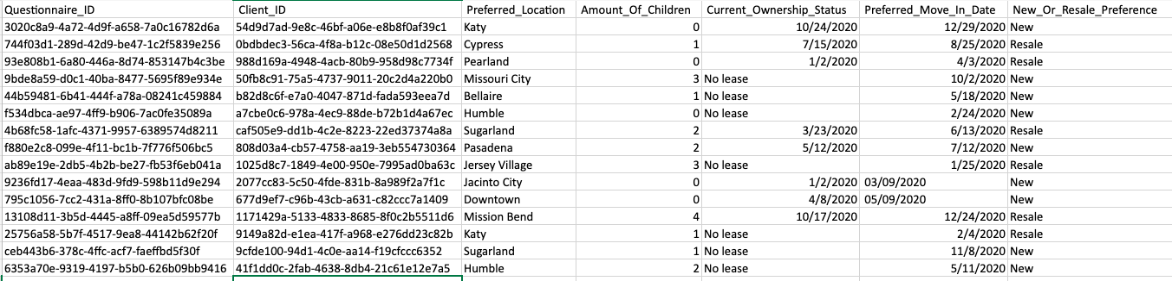

**Property Survey:**

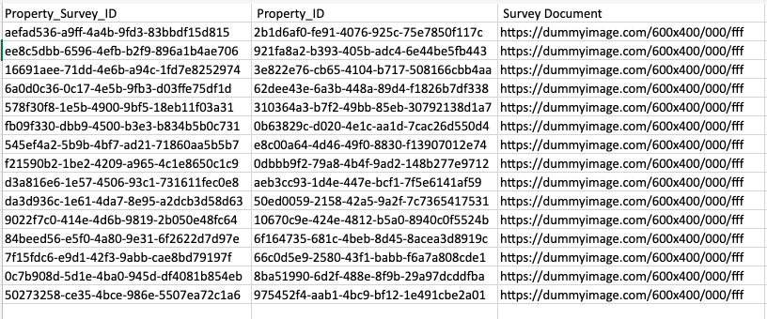

**Outdoor:**

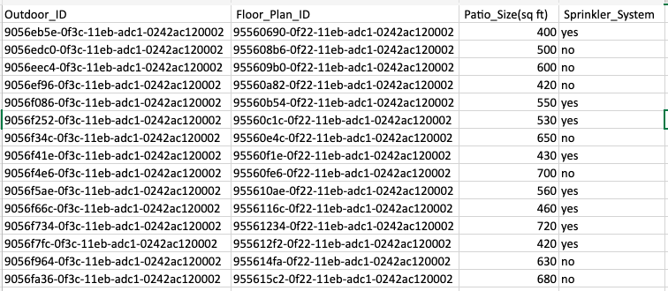

**Room:**

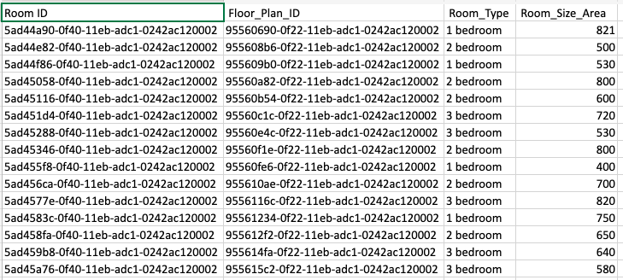

**Mortage Document:**

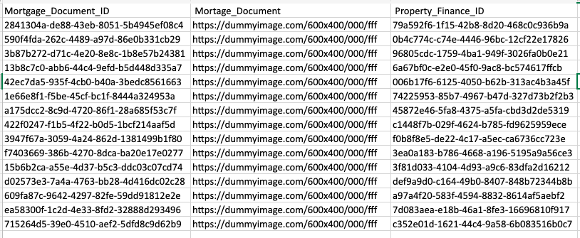

**Appointment:**

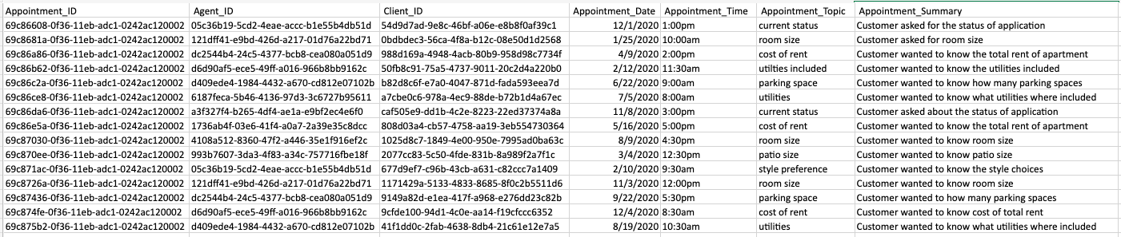

**New Home Questionnaire:**

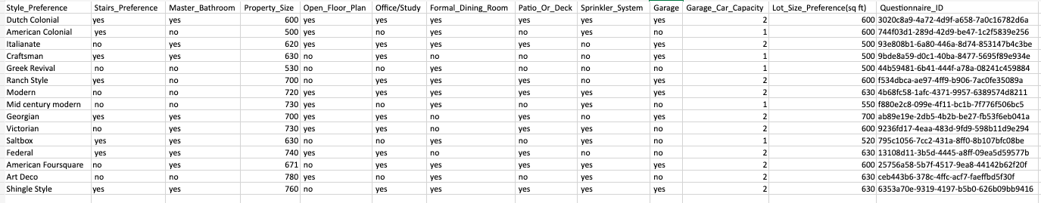

**SQL Queries:**

**SQL Query Code 1:**

SELECT

Property.Street_Address,

Property.Zip_Code,

Property.City,

Property_Finance.Total_Price_Estimate,

Title_Owner.Title_Owner,

Property_Remodel.Date_of_Remodel

FROM

Property

INNER JOIN

Property_Remodel ON Property.Property_ID=Property_Remodel.Property_ID

INNER JOIN

Property_Finance ON Property.Property_ID=Property_Finance.Property_ID

INNER JOIN

Title_Owner ON Property.Property_ID=Title_Owner.Property_ID

WHERE

Property.Zip_Code = '77502'

**SQL Query Code 2:**

SELECT

Property.Street_Address,

Property.City,

State.State_Name,

Open_House_Session.Date_Of_Open_House,

Floor_Plan.Floor_Number,

Property_Flyer.Flyer

FROM

Property

INNER JOIN

State ON Property.State_ID=state.State_ID

INNER JOIN

Open_House_Session ON Property.Property_ID=Open_House_Session.Property_ID

INNER JOIN

Floor_Plan ON Property.Property_ID=Floor_plan.Property_ID

INNER JOIN

Property_Flyer ON Property.Property_ID=Property_Flyer.Property_ID

WHERE

Open_House_Session.Date_Of_Open_House < '10/30/2020'

**SQL Query Code 3:**

SELECT

Property.City,

Property_Finance.Property_Tax,

State.State_Name,

Property_Finance.Monthly_Price_Estimate,

Appliance.Appliance,

Property_Flyer.Flyer

FROM

Property

INNER JOIN

State ON Property.State_ID=state.State_ID

INNER JOIN

Property_Finance ON Property.Property_ID=Property_Finance.Property_ID

INNER JOIN

Appliance ON Property.Property_ID=Appliance.Property_ID

INNER JOIN

Property_Flyer ON Property.Property_ID=Property_Flyer.Property_ID

WHERE

Appliance.Appliance= 'dishwasher'

**SQL Query Code 4:**

SELECT

Floor_Plan.Floor_Number,

Room.Room_Type,

Property.Street_Address,

Bathroom.Bathroom_Length

FROM

Floor_Plan

INNER JOIN

Room ON Floor_Plan.Floor_Plan_ID=Room.Floor_Plan_ID

INNER JOIN

Property ON Property.Property_ID=Floor_Plan.Property_ID

INNER JOIN

Bathroom ON Floor_Plan.Floor_Plan_ID=Bathroom.Floor_Plan_ID

WHERE

Bathrooom.Bathroom_Length > '70'

**SQL Insert Scripts:**

/* Insert Script 01 */

INSERT into Title_Owner(Title_Owner_ID,Property_ID,Title_Owner)  
VALUES (NEWID(), '008f31a4-f74c-4feb-a66c-5774d6721c00', 'Richard Joe');

/* Insert Script 02 */

INSERT into Floor_Plan(Floor_Plan,Floor_Number,Property_ID,Floor_Plan_ID)

VALUES ('<https://dummyimage.com/600x400/000/fff','4','2b1d6af0-fe91-4076-925c-75e7850f117c>', NEWID());

**Before insert:**

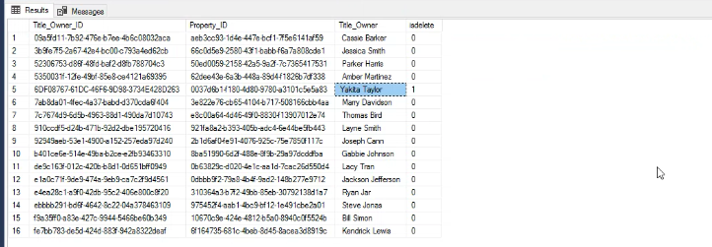

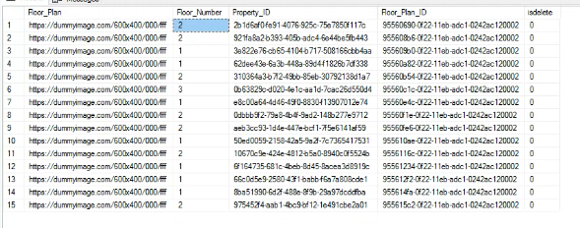

**After Insert:**

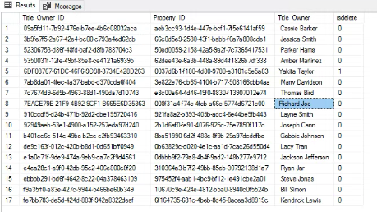

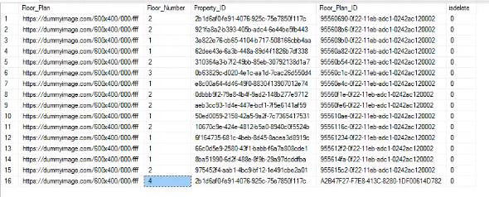

**Update Script**

/* Update Script 01 */

UPDATE [Title_Owner]  
SET Title_Owner.Title_Owner='John Cena'  
WHERE Title_Owner.Title_Owner_ID='09a5fd11-7b92-476e-b7ee-4b6c08032aca'

/* Update Script 02 */

UPDATE [Floor_Plan]  
SET Floor_Plan.Floor_Number='5'  
WHERE Floor_Plan.Floor_Plan_ID='95560a82-0f22-11eb-adc1-0242ac120002'

**Before Update:**

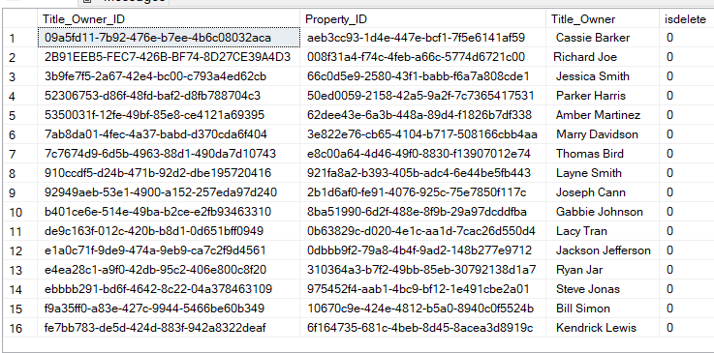

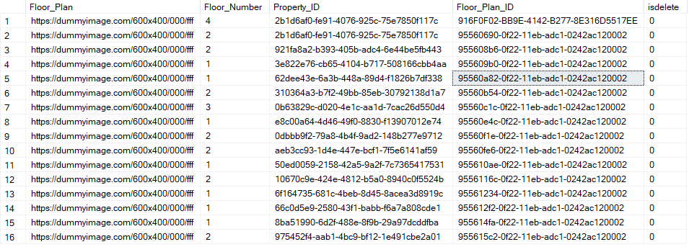

**After Update:**

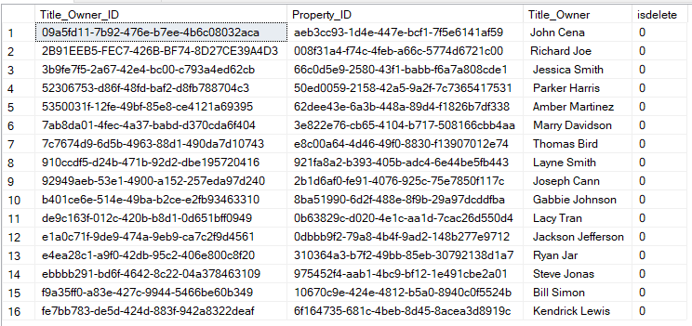

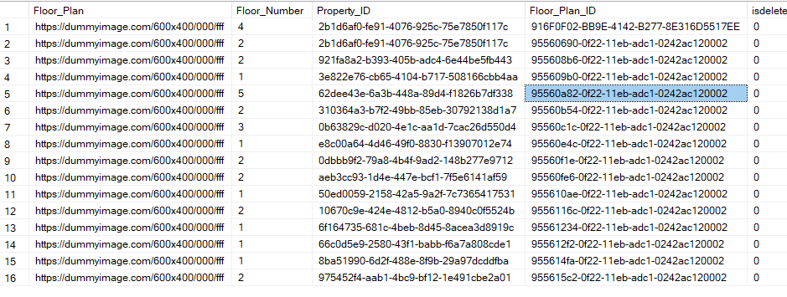

**Delete Script**

/* Soft Delete Script 01 */

UPDATE [Title_Owner]  
SET isdelete='1'  
WHERE Title_Owner.Title_Owner='Richard Joe'

/* Soft Delete Script 02 */

UPDATE [Floor_Plan]

SET isdelete='1'

WHERE Floor_Plan.Floor_Number='5'

**Before Delete:**

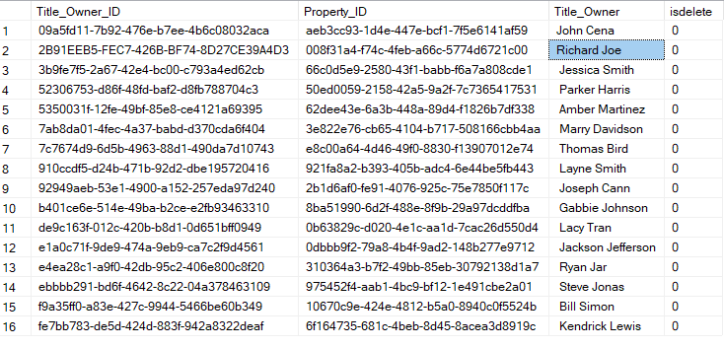

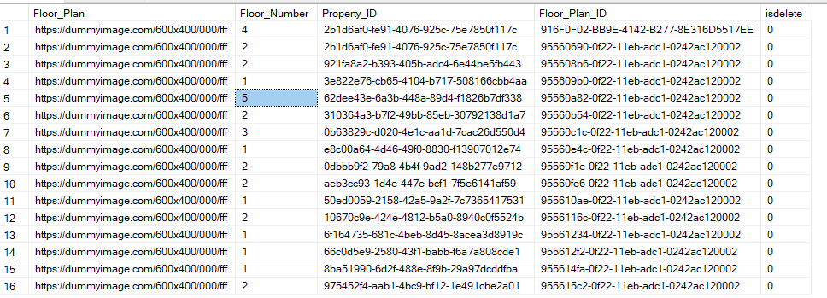

**After Delete:**

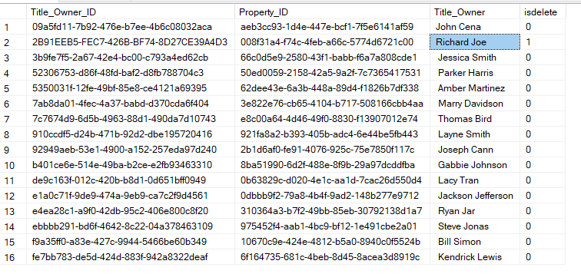

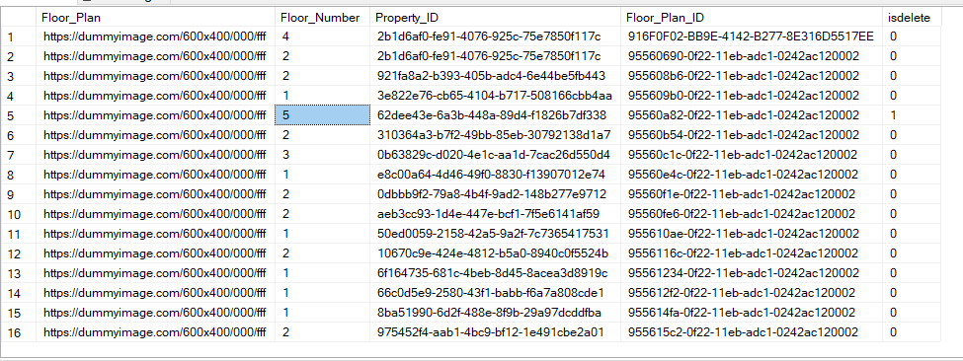

**SQL Queries Report:**

**Report Name 1:** Properties with Zip codes of 77502

**Report Description:** Just need to know properties that have the given Zip code.

**Business Purpose:** The processes minimize the result to the exact criteria being asked. This report will help agents identify which apartments are within the Zip code provided.

**SQL CODE:**

USE [3365DB4];

GO

SELECT

Property.Street_Address,

Property.Zip_Code,

Property.City,

Property_Finance.Total_Price_Estimate,

Title_Owner.Title_Owner,

Property_Remodel.Date_of_Remodel

FROM

Property

INNER JOIN

Property_Remodel ON Property.Property_ID=Property_Remodel.Property_ID

INNER JOIN

Property_Finance ON Property.Property_ID=Property_Finance.Property_ID

INNER JOIN

Title_Owner ON Property.Property_ID=Title_Owner.Property_ID

WHERE

Property.Zip_Code = '77502'

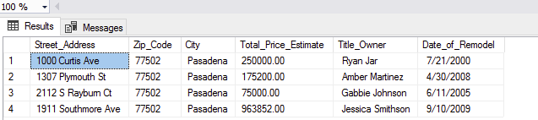

**1.Property**

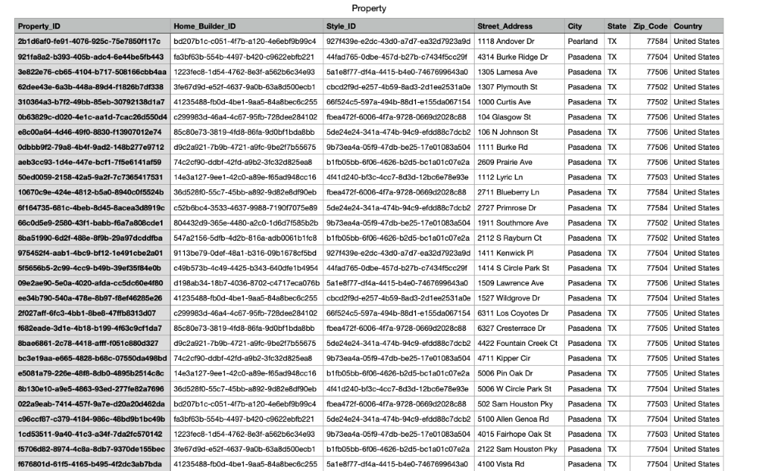

**2. Property Finance**

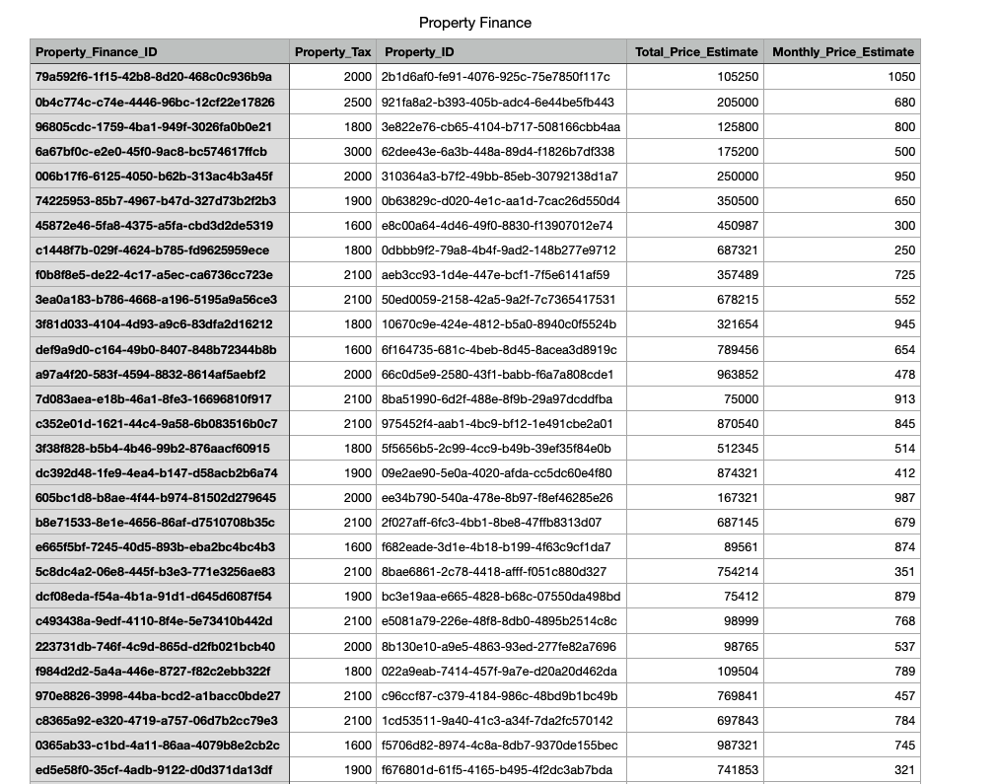

**3.Title Owner**

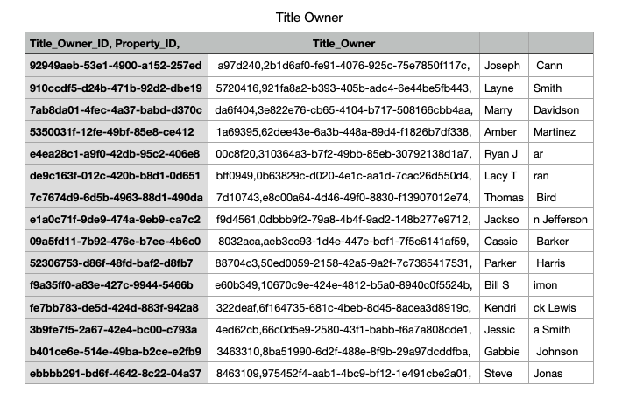

**4.Property Remodel**

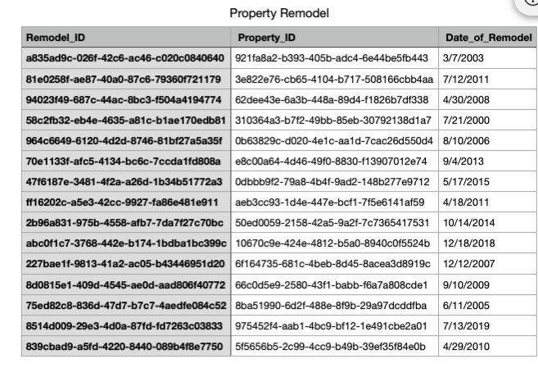

**Report Name 2:** Properties that have Open house before 10/30/2020

**Report Description:** Selects Floor plan, Property Flyer, and Property info based on open house session date.

**Business Purpose:** The processes minimize the result to the exact criteria being asked. This report will help agents identify which apartments held an open house before 10/30/2020.

**SQL CODE:**

USE [3365DB4];

GO

SELECT

Property.Street_Address,

Property.City,

State.State_Name,

Open_House_Session.Date_Of_Open_House,

Floor_Plan.Floor_Number,

Property_Flyer.Flyer

FROM

Property

INNER JOIN

State ON Property.State_ID=state.State_ID

INNER JOIN

Open_House_Session ON Property.Property_ID=Open_House_Session.Property_ID

INNER JOIN

Floor_Plan ON Property.Property_ID=Floor_plan.Property_ID

INNER JOIN

Property_Flyer ON Property.Property_ID=Property_Flyer.Property_ID

WHERE

Open_House_Session.Date_Of_Open_House < '10/30/2020'

**Report/Query Result:**

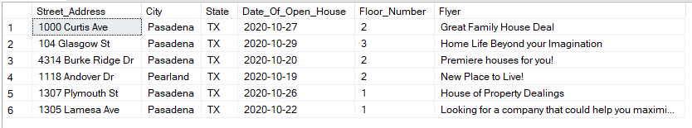

**1.Property**



**2.Open House Session**

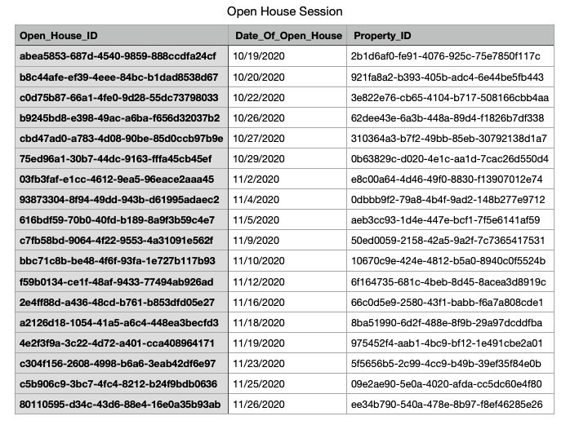

**3. Floor Plan**

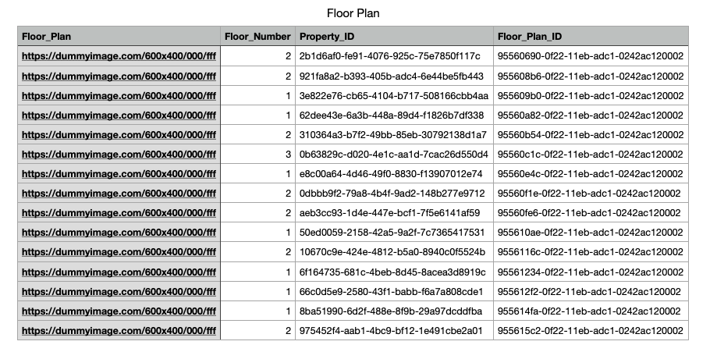

**4. Property Flyer**

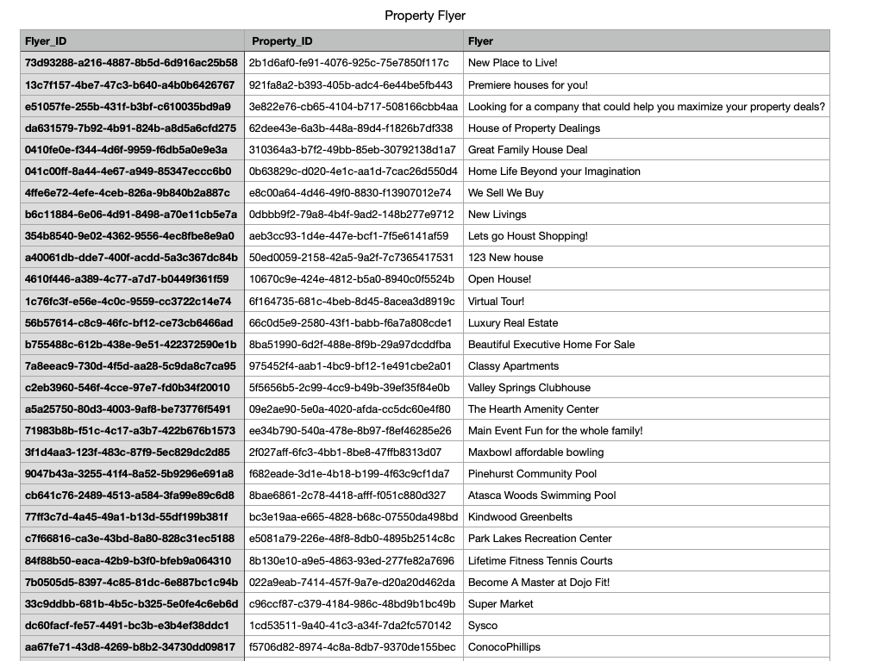

**Report Name 3:** Properties with dishwasher included

**Report Description:** Selects Property finance, Property Flyer and Property info based on appliance requested.

**Business Purpose:** The processes minimize the result to the exact criteria being asked. This report will help agents identify which apartments have a dishwasher included.

**SQL CODE:**

USE [3365DB4];

GO

SELECT

Property.City,

Property_Finance.Property_Tax,

State.State_Name,

Property_Finance.Monthly_Price_Estimate,

Appliance.Appliance,

Property_Flyer.Flyer

FROM

Property

INNER JOIN

State ON Property.State_ID=state.State_ID

INNER JOIN

Property_Finance ON Property.Property_ID=Property_Finance.Property_ID

INNER JOIN

Appliance ON Property.Property_ID=Appliance.Property_ID

INNER JOIN

Property_Flyer ON Property.Property_ID=Property_Flyer.Property_ID

WHERE

Appliance.Appliance= 'dishwasher'

**Report/Query Result:**

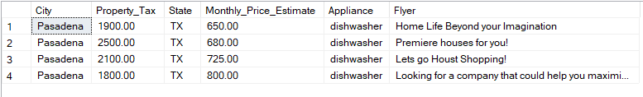

**1.Property**



**2. Property Finance**



**3. Appliance**

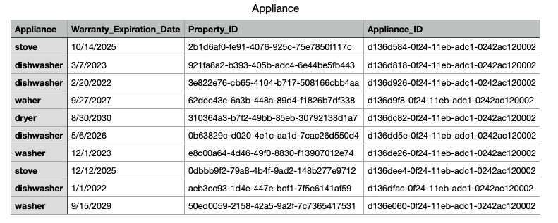

**4. Property Flyer**



**Report Name 4:** Properties with bathroom length than 70

**Report Description:** Selects Floor Plan, Room and Property info based on bathroom length requested.

**Business Purpose:** The processes minimize the result to the exact criteria being asked. This report will help agents identify which apartments have a bathroom longer in length than 70.

**SQL CODE:**

USE [3365DB4];

GO

SELECT

Floor_Plan.Floor_Number,

Room.Room_Type,

Property.Street_Address,

Bathroom.Bathroom_Length

FROM

Floor_Plan

INNER JOIN

Room ON Floor_Plan.Floor_Plan_ID=Room.Floor_Plan_ID

INNER JOIN

Property ON Property.Property_ID=Floor_Plan.Property_ID

INNER JOIN

Bathroom ON Floor_Plan.Floor_Plan_ID=Bathroom.Floor_Plan_ID

WHERE

Bathrooom.Bathroom_Length > '70'

**Report/Query Result:**

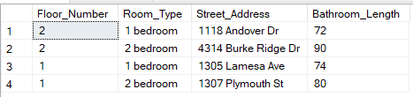

**1.Floor Plan**

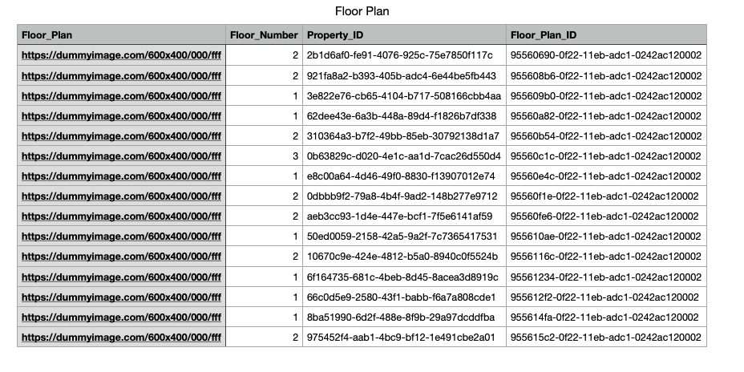

**2. Room**

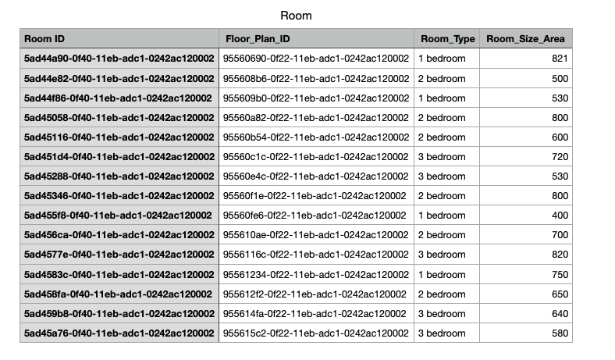

**3.Property**



**4. Bathroom**

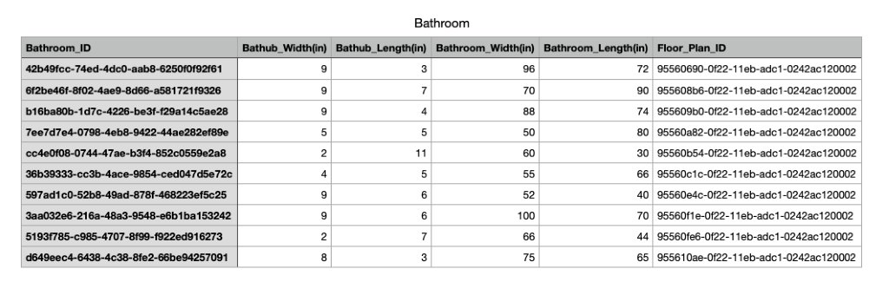

**Agent Email GUI**

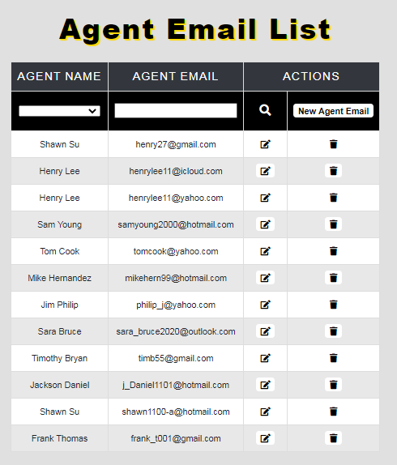

Agent Email list being displayed.

**Agent Email Filter**

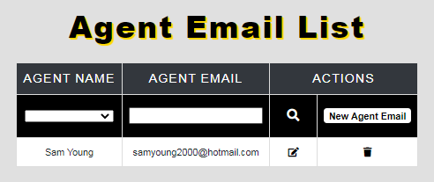

Agent Email being filter by Sam Young

**Agent Email Before Edit**

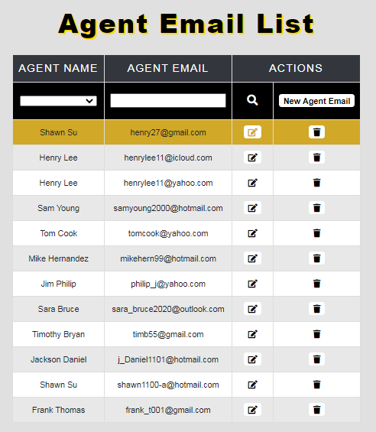

**Agent Email After Edit**

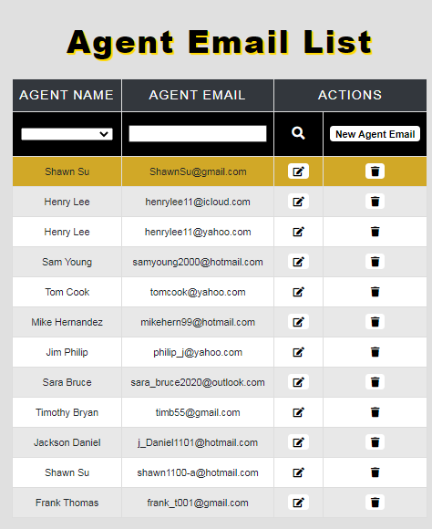

Shawn Su was edited

**Agent Email Before New**



**Agent Email After New**

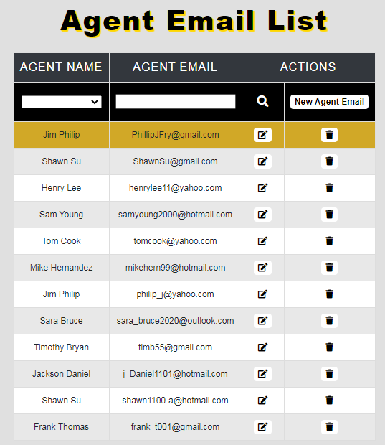

Jim Phillip was inserted as a new entry

**Agent Email Before Delete**

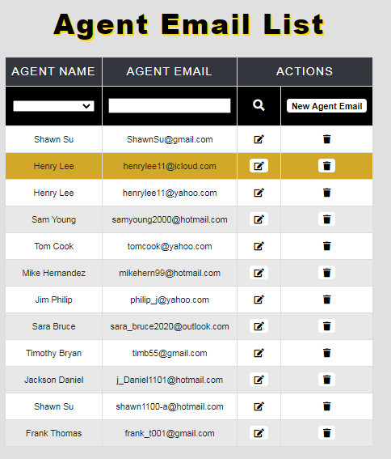

**Agent Email After Delete**

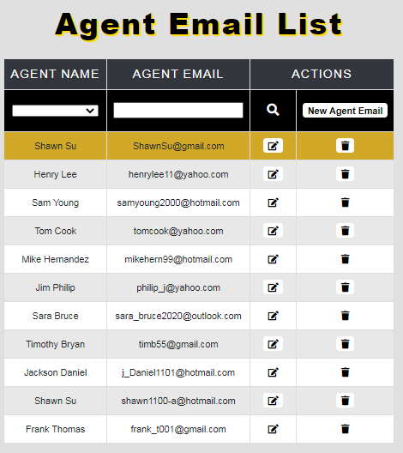

Henry Lee with the [henrylee11@icloud.com](mailto:henrylee11@icloud.com) was deleted.

**Utility Bill GUI**

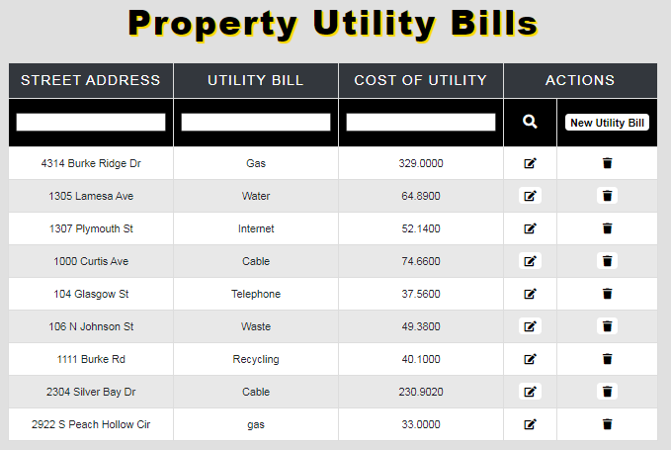

**Utility Bill Filter**

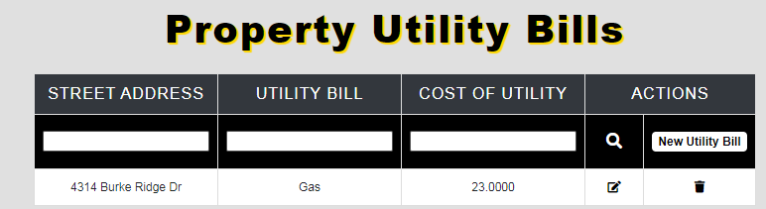

Utility bill being filter by Gas, address and cost

**Utility Bill Before Edit**

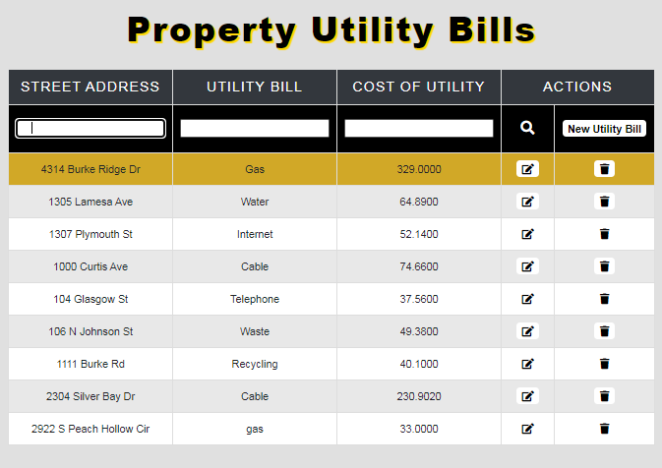

**Utility Bill after Edit**

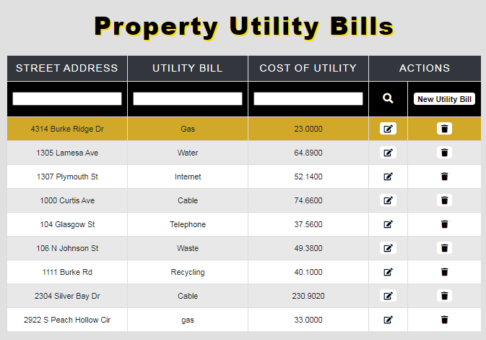

4314 Burke Ridge Dr was edited through utility cost

**Utility Bill Before New**



**Utility Bill after New**

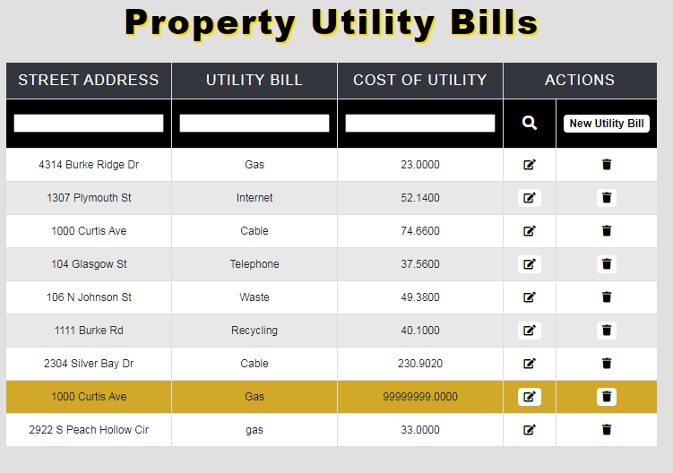

1000 Curtis Ave is a new entry

**Utility Bill Before Delete**

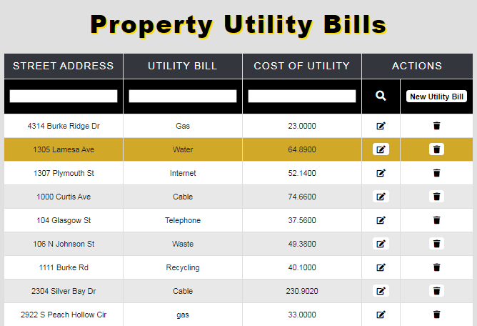

**Utility Bill After Delete**

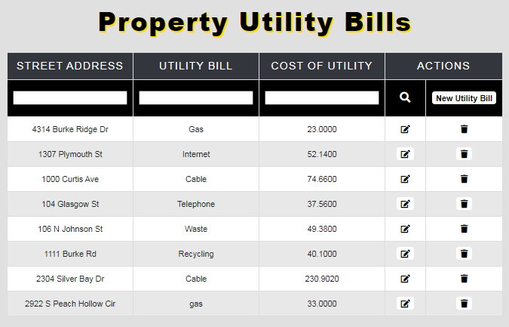**]**

1305 Lamesa Ave is deleted

**Floor Plan GUI**

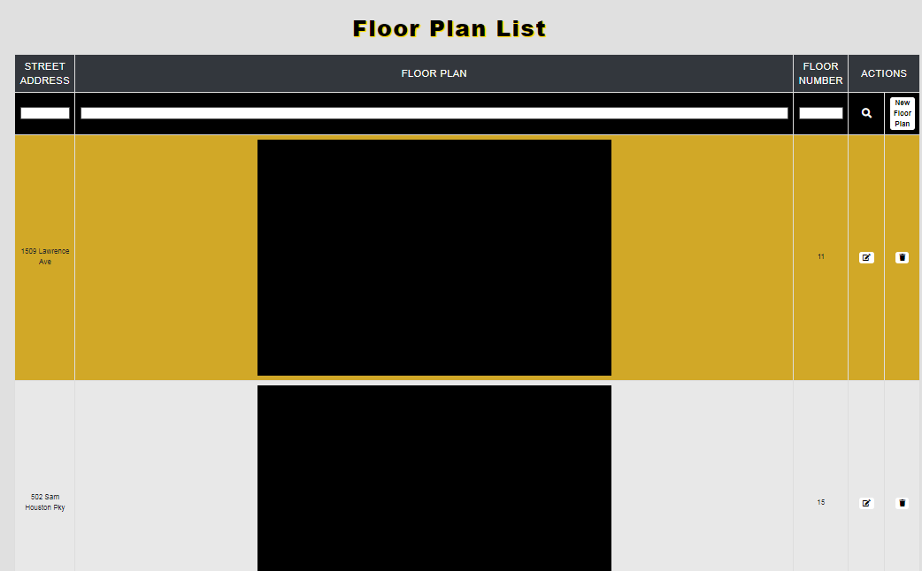

**Floor Plan filter**

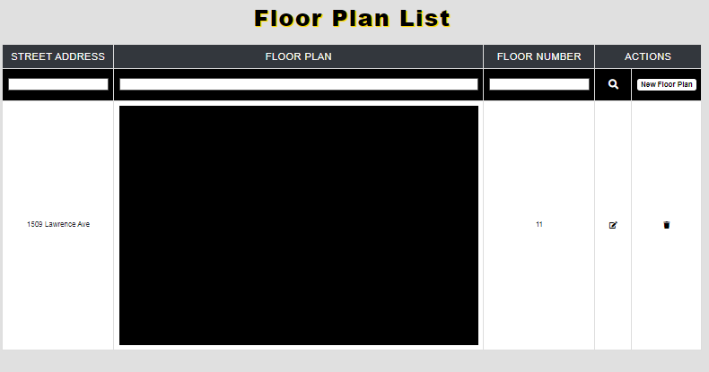

Floor Plan being filtered

**Floor Plan Before Edit**

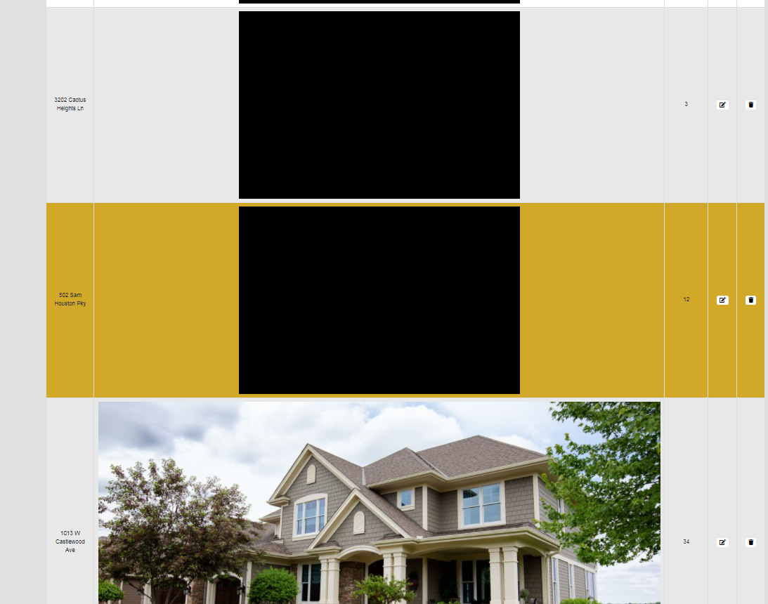

**Floor Plan After Edit**

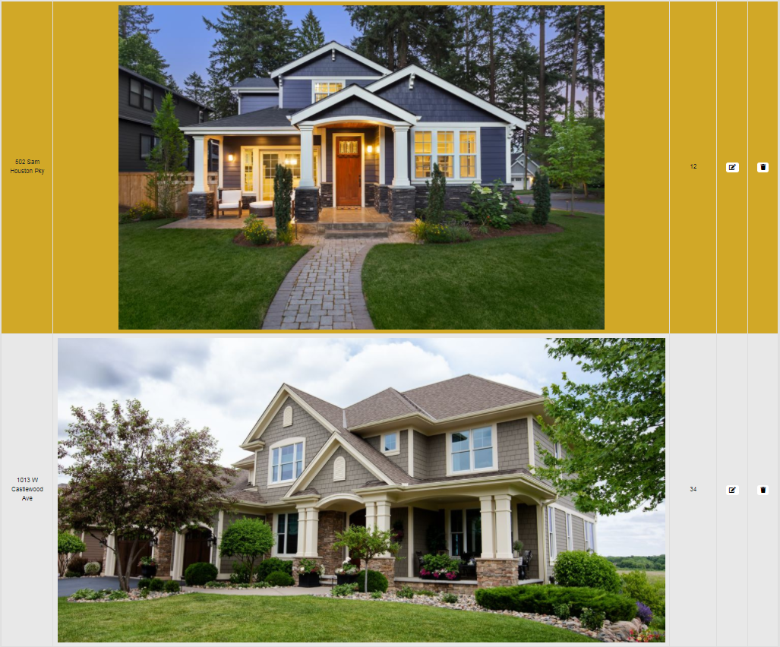

2nd entry was edited with a new floorplan

**Floor Plan before New**

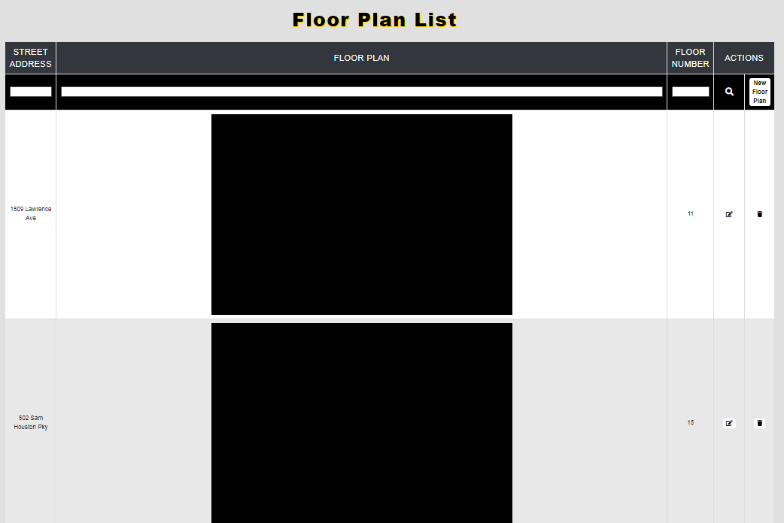

**Floor Plan after New**

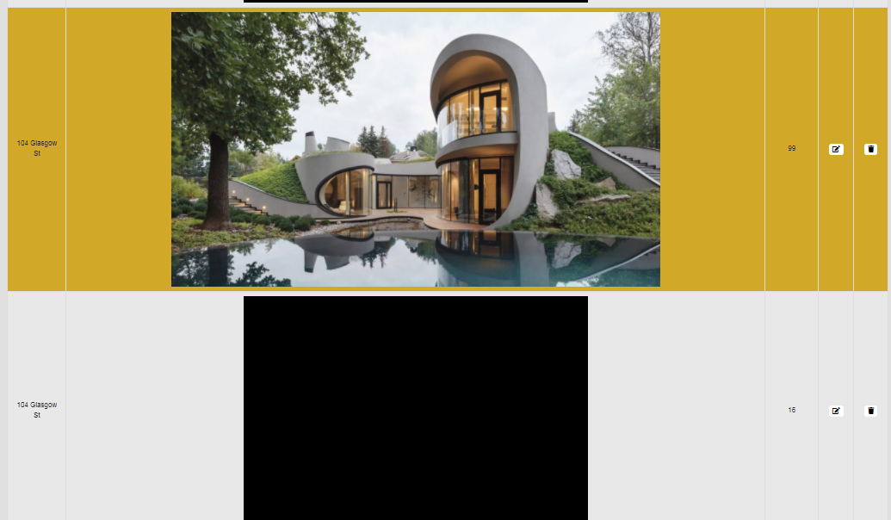

2nd entry is a new floorplan entry

**Floor Plan Before Delete**

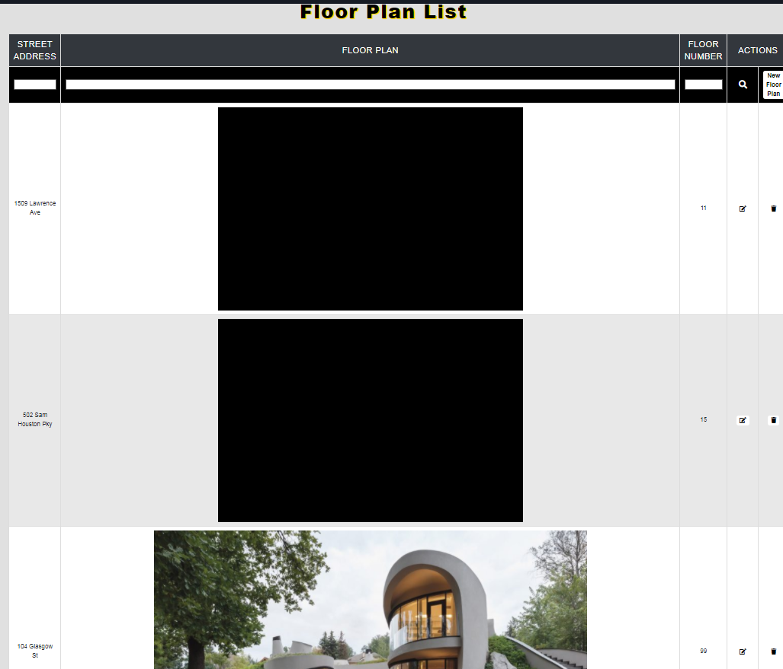

**Floor Plan After Delete**

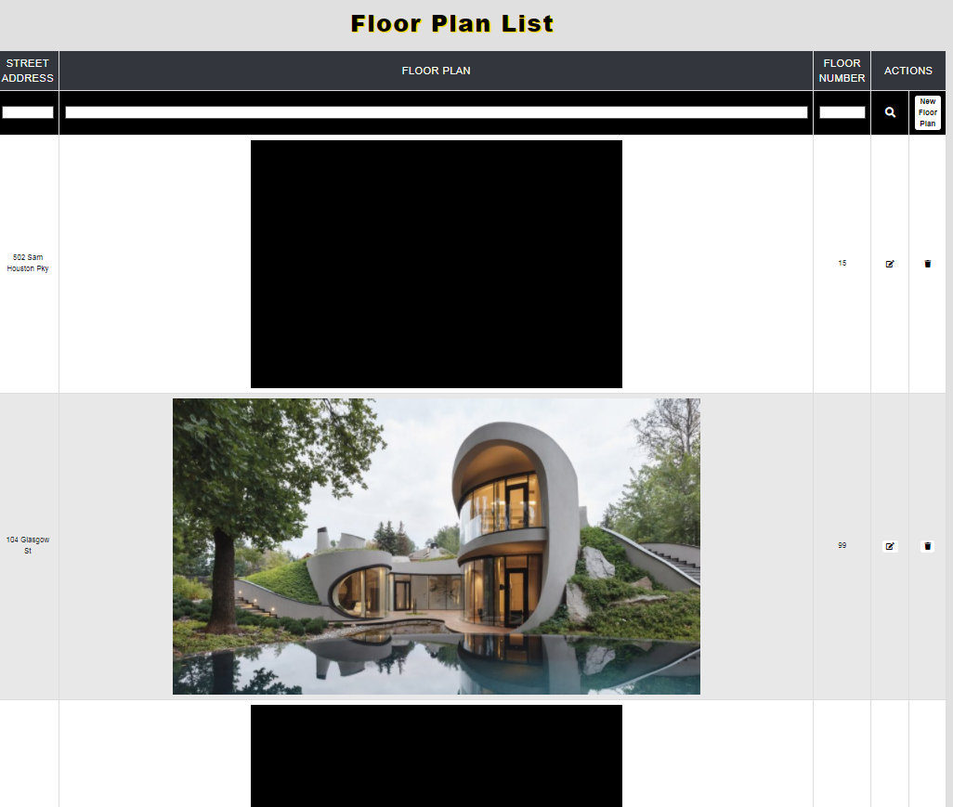

2nd entry is deleted

### **Carlos Moya Report**

**Create Scripts:**

CREATE TABLE [Agent_Email] (

[Agent_Email_ID] varchar(36) NOT NULL,

[Agent_ID] varchar(36) NOT NULL FOREIGN KEY REFERENCES Agent(Agent_ID),

[Agent_Email] nvarchar(255) NOT NULL,

CONSTRAINT [PK_Agent_Email] PRIMARY KEY ([Agent_Email_ID]),

);

CREATE TABLE [Agent_Phone_Number] (

[Agent_Phone_Number_ID] varchar(36) NOT NULL,

[Agent_ID] varchar(36) NOT NULL FOREIGN KEY REFERENCES Agent(Agent_ID),

[Agent_Phone_Number] varchar(15) NOT NULL,

[Agent_Phone_Type] varchar(15) NOT NULL,

CONSTRAINT [PK_Agent_Phone_Number] PRIMARY KEY ([Agent_Phone_Number_ID]),

);

CREATE TABLE [Home_Appraisal] (

[Home_Appraisal_ID] varchar(36) NOT NULL,

[Property_Finance_ID] varchar(36) NOT NULL FOREIGN KEY REFERENCES Property_Finance(Property_Finance_ID),

[Property_Area] varchar(50) NOT NULL,

[Appraisal_Value] money NOT NULL,

CONSTRAINT [PK_Home_Appraisal] PRIMARY KEY ([Home_Appraisal_ID]),

);

CREATE TABLE [Home_Builder] (

[Home_Builder_ID] varchar(36) NOT NULL,

[Home_Builder] varchar(100) NOT NULL,

CONSTRAINT [PK_Home_Builder_ID] PRIMARY KEY ([Home_Builder_ID]),

);

CREATE TABLE [Mortgage_Document] (

[Mortgage_Document_ID] varchar(36) NOT NULL,

[Mortgage_Document] varchar(max) NOT NULL,

[Property_Finance_ID] varchar(36) NOT NULL FOREIGN KEY REFERENCES Property_Finance(Property_Finance_ID),

CONSTRAINT [PK_Mortgage_Document] PRIMARY KEY ([Mortgage_Document_ID]),

);

CREATE TABLE [Utility_Bill] (

[Utility_Bill_ID] varchar(36) NOT NULL,

[Property_Finance_ID] varchar(36) NOT NULL FOREIGN KEY REFERENCES Property_Finance(Property_Finance_ID),

[Utility] varchar(20) NOT NULL,

[Cost_Of_Utility] money NOT NULL,

CONSTRAINT [PK_Utility_Bill] PRIMARY KEY ([Utility_Bill_ID]),

);

**Data Created:**

**HOA Email:**

|  |  |  |
| --- | --- | --- |
| HOA_Email_ID | HOA_ID | HOA_Email |
| 597f2dd0-0fcd-11eb-adc1-0242ac120002 | 13eb20ec-253e-476b-8dbb-ce2bd4cb9917 | HOA01@Gmail.com |
| 597f2fd8-0fcd-11eb-adc1-0242ac120002 | 66cfc3a0-7c09-4c5b-ade7-6d10a2f6b4d1 | HOA02@Yahoo.com |
| 597f30c8-0fcd-11eb-adc1-0242ac120002 | 115aa8af-9055-4cbb-b188-1aebb24bed0b | HOA03@Hotmail.com |
| 597f31a4-0fcd-11eb-adc1-0242ac120002 | 43b7599d-1252-4a2b-a7ad-fdfaa3f480ac | HOA04@Gmail.com |
| 597f3262-0fcd-11eb-adc1-0242ac120002 | 37e30129-c4c6-44fc-b9d4-6f742d7ec3ac | HOA05@Yahoo.com |
| 597f3334-0fcd-11eb-adc1-0242ac120002 | d3809445-7427-4091-9314-1e0e282d050e | HOA06@Hotmail.com |
| 597f33f2-0fcd-11eb-adc1-0242ac120002 | dba46f03-566f-4e71-9826-2a5bec3f468c | HOA07@Gmail.com |
| 597f34b0-0fcd-11eb-adc1-0242ac120002 | 7c216f55-cf66-48ba-8f00-47bfaa0031d1 | HOA08@Yahoo.com |
| 597f3730-0fcd-11eb-adc1-0242ac120002 | ae198d29-4301-4151-93ec-5aaa4bb56176 | HOA09@Hotmail.com |
| 597f3802-0fcd-11eb-adc1-0242ac120002 | 3152e825-77a3-4b48-be6a-0b067512ae63 | HOA10@Gmail.com |
| 597f38c0-0fcd-11eb-adc1-0242ac120002 | fd155060-929a-4bea-81df-1e303aa0f921 | HOA11@Yahoo.com |
| 597f397e-0fcd-11eb-adc1-0242ac120002 | d6aea6ae-0266-45d8-b48a-d4bade2ce06d | HOA12@Hotmail.com |
| 597f3a46-0fcd-11eb-adc1-0242ac120002 | c2c413b9-0dae-4e1c-b5d1-a8a914c642aa | HOA13@Gmail.com |
| 597f3b04-0fcd-11eb-adc1-0242ac120002 | fcb16b5e-479e-4b87-9946-7f118c1112a9 | HOA14@Yahoo.com |
| 597f3bcc-0fcd-11eb-adc1-0242ac120002 | eb46ec8b-ea9f-40e9-8c12-a8502e9062c9 | HOA15@Hotmail.com |

**Contract Status:**

|  |  |
| --- | --- |
| Contract_Status_ID | Contract_Status |
| 9a45f8da-29b4-45b4-a453-ace41714d37d | Pending |
| a770ac25-a1f4-4573-ac95-00ecd6e2925e | Active |
| bf146661-6d15-46f6-a818-eda7b3895325 | Closed |

**Contract Type:**

|  |  |
| --- | --- |
| Contract_Type_ID | Contract_Type |
| 1c4c6766-79f0-4c64-aeaa-185b19fede2b | Buying |
| bc156f2a-897d-41b6-8fc9-34e126caba07 | Selling |
| 8c6e86e6-2b05-418c-ae01-cfd933c3fbb5 | Leasing |
| a5e8e4cb-9de8-428e-8656-aeadd49ea1b6 | Renting |

**Lender:**

|  |  |  |  |
| --- | --- | --- | --- |
| Lender_ID | Lender_Company_ID | Lender_First_Name | Lender_Last_Name |
| 86c93616-0f21-11eb-adc1-0242ac120002 | b425e8e4-0f28-4c81-90cc-f04728378436 | Jeff | Bloom |
| 86c93832-0f21-11eb-adc1-0242ac120002 | af5d4df2-9d14-4efa-b738-65ba004afd71 | Robert | Davis |
| 86c93aa8-0f21-11eb-adc1-0242ac120002 | 18528c16-6026-4b2a-8cd9-1f06a30e0bf8 | Carissa | Meranda |
| 86c93b84-0f21-11eb-adc1-0242ac120002 | 3c06c8de-d231-412a-bdc0-8951c8222e56 | Bob | Ford |
| 86c93c56-0f21-11eb-adc1-0242ac120002 | de2b94ef-ffd2-47a9-a267-2d05ea4f948d | Michelle | Carson |
| 86c93d1e-0f21-11eb-adc1-0242ac120002 | 87064690-7cc3-4600-adde-b616477a5cda | Rick | Smith |
| 86c93ddc-0f21-11eb-adc1-0242ac120002 | 44b8790a-bc2f-4607-b936-5afcf3c2d521 | William | Huff |
| 86c93e9a-0f21-11eb-adc1-0242ac120002 | 3f6318d7-32ca-4eb6-b5f7-43a051a64436 | Elizabeth | Taylor |
| 86c940b6-0f21-11eb-adc1-0242ac120002 | 5364d51e-6cda-45d4-9a10-209fedafb655 | Chris | Stewart |
| 86c941a6-0f21-11eb-adc1-0242ac120002 | 2fc06bdd-9363-4f09-b65d-bf88ae090c65 | Samantha | Rodriguez |

**Lender Company:**

|  |  |
| --- | --- |
| Lender_Company_ID | Lender_Company |
| b425e8e4-0f28-4c81-90cc-f04728378436 | Wells Fargo |
| af5d4df2-9d14-4efa-b738-65ba004afd71 | Chase Bank |
| 18528c16-6026-4b2a-8cd9-1f06a30e0bf8 | Bank of America |
| 3c06c8de-d231-412a-bdc0-8951c8222e56 | Capital One Bank |
| de2b94ef-ffd2-47a9-a267-2d05ea4f948d | Frost Bank |
| 87064690-7cc3-4600-adde-b616477a5cda | Community Bank |
| 44b8790a-bc2f-4607-b936-5afcf3c2d521 | Citigroup Bank |
| 3f6318d7-32ca-4eb6-b5f7-43a051a64436 | First Union Bank |
| 5364d51e-6cda-45d4-9a10-209fedafb655 | WoodForest National Bank |
| 2fc06bdd-9363-4f09-b65d-bf88ae090c65 | Central Bank |

**Lender Email:**

|  |  |  |
| --- | --- | --- |
| Lender_Email_ID | Lender_ID | Lender_Email |
| fe174822-0f1f-11eb-adc1-0242ac120002 | 86c93616-0f21-11eb-adc1-0242ac120002 | Lender01@Gmail.com |
| fe174a34-0f1f-11eb-adc1-0242ac120002 | 86c93832-0f21-11eb-adc1-0242ac120002 | Lender02@Yahoo.com |
| fe174b38-0f1f-11eb-adc1-0242ac120002 | 86c93aa8-0f21-11eb-adc1-0242ac120002 | Lender03@Hotmail.com |
| fe174c5a-0f1f-11eb-adc1-0242ac120002 | 86c93b84-0f21-11eb-adc1-0242ac120002 | Lender04@Gmail.com |
| fe174d36-0f1f-11eb-adc1-0242ac120002 | 86c93c56-0f21-11eb-adc1-0242ac120002 | Lender05@Yahoo.com |
| fe174f2a-0f1f-11eb-adc1-0242ac120002 | 86c93d1e-0f21-11eb-adc1-0242ac120002 | Lender06@Hotmail.com |
| fe174ffc-0f1f-11eb-adc1-0242ac120002 | 86c93ddc-0f21-11eb-adc1-0242ac120002 | Lender07@Gmail.com |
| fe1750c4-0f1f-11eb-adc1-0242ac120002 | 86c93e9a-0f21-11eb-adc1-0242ac120002 | Lender08@Yahoo.com |
| fe175182-0f1f-11eb-adc1-0242ac120002 | 86c940b6-0f21-11eb-adc1-0242ac120002 | Lender09@Hotmail.com |
| fe175240-0f1f-11eb-adc1-0242ac120002 | 86c941a6-0f21-11eb-adc1-0242ac120002 | Lender10@Gmail.com |

**Lender Phone Number:**

|  |  |  |
| --- | --- | --- |
| Lender_Phone_Number_ID | Lender_ID | Lender_Phone_Number |
| 29bc3ef6-0f20-11eb-adc1-0242ac120002 | 86c93616-0f21-11eb-adc1-0242ac120002 | 281-556-7893 |
| 29bc4310-0f20-11eb-adc1-0242ac120002 | 86c93832-0f21-11eb-adc1-0242ac120002 | 713-299-9752 |
| 29bc441e-0f20-11eb-adc1-0242ac120002 | 86c93aa8-0f21-11eb-adc1-0242ac120002 | 832-512-6321 |
| 29bc44fa-0f20-11eb-adc1-0242ac120002 | 86c93b84-0f21-11eb-adc1-0242ac120002 | 281-637-8229 |
| 29bc45cc-0f20-11eb-adc1-0242ac120002 | 86c93c56-0f21-11eb-adc1-0242ac120002 | 713-542-3796 |
| 29bc4694-0f20-11eb-adc1-0242ac120002 | 86c93d1e-0f21-11eb-adc1-0242ac120002 | 832-156-1960 |
| 29bc475c-0f20-11eb-adc1-0242ac120002 | 86c93ddc-0f21-11eb-adc1-0242ac120002 | 281-610-0861 |
| 29bc49b4-0f20-11eb-adc1-0242ac120002 | 86c93e9a-0f21-11eb-adc1-0242ac120002 | 713-303-5061 |
| 29bc4a86-0f20-11eb-adc1-0242ac120002 | 86c940b6-0f21-11eb-adc1-0242ac120002 | 832-478-9058 |
| 29bc4b44-0f20-11eb-adc1-0242ac120002 | 86c941a6-0f21-11eb-adc1-0242ac120002 | 281-442-7852 |

**Utility Bill:**

|  |  |  |  |
| --- | --- | --- | --- |
| Utility_Bill_ID | Property_Finance_ID | Utility | Cost_Of_Utility($) |
| 1e47efc2-0f2d-11eb-adc1-0242ac120002 | 79a592f6-1f15-42b8-8d20-468c0c936b9a | Electricity | 151.23 |
| 1e47f1e8-0f2d-11eb-adc1-0242ac120002 | 0b4c774c-c74e-4446-96bc-12cf22e17826 | Gas | 44.96 |
| 1e47f2ec-0f2d-11eb-adc1-0242ac120002 | 96805cdc-1759-4ba1-949f-3026fa0b0e21 | Water | 64.89 |
| 1e47f3c8-0f2d-11eb-adc1-0242ac120002 | 6a67bf0c-e2e0-45f0-9ac8-bc574617ffcb | Internet | 52.14 |
| 1e47f670-0f2d-11eb-adc1-0242ac120002 | 006b17f6-6125-4050-b62b-313ac4b3a45f | Cable | 74.66 |
| 1e47f760-0f2d-11eb-adc1-0242ac120002 | 74225953-85b7-4967-b47d-327d73b2f2b3 | Telephone | 37.56 |
| 1e47f828-0f2d-11eb-adc1-0242ac120002 | 45872e46-5fa8-4375-a5fa-cbd3d2de5319 | Waste | 49.38 |
| 1e47f8f0-0f2d-11eb-adc1-0242ac120002 | c1448f7b-029f-4624-b785-fd9625959ece | Recycling | 40.1 |
| 1e47f9b8-0f2d-11eb-adc1-0242ac120002 | f0b8f8e5-de22-4c17-a5ec-ca6736cc723e | Lawn maintenance | 40 |
| 1e47fa76-0f2d-11eb-adc1-0242ac120002 | 3ea0a183-b786-4668-a196-5195a9a56ce3 | Security System | 56.88 |

**Paycheck:**

|  |  |  |  |  |
| --- | --- | --- | --- | --- |
| Paycheck_ID | Agent_ID | Paycheck_Amount | Date_Of_Payment | Month_Of_Services |
| 0f591bd4-0f29-11eb-adc1-0242ac120002 | 05c36b19-5cd2-4eae-accc-b1e55b4db51d | 1090.56 | 2/1/2020 | February |
| 0f591e54-0f29-11eb-adc1-0242ac120002 | 121dff41-e9bd-426d-a217-01d76a22bd71 | 1125.23 | 4/1/2020 | April |
| 0f591fe4-0f29-11eb-adc1-0242ac120002 | dc2544b4-24c5-4377-bcb8-cea080a051d9 | 1252.25 | 6/1/2020 | June |
| 0f5920f2-0f29-11eb-adc1-0242ac120002 | d6d90af5-ece5-49ff-a016-966b8bb9162c | 1001.86 | 7/1/2020 | July |
| 0f59220a-0f29-11eb-adc1-0242ac120002 | d409ede4-1984-4432-a670-cd812e07102b | 1320.78 | 8/1/2020 | August |
| 0f592354-0f29-11eb-adc1-0242ac120002 | 6187feca-5b46-4136-97d3-3c6727b95611 | 1108.98 | 9/1/2020 | September |
| 0f59241c-0f29-11eb-adc1-0242ac120002 | a3f327f4-b265-4df4-ae1a-e9bf2ec4e6f0 | 1458.36 | 10/1/2020 | October |
| 0f592534-0f29-11eb-adc1-0242ac120002 | 1736ab4f-03e6-41f4-a0a7-2a39e35c8dcc | 1346 | 11/1/2020 | November |
| 0f59266a-0f29-11eb-adc1-0242ac120002 | 4108a512-8360-47f2-a446-35e1f916ef2c | 1369.55 | 12/1/2020 | December |
| 0f59278c-0f29-11eb-adc1-0242ac120002 | 993b7607-3da3-4f83-a34c-757716fbe18f | 1256.46 | 1/1/2021 | January |

**Pet:**

|  |  |  |  |
| --- | --- | --- | --- |
| Pet_ID | Questionnaire_ID | Pet_Name | Pet_Species |
| 776a1c16-0fea-11eb-adc1-0242ac120002 | 3020c8a9-4a72-4d9f-a658-7a0c16782d6a | Bob | Cat |
| 776a1e3c-0fea-11eb-adc1-0242ac120002 | 744f03d1-289d-42d9-be47-1c2f5839e256 | Pluto | Dog |
| 776a1f7c-0fea-11eb-adc1-0242ac120002 | 93e808b1-6a80-446a-8d74-853147b4c3be | Nemo | Fish |
| 776a2062-0fea-11eb-adc1-0242ac120002 | 9bde8a59-d0c1-40ba-8477-5695f89e934e | Fred | Bird |
| 776a2148-0fea-11eb-adc1-0242ac120002 | 44b59481-6b41-444f-a78a-08241c459884 | Flynn | Cat |
| 776a22ec-0fea-11eb-adc1-0242ac120002 | 4b68fc58-1afc-4371-9957-6389574d8211 | Dory | Fish |
| 776a2224-0fea-11eb-adc1-0242ac120002 | f534dbca-ae97-4ff9-b906-7ac0fe35089a | Pepper | Dog |
| 776a2508-0fea-11eb-adc1-0242ac120002 | f880e2c8-099e-4f11-bc1b-7f776f506bc5 | Daisy | Bird |
| 776a25d0-0fea-11eb-adc1-0242ac120002 | ab89e19e-2db5-4b2b-be27-fb53f6eb041a | Toofy | Cat |
| 776a2698-0fea-11eb-adc1-0242ac120002 | 9236fd17-4eaa-483d-9fd9-598b11d9e294 | Olaf | Dog |
| 776a2760-0fea-11eb-adc1-0242ac120002 | 795c1056-7cc2-431a-8ff0-8b107bfc08be | Jerry | Fish |
| 776a28d2-0fea-11eb-adc1-0242ac120002 | 13108d11-3b5d-4445-a8ff-09ea5d59577b | Alfred | Bird |
| 776a29d6-0fea-11eb-adc1-0242ac120002 | 25756a58-5b7f-4517-9ea8-44142b62f20f | Garfield | Cat |
| 776a2c06-0fea-11eb-adc1-0242ac120002 | ceb443b6-378c-4ffc-acf7-faeffbd5f30f | Chewy | Dog |
| 776a2cc4-0fea-11eb-adc1-0242ac120002 | 6353a70e-9319-4197-b5b0-626b09bb9416 | Larry | Fish |

**SQL Queries:**

**SQL Query Code 1:**

SELECT

Lender.Lender_First_Name AS 'Lender First Name',

Lender.Lender_Last_Name AS 'Lender Last Name',

Lender_Company.Lender_Company AS 'Lender Company',

Lender_Email.Lender_Email AS 'Lender Email',

Lender_Phone_Number.Lender_Phone_Number AS 'Lender Phone Number'

FROM Lender

INNER JOIN

Lender_Company ON Lender.Lender_Company_ID = Lender_Company.Lender_Company_ID

INNER JOIN

Lender_Email ON Lender.Lender_ID = Lender_Email.Lender_ID

INNER JOIN

Lender_Phone_Number ON Lender.Lender_ID = Lender_Phone_Number.Lender_ID

**SQL Query Code 2:**

SELECT

Lender.Lender_First_Name AS 'Lender First Name',

Lender.Lender_Last_Name AS 'Lender Last Name',

Lender_Company.Lender_Company AS 'Lender Company',

Lender_Email.Lender_Email AS 'Lender Email',

Financing_Questionnaire.Financing_Arranged AS 'Financing Arranged',

Financing_Questionnaire.Loan_Amount AS 'Loan Amount',

Financing_Questionnaire.Loan_Letter_Inssuance AS 'Loan Letter Insurance',

Financing_Questionnaire.Enough_Funds_For_Earnest AS 'Enough Funds For Earnest',

Financing_Questionnaire.Lowest_Monthly_Range AS 'Lowest Monthly Range',

Financing_Questionnaire.Highest_Monthly_Range AS 'Highest Monthly Range'

FROM Lender

INNER JOIN

Lender_Company ON Lender.Lender_Company_ID = Lender_Company.Lender_Company_ID

INNER JOIN

Lender_Email ON Lender.Lender_ID = Lender_Email.Lender_ID

INNER JOIN

Financing_Questionnaire ON Lender.Lender_ID = Financing_Questionnaire.Lender_ID

**SQL Query Code 3:**

SELECT

Broker.Broker_Name AS 'Broker Name',

Broker_Company.Broker_Company AS 'Broker Company',

Broker_Email.Broker_Email AS 'Broker Email',

Broker_Phone_Number.Broker_Phone_Number AS 'Broker Phone Number',

Broker_Phone_Number.Broker_Phone_Type AS 'Broker Phone Type'

FROM Broker

INNER JOIN Broker_Company ON Broker.Broker_Company_ID = Broker_Company.Broker_Company_ID

INNER JOIN Broker_Email ON Broker.Broker_ID = Broker_Email.Broker_ID

INNER JOIN Broker_Phone_Number ON Broker.Broker_ID = Broker_Phone_Number.Broker_ID

WHERE

Broker_Phone_Number.Broker_Phone_Type = 'mobile'

**SQL Query Code 4:**

SELECT

Broker.Broker_Name AS 'Broker Name',

Broker_Company.Broker_Company AS 'Broker Company',

Broker_Email.Broker_Email AS 'Broker Email',

Commission_Plan.Total_Commission AS 'Total Commission',

Commission_Plan.Yun_Global_Commission_Percent AS 'Yun Global Commission Percent',

Commission_Plan.Broker_Commission_Percent AS 'Broker Commission Percent'

FROM Broker

INNER JOIN

Broker_Company ON Broker.Broker_Company_ID = Broker_Company.Broker_Company_ID

INNER JOIN

Broker_Email ON Broker.Broker_ID = Broker_Email.Broker_ID

INNER JOIN

Commission_Plan ON Broker.Broker_ID = Commission_Plan.Broker_ID

WHERE

Commission_Plan.Total_Commission > '50,000'

**SQL Update Scripts:**

/* Insert Script 01 */

SELECT * FROM [Lender_Company]

INSERT into Lender_Company(Lender_Company_ID,Lender_Company)

VALUES (NEWID(),'Bank of Houston');

/* Insert Script 02 */

INSERT into Lender_Company(Lender_Company_ID,Lender_Company)

VALUES (NEWID(),'Texas Bank');

**Before:**

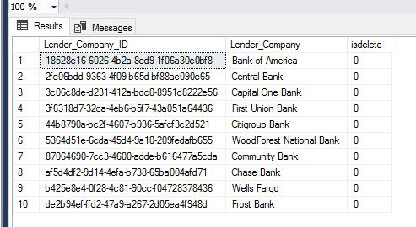

**After:**

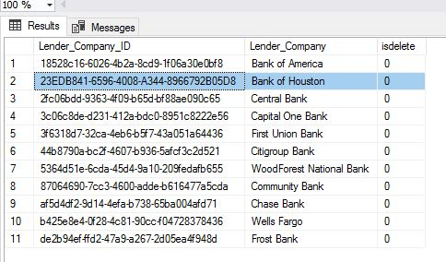

**Before:**



**After:**

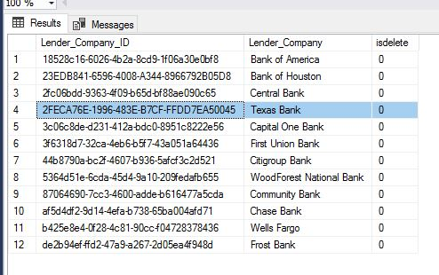

/* Update Script 01 */

SELECT * FROM [Lender_Phone_Number]

UPDATE [Lender_Phone_Number]

SET Lender_Phone_Number.Lender_Phone_Number = '832-963-9794'

WHERE Lender_Phone_Number.Lender_Phone_Number_ID = '29bc3ef6-0f20-11eb-adc1-0242ac120002'

/* Update Script 02 */

UPDATE [Lender_Phone_Number]

SET isdelete = '1'

WHERE Lender_Phone_Number.Lender_Phone_Number_ID = '29bc4310-0f20-11eb-adc1-0242ac120002'

**Before:**

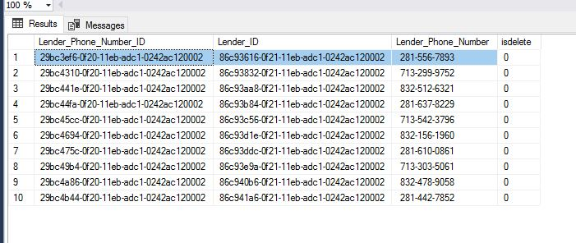

**After:**

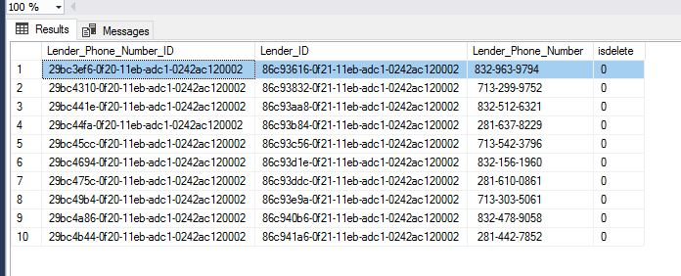

**Before:**

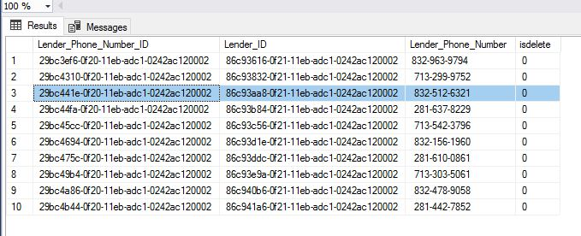

**After:**

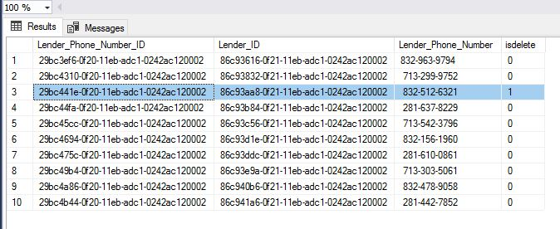

/* Soft Delete Script 01 */

SELECT * FROM [Pet]

UPDATE [Pet]

SET isdelete = '1'

WHERE Pet.Pet_ID = '776a22ec-0fea-11eb-adc1-0242ac120002'

/* Soft Delete Script 02 */

UPDATE [Pet]

SET isdelete = '1'

WHERE Pet.Pet_ID = '776a2062-0fea-11eb-adc1-0242ac120002'

**Before:**

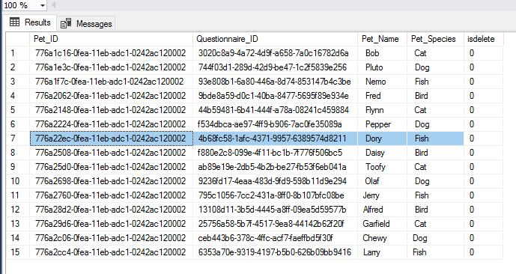

**After:**

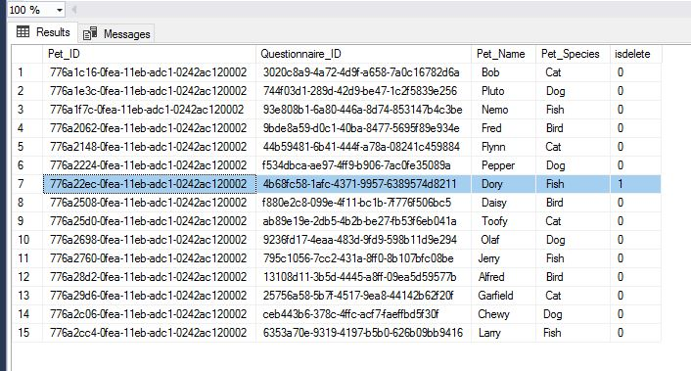

**Before:**

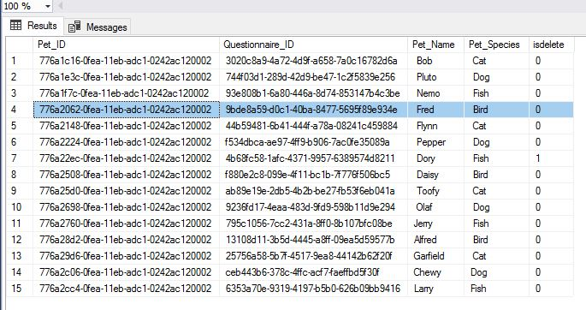

**After:**

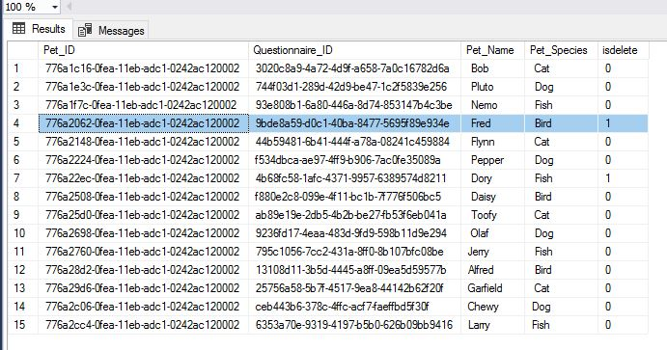

**SQL Queries Report:**

**1. Report Name:** Lender Information

**Report Description:** Lender Information for loans for purchasing properties.

**Business Purpose:** The client would need to have access to Lender companies’ information in order to pursue a loan for a property. Customers can browse through the list of lender companies to find which company would best fit them depending on the banks available.

**SQL CODE:**

USE [3365DB4].

GO

SELECT

Lender.Lender_First_Name AS 'Lender First Name',

Lender.Lender_Last_Name AS 'Lender Last Name',

Lender_Company.Lender_Company AS 'Lender Company',

Lender_Email.Lender_Email AS 'Lender Email',

Lender_Phone_Number.Lender_Phone_Number AS 'Lender Phone Number'

FROM Lender

INNER JOIN

Lender_Company ON Lender.Lender_Company_ID = Lender_Company.Lender_Company_ID

INNER JOIN

Lender_Email ON Lender.Lender_ID = Lender_Email.Lender_ID

INNER JOIN

Lender_Phone_Number ON Lender.Lender_ID = Lender_Phone_Number.Lender_ID

**Report/Query Results:**

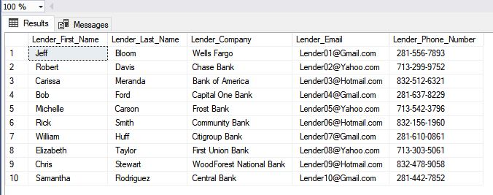

**Lender Table:**

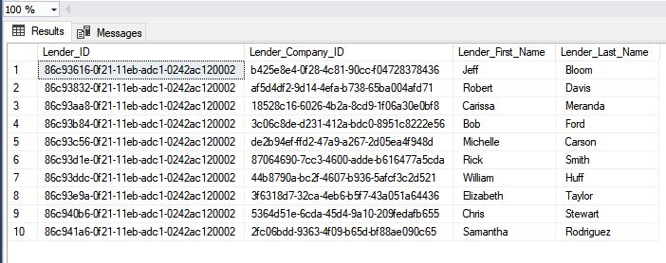

**Lender Company Table:**

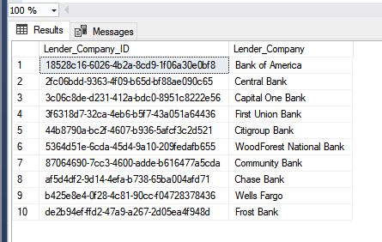

**Lender Email Table:**

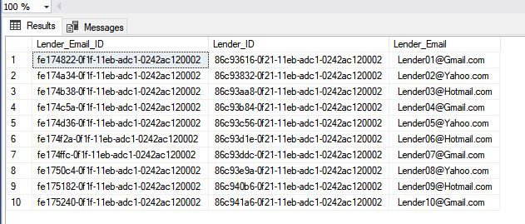

**Lender Phone Number Table:**

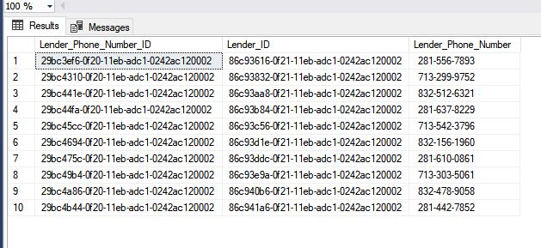

**2. Report Name:** Financing Information

**Report Description:** Selects Lender and Financing Questionnaire information that would be used to gather information such as loan amount, lowest, and highest monthly range.

**Business Purpose:**  The client could use this report to determine which lender company could offer the loan amount to purchase a selected property. The customer could also use this report to determine the lowest to highest monthly range.

**SQL CODE:**

USE [3365DB4];

GO

SELECT

Lender.Lender_First_Name AS 'Lender First Name',

Lender.Lender_Last_Name AS 'Lender Last Name',

Lender_Company.Lender_Company AS 'Lender Company',

Lender_Email.Lender_Email AS 'Lender Email',

Financing_Questionnaire.Financing_Arranged AS 'Financing Arranged',

Financing_Questionnaire.Loan_Amount AS 'Loan Amount',

Financing_Questionnaire.Loan_Letter_Inssuance AS 'Loan Letter Insurance',

Financing_Questionnaire.Enough_Funds_For_Earnest AS 'Enough Funds For Earnest',

Financing_Questionnaire.Lowest_Monthly_Range AS 'Lowest Monthly Range',

Financing_Questionnaire.Highest_Monthly_Range AS 'Highest Monthly Range'

FROM Lender

INNER JOIN

Lender_Company ON Lender.Lender_Company_ID = Lender_Company.Lender_Company_ID

INNER JOIN

Lender_Email ON Lender.Lender_ID = Lender_Email.Lender_ID

INNER JOIN

Financing_Questionnaire ON Lender.Lender_ID = Financing_Questionnaire.Lender_ID

**Report/Query Results:**

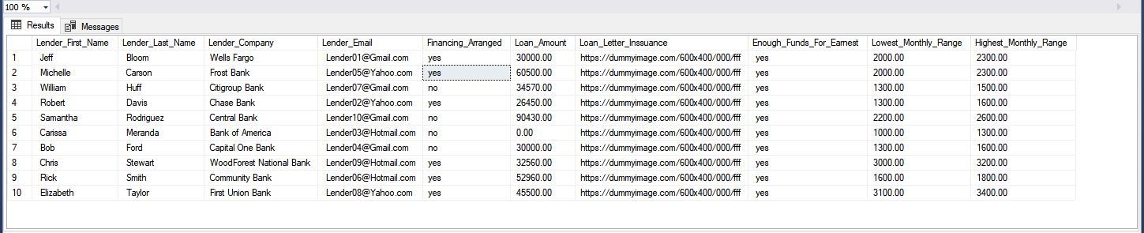

**Lender Table:**



**Lender Company Table:**



**Lender Email Table:**



**Financing Questionnaire Table:**

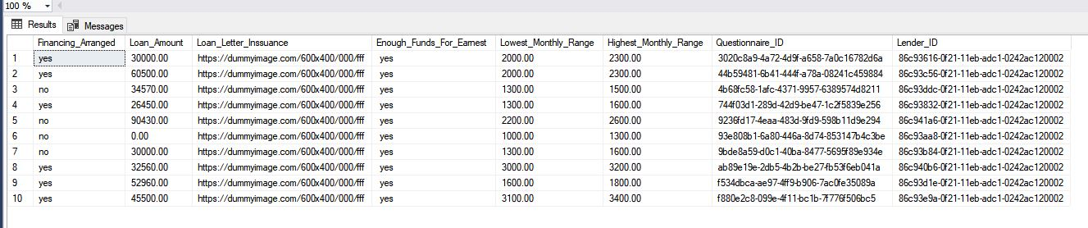

**3. Report Name:** Broker Information

**Report Description:** Select Broker information to determine the best broker company for the client.

**Business Purpose:**  The client would use a report like this to list contact information about potential broker companies. The client could search for a good broker company and a mobile phone number to contact an employee.

**SQL CODE:**

USE [3365DB4];

GO

SELECT

Broker.Broker_Name AS 'Broker Name',

Broker_Company.Broker_Company AS 'Broker Company',

Broker_Email.Broker_Email AS 'Broker Email',

Broker_Phone_Number.Broker_Phone_Number AS 'Broker Phone Number',

Broker_Phone_Number.Broker_Phone_Type AS 'Broker Phone Type'

FROM Broker

INNER JOIN Broker_Company ON Broker.Broker_Company_ID = Broker_Company.Broker_Company_ID

INNER JOIN Broker_Email ON Broker.Broker_ID = Broker_Email.Broker_ID

INNER JOIN Broker_Phone_Number ON Broker.Broker_ID = Broker_Phone_Number.Broker_ID

WHERE

Broker_Phone_Number.Broker_Phone_Type = 'mobile'

**Report/Query Results:**

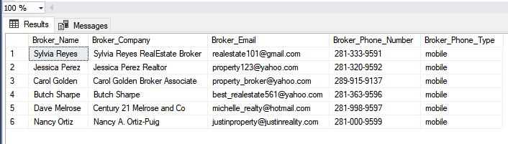

**Broker Table:**

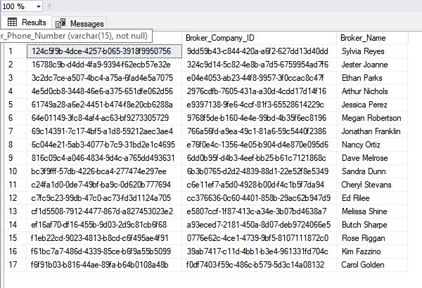

**Broker Company Table:**

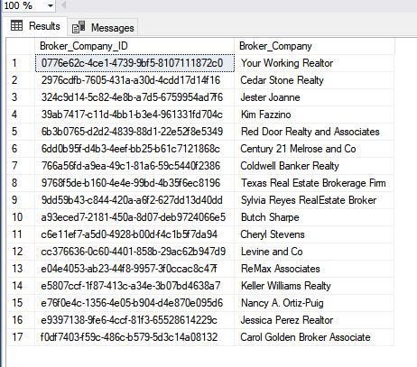

**Broker Email Table:**

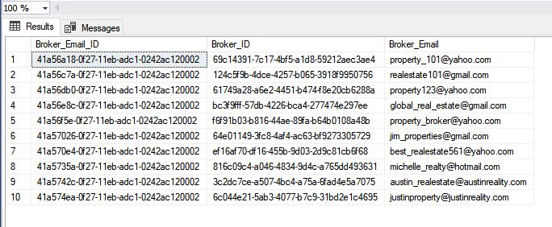

**Broker Phone Number Table:**

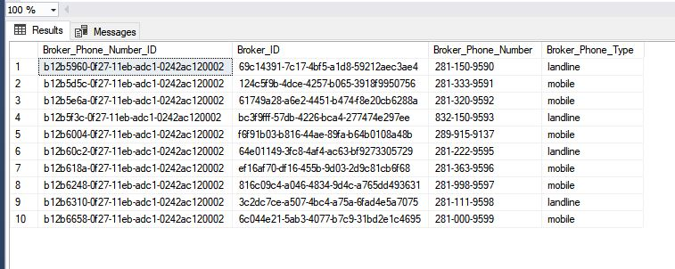

**4. Report Name:** Broker and Commission Plan

**Report Description:** Select Commission Plan that displays total commission

**Business Purpose:** The real estate agent could use this report to check which broker companies have made more than $50,000 in total commissions. Yun Global would benefit from this by determining which broker companies have higher total commissions.

**SQL CODE:**

USE [3365DB4];

GO

SELECT

Broker.Broker_Name AS 'Broker Name',

Broker_Company.Broker_Company AS 'Broker Company',

Broker_Email.Broker_Email AS 'Broker Email',

Commission_Plan.Total_Commission AS 'Total Commission',

Commission_Plan.Yun_Global_Commission_Percent AS 'Yun Global Commission Percent',

Commission_Plan.Broker_Commission_Percent AS 'Broker Commission Percent'

FROM Broker

INNER JOIN

Broker_Company ON Broker.Broker_Company_ID = Broker_Company.Broker_Company_ID

INNER JOIN

Broker_Email ON Broker.Broker_ID = Broker_Email.Broker_ID

INNER JOIN

Commission_Plan ON Broker.Broker_ID = Commission_Plan.Broker_ID

WHERE

Commission_Plan.Total_Commission > '50,000'

**Report/Query Results:**

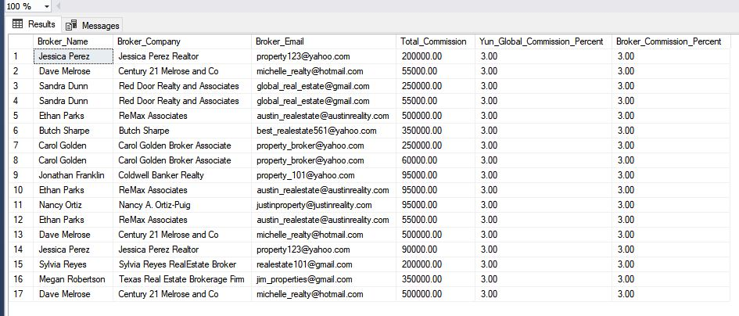

**Broker Table:**



**Broker Company Table:**



**Broker Email Table:**



**Commission Plan:**

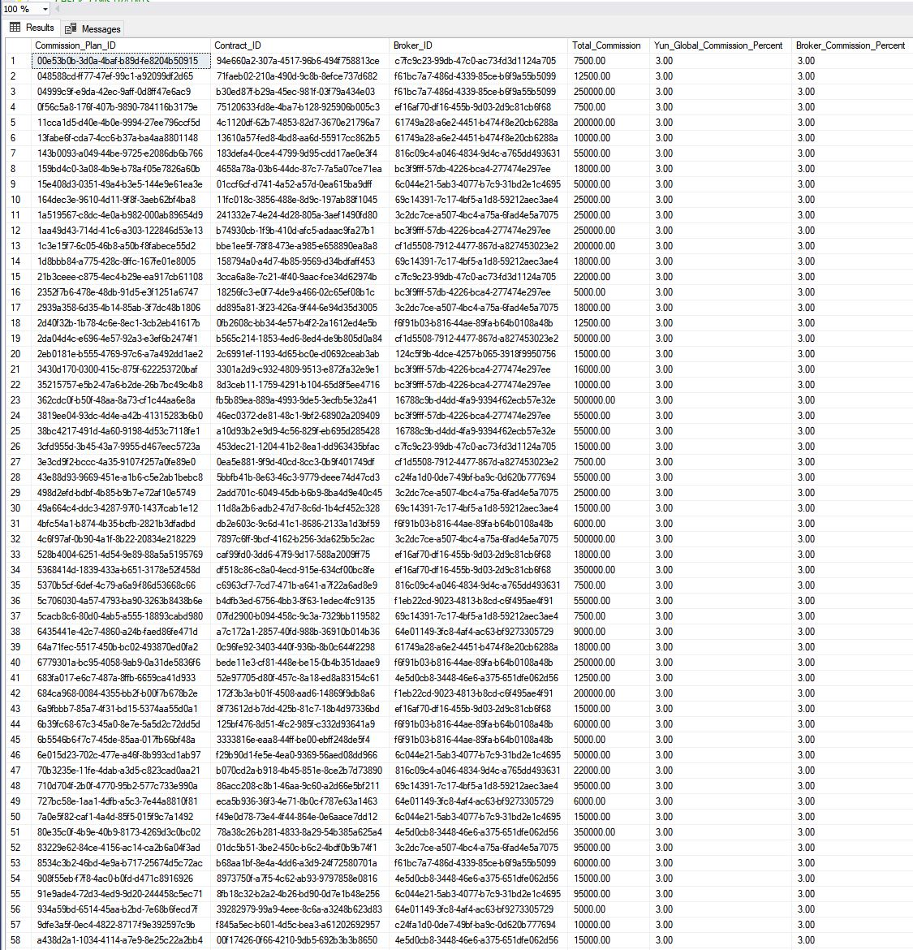

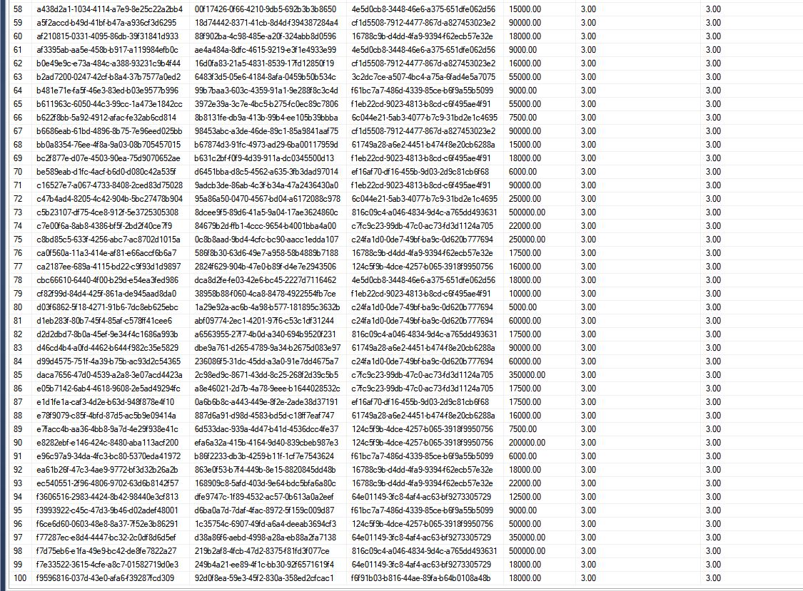

**GUI 1: Broker**

**Broker Page:**

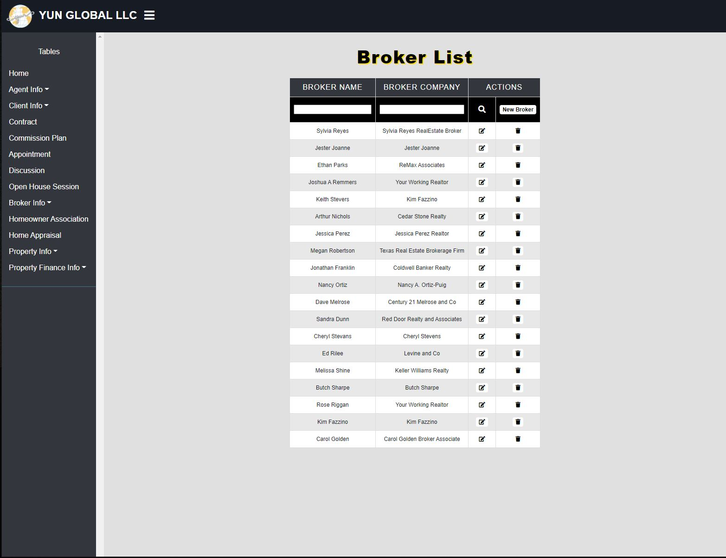

* Broker list being displayed.

**Broker Filer:**

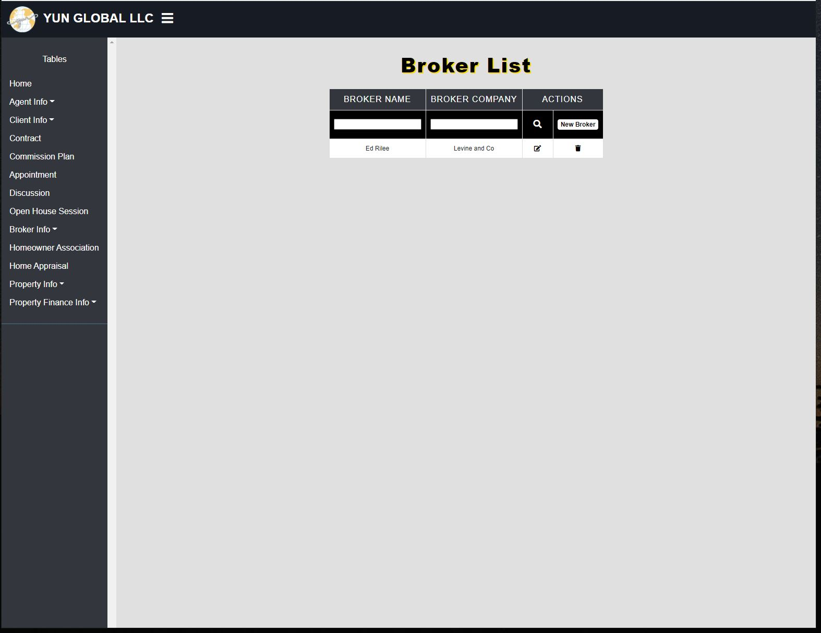

* Broker filter for the broker Ed Rilee.

**Broker Add:**

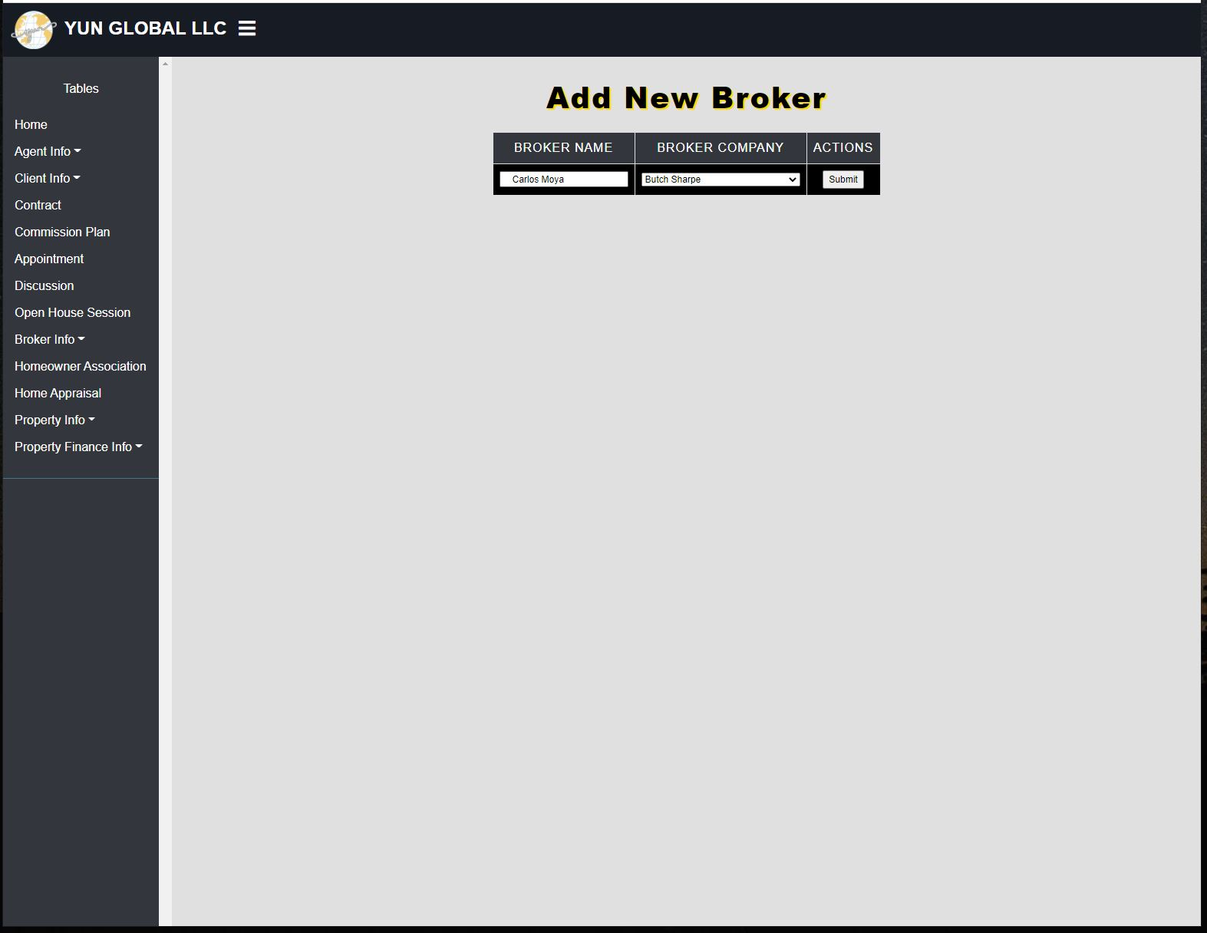

* Adding a new broker Carlos Moya.

**Broker Add After:**

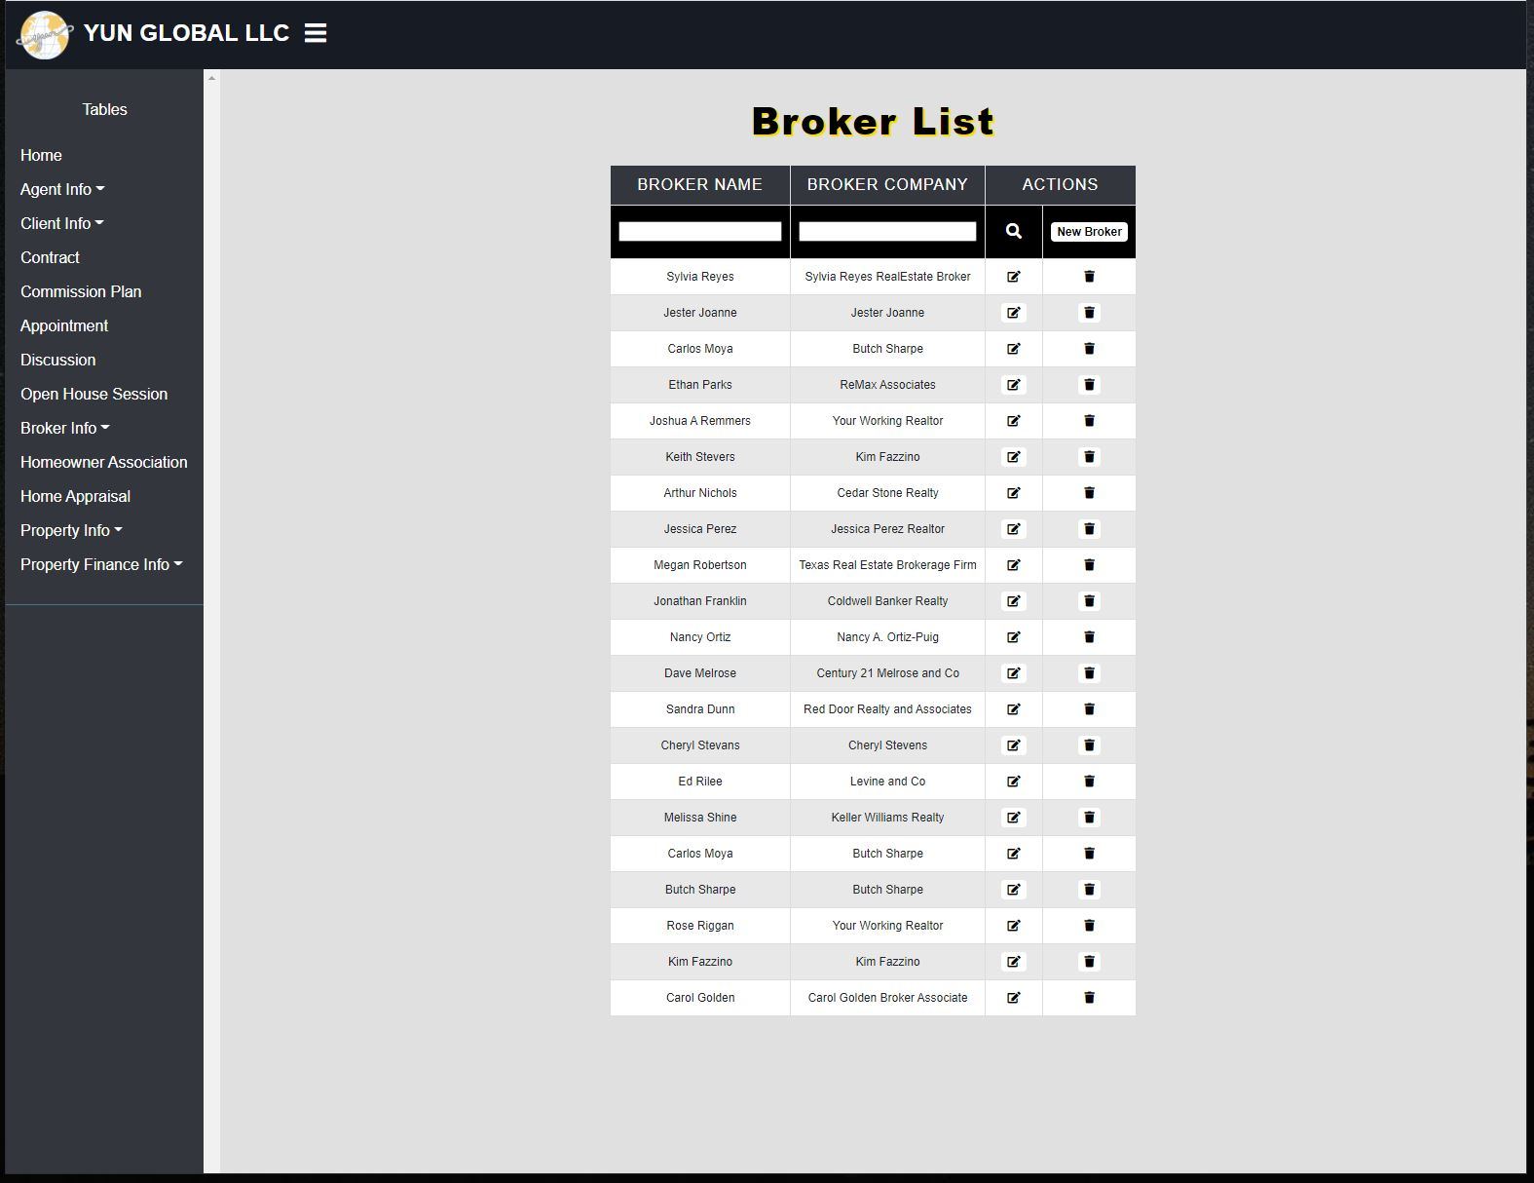

* New Broker Carlos Moya was added to the broker list.

**Broker Edit Before:**

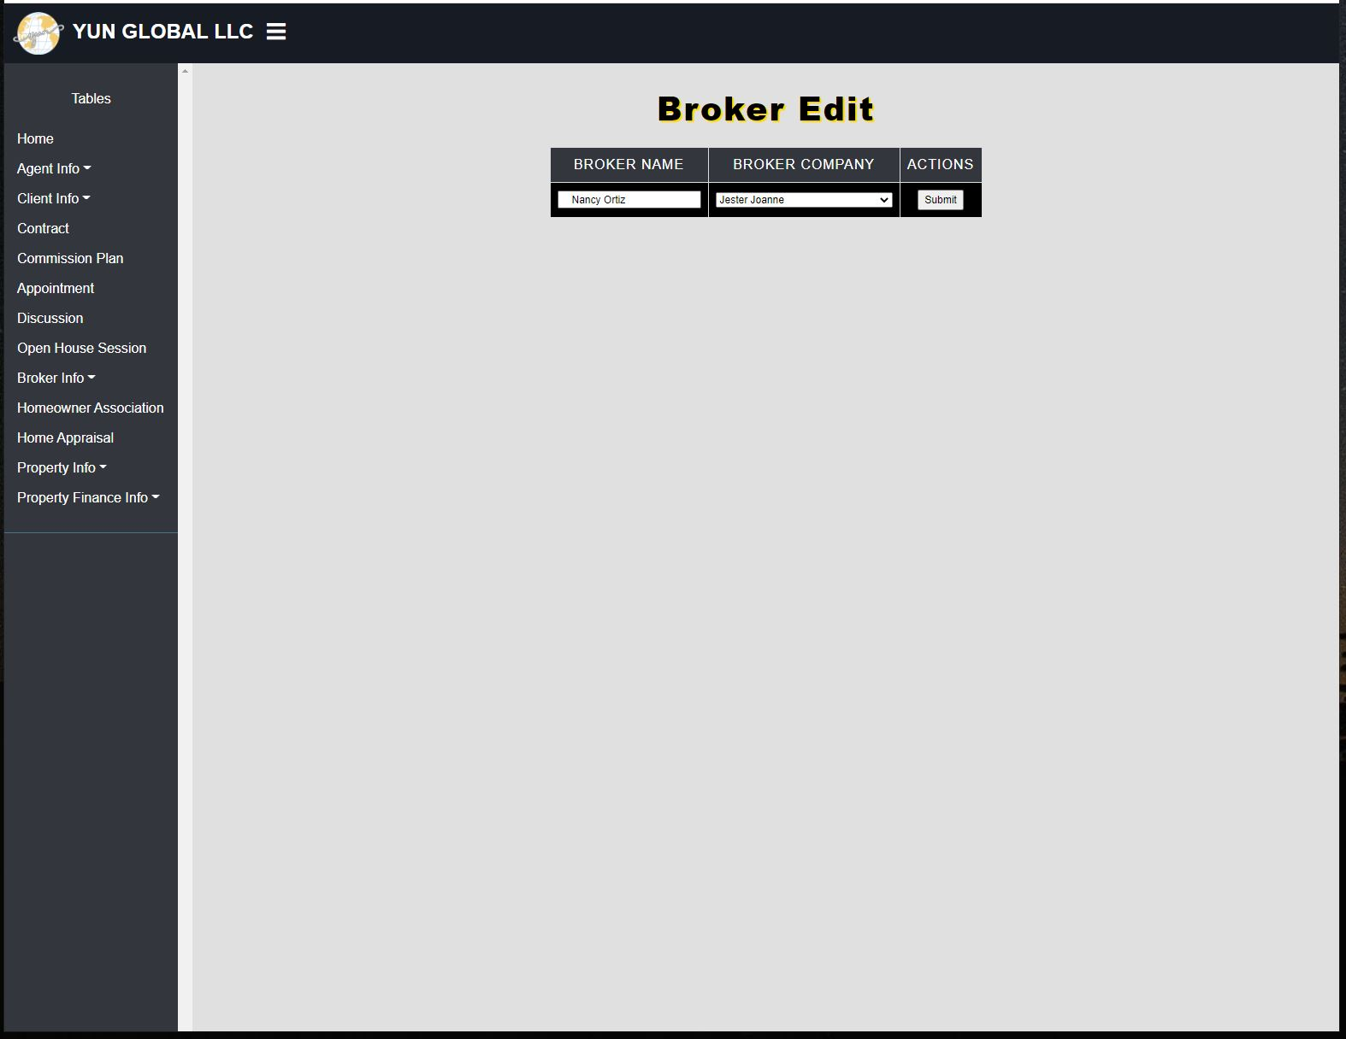

* Editing the broker Nancy Ortiz by changing the broker company.

**Broker Edit After:**

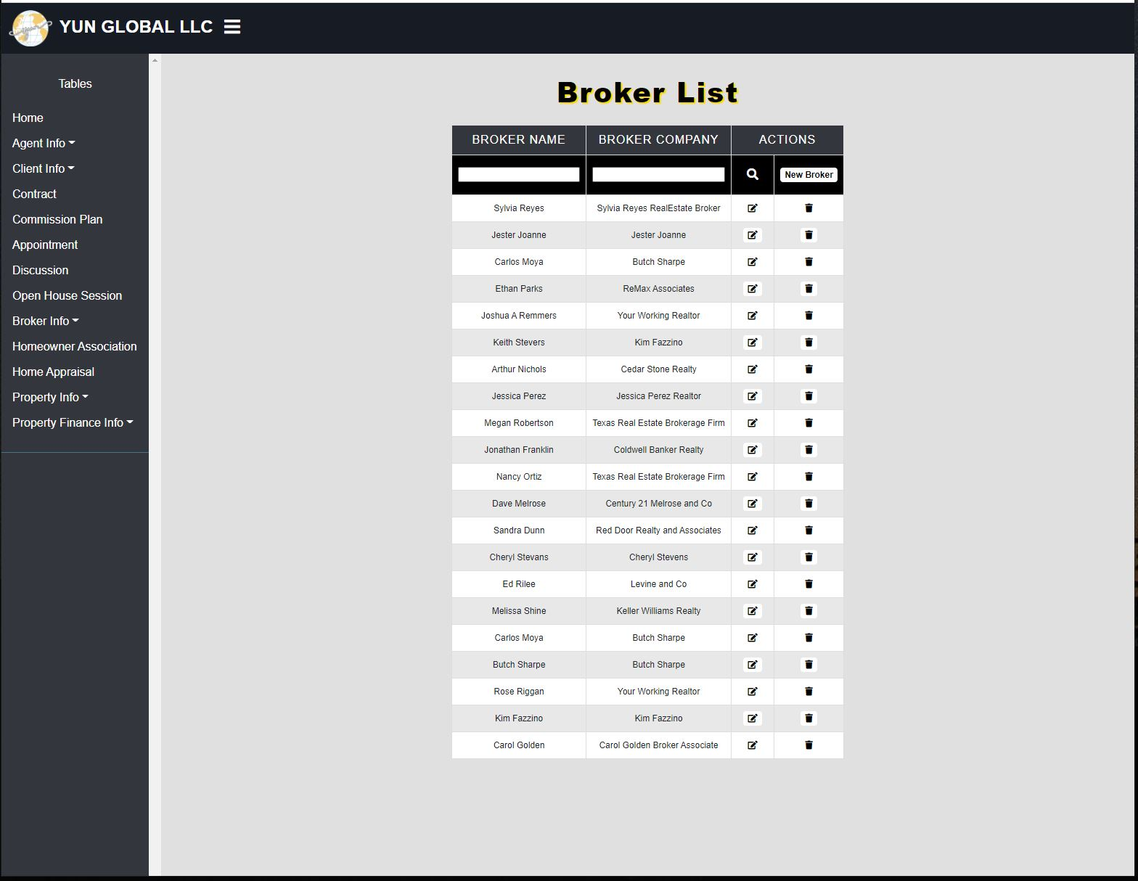

* Nancy Ortiz listed on the broker list with a new broker company.

**Broker Delete Before:**



* The broker list before deleting the broker Carlos Moya.

**Broker Delete After:**

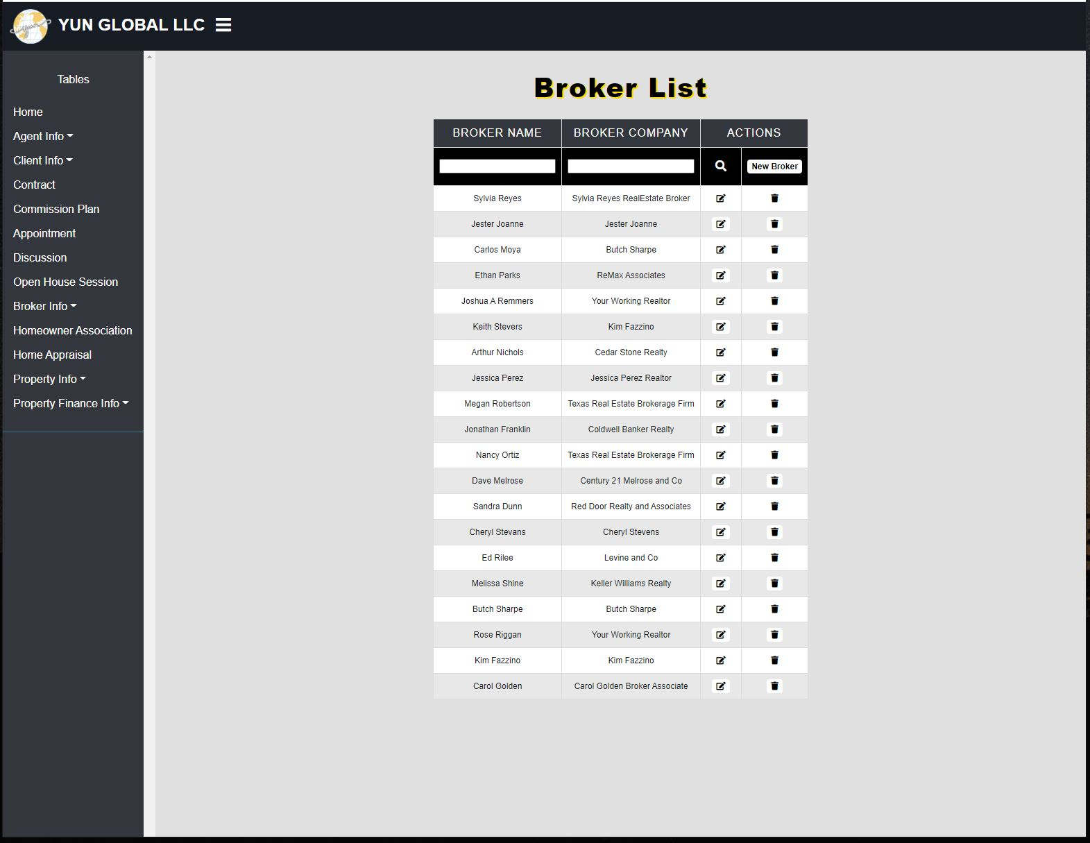

* The broker list after the broker Carlos Moya was deleted.

**GUI 2: Broker Email**

**Broker Email:**

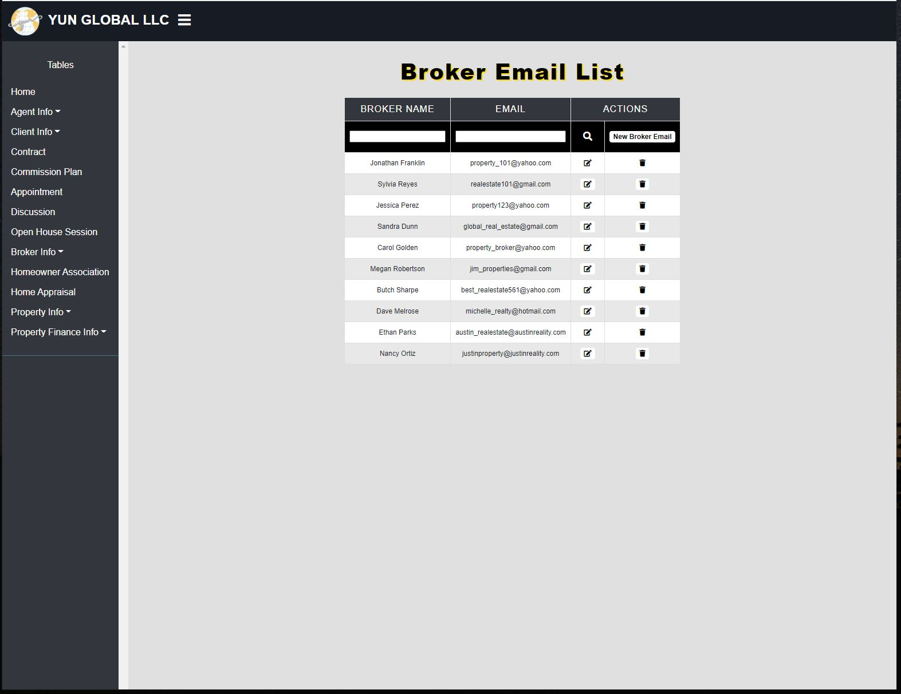

* Broker Email List being displayed.

**Broker Email Filter:**

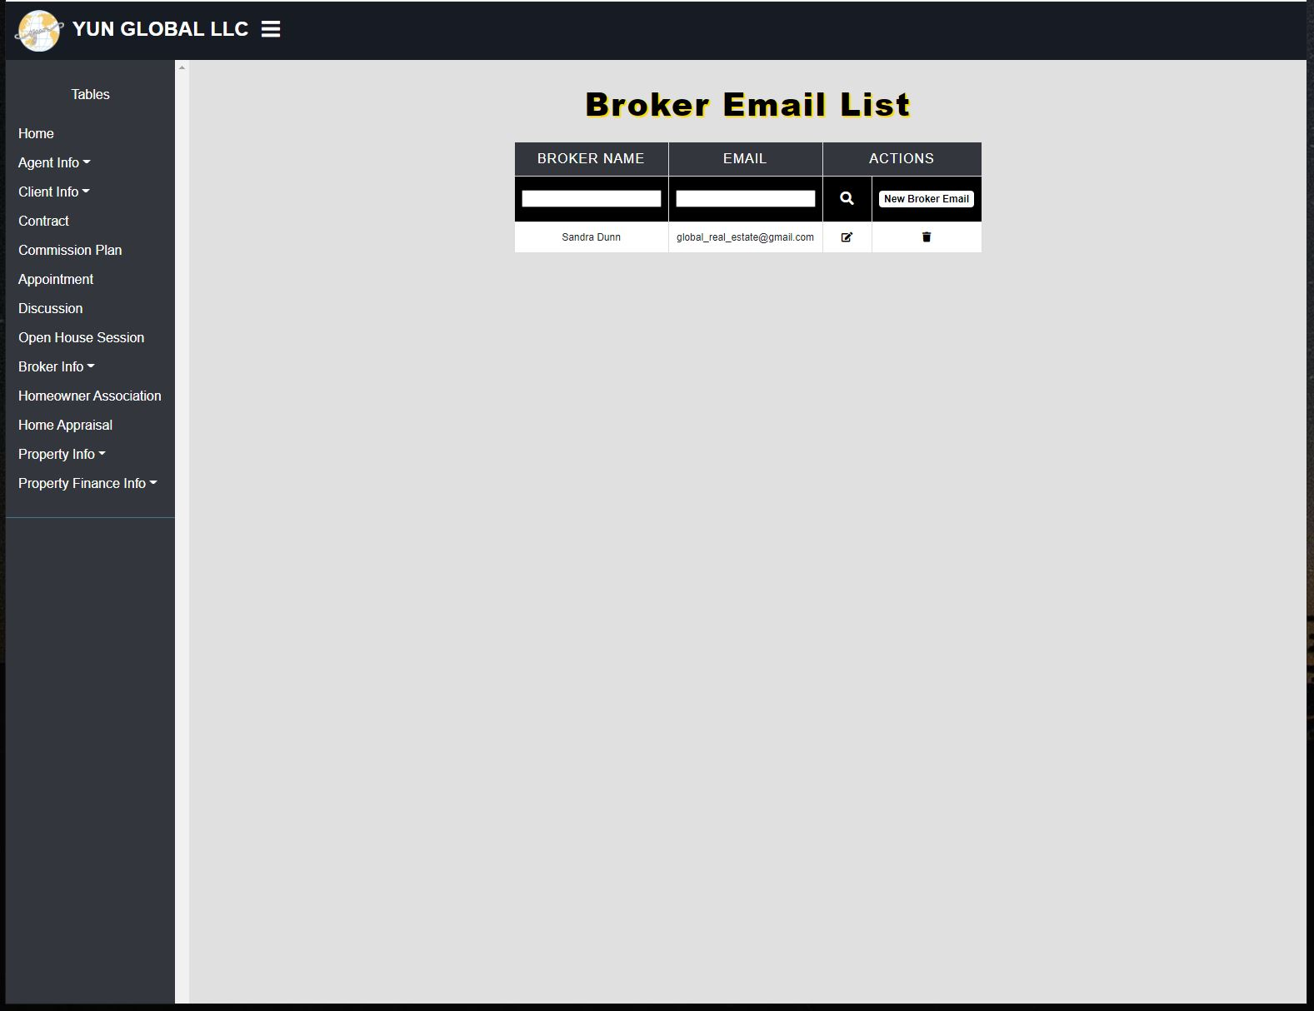

* Broker Email for Sandra Dunn being searched.

**Broker Email Add Before:**

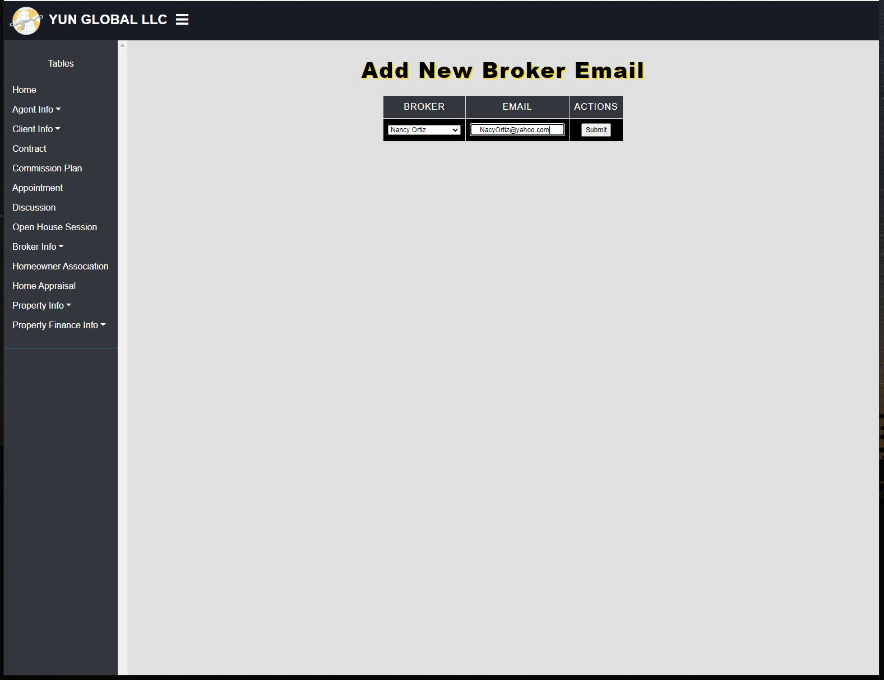

* Adding a new broker email [NancyOrtiz@yahoo.com](mailto:NancyOrtiz@yahoo.com) to the broker email list.

**Broker Email Add After:**

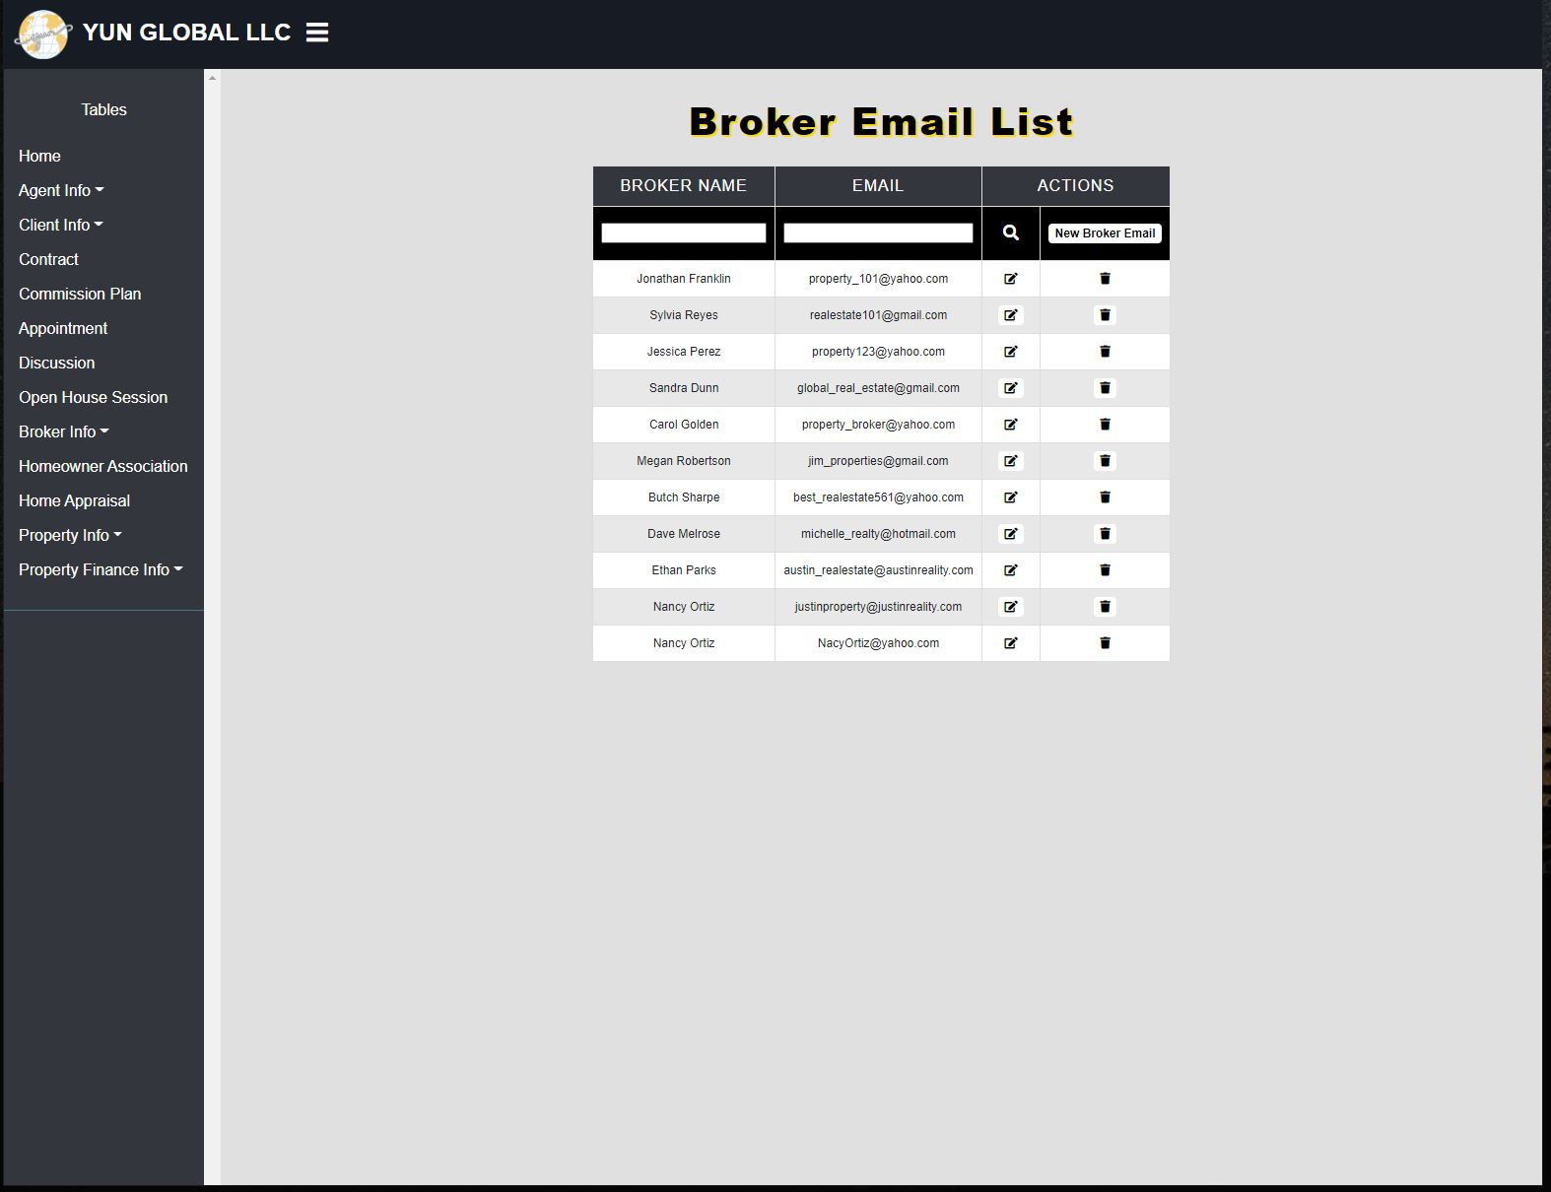

* Broker email list after the new broker email [NancyOrtiz@yahoo.com](mailto:NancyOrtiz@yahoo.com) was added.

**Broker Email Edit Before:**

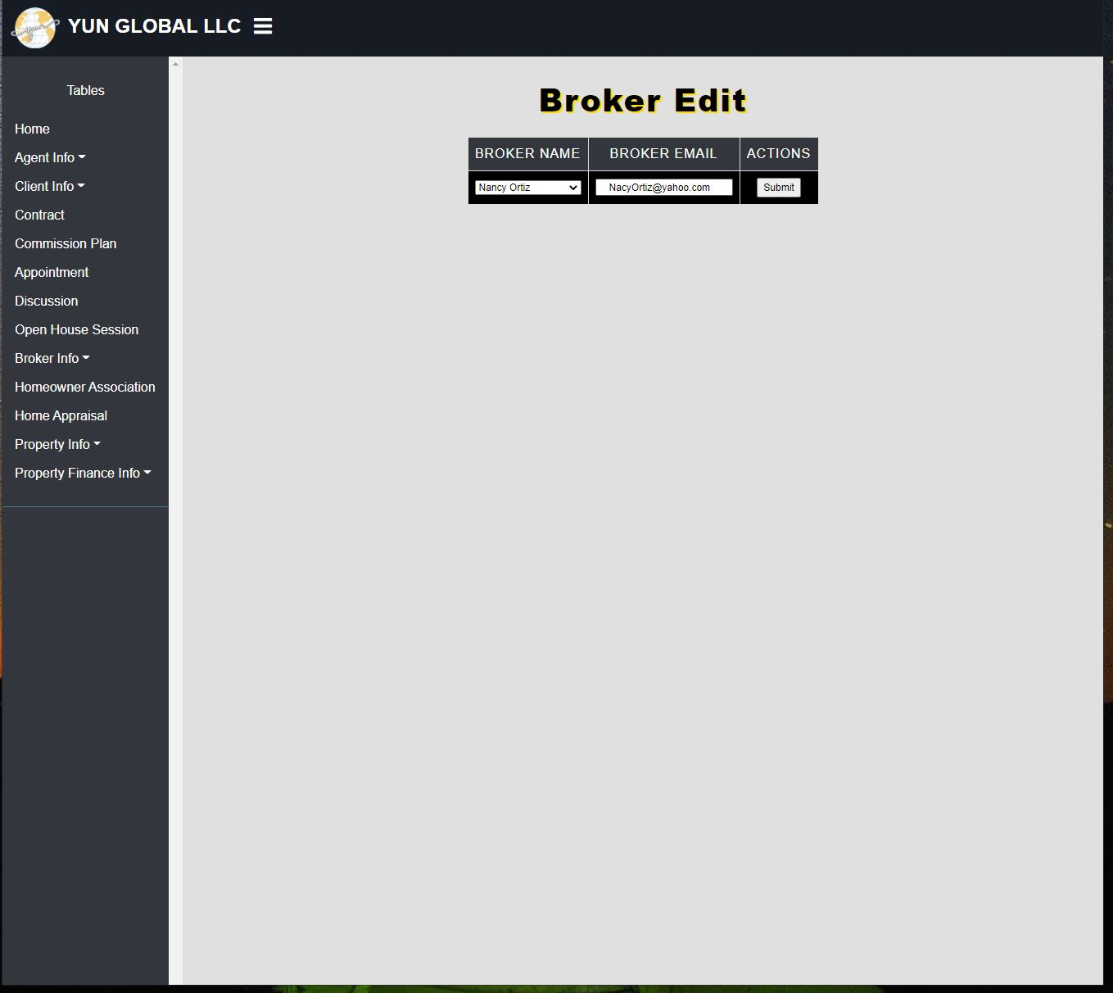

* Broker Email [NancyOrtiz@yahoo.com](mailto:NancyOrtiz@yahoo.com) being edited.

**Broker Email Edit After:**

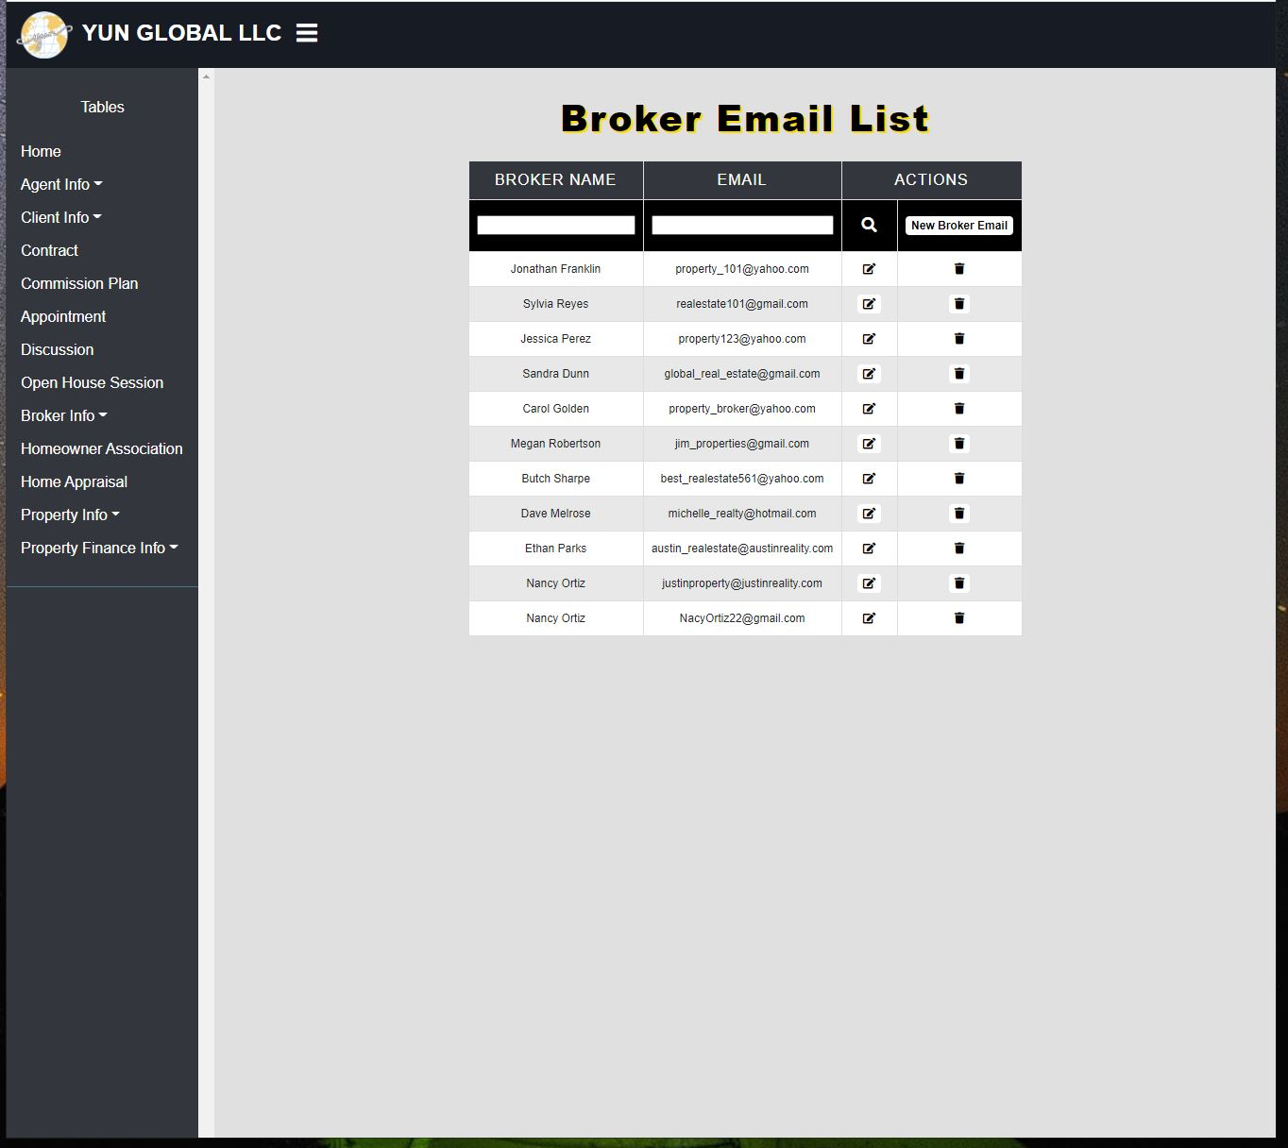

* Broke email [NancyOrtiz@yahoo.com](mailto:NancyOrtiz@yahoo.com) was changed to NancyOrtiz22@gmail.com .

**Broker Email Delete Before:**



* Broker email [NancyOrtiz22@gmail.com](mailto:NancyOrtiz22@gmail.com) was set for deletion.

**Broker Email Delete After:**

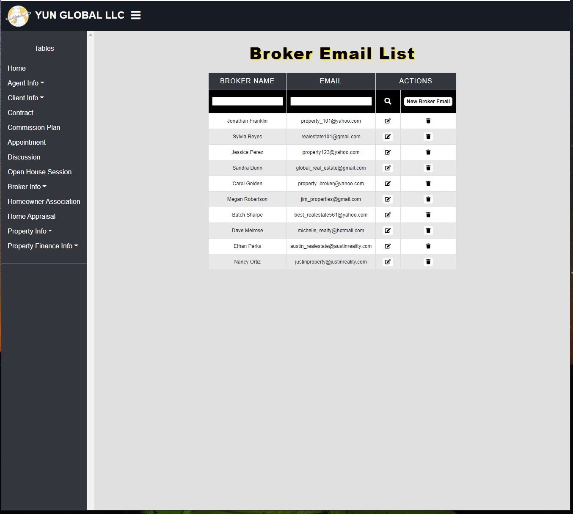

* Broker email list after [NancyOrtiz22@gmail.com](mailto:NancyOrtiz22@gmail.com) was deleted.

**GUI 3: Broker Phone Number**

**Broker Phone Number:**

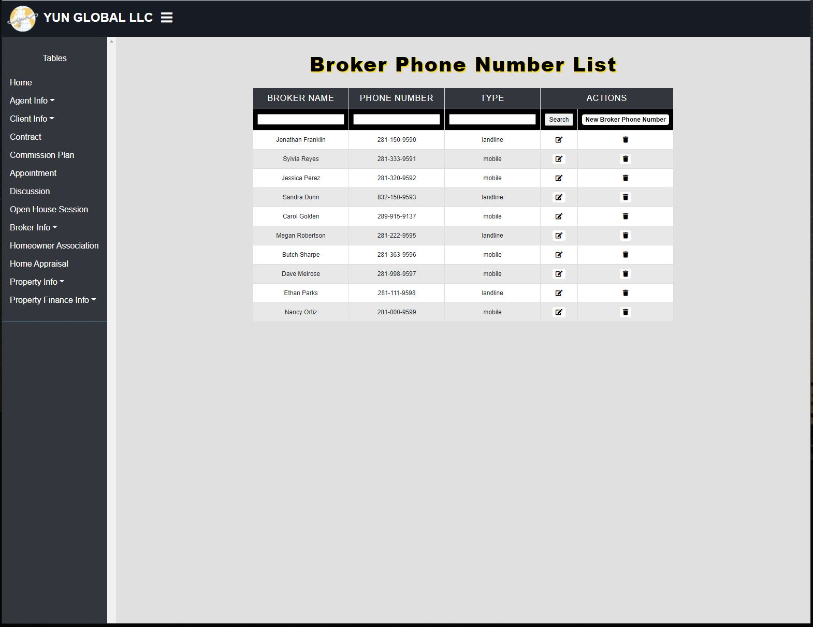

* Broker Phone Number list being displayed.

**Broker Phone Number Filter:**

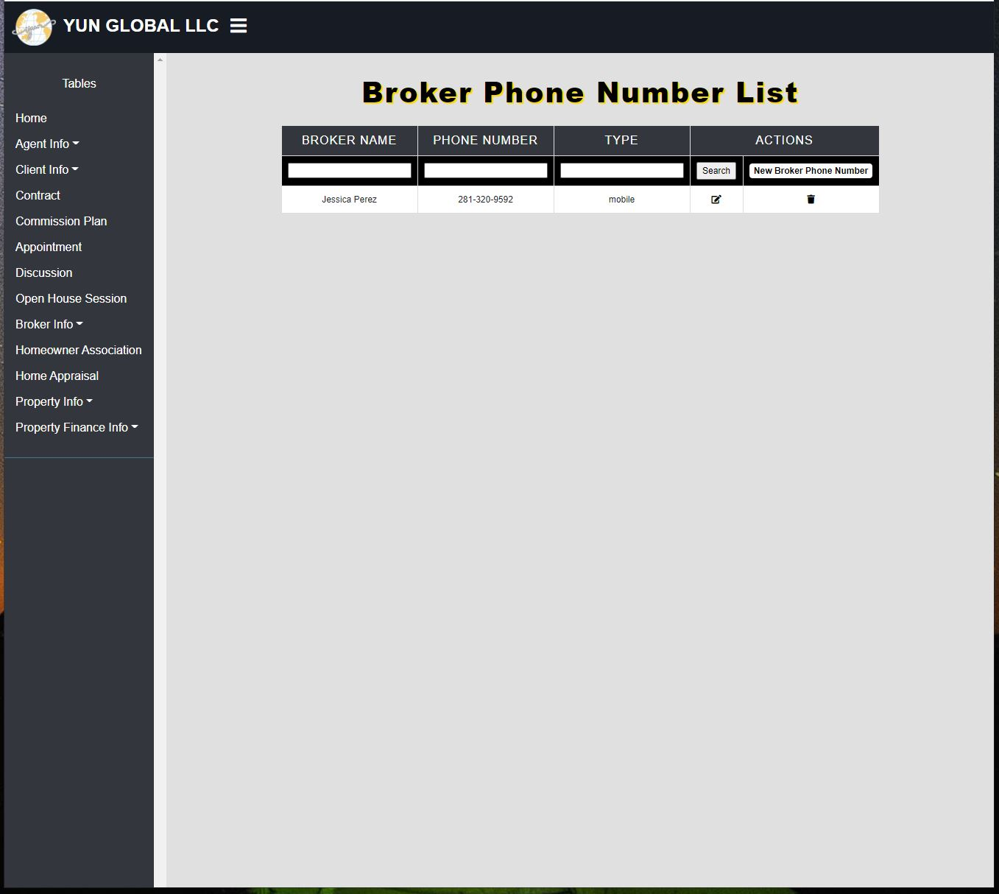

* Broker Phone Number for Jessica Perez was searched/filtered.

**Broker Phone Number Add Before:**

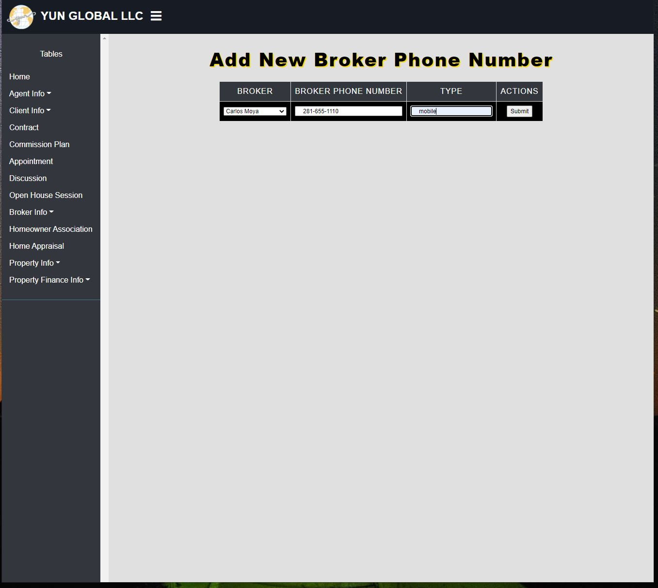

* New Broker Phone Number for the broker Carlos Moya 281-855-1110 being added to the list.

**Broker Phone Number Add After:**

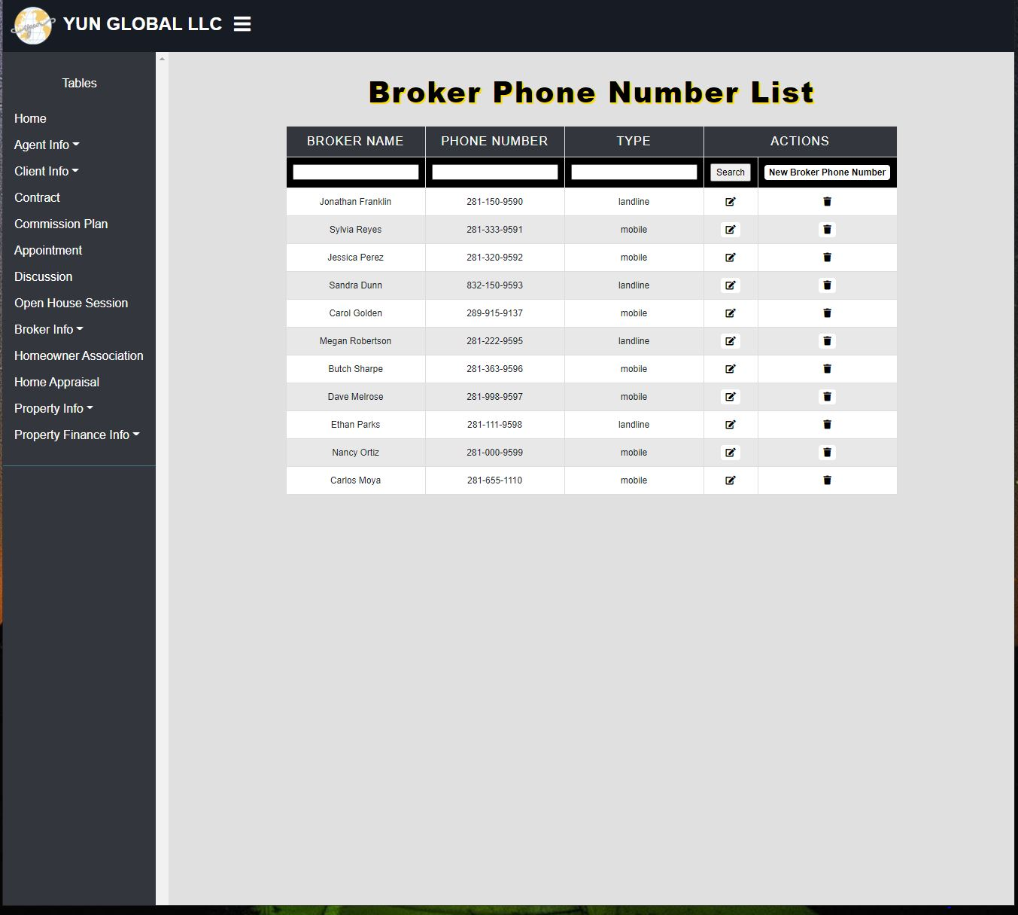

* Broker Phone Number list after the new broker Carlos Moya and number was added.

**Broker Phone Number Edit Before:**

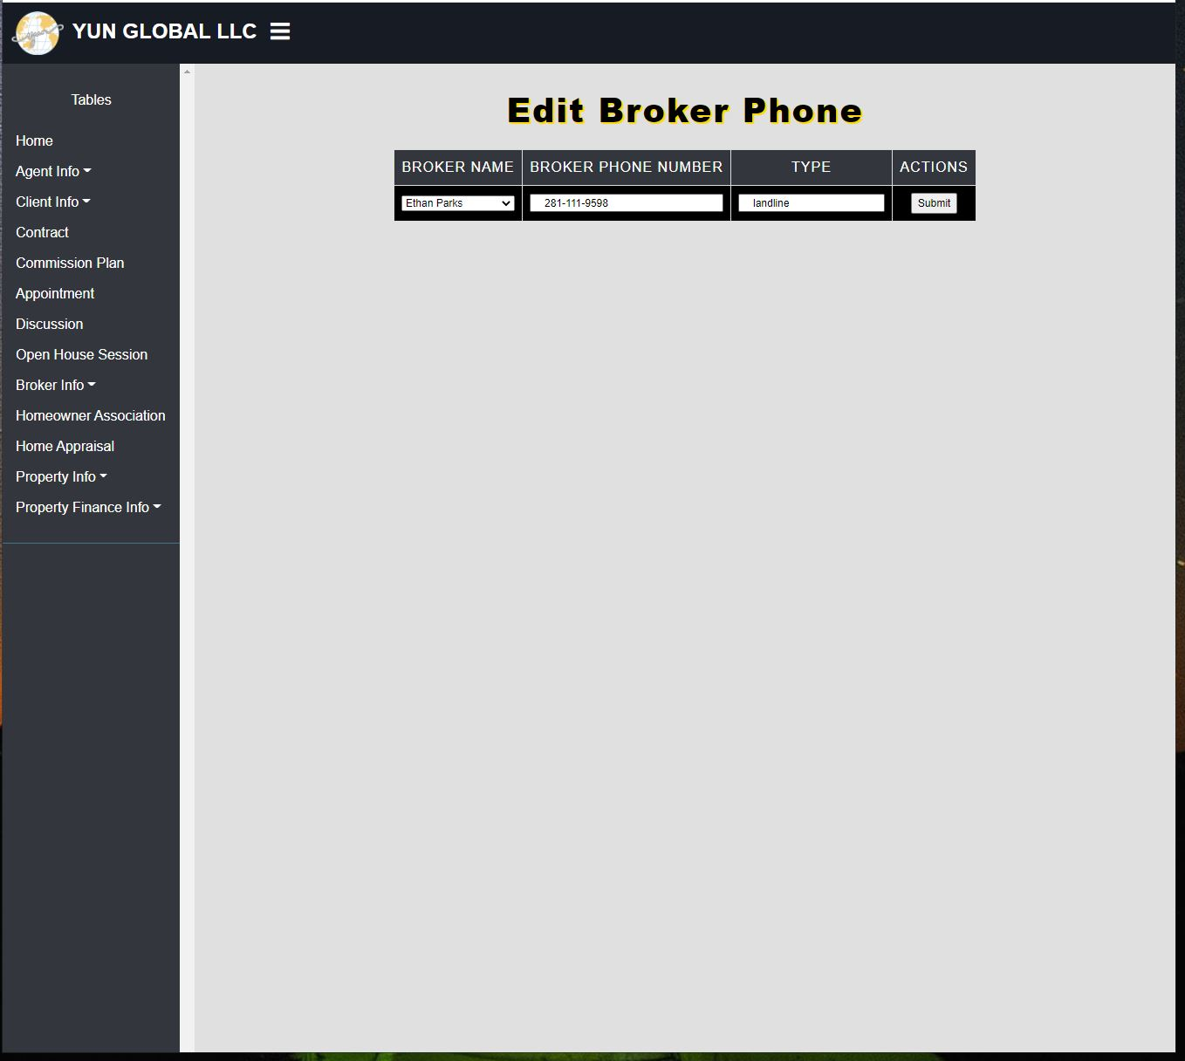

* The broker Ethan parks was selected to be edited.

**Broker Phone Number Edit After:**



* The edited broker phone number information for Ethan Parks was added to the list.

**Broker Phone Number Delete Before:**



* The broker Carlos Moya was selected to be deleted.

**Broker Phone Number Delete After:**

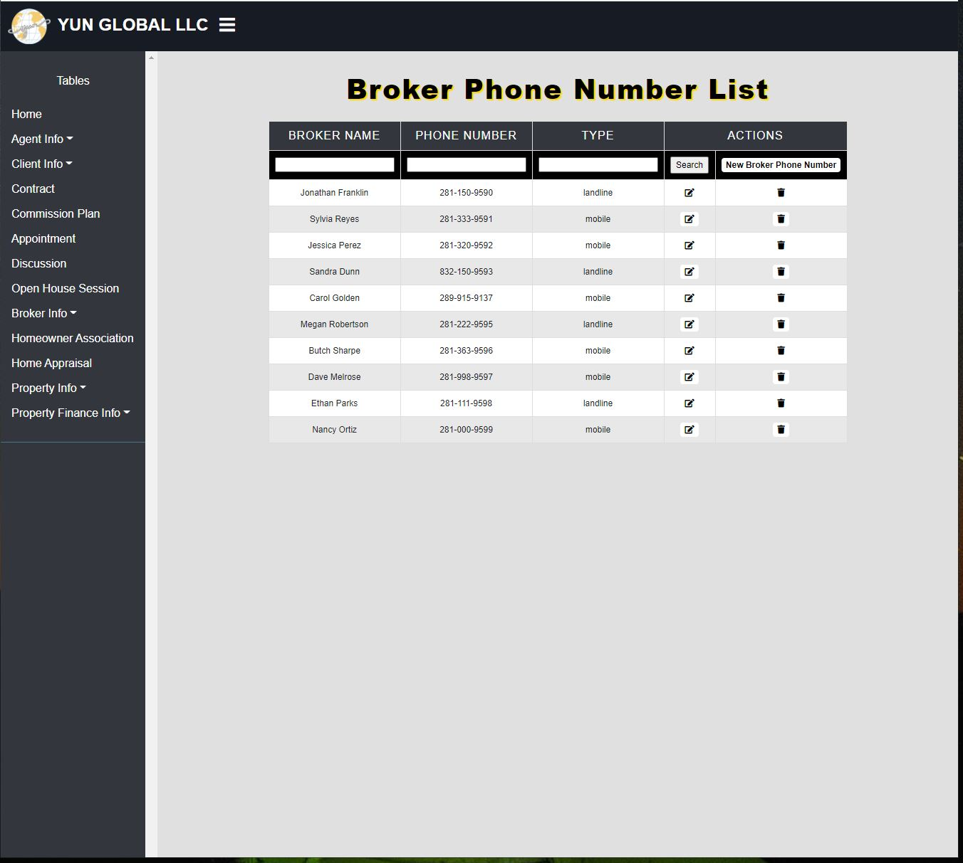

* The broker phone number list after the broker Carlos Moya was deleted.

### **Duy Truong Report**

**Create Script:**

**CREATE TABLE [Property_Photo] (**

**[Photo_ID] varchar(36) NOT NULL,**

**[Photo] varchar(max) NOT NULL,**

**[Property_ID] varchar(36) NOT NULL FOREIGN KEY REFERENCES Property(Property_ID),**

**CONSTRAINT [PK_Property_Photo] PRIMARY KEY ([Photo_ID]),**

**);**

**CREATE TABLE [Property_Video] (**

**[Video_ID] varchar(36) NOT NULL,**

**[Video] varchar(max) NOT NULL,**

**[Property_ID] varchar(36) NOT NULL FOREIGN KEY REFERENCES Property(Property_ID),**

**CONSTRAINT [PK_Property_Video] PRIMARY KEY ([Video_ID]),**

**);**

**CREATE TABLE [Client_Email] (**

**[Client_Email_ID] varchar(36) NOT NULL,**

**[Client_ID] varchar(36) NOT NULL FOREIGN KEY REFERENCES Client(Client_ID),**

**[Client_Email] nvarchar(255) NOT NULL,**

**CONSTRAINT [PK_Client_Email] PRIMARY KEY ([Client_Email_ID])**

**);**

**CREATE TABLE [Client_Status] (**

**[Client_Status_ID] varchar(36) NOT NULL,**

**[Client_Status] varchar(50) NOT NULL,**

**CONSTRAINT [PK_Client_Status_ID] PRIMARY KEY ([Client_Status_ID])**

**);**

**CREATE TABLE [Client_Phone_Number] (**

**[Client_Phone_Number_ID] varchar(36) NOT NULL,**

**[Client_ID] varchar(36) NOT NULL FOREIGN KEY REFERENCES Client(Client_ID),**

**[Client_Phone_Number] varchar(15) NOT NULL,**

**[Client_Type] varchar(10) NOT NULL,**

**CONSTRAINT [PK_Client_Phone_Number] PRIMARY KEY ([Client_Phone_Number_ID])**

**);**

**CREATE TABLE [Contract_Status] (**

**[Contract_Status_ID] varchar(36) NOT NULL,**

**[Contract_Status] varchar(30) NOT NULL,**

**CONSTRAINT [PK_Contract_Status] PRIMARY KEY ([Contract_Status_ID])**

**);**

**CREATE TABLE [Contract_Type] (**

**[Contract_Type_ID] varchar(36) NOT NULL,**

**[Contract_Type] varchar(30) NOT NULL,**

**CONSTRAINT [PK_Contract_Type_ID] PRIMARY KEY ([Contract_Type_ID])**

**);**

**Alter Script:**

**ALTER TABLE [Home_Builder] ADD isdelete bit NOT NULL DEFAULT 0**

**ALTER TABLE [Property] ADD isdelete bit NOT NULL DEFAULT 0**

**ALTER TABLE [Property_Finance] ADD isdelete bit NOT NULL DEFAULT 0**

**ALTER TABLE [Floor_Plan] ADD isdelete bit NOT NULL DEFAULT 0**

**ALTER TABLE [Property_Flyer] ADD isdelete bit NOT NULL DEFAULT 0**

**ALTER TABLE [Home_Inspection_Company] ADD isdelete bit NOT NULL DEFAULT 0**

**ALTER TABLE [Homeowner_Associate] ADD isdelete bit NOT NULL DEFAULT 0**

**ALTER TABLE [HOA_Email] ADD isdelete bit NOT NULL DEFAULT 0**

**ALTER TABLE [Agent] ADD isdelete bit NOT NULL DEFAULT 0**

**ALTER TABLE [Agent_Email] ADD isdelete bit NOT NULL DEFAULT 0**

**ALTER TABLE [Agent_Phone_Number] ADD isdelete bit NOT NULL DEFAULT 0**

**ALTER TABLE [Client] ADD isdelete bit NOT NULL DEFAULT 0**

**ALTER TABLE [Questionnaire] ADD isdelete bit NOT NULL DEFAULT 0**

**ALTER TABLE [Broker_Company] ADD isdelete bit NOT NULL DEFAULT 0**

**ALTER TABLE [Broker] ADD isdelete bit NOT NULL DEFAULT 0**

**ALTER TABLE [Contract] ADD isdelete bit NOT NULL DEFAULT 0**

**ALTER TABLE [Client_Selling_Plan] ADD isdelete bit NOT NULL DEFAULT 0**

**ALTER TABLE [Commission_Plan] ADD isdelete bit NOT NULL DEFAULT 0**

**ALTER TABLE [Property_Survey] ADD isdelete bit NOT NULL DEFAULT 0**

**ALTER TABLE [Nearby_Recreation] ADD isdelete bit NOT NULL DEFAULT 0**

**ALTER TABLE [Title_Owner] ADD isdelete bit NOT NULL DEFAULT 0**

**ALTER TABLE [Top_Feature] ADD isdelete bit NOT NULL DEFAULT 0**

**ALTER TABLE [Nearby_Businesses] ADD isdelete bit NOT NULL DEFAULT 0**

**ALTER TABLE [Heating_Unit] ADD isdelete bit NOT NULL DEFAULT 0**

**ALTER TABLE [Air_Conditioning_Unit] ADD isdelete bit NOT NULL DEFAULT 0**

**ALTER TABLE [Property_Remodel] ADD isdelete bit NOT NULL DEFAULT 0**

**ALTER TABLE [Outdoor] ADD isdelete bit NOT NULL DEFAULT 0**

**ALTER TABLE [Room] ADD isdelete bit NOT NULL DEFAULT 0**

**ALTER TABLE [Appliance] ADD isdelete bit NOT NULL DEFAULT 0**

**ALTER TABLE [Home_Appraisal] ADD isdelete bit NOT NULL DEFAULT 0**

**ALTER TABLE [Mortgage_Document] ADD isdelete bit NOT NULL DEFAULT 0**

**ALTER TABLE [Bathroom] ADD isdelete bit NOT NULL DEFAULT 0**

**ALTER TABLE [Garage] ADD isdelete bit NOT NULL DEFAULT 0**

**ALTER TABLE [Open_House_Session] ADD isdelete bit NOT NULL DEFAULT 0**

**ALTER TABLE [Property_Photo] ADD isdelete bit NOT NULL DEFAULT 0**

**ALTER TABLE [Property_Video] ADD isdelete bit NOT NULL DEFAULT 0**

**ALTER TABLE [Appointment] ADD isdelete bit NOT NULL DEFAULT 0**

**ALTER TABLE [New_Home_Questionnaire] ADD isdelete bit NOT NULL DEFAULT 0**

**ALTER TABLE [Lender_Company] ADD isdelete bit NOT NULL DEFAULT 0**

**ALTER TABLE [Lender] ADD isdelete bit NOT NULL DEFAULT 0**

**ALTER TABLE [Lender_Email] ADD isdelete bit NOT NULL DEFAULT 0**

**ALTER TABLE [Lender_Phone_Number] ADD isdelete bit NOT NULL DEFAULT 0**

**ALTER TABLE [Financing_Questionnaire] ADD isdelete bit NOT NULL DEFAULT 0**

**ALTER TABLE [Seller Disclosure form] ADD isdelete bit NOT NULL DEFAULT 0**

**ALTER TABLE [Client_Email] ADD isdelete bit NOT NULL DEFAULT 0**

**ALTER TABLE [Client_Phone_Number] ADD isdelete bit NOT NULL DEFAULT 0**

**ALTER TABLE [Property_Inspection] ADD isdelete bit NOT NULL DEFAULT 0**

**ALTER TABLE [School_District_Preference] ADD isdelete bit NOT NULL DEFAULT 0**

**ALTER TABLE [Broker_Email] ADD isdelete bit NOT NULL DEFAULT 0**

**ALTER TABLE [Broker_Phone_Number] ADD isdelete bit NOT NULL DEFAULT 0**

**ALTER TABLE [Commission_Payment] ADD isdelete bit NOT NULL DEFAULT 0**

**ALTER TABLE [Discussion] ADD isdelete bit NOT NULL DEFAULT 0**

**ALTER TABLE [Utility_Bill] ADD isdelete bit NOT NULL DEFAULT 0**

**ALTER TABLE [Paycheck] ADD isdelete bit NOT NULL DEFAULT 0**

**ALTER TABLE [Pet] ADD isdelete bit NOT NULL DEFAULT 0**

**ALTER TABLE [Login] ADD isdelete bit NOT NULL DEFAULT 0**

**Data Created:**

* **Property Data (core): Zoom in for more details.**



**Home Builder Data**

|  |  |
| --- | --- |
| **Home_Builder_ID** | **Home_Builder** |
| **bd207b1c-c051-4f7b-a120-4e6ebf9b99c4** | **Legion Custom Home Builders** |
| **fa3bf63b-554b-4497-b420-c9622ebfb221** | **Aspire Fine Homes** |
| **1223fec8-1d54-4762-8e3f-a562b6c34e93** | **Jamestown Estate Homes** |
| **3fe67d9d-e52f-4637-9a0b-63a8d500ecb1** | **Liberty Home Builders** |
| **41235488-fb0d-4be1-9aa5-84a8bec6c255** | **KB Home Design Studio Houston** |
| **c299983d-46a4-4c67-95fb-728dee284102** | **Savannah Home Builders** |
| **85c80e73-3819-4fd8-86fa-9d0bf1bda8bb** | **Cason Graye Homes** |
| **d9c2a921-7b9b-4721-a9fc-9be2f7b55675** | **Meritage Homes** |
| **74c2cf90-ddbf-42fd-a9b2-3fc32d825ea8** | **Gehan Homes** |
| **14e3a127-9ee1-42c0-a89e-f65ad948cc16** | **Censeo Homes** |
| **36d528f0-55c7-45bb-a892-9d82e8df90eb** | **Centex Homes** |
| **c52b6bc4-3533-4637-9988-7190f7075e89** | **Trendmaker Homes** |
| **804432d9-365e-4480-a2c0-1d6d7f585b2b** | **David Weekley Homes** |
| **547a2156-5dfb-4d2b-816a-adb0061b1fc8** | **CastleRock Communities** |
| **9113be79-0def-48a1-b316-09b1678cf5bd** | **Saratoga** |
| **c49b573b-4c49-4425-b343-640dfe1b4954** | **Lennar** |
| **d198ab34-18b7-4036-8702-c4717eca076b** | **Beazer Homes** |

**Property Style:**

|  |  |
| --- | --- |
| **Property_Style_ID** | **Style** |
| **927f439e-e2dc-43d0-a7d7-ea32d7923a9d** | **Modern** |
| **44fad765-0dbe-457d-b27b-c7434f5cc29f** | **Craftsman** |
| **5a1e8f77-df4a-4415-b4e0-7467699643a0** | **Carriage** |
| **cbcd2f9d-e257-4b59-8ad3-2d1ee2531a0e** | **Ranch** |
| **66f524c5-597a-494b-88d1-e155da067154** | **Farmhouses** |
| **fbea472f-6006-4f7a-9728-0669d2028c88** | **Contemporary** |
| **5de24e24-341a-474b-94c9-efdd88c7dcb2** | **Colonial** |
| **9b73ea4a-05f9-47db-be25-17e01083a504** | **Tudor** |
| **b1fb05bb-6f06-4626-b2d5-bc1a01c07e2a** | **Communities** |
| **4f41d240-bf3c-4cc7-8d3d-12bc6e78e93e** | **Apartment** |

**SQL Queries:**

**1.**

SELECT

Client.Client_First_Name AS 'Client First Name',

Client.Client_Last_Name AS 'Client Last Name',

Client_Email.Client_Email AS 'Email',

Client_Phone_Number.Client_Phone_Number AS 'Phone Number',

Contract_Status.Contract_Status AS 'Contract status'

FROM Client

INNER JOIN Client_Phone_Number ON Client.Client_ID = Client_Phone_Number.Client_ID

INNER JOIN Client_Email ON Client.Client_ID = Client_Email.Client_ID

INNER JOIN Contract ON Client.Client_ID = Contract.Client_ID

INNER JOIN Contract_Status ON Contract.Contract_Status_ID=Contract_Status.Contract_Status_ID

WHERE Contract_Status.Contract_Status='Active' OR Contract_Status.Contract_Status='Pending'

**2.**

SELECT

Client.Client_First_Name AS 'First Name',

Client.Client_Last_Name AS 'Last Name',

Client.Client_Type AS 'Client Type',

Client_Email.Client_Email AS 'Email',

Client_Phone_Number.Client_Phone_Number AS 'Phone Number',

Appointment.Appointment_Date AS 'Appointment Date',

Appointment.Appointment_Time AS 'Time'

FROM Client

INNER JOIN Client_Phone_Number ON Client.Client_ID = Client_Phone_Number.Client_ID

INNER JOIN Client_Email ON Client.Client_ID = Client_Email.Client_ID

INNER JOIN Appointment ON Client.Client_ID = Appointment.Client_ID

WHERE Client.Client_First_Name='Carlo' AND Client.Client_Last_Name='Jenkins'

**3.**

SELECT

Home_Builder.Home_Builder AS 'Home Builder Company',

Property_Style.Style AS 'Property Style',

Property_Finance.Total_Price_Estimate AS 'Total Price ($)',

Top_Feature.Top_Feature AS 'Top Feature',

Property.Street_Address AS 'Street Address',

Property.City AS 'City',

State.State_Name AS 'State',

Property.Zip_Code AS 'Zipcode'

FROM Property

INNER JOIN State ON Property.State_ID=State.State_ID

INNER JOIN Home_Builder ON Property.Home_Builder_ID=Home_Builder.Home_Builder_ID

INNER JOIN Top_Feature ON Property.Property_ID= Top_Feature.Property_ID

INNER JOIN Property_Style ON Property.Property_Style_ID=Property_Style.Property_Style_ID

INNER JOIN Property_Finance ON Property.Property_ID=Property_Finance.Property_ID

WHERE

Property.City='Pasadena' AND Property_Finance.Total_Price_Estimate < '200000'

**4.**

SELECT

Agent.Agent_First_Name AS 'Agent First Name',

Agent.Agent_Last_Name AS 'Agent Last Name',

Client.Client_First_Name AS 'Client First Name',

Client.Client_Last_Name AS 'Client Last Name',

Client_Email.Client_Email AS 'Client Email',

Client_Phone_Number AS 'Client Phone Number',

Discussion.Discussion_Topic AS 'Discussion Topic',

Discussion.Discussion_Summary AS 'Summary'

FROM Discussion

INNER JOIN Agent ON Discussion.Agent_ID=Agent.Agent_ID

INNER JOIN Client ON Discussion.Client_ID=Client.Client_ID

INNER JOIN Client_Phone_Number ON Client.Client_ID=Client_Phone_Number.Client_ID

INNER JOIN Client_Email ON Client.Client_ID=Client_Email.Client_ID

WHERE

Agent.Agent_First_Name='Jim' AND Discussion.Discussion_Summary='Pending'

**SQL Update script:**

**Member : Duy Truong**

/*Insert Script*/

INSERT into Agent(Agent_ID,Agent_First_Name,Agent_Last_Name,Title)

VALUES (NEWID(),'Steve','Yun','lead');

**Before:**

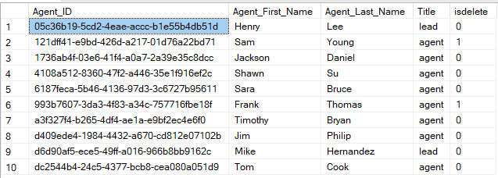

**After:**

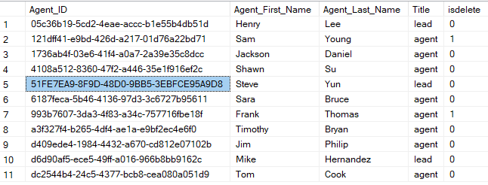

INSERT into Home_Builder(Home_Builder_ID,Home_Builder)

VALUES (NEWID(),'Southdown Contructions');

**Before:**

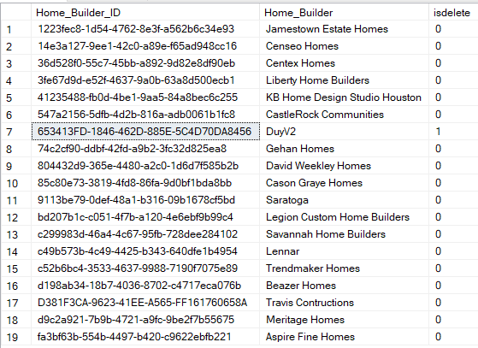

**After:**

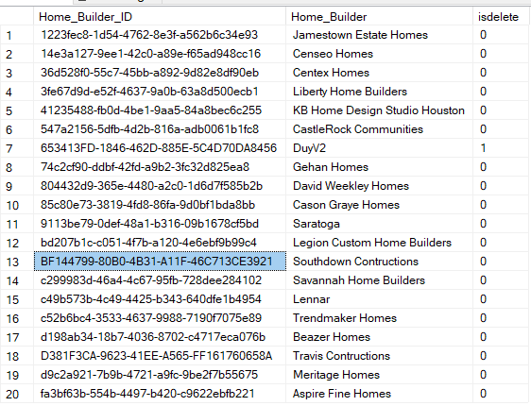

/*Update script*/

UPDATE [Agent]

SET Agent_First_Name='Michael'

WHERE Agent.Agent_ID='51FE7EA9-8F9D-48D0-9BB5-3EBFCE95A9D8'

**Before:**

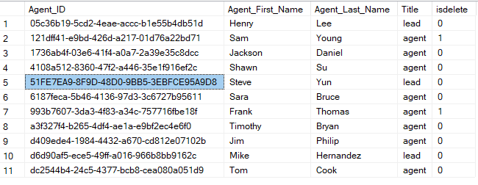

**After:**

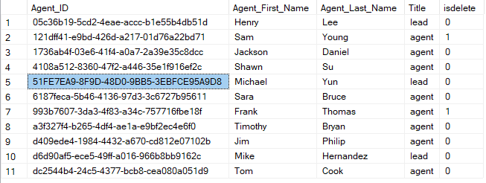

UPDATE [Home_Builder]

SET Home_Builder='Pearland Construction'

WHERE Home_Builder.Home_Builder_ID='BF144799-80B0-4B31-A11F-46C713CE3921'

**Before:**

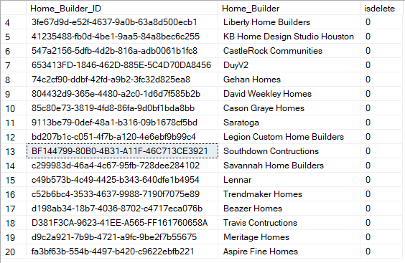

**After:**

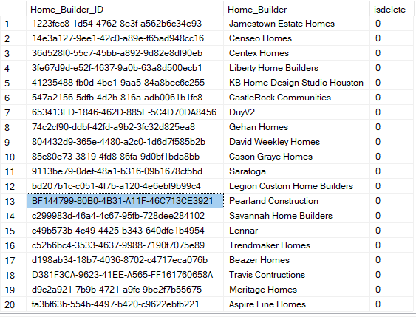

/*Soft Delete script*/

UPDATE [Home_Builder]

SET isdelete='1'

WHERE Home_Builder.Home_Builder='Pearland Construction'

**Before:**

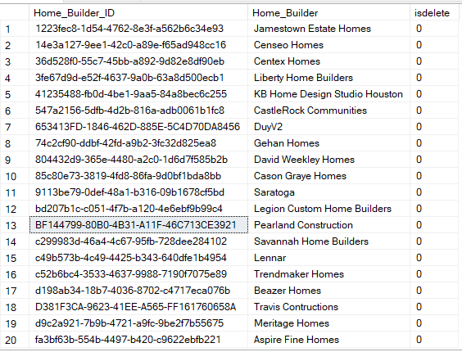

**After:**

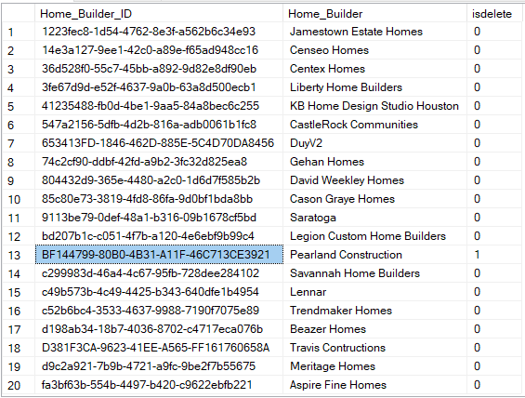

UPDATE [Agent]

SET isdelete='1'

WHERE Agent.Agent_ID='51FE7EA9-8F9D-48D0-9BB5-3EBFCE95A9D8'

**Before:**

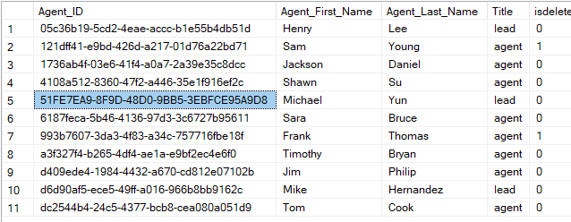

**After:**

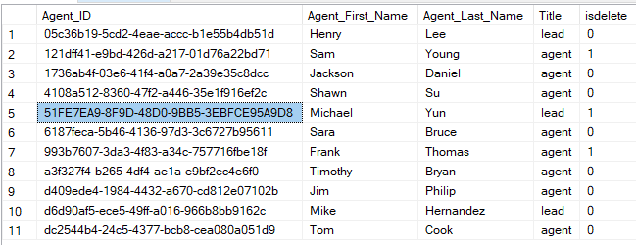

**SQL Queries Report:**

**Section: Duy Truong**

**Report name 1:** Client contact information and appointment date base on client name

**Report Description:** Select client name, their contact information, and appointment time based on client first and last name

**Businesses purpose:** Since Yun global is a small company with limited office space**.** Mr. Yun, the founder and boss of Yun Global can use this report to assist in keeping tabs on the amount of schedule appointment in the office base on the client name in for each appointment, their contact information in case of an update and their appointment time on that day.

**SQL Code**:

SELECT

Client.Client_First_Name AS 'First Name',

Client.Client_Last_Name AS 'Last Name',

Client.Client_Type AS 'Client Type',

Client_Email.Client_Email AS 'Email',

Client_Phone_Number.Client_Phone_Number AS 'Phone Number',

Appointment.Appointment_Date AS 'Appointment Date',

Appointment.Appointment_Time AS 'Time'

FROM Client

INNER JOIN Client_Phone_Number ON Client.Client_ID = Client_Phone_Number.Client_ID

INNER JOIN Client_Email ON Client.Client_ID = Client_Email.Client_ID

INNER JOIN Appointment ON Client.Client_ID = Appointment.Client_ID

WHERE Client.Client_First_Name='Carlo' AND Client.Client_Last_Name='Jenkins'

**Report/ Query Result**:



**Data list:**

**1.Client (25/100)**

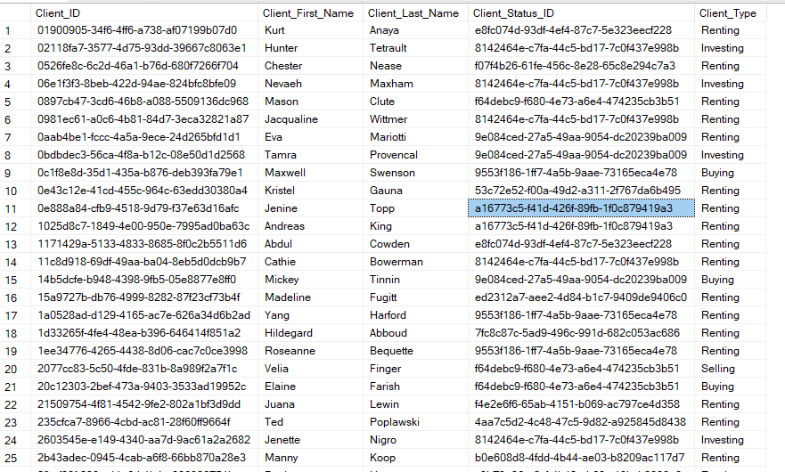

**2.Client Email (20/100)**

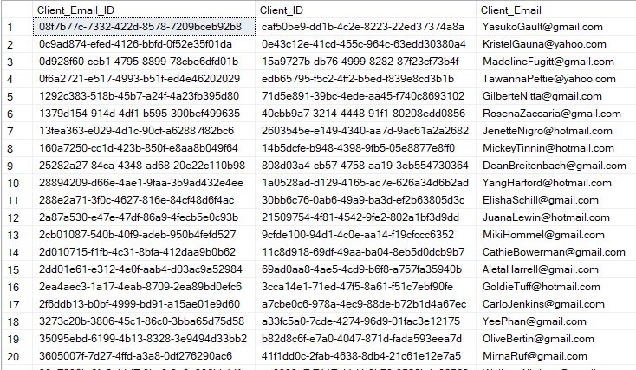

**3. Client Phone Number (20/100)**

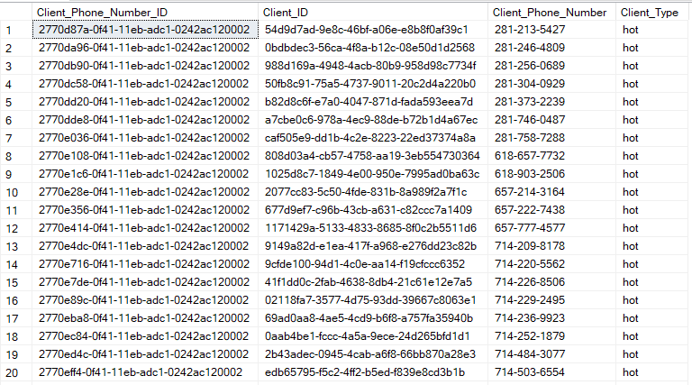

**4.Appointment**

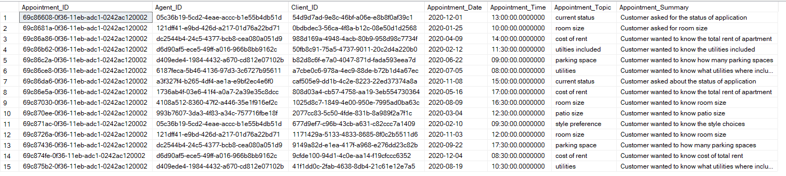

**Report name 2**: Property Information by property value and city

**Report Description:** Select Property that fall within a certain price range and locate in a specific city

**Business purpose**: Real estate agent from Yun Global can use this report to assist in creatin a property list base on the price range and city area. Client can tell the agent of the specific criteria of the property they are looking for and the agent can create the list on their laptop.

**SQL Code**:

SELECT

Home_Builder.Home_Builder AS 'Home Builder Company',

Property_Style.Style AS 'Property Style',

Property_Finance.Total_Price_Estimate AS 'Total Price ($)',

Top_Feature.Top_Feature AS 'Top Feature',

Property.Street_Address AS 'Street Address',

Property.City AS 'City',

State.State_Name AS 'State',

Property.Zip_Code AS 'Zipcode'

FROM Property

INNER JOIN State ON Property.State_ID=State.State_ID

INNER JOIN Home_Builder ON Property.Home_Builder_ID=Home_Builder.Home_Builder_ID

INNER JOIN Top_Feature ON Property.Property_ID= Top_Feature.Property_ID

INNER JOIN Property_Style ON Property.Property_Style_ID=Property_Style.Property_Style_ID

INNER JOIN Property_Finance ON Property.Property_ID=Property_Finance.Property_ID

WHERE

Property.City='Pasadena' AND Property_Finance.Total_Price_Estimate < '200000'

**Report/Query Result**:

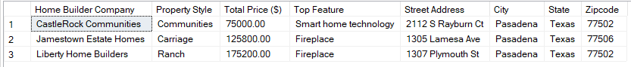

**Data List:**

**1.Home Builder**

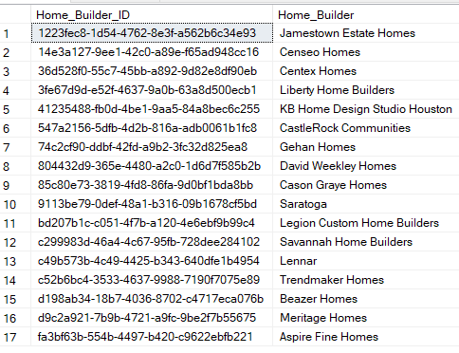

1. **Property (23/100)**

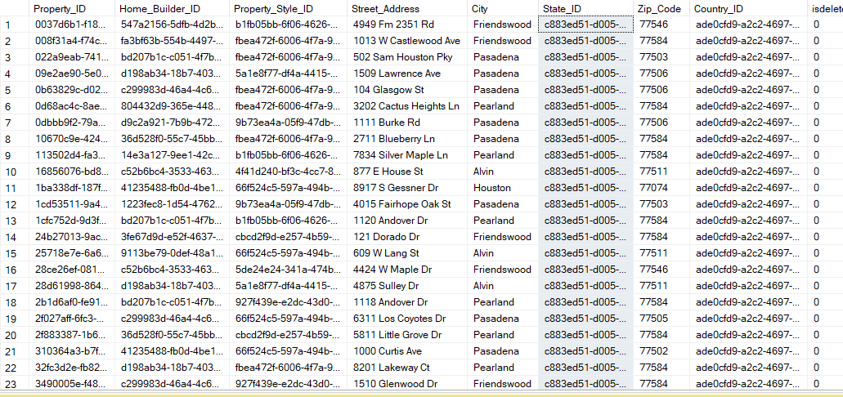

1. **Property Style**

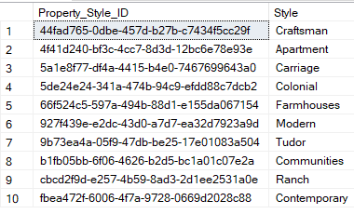

1. **Property Finance (20/100)**

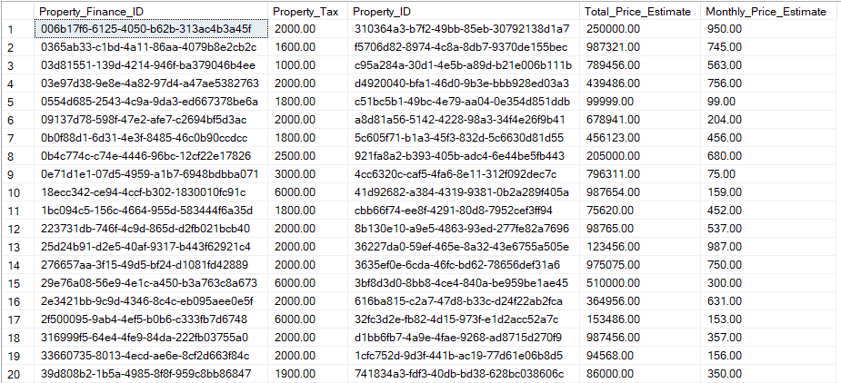

1. **Top Feature**

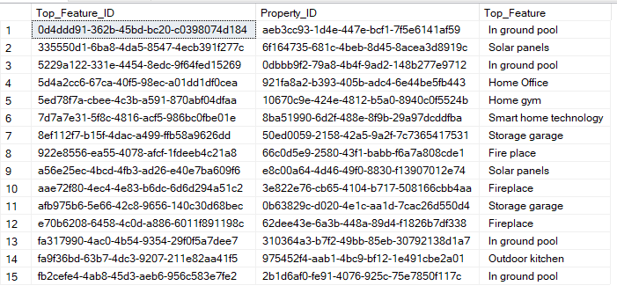

**6.State**

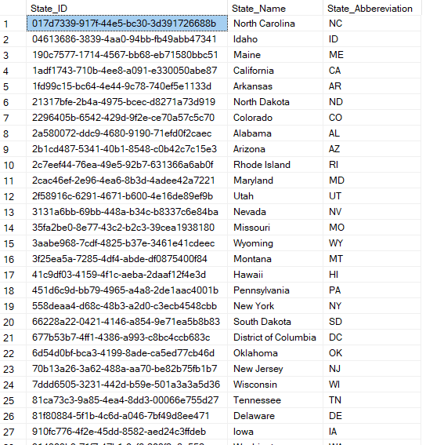

**Report Name 3:** List of clients and their contact information for all non-closed contract.

**Report Description:** Select clients and their contact information based on their contract status

**Businesses Purpose:** Mr. Yun. The boss of Yun Global can use this report to assist in keep tab on all non-closed contract, the corresponding client and their contact information. This will allow him to see if the company is behind or ahead of where it should be when it comes to closing contract.

**SQL Code**:

Client.Client_First_Name AS 'Client First Name',

Client.Client_Last_Name AS 'Client Last Name',

Client_Email.Client_Email AS 'Email',

Client_Phone_Number.Client_Phone_Number AS 'Phone Number',

Contract_Status.Contract_Status AS 'Contract status'

FROM Client

INNER JOIN Client_Phone_Number ON Client.Client_ID = Client_Phone_Number.Client_ID

INNER JOIN Client_Email ON Client.Client_ID = Client_Email.Client_ID

INNER JOIN Contract ON Client.Client_ID = Contract.Client_ID

INNER JOIN Contract_Status ON Contract.Contract_Status_ID=Contract_Status.Contract_Status_ID

WHERE Contract_Status.Contract_Status='Active' OR Contract_Status.Contract_Status='Pending'

**Query/Report Result**:

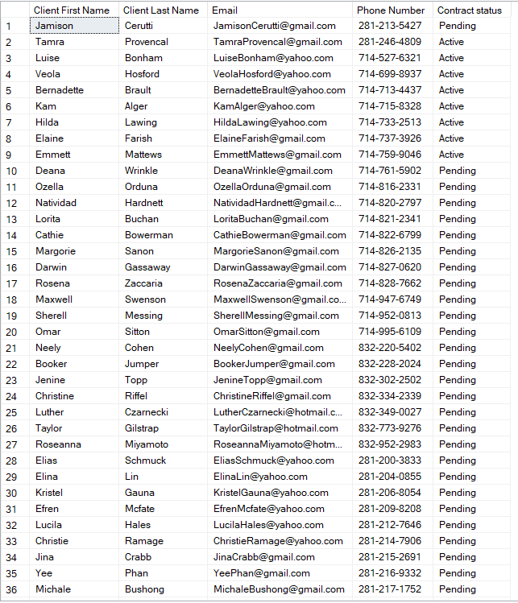

**Data List:**

**1.Contract (26/100)**

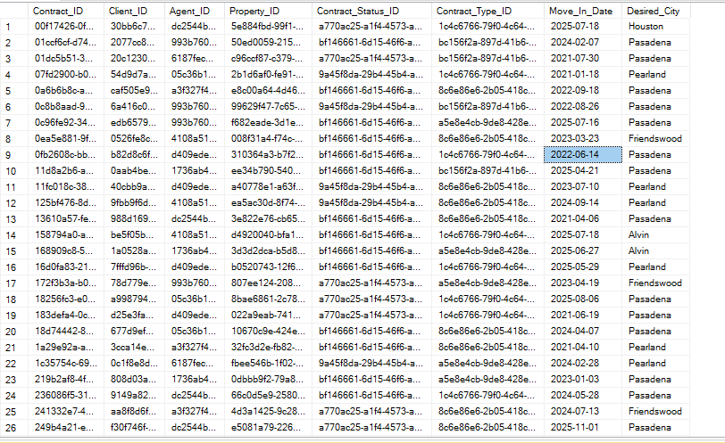

**2.Client (25/100)**



**3.Client email**



**4.Client Phone number (20/100)**



**5. Contract Status**

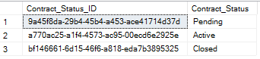

**Report name 4**: Client contact information to follow up on after a discussion with agent Jim

**Report Description:** Select client and their contact information based on the result of the discussion and agent name that conduct the discussion.

**Businesses purpose:** Real estate agent from Yun Global can use this report to follow up with a client after an unfinished discussion with them. Unfinished discussion is sorted by the agent name that conduct the discussion and any discussion that classify as ‘Pending’

**SQL Code**:

SELECT

Agent.Agent_First_Name AS 'Agent First Name',

Agent.Agent_Last_Name AS 'Agent Last Name',

Client.Client_First_Name AS 'Client First Name',

Client.Client_Last_Name AS 'Client Last Name',

Client_Email.Client_Email AS 'Client Email',

Client_Phone_Number AS 'Client Phone Number',

Discussion.Discussion_Topic AS 'Discussion Topic',

Discussion.Discussion_Summary AS 'Summary'

FROM Discussion

INNER JOIN Agent ON Discussion.Agent_ID=Agent.Agent_ID

INNER JOIN Client ON Discussion.Client_ID=Client.Client_ID

INNER JOIN Client_Phone_Number ON Client.Client_ID=Client_Phone_Number.Client_ID

INNER JOIN Client_Email ON Client.Client_ID=Client_Email.Client_ID

WHERE

Agent.Agent_First_Name='Jim' AND Discussion.Discussion_Summary='Pending'

**Query/Report Result**:

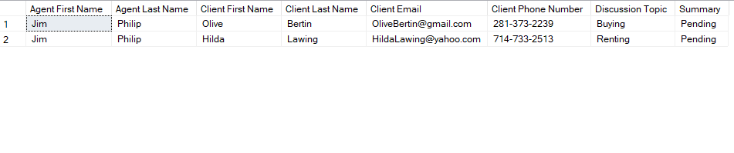

**Data List:**

**1.Agent**

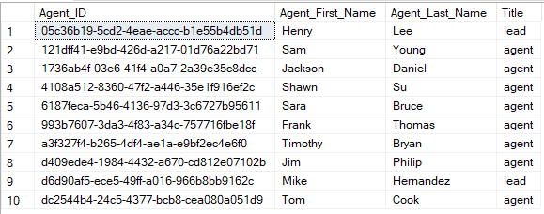

**2.Client**



**3.Client Email**



**4.Client Phone Number**



**5. Discussion**

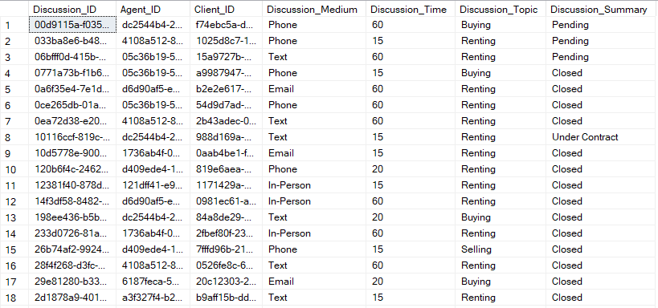

**Forms/ GUI print out and description:**

**GUI 1: Client view**

* This is the view that our sponsor sees when he clicks on the clients tab. He can filter the list by first name, last name, or client status via a drop-down table. The drop-down table is reference from the Client Status data table

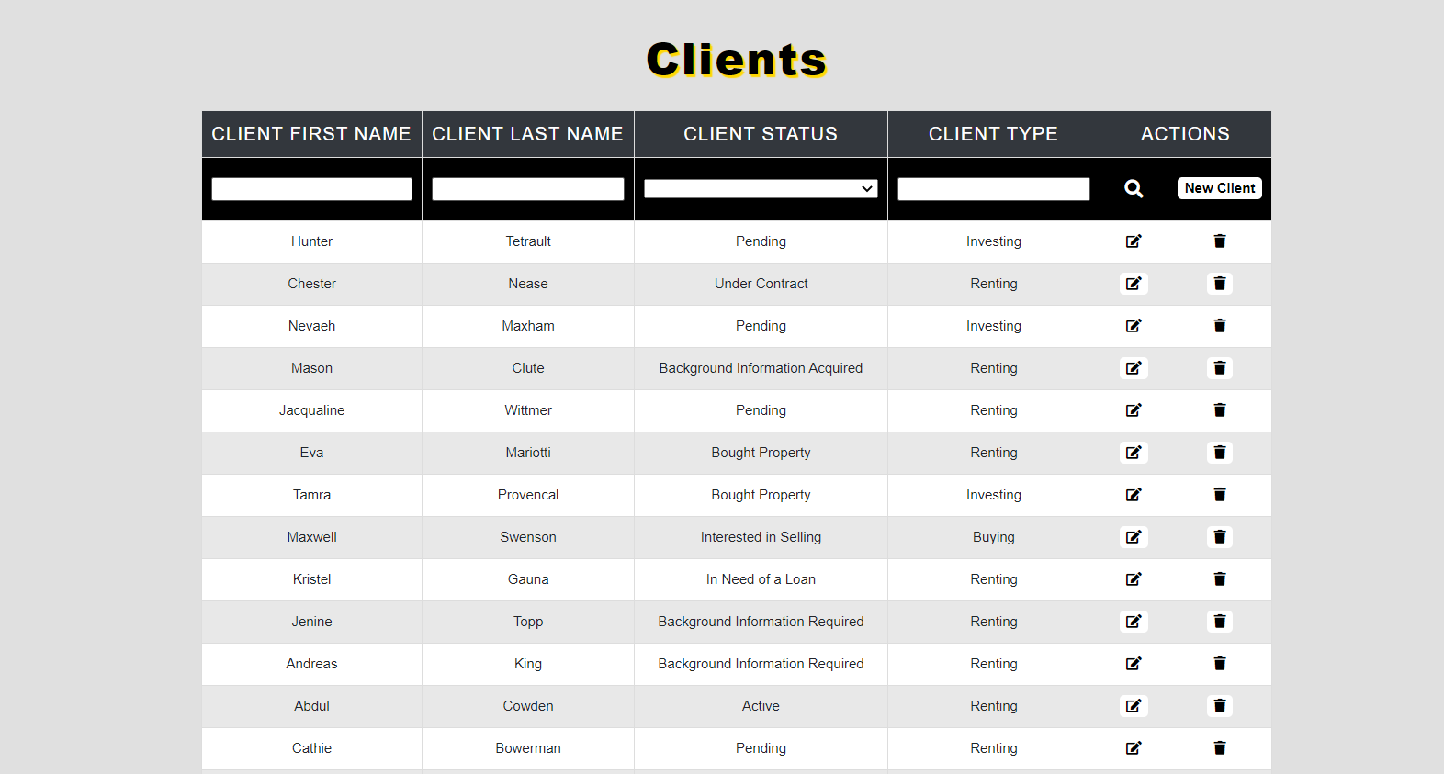

* **Edit:**
* To the right of each client our sponsor can choose to edit his client information.

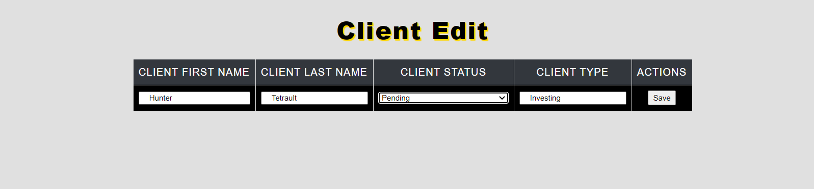

* **Add New Client:**
* Our sponsor can also choose to add new client

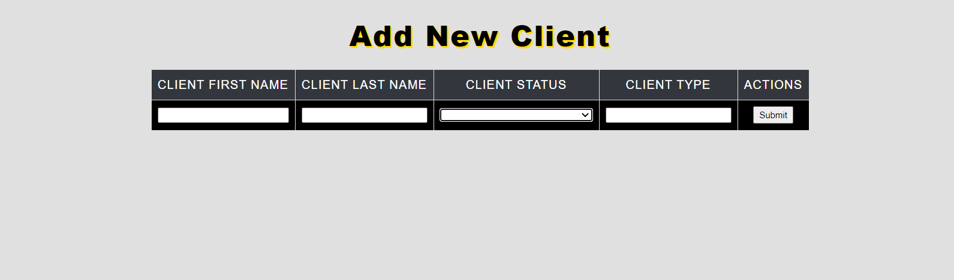

**GUI 2: Top Feature that belong to each Property view:**

* In this view, our sponsor can see the top feature that belong to each property

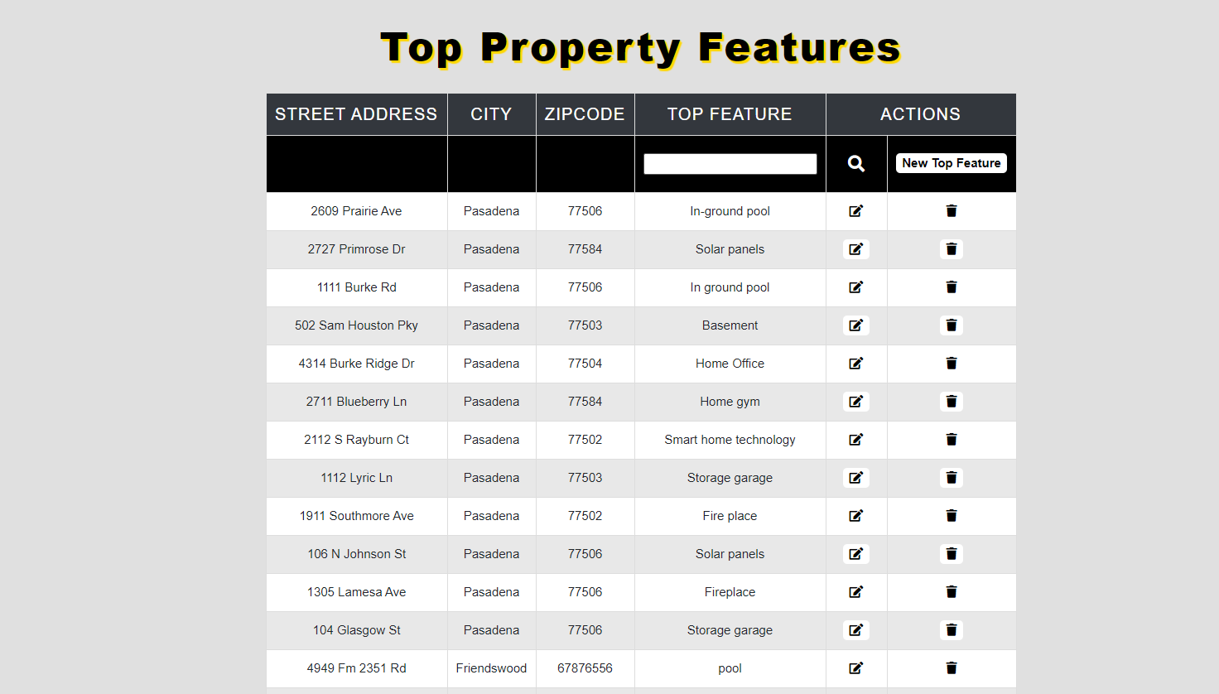

* **Edit:**
* To the right of each feature our sponsor can choose to edit the feature information.

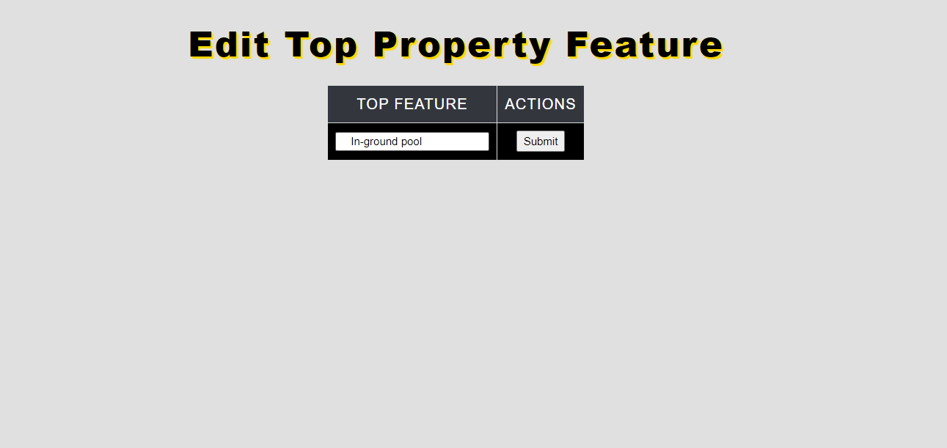

* **Add new Feature:**
* Our sponsor can use this form to add new feature to an already existing property in the database. The drop-down list is reference from the Property table

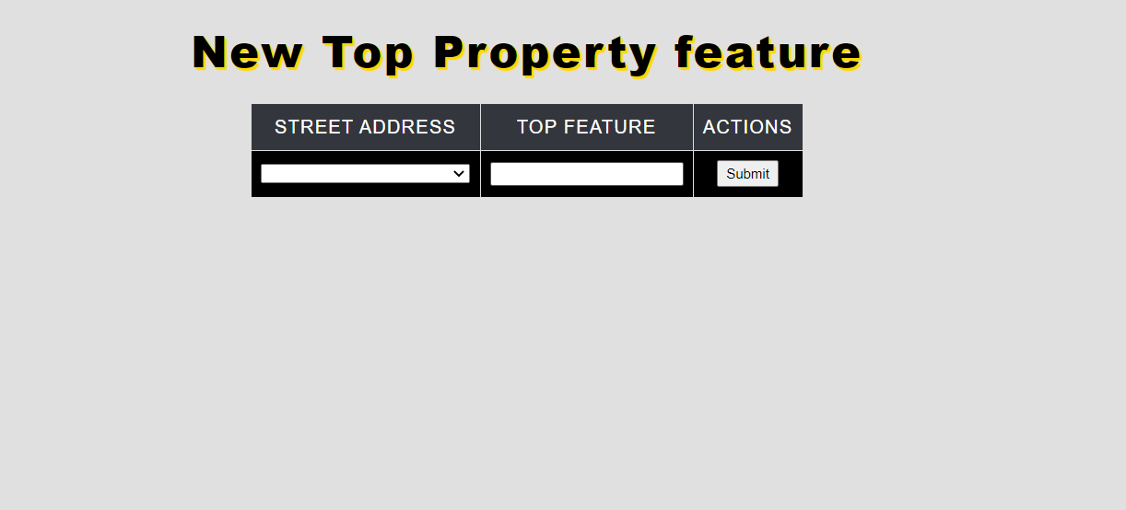

**GUI 3: Name of Title Owner for each property view:**

* In this view, our sponsor can see the name of the Title Owner for each Property

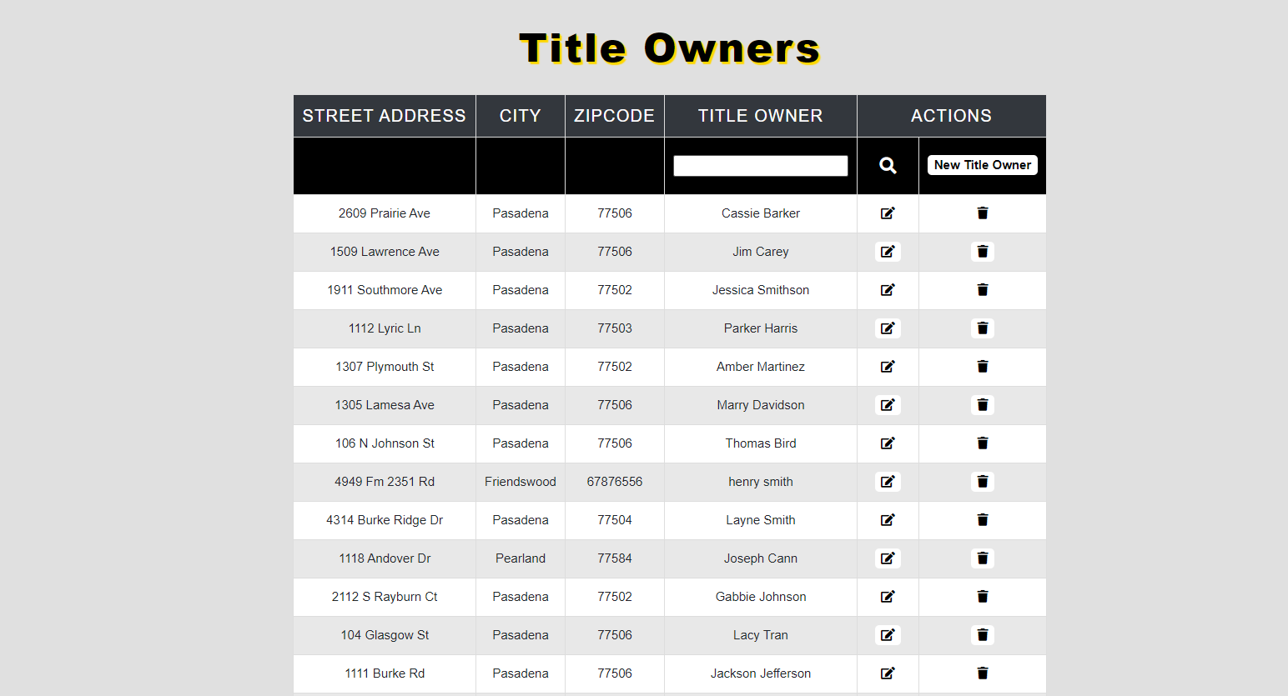

* **Edit:**
* To the right of each name our sponsor can choose to edit title owner name in case the information is wrong.



* **Add Title Owner:**
* Our sponsor can use this form to add new title owner to an already existing property in the database. The drop-down list is reference from the Property table

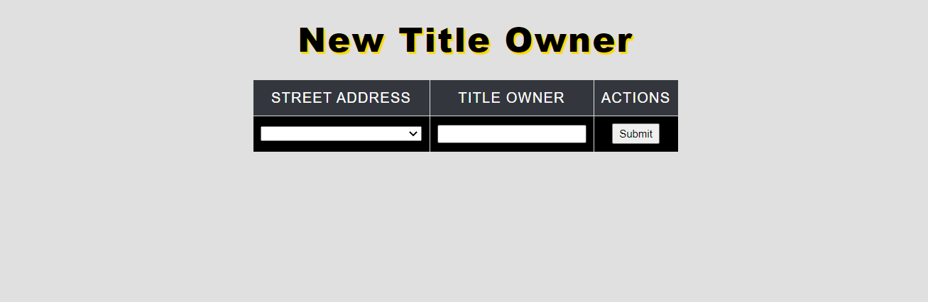

### **Travis Ho Report**

**Create Script:**

**CREATE TABLE [Commission_Plan] (**

**[Commission_Plan_ID] varchar(36) NOT NULL,**

**[Contract_ID] varchar(36) NOT NULL FOREIGN KEY REFERENCES Contract(Contract_ID),**

**[Broker_ID] varchar(36) NOT NULL FOREIGN KEY REFERENCES Broker(Broker_ID),**

**[Total_Commission] money NOT NULL,**

**[Yun_Global_Commission_Percent] decimal(4,2) NOT NULL,**

**[Broker_Commission_Percent] decimal(4,2) NOT NULL,**

**CONSTRAINT [PK_Commission_Plan] PRIMARY KEY ([Commission_Plan_ID])**

**);**

**CREATE TABLE [Country] (**

**[Country_ID] varchar(36) NOT NULL,**

**[Country_name] varchar(100) NOT NULL,**

**CONSTRAINT [PK_Country_ID] PRIMARY KEY ([Country_ID]),**

**);**

**CREATE TABLE [State] (**

**[State_ID] varchar(36) NOT NULL,**

**[State_Name] varchar(100) NOT NULL,**

**[State_Abbereviation] varchar(2) NOT NULL,**

**CONSTRAINT [PK_State_ID] PRIMARY KEY ([State_ID]),**

**);**

**CREATE TABLE [Login] (**

**[Login_ID] varchar(36) NOT NULL,**

**[Username] varchar(100) NOT NULL,**

**[Password] varchar(100) NOT NULL,**

**[Agent_ID] varchar(36) NOT NULL FOREIGN KEY REFERENCES Agent(Agent_ID),**

**CONSTRAINT [PK_Login] PRIMARY KEY ([Login_ID])**

**);**

**Bulk Insert Script:**

**BULK INSERT [Country]**

**FROM 'C:\Data\Country.csv'**

**WITH (**

**CHECK_CONSTRAINTS,**

**FIRSTROW = 2,**

**FIELDTERMINATOR = ','**

**)**

**BULK INSERT [State]**

**FROM 'C:\Data\State.csv'**

**WITH (**

**CHECK_CONSTRAINTS,**

**FIRSTROW = 2,**

**FIELDTERMINATOR = ','**

**)**

**BULK INSERT [Home_Builder]**

**FROM 'C:\Data\Home Builder.csv'**

**WITH (**

**CHECK_CONSTRAINTS,**

**FIRSTROW = 2,**

**FIELDTERMINATOR = ','**

**)**

**BULK INSERT [Property_Style]**

**FROM 'C:\Data\Property Style.csv'**

**WITH (**

**CHECK_CONSTRAINTS,**

**FIRSTROW = 2,**

**FIELDTERMINATOR = ','**

**)**

**BULK INSERT [Property]**

**FROM 'C:\Data\Property.csv'**

**WITH (**

**CHECK_CONSTRAINTS,**

**FIRSTROW = 2,**

**FIELDTERMINATOR = ','**

**)**

**BULK INSERT [Property_Finance]**

**FROM 'C:\Data\Property Finance.csv'**

**WITH (**

**CHECK_CONSTRAINTS,**

**FIRSTROW = 2,**

**FIELDTERMINATOR = ','**

**)**

**BULK INSERT [Floor_Plan]**

**FROM 'C:\Data\Floor Plan.csv'**

**WITH (**

**CHECK_CONSTRAINTS,**

**FIRSTROW = 2,**

**FIELDTERMINATOR = ','**

**)**

**BULK INSERT [Property_Flyer]**

**FROM 'C:\Data\Property Flyer.csv'**

**WITH (**

**CHECK_CONSTRAINTS,**

**FIRSTROW = 2,**

**FIELDTERMINATOR = ','**

**)**

**BULK INSERT [Home_Inspection_Company]**

**FROM 'C:\Data\Home Inspection Company.csv'**

**WITH (**

**CHECK_CONSTRAINTS,**

**FIRSTROW = 2,**

**FIELDTERMINATOR = ','**

**)**

**BULK INSERT [Homeowner_Associate]**

**FROM 'C:\Data\Homeowner Associate.csv'**

**WITH (**

**CHECK_CONSTRAINTS,**

**FIRSTROW = 2,**

**FIELDTERMINATOR = ','**

**)**

**BULK INSERT [HOA_Email]**

**FROM 'C:\Data\HOA Email.csv'**

**WITH (**

**CHECK_CONSTRAINTS,**

**FIRSTROW = 2,**

**FIELDTERMINATOR = ','**

**)**

**BULK INSERT [Agent]**

**FROM 'C:\Data\Agent.csv'**

**WITH (**

**CHECK_CONSTRAINTS,**

**FIRSTROW = 2,**

**FIELDTERMINATOR = ','**

**)**

**BULK INSERT [Login]**

**FROM 'C:\Data\Login.csv'**

**WITH (**

**CHECK_CONSTRAINTS,**

**FIRSTROW = 2,**

**FIELDTERMINATOR = ','**

**)**

**BULK INSERT [Agent_Email]**

**FROM 'C:\Data\Agent Email.csv'**

**WITH (**

**CHECK_CONSTRAINTS,**

**FIRSTROW = 2,**

**FIELDTERMINATOR = ','**

**)**

**BULK INSERT [Agent_Phone_Number]**

**FROM 'C:\Data\Agent Phone Number.csv'**

**WITH (**

**CHECK_CONSTRAINTS,**

**FIRSTROW = 2,**

**FIELDTERMINATOR = ','**

**)**

**BULK INSERT [Client_Status]**

**FROM 'C:\Data\Client Status.csv'**

**WITH (**

**CHECK_CONSTRAINTS,**

**FIRSTROW = 2,**

**FIELDTERMINATOR = ','**

**)**

**BULK INSERT [Client]**

**FROM 'C:\Data\Client.csv'**

**WITH (**

**CHECK_CONSTRAINTS,**

**FIRSTROW = 2,**

**FIELDTERMINATOR = ','**

**)**

**BULK INSERT [Questionnaire]**

**FROM 'C:\Data\Questionnaire.csv'**

**WITH (**

**CHECK_CONSTRAINTS,**

**FIRSTROW = 2,**

**FIELDTERMINATOR = ','**

**)**

**BULK INSERT [Discussion_Medium]**

**FROM 'C:\Data\Discussion Medium.csv'**

**WITH (**

**CHECK_CONSTRAINTS,**

**FIRSTROW = 2,**

**FIELDTERMINATOR = ','**

**)**

**BULK INSERT [Contract_Status]**

**FROM 'C:\Data\Contract Status.csv'**

**WITH (**

**CHECK_CONSTRAINTS,**

**FIRSTROW = 2,**

**FIELDTERMINATOR = ','**

**)**

**BULK INSERT [Contract_Type]**

**FROM 'C:\Data\Contract Type.csv'**

**WITH (**

**CHECK_CONSTRAINTS,**

**FIRSTROW = 2,**

**FIELDTERMINATOR = ','**

**)**

**BULK INSERT [Broker_Company]**

**FROM 'C:\Data\Broker Company.csv'**

**WITH (**

**CHECK_CONSTRAINTS,**

**FIRSTROW = 2,**

**FIELDTERMINATOR = ','**

**)**

**BULK INSERT [Broker]**

**FROM 'C:\Data\Broker.csv'**

**WITH (**

**CHECK_CONSTRAINTS,**

**FIRSTROW = 2,**

**FIELDTERMINATOR = ','**

**)**

**BULK INSERT [Contract]**

**FROM 'C:\Data\Contract.csv'**

**WITH (**

**CHECK_CONSTRAINTS,**

**FIRSTROW = 2,**

**FIELDTERMINATOR = ','**

**)**

**BULK INSERT [Client_Selling_Plan]**

**FROM 'C:\Data\Client Selling Plan.csv'**

**WITH (**

**CHECK_CONSTRAINTS,**

**FIRSTROW = 2,**

**FIELDTERMINATOR = ','**

**)**

**BULK INSERT [Commission_Plan]**

**FROM 'C:\Data\Commission Plan.csv'**

**WITH (**

**CHECK_CONSTRAINTS,**

**FIRSTROW = 2,**

**FIELDTERMINATOR = ','**

**)**

**BULK INSERT [Property_Survey]**

**FROM 'C:\Data\Property Survey.csv'**

**WITH (**

**CHECK_CONSTRAINTS,**

**FIRSTROW = 2,**

**FIELDTERMINATOR = ','**

**)**

**BULK INSERT [Nearby_Recreation]**

**FROM 'C:\Data\Nearby Recreation.csv'**

**WITH (**

**CHECK_CONSTRAINTS,**

**FIRSTROW = 2,**

**FIELDTERMINATOR = ','**

**)**

**BULK INSERT [Title_Owner]**

**FROM 'C:\Data\Title Owner.csv'**

**WITH (**

**CHECK_CONSTRAINTS,**

**FIRSTROW = 2,**

**FIELDTERMINATOR = ','**

**)**

**BULK INSERT [Top_Feature]**

**FROM 'C:\Data\Top Feature.csv'**

**WITH (**

**CHECK_CONSTRAINTS,**

**FIRSTROW = 2,**

**FIELDTERMINATOR = ','**

**)**

**BULK INSERT [Nearby_Businesses]**

**FROM 'C:\Data\Nearby Business.csv'**

**WITH (**

**CHECK_CONSTRAINTS,**

**FIRSTROW = 2,**

**FIELDTERMINATOR = ','**

**)**

**BULK INSERT [Heating_Unit]**

**FROM 'C:\Data\Heating Unit.csv'**

**WITH (**

**CHECK_CONSTRAINTS,**

**FIRSTROW = 2,**

**FIELDTERMINATOR = ','**

**)**

**BULK INSERT [Air_Conditioning_Unit]**

**FROM 'C:\Data\Air Conditioning Unit.csv'**

**WITH (**

**CHECK_CONSTRAINTS,**

**FIRSTROW = 2,**

**FIELDTERMINATOR = ','**

**)**

**BULK INSERT [Property_Remodel]**

**FROM 'C:\Data\Property Remodel.csv'**

**WITH (**

**CHECK_CONSTRAINTS,**

**FIRSTROW = 2,**

**FIELDTERMINATOR = ','**

**)**

**BULK INSERT [Outdoor]**

**FROM 'C:\Data\Outdoor.csv'**

**WITH (**

**CHECK_CONSTRAINTS,**

**FIRSTROW = 2,**

**FIELDTERMINATOR = ','**

**)**

**BULK INSERT [Room]**

**FROM 'C:\Data\Room.csv'**

**WITH (**

**CHECK_CONSTRAINTS,**

**FIRSTROW = 2,**

**FIELDTERMINATOR = ','**

**)**

**BULK INSERT [Appliance]**

**FROM 'C:\Data\Appliance.csv'**

**WITH (**

**CHECK_CONSTRAINTS,**

**FIRSTROW = 2,**

**FIELDTERMINATOR = ','**

**)**

**BULK INSERT [Home_Appraisal]**

**FROM 'C:\Data\Home Appraisal.csv'**

**WITH (**

**CHECK_CONSTRAINTS,**

**FIRSTROW = 2,**

**FIELDTERMINATOR = ','**

**)**

**BULK INSERT [Mortgage_Document]**

**FROM 'C:\Data\Mortage Document.csv'**

**WITH (**

**CHECK_CONSTRAINTS,**

**FIRSTROW = 2,**

**FIELDTERMINATOR = ','**

**)**

**BULK INSERT [Bathroom]**

**FROM 'C:\Data\Bathroom.csv'**

**WITH (**

**CHECK_CONSTRAINTS,**

**FIRSTROW = 2,**

**FIELDTERMINATOR = ','**

**)**

**BULK INSERT [Garage]**

**FROM 'C:\Data\Garage.csv'**

**WITH (**

**CHECK_CONSTRAINTS,**

**FIRSTROW = 2,**

**FIELDTERMINATOR = ','**

**)**

**BULK INSERT [Open_House_Session]**

**FROM 'C:\Data\Open House Session.csv'**

**WITH (**

**CHECK_CONSTRAINTS,**

**FIRSTROW = 2,**

**FIELDTERMINATOR = ','**

**)**

**BULK INSERT [Property_Photo]**

**FROM 'C:\Data\Property Photo.csv'**

**WITH (**

**CHECK_CONSTRAINTS,**

**FIRSTROW = 2,**

**FIELDTERMINATOR = ','**

**)**

**BULK INSERT [Property_Video]**

**FROM 'C:\Data\Property Video.csv'**

**WITH (**

**CHECK_CONSTRAINTS,**

**FIRSTROW = 2,**

**FIELDTERMINATOR = ','**

**)**

**BULK INSERT [Appointment]**

**FROM 'C:\Data\Appointment.csv'**

**WITH (**

**CHECK_CONSTRAINTS,**

**FIRSTROW = 2,**

**FIELDTERMINATOR = ','**

**)**

**BULK INSERT [New_Home_Questionnaire]**

**FROM 'C:\Data\New Home Questionnare.csv'**

**WITH (**

**CHECK_CONSTRAINTS,**

**FIRSTROW = 2,**

**FIELDTERMINATOR = ','**

**)**

**BULK INSERT [Lender_Company]**

**FROM 'C:\Data\Lender Company.csv'**

**WITH (**

**CHECK_CONSTRAINTS,**

**FIRSTROW = 2,**

**FIELDTERMINATOR = ','**

**)**

**BULK INSERT [Lender]**

**FROM 'C:\Data\Lender.csv'**

**WITH (**

**CHECK_CONSTRAINTS,**

**FIRSTROW = 2,**

**FIELDTERMINATOR = ','**

**)**

**BULK INSERT [Lender_Email]**

**FROM 'C:\Data\Lender Email.csv'**

**WITH (**

**CHECK_CONSTRAINTS,**

**FIRSTROW = 2,**

**FIELDTERMINATOR = ','**

**)**

**BULK INSERT [Lender_Phone_Number]**

**FROM 'C:\Data\Lender Phone Number.csv'**

**WITH (**

**CHECK_CONSTRAINTS,**

**FIRSTROW = 2,**

**FIELDTERMINATOR = ','**

**)**

**BULK INSERT [Financing_Questionnaire]**

**FROM 'C:\Data\Financing Questionnaire.csv'**

**WITH (**

**CHECK_CONSTRAINTS,**

**FIRSTROW = 2,**

**FIELDTERMINATOR = ','**

**)**

**BULK INSERT [Seller Disclosure form]**

**FROM 'C:\Data\Seller Disclosure Form.csv'**

**WITH (**

**CHECK_CONSTRAINTS,**

**FIRSTROW = 2,**

**FIELDTERMINATOR = ','**

**)**

**BULK INSERT [Client_Email]**

**FROM 'C:\Data\Client Email.csv'**

**WITH (**

**CHECK_CONSTRAINTS,**

**FIRSTROW = 2,**

**FIELDTERMINATOR = ','**

**)**

**BULK INSERT [Client_Phone_Number]**

**FROM 'C:\Data\Client Phone Number.csv'**

**WITH (**

**CHECK_CONSTRAINTS,**

**FIRSTROW = 2,**

**FIELDTERMINATOR = ','**

**)**

**BULK INSERT [Property_Inspection]**

**FROM 'C:\Data\Property Inspection.csv'**

**WITH (**

**CHECK_CONSTRAINTS,**

**FIRSTROW = 2,**

**FIELDTERMINATOR = ','**

**)**

**BULK INSERT [School_District_Preference]**

**FROM 'C:\Data\School District Preference.csv'**

**WITH (**

**CHECK_CONSTRAINTS,**

**FIRSTROW = 2,**

**FIELDTERMINATOR = ','**

**)**

**BULK INSERT [Broker_Email]**

**FROM 'C:\Data\Broker Email.csv'**

**WITH (**

**CHECK_CONSTRAINTS,**

**FIRSTROW = 2,**

**FIELDTERMINATOR = ','**

**)**

**BULK INSERT [Broker_Phone_Number]**

**FROM 'C:\Data\Broker Phone Number.csv'**

**WITH (**

**CHECK_CONSTRAINTS,**

**FIRSTROW = 2,**

**FIELDTERMINATOR = ','**

**)**

**BULK INSERT [Commission_Payment]**

**FROM 'C:\Data\Commission Payment.csv'**

**WITH (**

**CHECK_CONSTRAINTS,**

**FIRSTROW = 2,**

**FIELDTERMINATOR = ','**

**)**

**BULK INSERT [Discussion]**

**FROM 'C:\Data\Discussion.csv'**

**WITH (**

**CHECK_CONSTRAINTS,**

**FIRSTROW = 2,**

**FIELDTERMINATOR = ','**

**)**

**BULK INSERT [Utility_Bill]**

**FROM 'C:\Data\Utility Bill.csv'**

**WITH (**

**CHECK_CONSTRAINTS,**

**FIRSTROW = 2,**

**FIELDTERMINATOR = ','**

**)**

**BULK INSERT [Paycheck]**

**FROM 'C:\Data\Paycheck.csv'**

**WITH (**

**CHECK_CONSTRAINTS,**

**FIRSTROW = 2,**

**FIELDTERMINATOR = ','**

**)**

**BULK INSERT [Pet]**

**FROM 'C:\Data\Pet.csv'**

**WITH (**

**CHECK_CONSTRAINTS,**

**FIRSTROW = 2,**

**FIELDTERMINATOR = ','**

**)**

**Data Created:**

* **State**

|  |  |  |
| --- | --- | --- |
| **State_ID** | **State_Name** | **State_Abbreviation** |
| **2a580072-ddc9-4680-9190-71efd0f2caec** | **Alabama** | **AL** |
| **99f303eb-405b-40cc-8237-c641c7dab235** | **Alaska** | **AK** |
| **2b1cd487-5341-40b1-8548-c0b42c7c15e3** | **Arizona** | **AZ** |
| **1fd99c15-bc64-4e44-9c78-740ef5e1133d** | **Arkansas** | **AR** |
| **1adf1743-710b-4ee8-a091-e330050abe87** | **California** | **CA** |
| **2296405b-6542-429d-9f2e-ce70a57c5c70** | **Colorado** | **CO** |
| **f192e95e-a732-448e-a285-f98942e665ed** | **Connecticut** | **CT** |
| **81f80884-5f1b-4c6d-a046-7bf49d8ee471** | **Delaware** | **DE** |
| **677b53b7-4ff1-4386-a993-c8bc4ccb683c** | **District of Columbia** | **DC** |
| **bf69f10e-cda4-45e7-8dd2-5471ca490b16** | **Florida** | **FL** |
| **e108554a-d108-42c0-9fb0-d21175f46488** | **Georgia** | **GA** |
| **41c9df03-4159-4f1c-aeba-2daaf12f4e3d** | **Hawaii** | **HI** |
| **04613686-3839-4aa0-94bb-fb49abb47341** | **Idaho** | **ID** |
| **d3a714cd-4a1c-4326-a503-14d1456dd329** | **Illinois** | **IL** |
| **dfadb5bf-5c4b-45e4-9fb6-dcfbe49da93a** | **Indiana** | **IN** |
| **910fc776-4f2e-45dd-8582-aed24c3ffdeb** | **Iowa** | **IA** |
| **d4522f43-92ee-4207-bccd-dccbc5cd1643** | **Kansas** | **KS** |
| **d2094af4-2281-461a-b489-7ce1fd0b3fb3** | **Kentucky** | **KY** |
| **e93646a7-2611-4afb-9f75-aac4564bc95b** | **Louisiana** | **LA** |
| **190c7577-1714-4567-bb68-eb71580bbc51** | **Maine** | **ME** |
| **3f25ea5a-7285-4df4-abde-df0875400f84** | **Montana** | **MT** |
| **b4164c06-0e2c-47b9-827a-cac7bb75690d** | **Nebraska** | **NE** |
| **3131a6bb-69bb-448a-b34c-b8337c6e84ba** | **Nevada** | **NV** |
| **cb480ff8-fb3f-438f-b60c-b78401b55df7** | **New Hampshire** | **NH** |
| **70b13a26-3a62-488a-aa70-be82b75fb1b7** | **New Jersey** | **NJ** |
| **e41844d4-59ec-4107-a5bf-d6d3a17cf41a** | **New Mexico** | **NM** |
| **558deaa4-d68c-48b3-a2d0-c3ecb4548cbb** | **New York** | **NY** |
| **017d7339-917f-44e5-bc30-3d391726688b** | **North Carolina** | **NC** |
| **21317bfe-2b4a-4975-bcec-d8271a73d919** | **North Dakota** | **ND** |
| **c9df844e-4a42-4dbb-9294-3678d2b24ed9** | **Ohio** | **OH** |
| **6d54d0bf-bca3-4199-8ade-ca5ed77cb46d** | **Oklahoma** | **OK** |
| **dad4a928-da3d-4260-ac6d-28a1490b6c4a** | **Oregon** | **OR** |
| **2cac46ef-2e96-4ea6-8b3d-4adee42a7221** | **Maryland** | **MD** |
| **9426deac-6306-4b95-b9f2-fe03d8f8d20c** | **Massachusetts** | **MA** |
| **d91cc1b6-b98f-472f-abf0-bc4782b6094d** | **Michigan** | **MI** |
| **d6efda1f-cd3d-4820-97c7-8680196218ee** | **Minnesota** | **MN** |
| **f236a543-67a0-459f-b7c8-b1c22f62e21b** | **Mississippi** | **MS** |
| **35fa2be0-8e77-43c2-b2c3-39cea1938180** | **Missouri** | **MO** |
| **451d6c9d-bb79-4965-a4a8-2de1aac4001b** | **Pennsylvania** | **PA** |
| **2c7eef44-76ea-49e5-92b7-631366a6ab0f** | **Rhode Island** | **RI** |
| **ab885b24-aa38-4f3c-b4d1-6c70570c1f52** | **South Carolina** | **SC** |
| **66228a22-0421-4146-a854-9e71ea5b8b83** | **South Dakota** | **SD** |
| **81ca73c3-9a85-4ea4-8dd3-00066e755d27** | **Tennessee** | **TN** |
| **c883ed51-d005-4520-b9b2-d3c5655fc385** | **Texas** | **TX** |
| **2f58916c-6291-4671-b600-4e16de89ef9b** | **Utah** | **UT** |
| **ceda863a-fa6e-4cf9-9e16-9f4ec78f7b7c** | **Vermont** | **VT** |
| **f533c2e5-bfc4-4722-8f37-45fed39dd8a0** | **Virginia** | **VA** |
| **914989b9-71f7-47b1-8cf6-283f2e0e552c** | **Washington** | **WA** |
| **c9d37f71-3155-472b-ba96-7b5b916609ec** | **West Virginia** | **WV** |
| **7ddd6505-3231-442d-b59e-501a3a3a5d36** | **Wisconsin** | **WI** |
| **3aabe968-7cdf-4825-b37e-3461e41cdeec** | **Wyoming** | **WY** |

* **Country**

|  |  |
| --- | --- |
| **Country_ID** | **Country_Name** |
| **f2f93157-5e0e-4eb3-9c41-7536cfe28a9e** | **Afghanistan** |
| **7065ab4f-299e-4dfe-8c0a-e916ee10d87a** | **Albania** |
| **b4c234f5-4843-4411-93cc-389e9b991d72** | **Algeria** |
| **dcb3a675-2e01-46d1-9bc5-64716e81201c** | **Andorra** |
| **d51a0ae4-0be9-4fc8-a1ea-7820bb838481** | **Angola** |
| **d0adad3e-34cc-4ba6-9569-6c446dc32ce6** | **Antigua & Deps** |
| **fd5302d4-3053-4d37-871c-4b313a9decab** | **Argentina** |
| **0517affc-bc9d-4213-b261-b11ae776f0fa** | **Armenia** |
| **923cd799-a466-4f0d-bbb7-21cad473e817** | **Australia** |
| **688ecb7a-57d8-4b2e-83f4-c0bbb671da4d** | **Austria** |
| **ad6c9bad-8909-4160-bc2a-3196a0397237** | **Azerbaijan** |
| **b02d3eed-ecc3-4235-bc7f-ff261380e290** | **Bahamas** |
| **426d7fdd-fef8-4645-94c1-5ad4342454cf** | **Bahrain** |
| **6b5bcd51-68d1-413f-ae46-0b1102bd8d07** | **Bangladesh** |
| **d1361af1-4f73-49da-87e9-9f30ae6e80e1** | **Barbados** |
| **cc478087-ac1c-413e-bd37-ebfccb2115c6** | **Belarus** |
| **c899975b-ddc2-4def-a9d6-838d86671cc8** | **Belgium** |
| **3f10c851-115c-459b-988e-27ea64e31972** | **Belize** |
| **ce5aa89e-43cf-49e8-9cf9-ae387b02705a** | **Benin** |
| **bffa1838-8066-4412-aae4-e4bbd6827923** | **Bhutan** |
| **cb08b2cf-6bac-4820-a849-16c567fd8230** | **Bolivia** |
| **744f652d-3b27-4c11-817e-805189e943ee** | **Bosnia Herzegovina** |
| **b686c3cf-e98c-47d9-9abc-00781e17bb73** | **Botswana** |
| **4303caed-7979-4451-9f8d-d675900f0e8a** | **Brazil** |
| **eadced89-241e-47dc-92fc-4695eb426cc5** | **Brunei** |
| **e1debddc-af0d-4269-9915-6f6bbb4286f6** | **Bulgaria** |
| **c40f6d39-ce36-4538-a6d7-5b53ac7e0dd4** | **Burkina** |
| **10f44ace-bc5f-4308-beea-f29c745c2368** | **Burundi** |
| **332be794-d8cc-4c63-840c-b19766177315** | **Cambodia** |
| **04dcda25-c479-41a9-8b18-b4765f363c0a** | **Cameroon** |
| **5104c462-1298-44d3-a28a-b7f996cdedfc** | **Canada** |
| **037d3f9c-ffd5-4a93-b823-773f1ffefa42** | **Cape Verde** |
| **e93e9961-a881-4508-9e67-3ba89d7decbf** | **Central African Rep** |
| **2f65c23b-b25e-4c79-92ae-24c29fddf8ab** | **Chad** |
| **61f263f5-cd1c-4d57-be7a-fd721be09e61** | **Chile** |
| **04108658-d1f0-4b6e-a0e4-73f954f73930** | **China** |
| **99f71501-39b0-4d45-99d8-8d11036e3192** | **Colombia** |
| **685e76c0-e654-4869-bc76-3e0520396626** | **Comoros** |
| **603b9839-0eea-4cc5-b5d0-698c87258308** | **Congo** |
| **02ca311a-75bb-4189-b5cb-b6551b394c39** | **Congo {Democratic Rep}** |
| **c0c25187-ed1e-4ef3-8a6e-daf66fc92c7f** | **Costa Rica** |
| **c9a76d59-fae3-4d0c-990a-0188b7c7e848** | **Croatia** |
| **a40b8c4c-d6e0-4afd-b39a-185320b7c472** | **Cuba** |
| **9a169aa2-6067-4175-bd59-8e8408b5af57** | **Cyprus** |
| **1dab9af9-4775-4c4b-9538-a86bb253ab98** | **Czech Republic** |
| **3379f12c-c6bd-415c-845f-360add930cc6** | **Denmark** |
| **43ca244b-185f-4749-8801-685375136bb2** | **Djibouti** |
| **05a2426b-a93a-4cbf-b293-67330581f51e** | **Dominica** |
| **93ee8d49-45f3-4813-8b8f-b803f58ec028** | **Dominican Republic** |
| **8f8b9985-8950-41a5-9614-0d2eb1e267f8** | **East Timor** |
| **35cfb5d5-fdb2-4422-ab78-7e1712b5f057** | **Ecuador** |
| **2b6ebf1d-4d9a-4210-881c-6cacfa609902** | **Egypt** |
| **dca72754-e469-40cd-8de2-c1f747c91171** | **El Salvador** |
| **fea48dc5-2ffe-431c-959d-fabb7065b19b** | **Equatorial Guinea** |
| **fbf72808-4cd0-4b8c-b0cf-309d2bb1cc7a** | **Eritrea** |
| **dfe9b8d7-6f86-4b5f-837b-6c804c8d34c0** | **Estonia** |
| **54e06dec-effb-452d-942d-a5d7618872d1** | **Ethiopia** |
| **5db12c87-cbcd-44ce-acbf-a8195e50c748** | **Fiji** |
| **79b018b6-0af1-4b62-a3b8-d6c3a320c6bf** | **Finland** |
| **e1008897-a233-40fa-a807-590debecddbc** | **France** |
| **6cca242e-88fb-49bd-bc78-609f17ffe5fc** | **Gabon** |
| **303bf13a-91c8-489d-bd59-4e8d2b41e788** | **Gambia** |
| **802091e0-2ae8-4b6a-a5c8-f90da19de932** | **Georgia** |
| **a600246f-d26a-4232-9ce3-aa365d3f8b0f** | **Germany** |
| **91b15159-7e16-4952-a725-afa16cb17dc4** | **Ghana** |
| **afa616bd-52d9-4f28-8019-781586f36e84** | **Greece** |
| **8b7b10ab-4991-4072-bc43-e01f8a63dbc3** | **Grenada** |
| **deae3302-b97d-48fd-9828-4a0f285bf3f7** | **Guatemala** |
| **46556900-93b5-48d5-8562-f268290f5b90** | **Guinea** |
| **ecb3a7a0-2b13-440c-b9f3-b2a24f2bf28f** | **Guinea-Bissau** |
| **eafff375-5f21-4cdc-a53e-75bf06eb9fe5** | **Guyana** |
| **568ae6cd-cad4-4267-aeea-08a9bb1d5c8c** | **Haiti** |
| **b0e7e905-8836-4f2b-bde6-fed5b10057f6** | **Honduras** |
| **4a5e31b2-bcd2-47b1-9d02-bb79737c59b2** | **Hungary** |
| **e078362b-a01b-4111-9754-4c95e6eaebff** | **Iceland** |
| **6f63ad82-ab39-45b7-9679-43ff2c3b964d** | **India** |
| **9bc2dcb5-1438-47b1-8720-cb298b1390e8** | **Indonesia** |
| **b70176fa-f9a2-4195-8c7d-e3316d01fa44** | **Iran** |
| **0a9ceb36-9b86-4702-9e51-c17a572b1902** | **Iraq** |
| **afb03d8d-35a2-4f4b-b829-9feb4081f0ed** | **Ireland {Republic}** |
| **5fda3061-0e8f-481c-8434-3ac6c358dabf** | **Israel** |
| **a8ed7720-d03c-4dec-9d5e-9cd5749dccd9** | **Italy** |
| **10d7378b-5fac-4bc8-8e52-c9a1868c1e80** | **Ivory Coast** |
| **81888dc4-0d08-4971-bdf3-f4e5d3f3a510** | **Jamaica** |
| **0bb5fb69-319c-421a-b100-db23384d2f9c** | **Japan** |
| **deb5cbe6-8fd7-4bd7-b41b-3e8bad653977** | **Jordan** |
| **a3a69040-0be2-4854-855e-e6afe05d18b5** | **Kazakhstan** |
| **78c0bdf9-5202-41ac-b18a-8d7e11766915** | **Kenya** |
| **f29592a8-01da-44f9-851e-1f4fb147b207** | **Kiribati** |
| **49ede068-2306-43d0-afb0-a83b3cc70ccb** | **Korea North** |
| **2c4a7641-4de8-4870-a85e-dfd4ecb266a8** | **Korea South** |
| **cbe5f9bc-6cf0-4679-bab3-fb0f79d500a6** | **Kosovo** |
| **87640051-896b-46d7-b773-b9a761657df2** | **Kuwait** |
| **3054ce29-b2fc-4906-964e-312275289e48** | **Kyrgyzstan** |
| **47bdbda3-991b-412c-83c2-0dfb1af0f3c9** | **Laos** |
| **7918e451-449c-47db-a790-5820bbf5ba5f** | **Latvia** |
| **d3af819e-5745-41a1-aea3-c62fed1b99ff** | **Lebanon** |
| **e8ac8cde-c1e6-4ae4-b7b0-68985864a52e** | **Lesotho** |
| **a0e04189-fadb-4bf0-a339-3dc949d83c34** | **Liberia** |
| **818f7c39-b82d-4bb7-b78a-25366c93efa1** | **Libya** |
| **e7ccdac0-3e46-467b-af02-0d492f802b34** | **Liechtenstein** |
| **5087a589-31d8-4379-b9e5-85b62ac4d75f** | **Lithuania** |
| **13b08d14-931a-4608-b710-e14174e28087** | **Luxembourg** |
| **d9aef44b-e14b-462c-879c-fab0c02976cd** | **Macedonia** |
| **ffa5317b-9653-44b9-8269-d0bb1fee287b** | **Madagascar** |
| **8b18586e-9fad-4cc2-be64-b75f16c146f6** | **Malawi** |
| **631650f3-ef65-4cc6-8853-158944cc38cf** | **Malaysia** |
| **54988e64-c9c2-4779-a823-3ad4f750d810** | **Maldives** |
| **40dba41c-ca99-4ade-ab24-3fb02d5b673f** | **Mali** |
| **c9e76db7-a625-4afe-b676-440cf096deb9** | **Malta** |
| **75dbe6bc-b8b7-4f9d-be46-459c931bcbe8** | **Marshall Islands** |
| **224b5817-d67d-4d31-8133-14c282ed6f36** | **Mauritania** |
| **981653ec-6b0f-42ab-8f2e-8d191d98f9fa** | **Mauritius** |
| **618750dd-8143-4c8b-98ef-01c2189f999a** | **Mexico** |
| **922ff142-923c-4c16-ad00-0b68581512f5** | **Micronesia** |
| **09bfeef6-9c0e-4b63-b2c9-66c81c90e500** | **Moldova** |
| **93bce2b0-f203-438e-aafe-4495ac5bf942** | **Monaco** |
| **b729ff60-82c9-48fd-801e-72e997e0fac2** | **Mongolia** |
| **365a4132-fae4-4906-bfd2-fed4d3404456** | **Montenegro** |
| **8d178391-d5ad-4d9a-834c-405fa0006bc9** | **Morocco** |
| **6bb14167-f27a-47ae-9d68-b4c51d9fc734** | **Mozambique** |
| **9201e875-17ff-466d-b62e-6f56e6135acd** | **Myanmar, {Burma}** |
| **06b6136e-b34b-490a-9a55-50d29da2d21f** | **Namibia** |
| **b57e4361-bf55-425a-a809-c9db56bb1465** | **Nauru** |
| **c1c9f7b7-b10a-4d88-b0ad-5e785e3574c2** | **Nepal** |
| **2cb021d1-ecf5-4c32-993c-4a02fabb75be** | **Netherlands** |
| **e931b369-08c6-4a59-b171-e38bf5c0090b** | **New Zealand** |
| **52e0dca4-a46a-4b4e-9aa0-93bf3d077efd** | **Nicaragua** |
| **f4519b8d-95ed-473c-b44b-1bbb55640c68** | **Niger** |
| **fa466473-a90a-4c6e-a281-c99b5f0c23fe** | **Nigeria** |
| **2622febc-e36c-4d1d-9d06-ab93f5a302e8** | **Norway** |
| **f8508110-dd0a-4415-889e-c06da6cec626** | **Oman** |
| **fd5c8465-1228-4a77-ac66-61355b0636e5** | **Pakistan** |
| **b895ff8b-8b39-4c94-9d1d-9a53842272ef** | **Palau** |
| **f4d013d7-c51a-444b-9932-bf4ac7836b9b** | **Panama** |
| **6f1c7497-41e8-47f9-8c03-23c3e861373f** | **Papua New Guinea** |
| **501b527a-a1b1-4af3-89e3-834192d71af1** | **Paraguay** |
| **c2983377-d4ca-4502-a0a1-e164747c69b8** | **Peru** |
| **cf066617-0412-4852-a233-778ac7e76fa6** | **Philippines** |
| **1078e280-2873-46d2-9b36-faf16ebc87cd** | **Poland** |
| **2af242bc-00bd-4003-844b-4ecc5e57dafc** | **Portugal** |
| **d0233b24-08b5-46f5-baf4-4ae03979de1e** | **Qatar** |
| **0ef2e19a-f40b-4a70-a3ee-a01b0cb0d603** | **Romania** |
| **c04a5128-feae-4024-8a0c-e8776e7e346d** | **Russian Federation** |
| **e813a507-1000-40b7-839a-2bf734e18182** | **Rwanda** |
| **b9fd711f-db01-444a-a6f6-350ffa3cccc8** | **St Kitts & Nevis** |
| **7a7b39f6-b93d-47ea-b42d-32662f29135b** | **St Lucia** |
| **d23a60b9-9cae-40ea-b700-f5c593ee7bf8** | **Saint Vincent & the Grenadines** |
| **f6127449-35ae-44f6-802a-916aebb8f466** | **Samoa** |
| **1eea370f-43f0-4e7b-abcd-d4991a5265da** | **San Marino** |
| **81224e0d-dc3f-4b1a-90cc-aa93c942c34b** | **Sao Tome & Principe** |
| **72d6261a-242a-450c-ba4f-8ea25e611171** | **Saudi Arabia** |
| **dbfb0157-b396-414c-834d-655232f3fedd** | **Senegal** |
| **dec9f868-4acc-43f3-8abc-1fd1ad06a429** | **Serbia** |
| **2b558c2d-d290-44fb-96e3-0f98ab294a55** | **Seychelles** |
| **a6a29eeb-8d09-4dbf-8d9b-2dfb349543f6** | **Sierra Leone** |
| **098a9e3e-2f0c-42ec-a423-c8ef9bd75ce9** | **Singapore** |
| **acb31616-b8e6-4edf-82f0-5dfe19443a73** | **Slovakia** |
| **4eb83418-72df-4734-9975-ccda1434e7b2** | **Slovenia** |
| **e35266ed-f643-48b7-ab27-ab5393776226** | **Solomon Islands** |
| **1a7bad3b-4d87-4ce5-8583-a882ec9b03df** | **Somalia** |
| **c95edf8d-8914-437a-9fa1-9d03c0d63ced** | **South Africa** |
| **ef36ea00-0c6e-49b2-928a-cb7b22b7e200** | **South Sudan** |
| **b3999f0e-6067-4bea-8a87-567a8e23ef82** | **Spain** |
| **133e5957-2a80-4a23-947e-8e2c914c7c0b** | **Sri Lanka** |
| **36aa9c30-7d59-470a-835e-01d5f1433c88** | **Sudan** |
| **cf6117af-b86d-4c29-812d-46413230aa3e** | **Suriname** |
| **0731d1bd-ac8d-4b60-af25-7d86211d2ddd** | **Swaziland** |
| **179639d2-6681-4c8f-bc06-7aeac0d6d910** | **Sweden** |
| **8530e25a-bb10-4f9f-af42-0326c540d60d** | **Switzerland** |
| **88b781f5-e71a-4ffa-ba0b-be51fcf88720** | **Syria** |
| **882a0160-5c1c-4578-8d3c-02dd686e92be** | **Taiwan** |
| **6f94b54f-37a0-4dde-bd3d-13db177d4b57** | **Tajikistan** |
| **37df097e-56ec-46b1-9670-d5e60b82e8fe** | **Tanzania** |
| **6c7b1e18-a475-4985-9d57-c11b25ee0c6b** | **Thailand** |
| **0145ec36-b152-45ef-8a60-44bb0e11b340** | **Togo** |
| **8f450174-a879-43e7-bb58-90519cf12dcc** | **Tonga** |
| **b15baa0f-4526-464c-b89a-d6aa650bb75e** | **Trinidad & Tobago** |
| **4be4f604-fe8c-485c-b2cc-0f6b729558ba** | **Tunisia** |
| **b990a19f-bcb2-46b7-95cf-d3cbdf8caf02** | **Turkey** |
| **cccb5bcf-c188-4121-bcc4-de1422154c3e** | **Turkmenistan** |
| **15b97a45-aeff-4035-aae3-307549291ce3** | **Tuvalu** |
| **4d7b2962-3d9d-4a4c-9478-a6763fe8db1e** | **Uganda** |
| **d08d65ec-8d24-4d40-a2a2-fc3e7c5dd234** | **Ukraine** |
| **312df81a-768f-43e0-a17e-abd5e0274688** | **United Arab Emirates** |
| **7ba3d493-b560-40c7-83d7-173bc56046d7** | **United Kingdom** |
| **ade0cfd9-a2c2-4697-9ac8-aa5ff4f02a7f** | **United States** |
| **d37b6a9a-f85c-47ba-bbf6-f481ced87d9e** | **Uruguay** |
| **4b04af2d-b43e-4bb3-801a-52554f680962** | **Uzbekistan** |
| **e2a0abe2-b702-4bb7-b594-e889fb2f577c** | **Vanuatu** |
| **0056bb37-c8e7-4a6d-b69e-502a07e5714f** | **Vatican City** |
| **32707c28-188c-442e-a9f1-416fdb415d0b** | **Venezuela** |
| **35237895-e7db-46c2-be49-52fd205a1a33** | **Vietnam** |
| **236f04bf-46a0-45e3-89f4-46a707833b68** | **Yemen** |
| **4c7dbd93-cfb5-4816-8302-dad347713c53** | **Zambia** |
| **6b1fa067-7075-475f-99eb-39aafa8563d1** | **Zimbabwe** |

* **Contract (core): Zoom in for more details**



* **Property Inspection**



* **Property Photo**

|  |  |  |
| --- | --- | --- |
| **Photo ID** | **Photo** | **Property_ID** |
| **840bbfcc-0fa1-11eb-adc1-0242ac120002** | **https://dummyimage.com/600x400/000/fff** | **2b1d6af0-fe91-4076-925c-75e7850f117c** |
| **840bc224-0fa1-11eb-adc1-0242ac120002** | **https://dummyimage.com/600x400/000/fff** | **921fa8a2-b393-405b-adc4-6e44be5fb443** |
| **840bc440-0fa1-11eb-adc1-0242ac120002** | **https://dummyimage.com/600x400/000/fff** | **3e822e76-cb65-4104-b717-508166cbb4aa** |
| **840bc526-0fa1-11eb-adc1-0242ac120002** | **https://dummyimage.com/600x400/000/fff** | **62dee43e-6a3b-448a-89d4-f1826b7df338** |
| **840bc5ee-0fa1-11eb-adc1-0242ac120002** | **https://dummyimage.com/600x400/000/fff** | **310364a3-b7f2-49bb-85eb-30792138d1a7** |
| **840bc6b6-0fa1-11eb-adc1-0242ac120002** | **https://dummyimage.com/600x400/000/fff** | **0b63829c-d020-4e1c-aa1d-7cac26d550d4** |
| **840bc774-0fa1-11eb-adc1-0242ac120002** | **https://dummyimage.com/600x400/000/fff** | **e8c00a64-4d46-49f0-8830-f13907012e74** |
| **840bc8e6-0fa1-11eb-adc1-0242ac120002** | **https://dummyimage.com/600x400/000/fff** | **0dbbb9f2-79a8-4b4f-9ad2-148b277e9712** |
| **840bc9ae-0fa1-11eb-adc1-0242ac120002** | **https://dummyimage.com/600x400/000/fff** | **aeb3cc93-1d4e-447e-bcf1-7f5e6141af59** |
| **840bcb0c-0fa1-11eb-adc1-0242ac120002** | **https://dummyimage.com/600x400/000/fff** | **50ed0059-2158-42a5-9a2f-7c7365417531** |
| **840bccce-0fa1-11eb-adc1-0242ac120002** | **https://dummyimage.com/600x400/000/fff** | **10670c9e-424e-4812-b5a0-8940c0f5524b** |
| **840bcd96-0fa1-11eb-adc1-0242ac120002** | **https://dummyimage.com/600x400/000/fff** | **6f164735-681c-4beb-8d45-8acea3d8919c** |
| **840bce72-0fa1-11eb-adc1-0242ac120002** | **https://dummyimage.com/600x400/000/fff** | **66c0d5e9-2580-43f1-babb-f6a7a808cde1** |
| **840bd020-0fa1-11eb-adc1-0242ac120002** | **https://dummyimage.com/600x400/000/fff** | **8ba51990-6d2f-488e-8f9b-29a97dcddfba** |
| **840bd0fc-0fa1-11eb-adc1-0242ac120002** | **https://dummyimage.com/600x400/000/fff** | **975452f4-aab1-4bc9-bf12-1e491cbe2a01** |
| **840bd1c4-0fa1-11eb-adc1-0242ac120002** | **https://dummyimage.com/600x400/000/fff** | **5f5656b5-2c99-4cc9-b49b-39ef35f84e0b** |
| **840bd386-0fa1-11eb-adc1-0242ac120002** | **https://dummyimage.com/600x400/000/fff** | **09e2ae90-5e0a-4020-afda-cc5dc60e4f80** |
| **840bd44e-0fa1-11eb-adc1-0242ac120002** | **https://dummyimage.com/600x400/000/fff** | **ee34b790-540a-478e-8b97-f8ef46285e26** |
| **840bd516-0fa1-11eb-adc1-0242ac120002** | **https://dummyimage.com/600x400/000/fff** | **2f027aff-6fc3-4bb1-8be8-47ffb8313d07** |
| **840bd66a-0fa1-11eb-adc1-0242ac120002** | **https://dummyimage.com/600x400/000/fff** | **f682eade-3d1e-4b18-b199-4f63c9cf1da7** |
| **840bd732-0fa1-11eb-adc1-0242ac120002** | **https://dummyimage.com/600x400/000/fff** | **8bae6861-2c78-4418-afff-f051c880d327** |
| **840bd8ae-0fa1-11eb-adc1-0242ac120002** | **https://dummyimage.com/600x400/000/fff** | **bc3e19aa-e665-4828-b68c-07550da498bd** |
| **840bd980-0fa1-11eb-adc1-0242ac120002** | **https://dummyimage.com/600x400/000/fff** | **e5081a79-226e-48f8-8db0-4895b2514c8c** |
| **840bdae8-0fa1-11eb-adc1-0242ac120002** | **https://dummyimage.com/600x400/000/fff** | **8b130e10-a9e5-4863-93ed-277fe82a7696** |
| **840bdbba-0fa1-11eb-adc1-0242ac120002** | **https://dummyimage.com/600x400/000/fff** | **022a9eab-7414-457f-9a7e-d20a20d462da** |
| **840bdc82-0fa1-11eb-adc1-0242ac120002** | **https://dummyimage.com/600x400/000/fff** | **c96ccf87-c379-4184-986c-48bd9b1bc49b** |
| **840bddcc-0fa1-11eb-adc1-0242ac120002** | **https://dummyimage.com/600x400/000/fff** | **1cd53511-9a40-41c3-a34f-7da2fc570142** |
| **840bdf34-0fa1-11eb-adc1-0242ac120002** | **https://dummyimage.com/600x400/000/fff** | **f5706d82-8974-4c8a-8db7-9370de155bec** |
| **840be100-0fa1-11eb-adc1-0242ac120002** | **https://dummyimage.com/600x400/000/fff** | **f676801d-61f5-4165-b495-4f2dc3ab7bda** |
| **840be33a-0fa1-11eb-adc1-0242ac120002** | **https://dummyimage.com/600x400/000/fff** | **99629f47-7c65-4e00-9e3a-364414124a83** |
| **840be420-0fa1-11eb-adc1-0242ac120002** | **https://dummyimage.com/600x400/000/fff** | **36227da0-59ef-465e-8a32-43e6755a505e** |
| **840be4f2-0fa1-11eb-adc1-0242ac120002** | **https://dummyimage.com/600x400/000/fff** | **41d92682-a384-4319-9381-0b2a289f405a** |
| **840be65a-0fa1-11eb-adc1-0242ac120002** | **https://dummyimage.com/600x400/000/fff** | **5a0fff10-6f49-424f-9403-6e02170573e2** |
| **840be72c-0fa1-11eb-adc1-0242ac120002** | **https://dummyimage.com/600x400/000/fff** | **cb4a3d27-79b4-45c4-964a-7da08297246a** |
| **840be8f8-0fa1-11eb-adc1-0242ac120002** | **https://dummyimage.com/600x400/000/fff** | **a40778e1-a63f-4a6b-b6a2-0df8bb634cf8** |
| **840be9d4-0fa1-11eb-adc1-0242ac120002** | **https://dummyimage.com/600x400/000/fff** | **fbee546b-1f02-433c-9f25-04f98b5fb06c** |
| **840bea92-0fa1-11eb-adc1-0242ac120002** | **https://dummyimage.com/600x400/000/fff** | **0d68ac4c-8ae1-4655-8196-45aa6d48c86b** |
| **840beb5a-0fa1-11eb-adc1-0242ac120002** | **https://dummyimage.com/600x400/000/fff** | **f491d809-59fb-4aea-bf69-773845170f37** |
| **840becea-0fa1-11eb-adc1-0242ac120002** | **https://dummyimage.com/600x400/000/fff** | **ea5ac30d-8f74-4cef-854a-7c8a9ba6fb39** |
| **840bedbc-0fa1-11eb-adc1-0242ac120002** | **https://dummyimage.com/600x400/000/fff** | **b631ec30-6479-40ea-9690-ef4d4658b2c1** |
| **840bee84-0fa1-11eb-adc1-0242ac120002** | **https://dummyimage.com/600x400/000/fff** | **591531b1-4b08-4084-996e-7d4e33ce242f** |
| **840befba-0fa1-11eb-adc1-0242ac120002** | **https://dummyimage.com/600x400/000/fff** | **a8d81a56-5142-4228-98a3-34f4e26f9b41** |
| **840bf08c-0fa1-11eb-adc1-0242ac120002** | **https://dummyimage.com/600x400/000/fff** | **c95a284a-30d1-4e5b-a89d-b21e006b111b** |
| **840bf1d6-0fa1-11eb-adc1-0242ac120002** | **https://dummyimage.com/600x400/000/fff** | **db8f1f4c-9962-4ec3-9bf2-4e133f0e8d77** |
| **840bf2a8-0fa1-11eb-adc1-0242ac120002** | **https://dummyimage.com/600x400/000/fff** | **b0520743-12f6-4796-aa70-a975d9887d2a** |
| **840bf406-0fa1-11eb-adc1-0242ac120002** | **https://dummyimage.com/600x400/000/fff** | **875dd1f0-a212-4ef9-946e-3d0b80b415b8** |
| **840bf546-0fa1-11eb-adc1-0242ac120002** | **https://dummyimage.com/600x400/000/fff** | **32fc3d2e-fb82-4d15-973f-e1d2acc52a7c** |
| **840bf60e-0fa1-11eb-adc1-0242ac120002** | **https://dummyimage.com/600x400/000/fff** | **7b5129f9-ccae-4eaf-9390-048ce0b11e44** |
| **840bf7b2-0fa1-11eb-adc1-0242ac120002** | **https://dummyimage.com/600x400/000/fff** | **741834a3-fdf3-40db-bd38-628bc038606c** |
| **840bf87a-0fa1-11eb-adc1-0242ac120002** | **https://dummyimage.com/600x400/000/fff** | **113502d4-fa3a-4a23-80a6-d27f951bcf19** |
| **840bfa64-0fa1-11eb-adc1-0242ac120002** | **https://dummyimage.com/600x400/000/fff** | **2f883387-1b68-4c10-9272-7925ec99a2a4** |
| **840bfb2c-0fa1-11eb-adc1-0242ac120002** | **https://dummyimage.com/600x400/000/fff** | **785ff909-f010-4705-8c74-71a48c6f8a48** |
| **840bfc80-0fa1-11eb-adc1-0242ac120002** | **https://dummyimage.com/600x400/000/fff** | **3bf8d3d0-8bb8-4ce4-840a-be959be1ae45** |
| **840bfd48-0fa1-11eb-adc1-0242ac120002** | **https://dummyimage.com/600x400/000/fff** | **e815939c-0675-488f-9d51-c8909472bfd5** |
| **840bfec4-0fa1-11eb-adc1-0242ac120002** | **https://dummyimage.com/600x400/000/fff** | **1ba338df-187f-4463-b283-c11debea714b** |
| **840bff8c-0fa1-11eb-adc1-0242ac120002** | **https://dummyimage.com/600x400/000/fff** | **3bdb4744-0bc8-483c-9aca-5e13e9516bfc** |
| **840c0054-0fa1-11eb-adc1-0242ac120002** | **https://dummyimage.com/600x400/000/fff** | **3635ef0e-6cda-46fc-bd62-78656def31a6** |
| **840c0176-0fa1-11eb-adc1-0242ac120002** | **https://dummyimage.com/600x400/000/fff** | **7d73d4c3-47fb-4c62-9144-64dab859ea6d** |
| **840c02de-0fa1-11eb-adc1-0242ac120002** | **https://dummyimage.com/600x400/000/fff** | **5357fdc2-28e1-46e7-984a-71d5a4f931c8** |
| **840c03a6-0fa1-11eb-adc1-0242ac120002** | **https://dummyimage.com/600x400/000/fff** | **d0c25909-4cfe-4d2c-82a1-4d17502a7e36** |
| **840c0572-0fa1-11eb-adc1-0242ac120002** | **https://dummyimage.com/600x400/000/fff** | **6c3837b9-a100-465b-99c3-f6d69df6f12c** |
| **840c0644-0fa1-11eb-adc1-0242ac120002** | **https://dummyimage.com/600x400/000/fff** | **72aaf3ee-d2fa-4d3c-bb3d-f83b46391690** |
| **840c078e-0fa1-11eb-adc1-0242ac120002** | **https://dummyimage.com/600x400/000/fff** | **6b13a2ce-fcd4-4a6a-8ecf-6a267a796535** |
| **840c0860-0fa1-11eb-adc1-0242ac120002** | **https://dummyimage.com/600x400/000/fff** | **ec62a02f-71f5-4b78-b05e-257178426a95** |
| **840c0a0e-0fa1-11eb-adc1-0242ac120002** | **https://dummyimage.com/600x400/000/fff** | **654ad4e9-8a81-4a84-b0f6-bd0992da12b5** |
| **840c0aea-0fa1-11eb-adc1-0242ac120002** | **https://dummyimage.com/600x400/000/fff** | **a7c8c067-3e80-4871-9f3d-5b64e888b04d** |
| **840c0ba8-0fa1-11eb-adc1-0242ac120002** | **https://dummyimage.com/600x400/000/fff** | **16856076-bd8c-4a9e-85e7-d4d7abb7c9aa** |
| **840c0c70-0fa1-11eb-adc1-0242ac120002** | **https://dummyimage.com/600x400/000/fff** | **3d3d2dca-b5d8-4667-9587-cfba8af4473d** |
| **840c0dce-0fa1-11eb-adc1-0242ac120002** | **https://dummyimage.com/600x400/000/fff** | **d4920040-bfa1-46d0-9b3e-bbb928ed03a3** |
| **840c0e96-0fa1-11eb-adc1-0242ac120002** | **https://dummyimage.com/600x400/000/fff** | **25718e7e-6a68-48e5-85f5-74a03bc110f3** |
| **840c1026-0fa1-11eb-adc1-0242ac120002** | **https://dummyimage.com/600x400/000/fff** | **63110407-7a88-4a9f-af92-1dc9f460bc2f** |
| **840c10ee-0fa1-11eb-adc1-0242ac120002** | **https://dummyimage.com/600x400/000/fff** | **45360f67-a623-4410-a5f1-c0b2daa9f83a** |
| **840c11b6-0fa1-11eb-adc1-0242ac120002** | **https://dummyimage.com/600x400/000/fff** | **28d61998-864f-4cb5-8af7-342ca8dc63cf** |
| **840c1274-0fa1-11eb-adc1-0242ac120002** | **https://dummyimage.com/600x400/000/fff** | **438cc7e7-e0d2-4e00-847d-ad3d7671b507** |
| **840c1422-0fa1-11eb-adc1-0242ac120002** | **https://dummyimage.com/600x400/000/fff** | **b4ac0a66-10c0-4acd-adca-0d036edfe064** |
| **840c14ea-0fa1-11eb-adc1-0242ac120002** | **https://dummyimage.com/600x400/000/fff** | **e6fd7023-32b3-4397-9b99-3f14393c6478** |
| **840c15a8-0fa1-11eb-adc1-0242ac120002** | **https://dummyimage.com/600x400/000/fff** | **cbb66f74-ee8f-4291-80d8-7952cef3ff94** |
| **840c17ba-0fa1-11eb-adc1-0242ac120002** | **https://dummyimage.com/600x400/000/fff** | **616ba815-c2a7-47d8-b33c-d24f22ab2fca** |
| **840c188c-0fa1-11eb-adc1-0242ac120002** | **https://dummyimage.com/600x400/000/fff** | **008f31a4-f74c-4feb-a66c-5774d6721c00** |
| **840c194a-0fa1-11eb-adc1-0242ac120002** | **https://dummyimage.com/600x400/000/fff** | **807ee124-208e-406c-b7b7-228911e13b73** |
| **840c1a08-0fa1-11eb-adc1-0242ac120002** | **https://dummyimage.com/600x400/000/fff** | **24b27013-9ace-4f2c-82a8-c3e55e79e5b9** |
| **840c1ad0-0fa1-11eb-adc1-0242ac120002** | **https://dummyimage.com/600x400/000/fff** | **5c605f71-b1a3-45f3-832d-5c6630d81d55** |
| **840c1ca6-0fa1-11eb-adc1-0242ac120002** | **https://dummyimage.com/600x400/000/fff** | **3490005e-f48e-42f6-bee4-d114528f6a67** |
| **840c1d78-0fa1-11eb-adc1-0242ac120002** | **https://dummyimage.com/600x400/000/fff** | **c264fc18-e241-44df-907e-8d133a61a6b3** |
| **840c1e40-0fa1-11eb-adc1-0242ac120002** | **https://dummyimage.com/600x400/000/fff** | **5d087201-9225-4f53-9c3a-124b9aabdc38** |
| **840c1f76-0fa1-11eb-adc1-0242ac120002** | **https://dummyimage.com/600x400/000/fff** | **c51bc5b1-49bc-4e79-aa04-0e354d851ddb** |
| **840c2048-0fa1-11eb-adc1-0242ac120002** | **https://dummyimage.com/600x400/000/fff** | **4d3a1425-9c28-4cff-9d23-af9ce2918104** |
| **840c2192-0fa1-11eb-adc1-0242ac120002** | **https://dummyimage.com/600x400/000/fff** | **d1bb6fb7-4a9e-4fae-9268-ad8715d270f9** |
| **840c225a-0fa1-11eb-adc1-0242ac120002** | **https://dummyimage.com/600x400/000/fff** | **28ce26ef-0812-4982-af67-21fd4c85dfb2** |
| **840c2408-0fa1-11eb-adc1-0242ac120002** | **https://dummyimage.com/600x400/000/fff** | **cacdd116-0d35-4a44-b95d-b3337ef1b737** |
| **840c24da-0fa1-11eb-adc1-0242ac120002** | **https://dummyimage.com/600x400/000/fff** | **0037d6b1-f180-4d80-9780-a3101c5e5a83** |
| **840c25a2-0fa1-11eb-adc1-0242ac120002** | **https://dummyimage.com/600x400/000/fff** | **d64e4f85-86bc-44ad-9aab-29622fe3aa53** |
| **840c2660-0fa1-11eb-adc1-0242ac120002** | **https://dummyimage.com/600x400/000/fff** | **5e884fbd-99f1-4fe7-ac3d-815946eb5364** |
| **840c2822-0fa1-11eb-adc1-0242ac120002** | **https://dummyimage.com/600x400/000/fff** | **7688039c-7119-4168-a73c-60db37862163** |
| **840c28ea-0fa1-11eb-adc1-0242ac120002** | **https://dummyimage.com/600x400/000/fff** | **4cc6320c-caf5-4fa6-8e11-312f092dec7c** |
| **840c29a8-0fa1-11eb-adc1-0242ac120002** | **https://dummyimage.com/600x400/000/fff** | **f639ed99-c6f6-4de6-a4ae-979db7034699** |
| **840c2ade-0fa1-11eb-adc1-0242ac120002** | **https://dummyimage.com/600x400/000/fff** | **aee65602-ff97-46c9-adaa-a14366a6f106** |
| **840c2ba6-0fa1-11eb-adc1-0242ac120002** | **https://dummyimage.com/600x400/000/fff** | **d9afc1cf-901c-4bc4-9cc5-654f8a0b21cb** |
| **840c2cd2-0fa1-11eb-adc1-0242ac120002** | **https://dummyimage.com/600x400/000/fff** | **1cfc752d-9d3f-441b-ac19-77d61e06b8d5** |
| **840c2e58-0fa1-11eb-adc1-0242ac120002** | **https://dummyimage.com/600x400/000/fff** | **85433e8c-b157-46e9-b013-ca25f1119cfd** |

* **Property Video:**

|  |  |  |
| --- | --- | --- |
| **Video ID** | **Video** | **Property_ID** |
| **987b49b4-0fa1-11eb-adc1-0242ac120002** | **https://dummyimage.com/600x400/000/fff** | **2b1d6af0-fe91-4076-925c-75e7850f117c** |
| **987b4e8c-0fa1-11eb-adc1-0242ac120002** | **https://dummyimage.com/600x400/000/fff** | **921fa8a2-b393-405b-adc4-6e44be5fb443** |
| **987b4fae-0fa1-11eb-adc1-0242ac120002** | **https://dummyimage.com/600x400/000/fff** | **3e822e76-cb65-4104-b717-508166cbb4aa** |
| **987b508a-0fa1-11eb-adc1-0242ac120002** | **https://dummyimage.com/600x400/000/fff** | **62dee43e-6a3b-448a-89d4-f1826b7df338** |
| **987b515c-0fa1-11eb-adc1-0242ac120002** | **https://dummyimage.com/600x400/000/fff** | **310364a3-b7f2-49bb-85eb-30792138d1a7** |
| **987b5224-0fa1-11eb-adc1-0242ac120002** | **https://dummyimage.com/600x400/000/fff** | **0b63829c-d020-4e1c-aa1d-7cac26d550d4** |
| **987b52ec-0fa1-11eb-adc1-0242ac120002** | **https://dummyimage.com/600x400/000/fff** | **e8c00a64-4d46-49f0-8830-f13907012e74** |
| **987b53be-0fa1-11eb-adc1-0242ac120002** | **https://dummyimage.com/600x400/000/fff** | **0dbbb9f2-79a8-4b4f-9ad2-148b277e9712** |
| **987b5486-0fa1-11eb-adc1-0242ac120002** | **https://dummyimage.com/600x400/000/fff** | **aeb3cc93-1d4e-447e-bcf1-7f5e6141af59** |
| **987b5738-0fa1-11eb-adc1-0242ac120002** | **https://dummyimage.com/600x400/000/fff** | **50ed0059-2158-42a5-9a2f-7c7365417531** |
| **987b580a-0fa1-11eb-adc1-0242ac120002** | **https://dummyimage.com/600x400/000/fff** | **10670c9e-424e-4812-b5a0-8940c0f5524b** |
| **987b58c8-0fa1-11eb-adc1-0242ac120002** | **https://dummyimage.com/600x400/000/fff** | **6f164735-681c-4beb-8d45-8acea3d8919c** |
| **987b5990-0fa1-11eb-adc1-0242ac120002** | **https://dummyimage.com/600x400/000/fff** | **66c0d5e9-2580-43f1-babb-f6a7a808cde1** |
| **987b5a4e-0fa1-11eb-adc1-0242ac120002** | **https://dummyimage.com/600x400/000/fff** | **8ba51990-6d2f-488e-8f9b-29a97dcddfba** |
| **987b5b16-0fa1-11eb-adc1-0242ac120002** | **https://dummyimage.com/600x400/000/fff** | **975452f4-aab1-4bc9-bf12-1e491cbe2a01** |
| **987b5bd4-0fa1-11eb-adc1-0242ac120002** | **https://dummyimage.com/600x400/000/fff** | **5f5656b5-2c99-4cc9-b49b-39ef35f84e0b** |
| **987b5e5e-0fa1-11eb-adc1-0242ac120002** | **https://dummyimage.com/600x400/000/fff** | **09e2ae90-5e0a-4020-afda-cc5dc60e4f80** |
| **987b5f30-0fa1-11eb-adc1-0242ac120002** | **https://dummyimage.com/600x400/000/fff** | **ee34b790-540a-478e-8b97-f8ef46285e26** |
| **987b5fee-0fa1-11eb-adc1-0242ac120002** | **https://dummyimage.com/600x400/000/fff** | **2f027aff-6fc3-4bb1-8be8-47ffb8313d07** |
| **987b60b6-0fa1-11eb-adc1-0242ac120002** | **https://dummyimage.com/600x400/000/fff** | **f682eade-3d1e-4b18-b199-4f63c9cf1da7** |
| **987b617e-0fa1-11eb-adc1-0242ac120002** | **https://dummyimage.com/600x400/000/fff** | **8bae6861-2c78-4418-afff-f051c880d327** |
| **987b6250-0fa1-11eb-adc1-0242ac120002** | **https://dummyimage.com/600x400/000/fff** | **bc3e19aa-e665-4828-b68c-07550da498bd** |
| **987b630e-0fa1-11eb-adc1-0242ac120002** | **https://dummyimage.com/600x400/000/fff** | **e5081a79-226e-48f8-8db0-4895b2514c8c** |
| **987b63d6-0fa1-11eb-adc1-0242ac120002** | **https://dummyimage.com/600x400/000/fff** | **8b130e10-a9e5-4863-93ed-277fe82a7696** |
| **987b6638-0fa1-11eb-adc1-0242ac120002** | **https://dummyimage.com/600x400/000/fff** | **022a9eab-7414-457f-9a7e-d20a20d462da** |
| **987b6700-0fa1-11eb-adc1-0242ac120002** | **https://dummyimage.com/600x400/000/fff** | **c96ccf87-c379-4184-986c-48bd9b1bc49b** |
| **987b67dc-0fa1-11eb-adc1-0242ac120002** | **https://dummyimage.com/600x400/000/fff** | **1cd53511-9a40-41c3-a34f-7da2fc570142** |
| **987b689a-0fa1-11eb-adc1-0242ac120002** | **https://dummyimage.com/600x400/000/fff** | **f5706d82-8974-4c8a-8db7-9370de155bec** |
| **987b696c-0fa1-11eb-adc1-0242ac120002** | **https://dummyimage.com/600x400/000/fff** | **f676801d-61f5-4165-b495-4f2dc3ab7bda** |
| **987b6a2a-0fa1-11eb-adc1-0242ac120002** | **https://dummyimage.com/600x400/000/fff** | **99629f47-7c65-4e00-9e3a-364414124a83** |
| **987b6af2-0fa1-11eb-adc1-0242ac120002** | **https://dummyimage.com/600x400/000/fff** | **36227da0-59ef-465e-8a32-43e6755a505e** |
| **987b6bb0-0fa1-11eb-adc1-0242ac120002** | **https://dummyimage.com/600x400/000/fff** | **41d92682-a384-4319-9381-0b2a289f405a** |
| **987b6e94-0fa1-11eb-adc1-0242ac120002** | **https://dummyimage.com/600x400/000/fff** | **5a0fff10-6f49-424f-9403-6e02170573e2** |
| **987b6f52-0fa1-11eb-adc1-0242ac120002** | **https://dummyimage.com/600x400/000/fff** | **cb4a3d27-79b4-45c4-964a-7da08297246a** |
| **987b7010-0fa1-11eb-adc1-0242ac120002** | **https://dummyimage.com/600x400/000/fff** | **a40778e1-a63f-4a6b-b6a2-0df8bb634cf8** |
| **987b70d8-0fa1-11eb-adc1-0242ac120002** | **https://dummyimage.com/600x400/000/fff** | **fbee546b-1f02-433c-9f25-04f98b5fb06c** |
| **987b71a0-0fa1-11eb-adc1-0242ac120002** | **https://dummyimage.com/600x400/000/fff** | **0d68ac4c-8ae1-4655-8196-45aa6d48c86b** |
| **987b7268-0fa1-11eb-adc1-0242ac120002** | **https://dummyimage.com/600x400/000/fff** | **f491d809-59fb-4aea-bf69-773845170f37** |
| **987b7330-0fa1-11eb-adc1-0242ac120002** | **https://dummyimage.com/600x400/000/fff** | **ea5ac30d-8f74-4cef-854a-7c8a9ba6fb39** |
| **987b76f0-0fa1-11eb-adc1-0242ac120002** | **https://dummyimage.com/600x400/000/fff** | **b631ec30-6479-40ea-9690-ef4d4658b2c1** |
| **987b77ea-0fa1-11eb-adc1-0242ac120002** | **https://dummyimage.com/600x400/000/fff** | **591531b1-4b08-4084-996e-7d4e33ce242f** |
| **987b78b2-0fa1-11eb-adc1-0242ac120002** | **https://dummyimage.com/600x400/000/fff** | **a8d81a56-5142-4228-98a3-34f4e26f9b41** |
| **987b797a-0fa1-11eb-adc1-0242ac120002** | **https://dummyimage.com/600x400/000/fff** | **c95a284a-30d1-4e5b-a89d-b21e006b111b** |
| **987b7a42-0fa1-11eb-adc1-0242ac120002** | **https://dummyimage.com/600x400/000/fff** | **db8f1f4c-9962-4ec3-9bf2-4e133f0e8d77** |
| **987b7b0a-0fa1-11eb-adc1-0242ac120002** | **https://dummyimage.com/600x400/000/fff** | **b0520743-12f6-4796-aa70-a975d9887d2a** |
| **987b7d58-0fa1-11eb-adc1-0242ac120002** | **https://dummyimage.com/600x400/000/fff** | **875dd1f0-a212-4ef9-946e-3d0b80b415b8** |
| **987b7e34-0fa1-11eb-adc1-0242ac120002** | **https://dummyimage.com/600x400/000/fff** | **32fc3d2e-fb82-4d15-973f-e1d2acc52a7c** |
| **987b7ef2-0fa1-11eb-adc1-0242ac120002** | **https://dummyimage.com/600x400/000/fff** | **7b5129f9-ccae-4eaf-9390-048ce0b11e44** |
| **987b7fba-0fa1-11eb-adc1-0242ac120002** | **https://dummyimage.com/600x400/000/fff** | **741834a3-fdf3-40db-bd38-628bc038606c** |
| **987b8082-0fa1-11eb-adc1-0242ac120002** | **https://dummyimage.com/600x400/000/fff** | **113502d4-fa3a-4a23-80a6-d27f951bcf19** |
| **987b814a-0fa1-11eb-adc1-0242ac120002** | **https://dummyimage.com/600x400/000/fff** | **2f883387-1b68-4c10-9272-7925ec99a2a4** |
| **987b8212-0fa1-11eb-adc1-0242ac120002** | **https://dummyimage.com/600x400/000/fff** | **785ff909-f010-4705-8c74-71a48c6f8a48** |
| **987b847e-0fa1-11eb-adc1-0242ac120002** | **https://dummyimage.com/600x400/000/fff** | **3bf8d3d0-8bb8-4ce4-840a-be959be1ae45** |
| **987b8546-0fa1-11eb-adc1-0242ac120002** | **https://dummyimage.com/600x400/000/fff** | **e815939c-0675-488f-9d51-c8909472bfd5** |
| **987b860e-0fa1-11eb-adc1-0242ac120002** | **https://dummyimage.com/600x400/000/fff** | **1ba338df-187f-4463-b283-c11debea714b** |
| **987b86d6-0fa1-11eb-adc1-0242ac120002** | **https://dummyimage.com/600x400/000/fff** | **3bdb4744-0bc8-483c-9aca-5e13e9516bfc** |
| **987b879e-0fa1-11eb-adc1-0242ac120002** | **https://dummyimage.com/600x400/000/fff** | **3635ef0e-6cda-46fc-bd62-78656def31a6** |
| **987b8866-0fa1-11eb-adc1-0242ac120002** | **https://dummyimage.com/600x400/000/fff** | **7d73d4c3-47fb-4c62-9144-64dab859ea6d** |
| **987b8aa0-0fa1-11eb-adc1-0242ac120002** | **https://dummyimage.com/600x400/000/fff** | **5357fdc2-28e1-46e7-984a-71d5a4f931c8** |
| **987b8b68-0fa1-11eb-adc1-0242ac120002** | **https://dummyimage.com/600x400/000/fff** | **d0c25909-4cfe-4d2c-82a1-4d17502a7e36** |
| **987b8c3a-0fa1-11eb-adc1-0242ac120002** | **https://dummyimage.com/600x400/000/fff** | **6c3837b9-a100-465b-99c3-f6d69df6f12c** |
| **987b8d02-0fa1-11eb-adc1-0242ac120002** | **https://dummyimage.com/600x400/000/fff** | **72aaf3ee-d2fa-4d3c-bb3d-f83b46391690** |
| **987b8dc0-0fa1-11eb-adc1-0242ac120002** | **https://dummyimage.com/600x400/000/fff** | **6b13a2ce-fcd4-4a6a-8ecf-6a267a796535** |
| **987b8e92-0fa1-11eb-adc1-0242ac120002** | **https://dummyimage.com/600x400/000/fff** | **ec62a02f-71f5-4b78-b05e-257178426a95** |
| **987b8f50-0fa1-11eb-adc1-0242ac120002** | **https://dummyimage.com/600x400/000/fff** | **654ad4e9-8a81-4a84-b0f6-bd0992da12b5** |
| **987b91a8-0fa1-11eb-adc1-0242ac120002** | **https://dummyimage.com/600x400/000/fff** | **a7c8c067-3e80-4871-9f3d-5b64e888b04d** |
| **987b927a-0fa1-11eb-adc1-0242ac120002** | **https://dummyimage.com/600x400/000/fff** | **16856076-bd8c-4a9e-85e7-d4d7abb7c9aa** |
| **987b9338-0fa1-11eb-adc1-0242ac120002** | **https://dummyimage.com/600x400/000/fff** | **3d3d2dca-b5d8-4667-9587-cfba8af4473d** |
| **987b93f6-0fa1-11eb-adc1-0242ac120002** | **https://dummyimage.com/600x400/000/fff** | **d4920040-bfa1-46d0-9b3e-bbb928ed03a3** |
| **987b94be-0fa1-11eb-adc1-0242ac120002** | **https://dummyimage.com/600x400/000/fff** | **25718e7e-6a68-48e5-85f5-74a03bc110f3** |
| **987b9590-0fa1-11eb-adc1-0242ac120002** | **https://dummyimage.com/600x400/000/fff** | **63110407-7a88-4a9f-af92-1dc9f460bc2f** |
| **987b9824-0fa1-11eb-adc1-0242ac120002** | **https://dummyimage.com/600x400/000/fff** | **45360f67-a623-4410-a5f1-c0b2daa9f83a** |
| **987b98f6-0fa1-11eb-adc1-0242ac120002** | **https://dummyimage.com/600x400/000/fff** | **28d61998-864f-4cb5-8af7-342ca8dc63cf** |
| **987b99be-0fa1-11eb-adc1-0242ac120002** | **https://dummyimage.com/600x400/000/fff** | **438cc7e7-e0d2-4e00-847d-ad3d7671b507** |
| **987b9a7c-0fa1-11eb-adc1-0242ac120002** | **https://dummyimage.com/600x400/000/fff** | **b4ac0a66-10c0-4acd-adca-0d036edfe064** |
| **987b9b3a-0fa1-11eb-adc1-0242ac120002** | **https://dummyimage.com/600x400/000/fff** | **e6fd7023-32b3-4397-9b99-3f14393c6478** |
| **987b9bf8-0fa1-11eb-adc1-0242ac120002** | **https://dummyimage.com/600x400/000/fff** | **cbb66f74-ee8f-4291-80d8-7952cef3ff94** |
| **987b9cb6-0fa1-11eb-adc1-0242ac120002** | **https://dummyimage.com/600x400/000/fff** | **616ba815-c2a7-47d8-b33c-d24f22ab2fca** |
| **987b9d7e-0fa1-11eb-adc1-0242ac120002** | **https://dummyimage.com/600x400/000/fff** | **008f31a4-f74c-4feb-a66c-5774d6721c00** |
| **987b9fcc-0fa1-11eb-adc1-0242ac120002** | **https://dummyimage.com/600x400/000/fff** | **807ee124-208e-406c-b7b7-228911e13b73** |
| **987ba094-0fa1-11eb-adc1-0242ac120002** | **https://dummyimage.com/600x400/000/fff** | **24b27013-9ace-4f2c-82a8-c3e55e79e5b9** |
| **987ba152-0fa1-11eb-adc1-0242ac120002** | **https://dummyimage.com/600x400/000/fff** | **5c605f71-b1a3-45f3-832d-5c6630d81d55** |
| **987ba21a-0fa1-11eb-adc1-0242ac120002** | **https://dummyimage.com/600x400/000/fff** | **3490005e-f48e-42f6-bee4-d114528f6a67** |
| **987ba2e2-0fa1-11eb-adc1-0242ac120002** | **https://dummyimage.com/600x400/000/fff** | **c264fc18-e241-44df-907e-8d133a61a6b3** |
| **987ba3aa-0fa1-11eb-adc1-0242ac120002** | **https://dummyimage.com/600x400/000/fff** | **5d087201-9225-4f53-9c3a-124b9aabdc38** |
| **987ba472-0fa1-11eb-adc1-0242ac120002** | **https://dummyimage.com/600x400/000/fff** | **c51bc5b1-49bc-4e79-aa04-0e354d851ddb** |
| **987ba6c0-0fa1-11eb-adc1-0242ac120002** | **https://dummyimage.com/600x400/000/fff** | **4d3a1425-9c28-4cff-9d23-af9ce2918104** |
| **987ba788-0fa1-11eb-adc1-0242ac120002** | **https://dummyimage.com/600x400/000/fff** | **d1bb6fb7-4a9e-4fae-9268-ad8715d270f9** |
| **987ba846-0fa1-11eb-adc1-0242ac120002** | **https://dummyimage.com/600x400/000/fff** | **28ce26ef-0812-4982-af67-21fd4c85dfb2** |
| **987ba8fa-0fa1-11eb-adc1-0242ac120002** | **https://dummyimage.com/600x400/000/fff** | **cacdd116-0d35-4a44-b95d-b3337ef1b737** |
| **987ba9c2-0fa1-11eb-adc1-0242ac120002** | **https://dummyimage.com/600x400/000/fff** | **0037d6b1-f180-4d80-9780-a3101c5e5a83** |
| **987baa8a-0fa1-11eb-adc1-0242ac120002** | **https://dummyimage.com/600x400/000/fff** | **d64e4f85-86bc-44ad-9aab-29622fe3aa53** |
| **987bab52-0fa1-11eb-adc1-0242ac120002** | **https://dummyimage.com/600x400/000/fff** | **5e884fbd-99f1-4fe7-ac3d-815946eb5364** |
| **987baddc-0fa1-11eb-adc1-0242ac120002** | **https://dummyimage.com/600x400/000/fff** | **7688039c-7119-4168-a73c-60db37862163** |
| **987baeae-0fa1-11eb-adc1-0242ac120002** | **https://dummyimage.com/600x400/000/fff** | **4cc6320c-caf5-4fa6-8e11-312f092dec7c** |
| **987baf76-0fa1-11eb-adc1-0242ac120002** | **https://dummyimage.com/600x400/000/fff** | **f639ed99-c6f6-4de6-a4ae-979db7034699** |
| **987bb03e-0fa1-11eb-adc1-0242ac120002** | **https://dummyimage.com/600x400/000/fff** | **aee65602-ff97-46c9-adaa-a14366a6f106** |
| **987bb106-0fa1-11eb-adc1-0242ac120002** | **https://dummyimage.com/600x400/000/fff** | **d9afc1cf-901c-4bc4-9cc5-654f8a0b21cb** |
| **987bb1c4-0fa1-11eb-adc1-0242ac120002** | **https://dummyimage.com/600x400/000/fff** | **1cfc752d-9d3f-441b-ac19-77d61e06b8d5** |
| **987bb28c-0fa1-11eb-adc1-0242ac120002** | **https://dummyimage.com/600x400/000/fff** | **85433e8c-b157-46e9-b013-ca25f1119cfd** |

**SQL Queries:**

**1.**

SELECT

Client.Client_First_Name AS 'Client First Name',

Client.Client_Last_Name AS 'Client Last Name',

Agent.Agent_First_Name AS 'Agent First Name',

Agent.Agent_Last_Name AS 'Agent Last Name',

Property.Street_Address AS 'Property Address'

FROM Contract

INNER JOIN Client ON Contract.Client_ID LIKE Client.Client_ID

INNER JOIN Agent ON Contract.Agent_ID LIKE Agent.Agent_ID

INNER JOIN Property ON Contract.Property_ID LIKE Property.Property_ID

AND Contract.Contract_Status_ID LIKE 'a770ac25-a1f4-4573-ac95-00ecd6e2925e'

**2.**

SELECT

Property.Street_Address AS 'Property Address',

Property_Flyer.Flyer AS 'Property Flyer',

Nearby_Businesses.Business AS 'Nearby Business',

Nearby_Recreation.Recreation AS 'Nearby Recreation'

FROM Property_Flyer

FULL JOIN Nearby_Businesses ON Property_Flyer.Flyer_ID LIKE Nearby_Businesses.Flyer_ID

FULL JOIN Nearby_Recreation ON Property_Flyer.Flyer_ID LIKE Nearby_Recreation.Flyer_ID

INNER JOIN Property ON Property_Flyer.Property_ID LIKE Property.Property_ID

AND Property.Street_Address LIKE '8917 S Gessner Dr'

**3.**

SELECT

Client.Client_First_Name AS 'Client First Name',

Client.Client_Last_Name AS 'Client Last Name',

Client.Client_Type AS 'Client Type',

Financing_Questionnaire.Financing_Arranged AS 'Financing Arranged?',

Questionnaire.Preferred_Location AS 'Preferred Location',

Client_Phone_Number.Client_Phone_Number AS 'Client Phone Number',

Client_Email.Client_Email AS 'Client Email'

FROM Questionnaire

INNER JOIN Client ON Client.Client_ID LIKE Questionnaire.Client_ID

INNER JOIN Financing_Questionnaire ON Questionnaire.Questionnaire_ID LIKE Financing_Questionnaire.Questionnaire_ID

INNER JOIN Client_Status ON Client.Client_Status_ID LIKE Client_Status.Client_Status_ID

INNER JOIN Client_Phone_Number ON Client_Phone_Number.Client_ID LIKE Client.Client_ID

INNER JOIN Client_Email ON Client_Email.Client_ID LIKE Client.Client_ID

AND Client.Client_Status_ID LIKE '4e9323df-8039-4503-b05e-1ec1d1f9532b'

**4.**

SELECT

Property.Street_Address AS 'Property Address',

Property_Photo.Photo AS 'Property Photo',

Property_Video.Video AS 'Property Video',

Property_Survey.Survey_Document AS 'Property Survey',

Open_House_Session.Date_Of_Open_House AS 'Date of Open House'

FROM Property

INNER JOIN Property_Photo ON Property_Photo.Property_ID LIKE Property.Property_ID

INNER JOIN Property_Video ON Property_Video.Property_ID LIKE Property.Property_ID

INNER JOIN Property_Survey ON Property_Survey.Property_ID LIKE Property.Property_ID

INNER JOIN Open_House_Session ON Open_House_Session.Property_ID LIKE Property.Property_ID

AND Property.Street_Address LIKE '2112 S Rayburn Ct'

**SQL Update script:**

**Member : Travis Ho**

/* Insert Script*/

INSERT into Property_Photo(Photo_ID, Property_ID, Photo)

VALUES(NEWID(), '0037d6b1-f180-4d80-9780-a3101c5e5a83', ‘https://dummyimage.com/600x400/000/fff’);

**Before:**

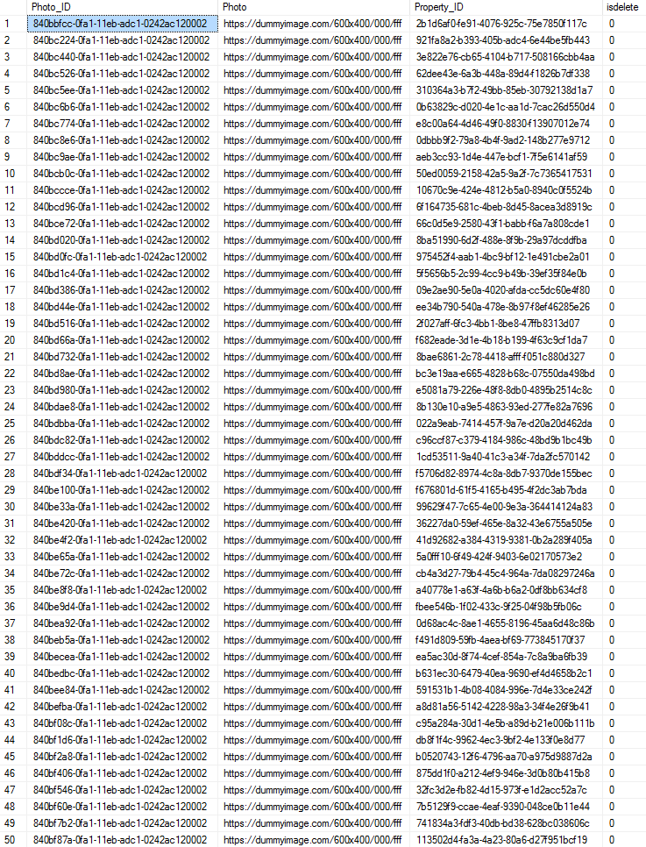

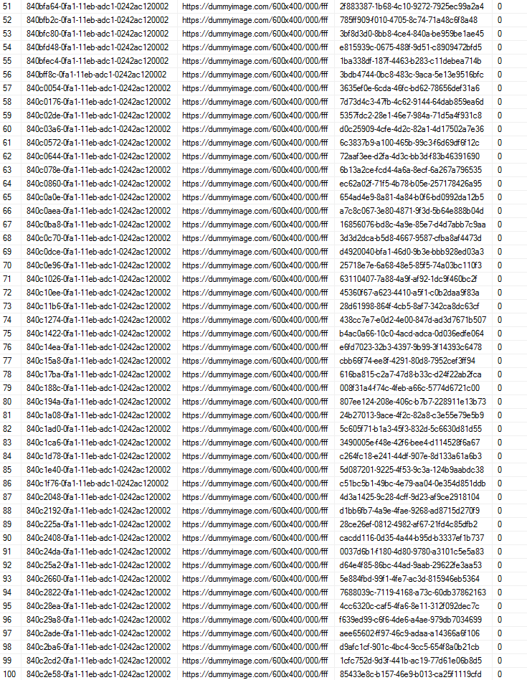

**After:**

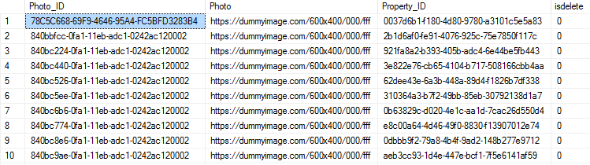

INSERT into Property_Video(Video_ID, Property_ID, Video)

VALUES(NEWID(), '113502d4-fa3a-4a23-80a6-d27f951bcf19', '<https://dummyimage.com/600x400/000/fff>');

**Before:**

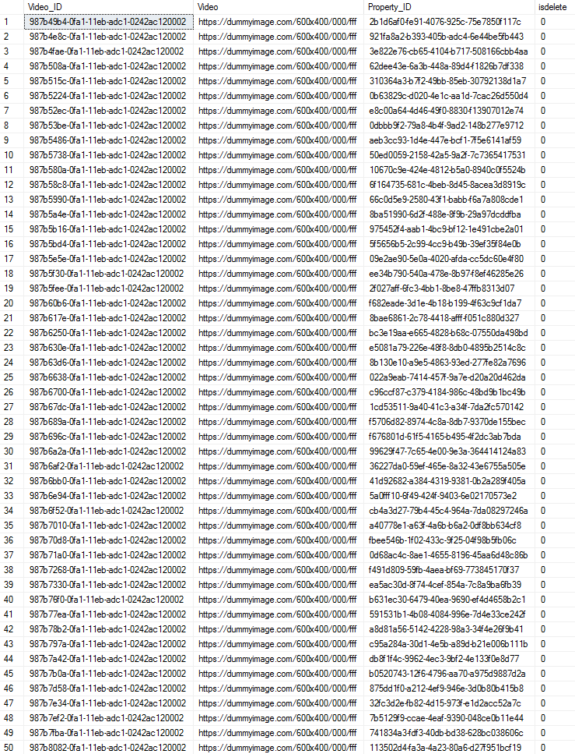

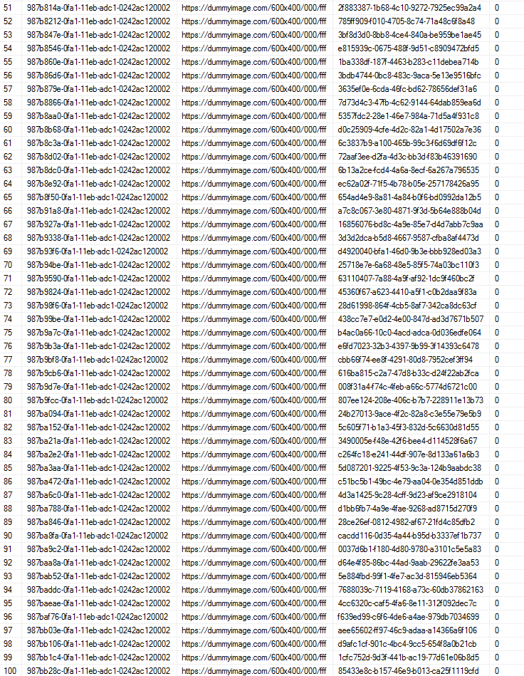

**After:**

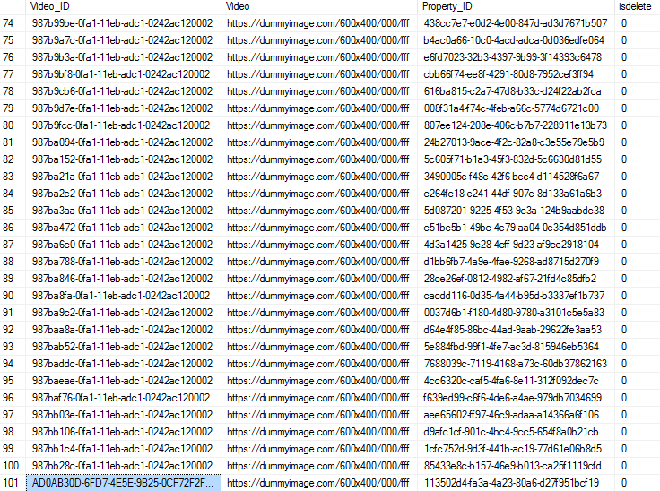

/*Update Script*/

UPDATE [Property_Photo]

SET Property_ID='2b1d6af0-fe91-4076-925c-75e7850f117c'

WHERE Photo_ID='840bcb0c-0fa1-11eb-adc1-0242ac120002'

**Before:**

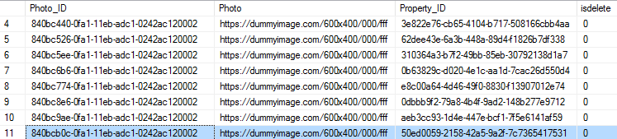

**After:**

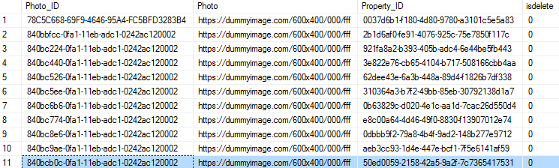

UPDATE [Property_Video]

SET Property_ID='3d3d2dca-b5d8-4667-9587-cfba8af4473d'

WHERE Video_ID='987b6700-0fa1-11eb-adc1-0242ac120002'

**Before:**

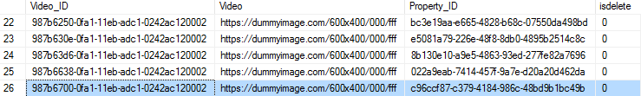

**After:**

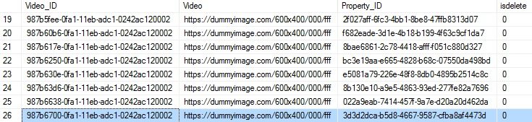

/*Soft Delete Script*/

UPDATE [Property_Photo]

SET isdelete=’1’

WHERE Photo_ID='840bd980-0fa1-11eb-adc1-0242ac120002'

**Before:**



**After:**

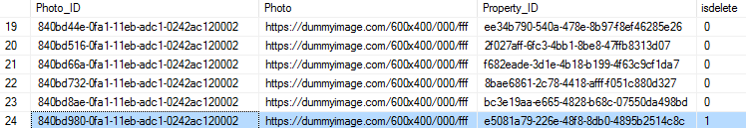

UPDATE [Property_Video]

SET isdelete=1

WHERE Video_ID='987b70d8-0fa1-11eb-adc1-0242ac120002'

**Before:**

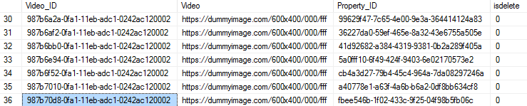

**After:**



**SQL Queries Report:**

**Section: Travis Ho**

**Report Name 1:** Active Contracts

**Report Description:** Returns a table of contracts that are active. Shows client first and last name, agent first and last name, and property address.

**Business Purpose:** This report would be used by Yun Global to analyze the list of contracts that are still active. This can be used for various purposes, like seeing what contracts are being worked on by which agents, and for what clients.

**SQL Code:**

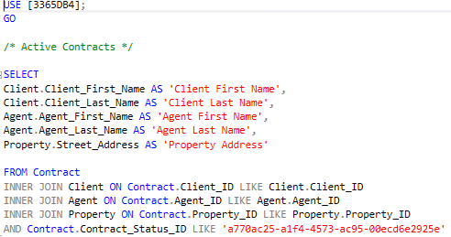

**Report/Query Result:**

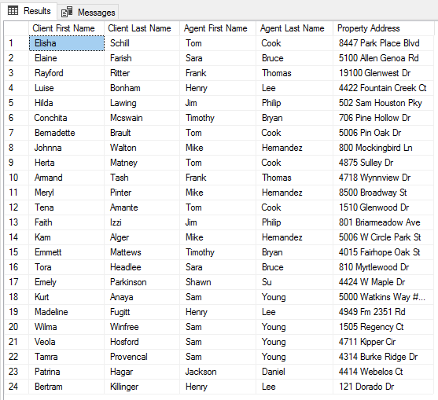

**Data List:**

**1. Client**

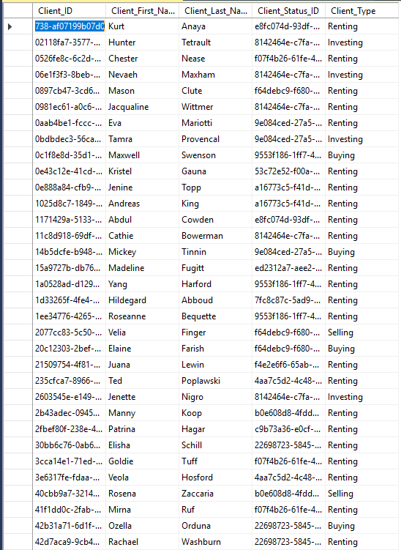

**2. Agent**

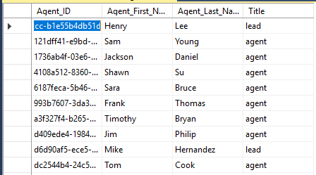

**3. Property**

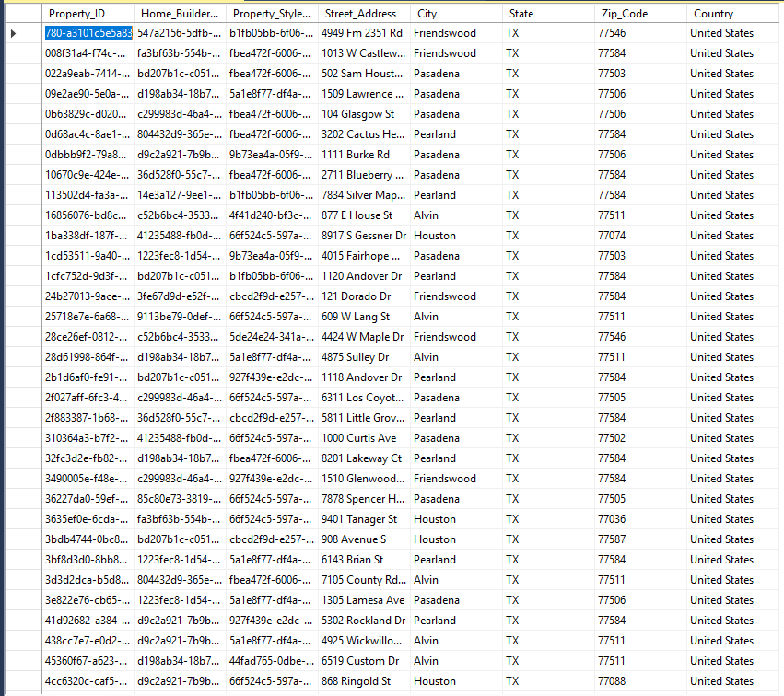

**4. Contract**

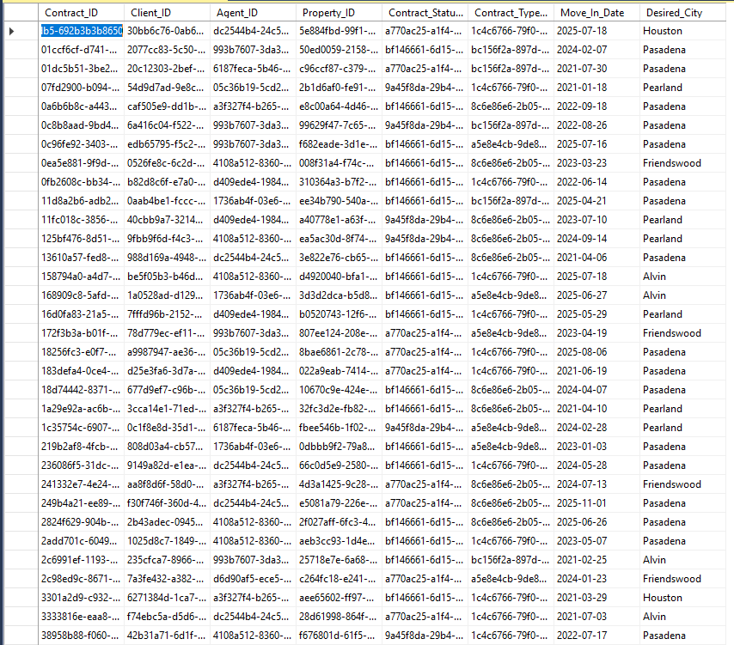aa

**Report Name 2:** Nearby Attractions of a Property

**Report Description:** Returns a table of attractions of a specific property. Shows property address, property flyer, nearby business, and nearby recreation.

**Business Purpose:** This report would be used by Yun Global to display the nearby attractions of a property in order to show potential buyers the appeals nearby a property.

**SQL Code:**

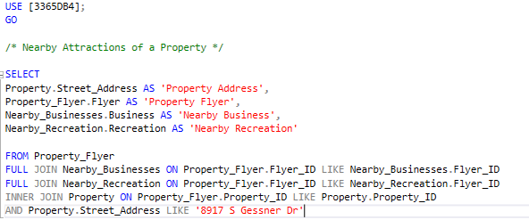

**Report/Query Result:**

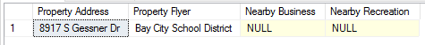

**Data List:**

**1. Property**

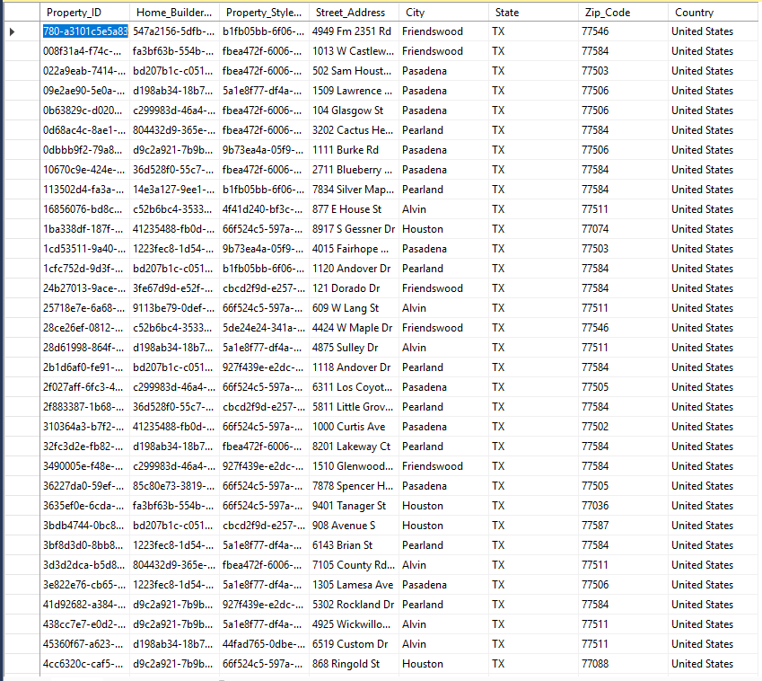

**2. Property Flyer**

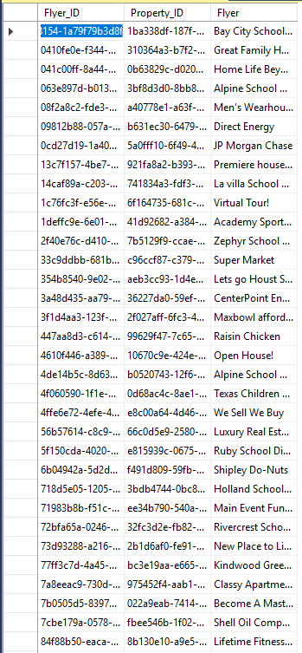

**3. Nearby Business**

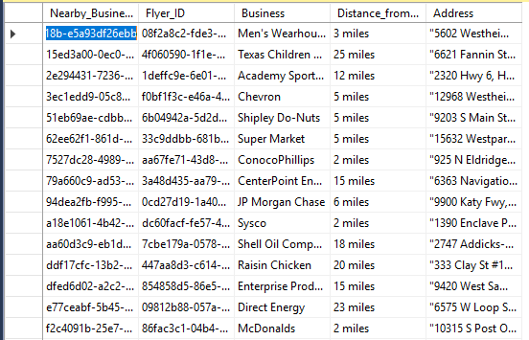

**4. Nearby Recreation**

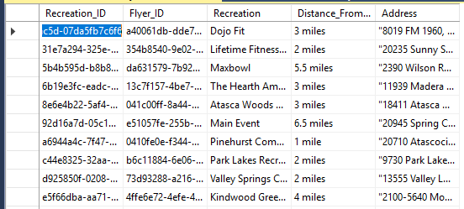

**Report Name 3:** Clients with Arranged Finances that are Willing to Buy Property

**Report Description:** Returns a table of clients. Also shows client type, financing arranged, preferred location, client phone number, and client email.

**Business Purpose:** This report would be used by Yun Global to get a table of clients that are willing to buy property and have their finances arranged. This will also give them easy routes for agents to contact the clients through phone number and email.

**SQL Code:**

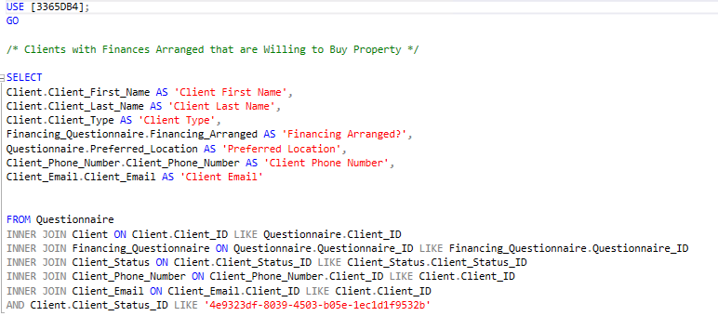

**Report/Query Result:**



**Data List:**

**1. Client**

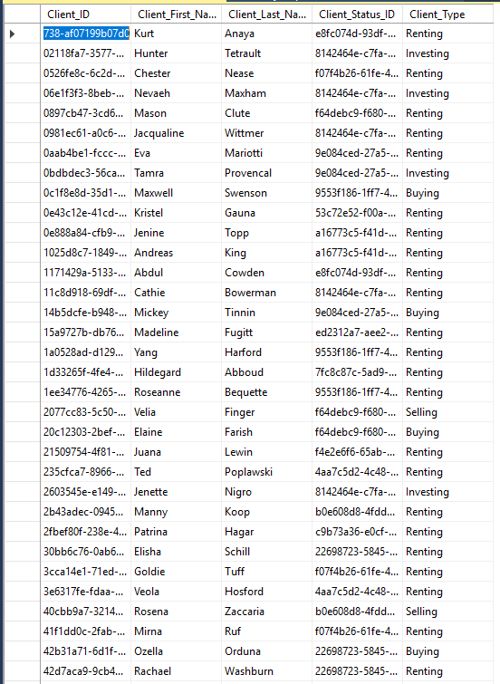

**2. Financing Questionnaire**

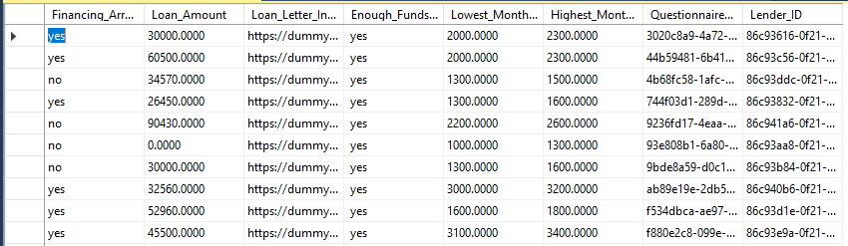

**3. Questionnaire**

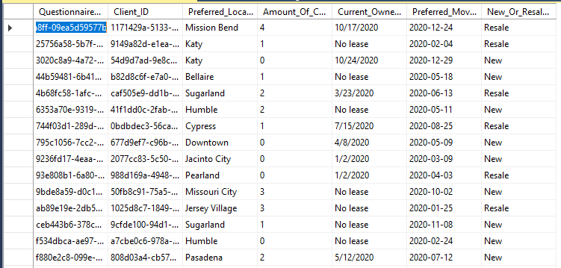

**4. Client Phone Number**

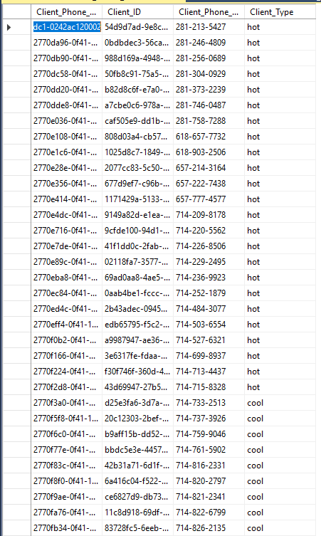

**5. Client Email**

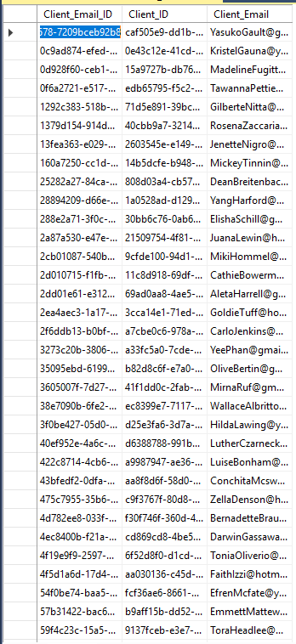

**Report Name 4:** Property Media

**Report Description:** Returns a table of property media of a specific property.

**Business Purpose:** This report would be used by Yun Global to get a table of clients that are willing to buy property and have their finances arranged. This will also give them easy routes for agents to contact the clients through phone number and email.

**SQL Code:**

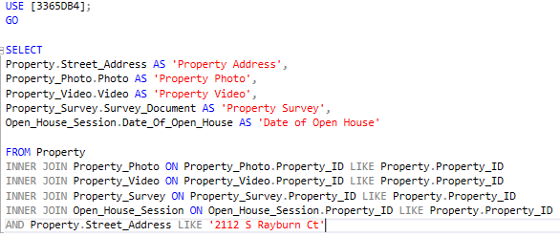

**Report/Query Result:**



**Data List:**

**1. Property**

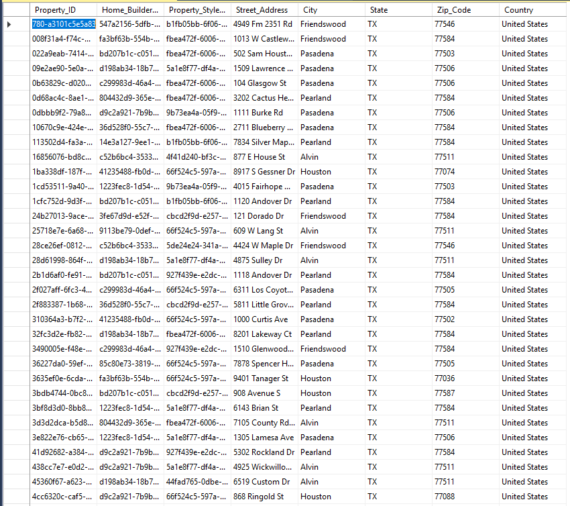

**2. Property Photo**

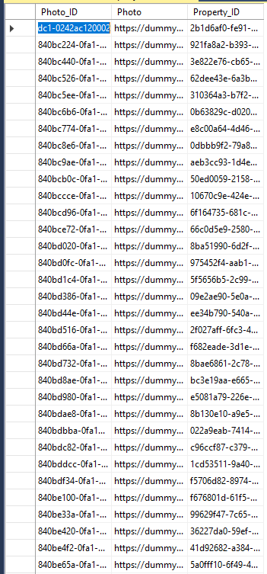

**3. Property Video**

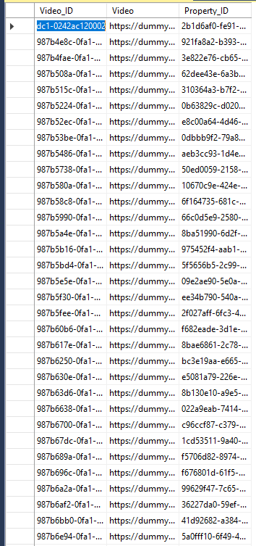

**4. Property Survey**

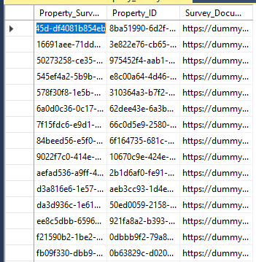

**5. Open House Session**

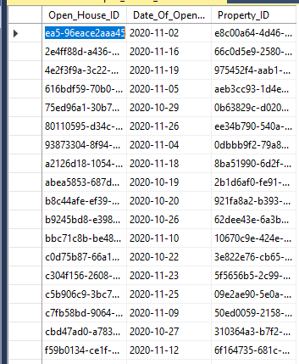

**GUI Forms:**

**1. Property**

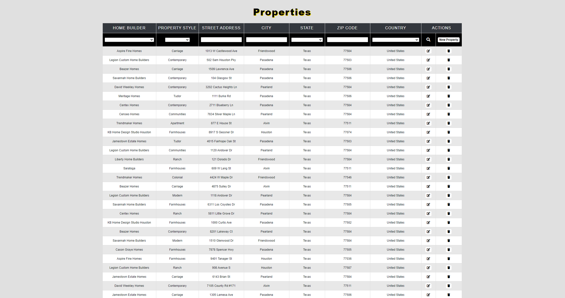

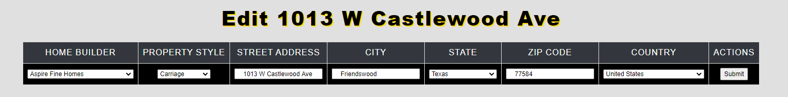

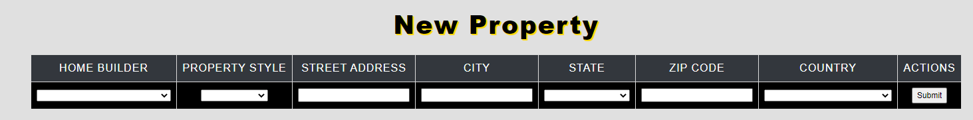

**2. Property Finance**

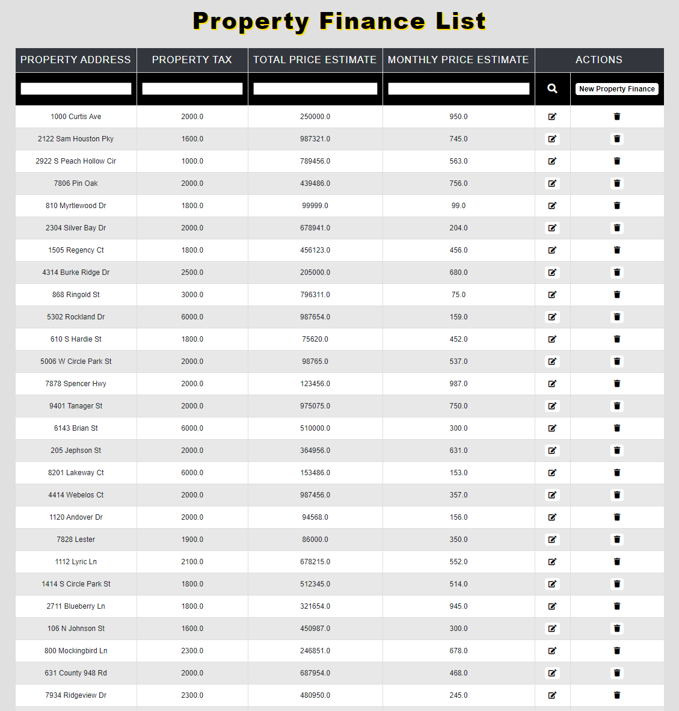



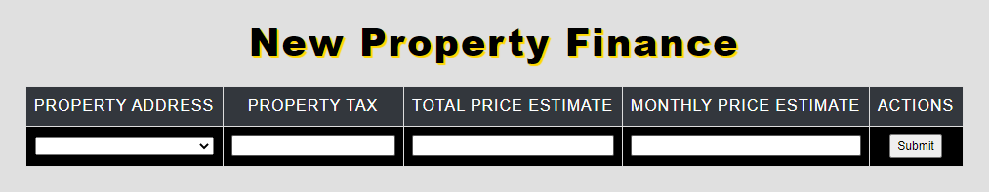

**3. Agent**

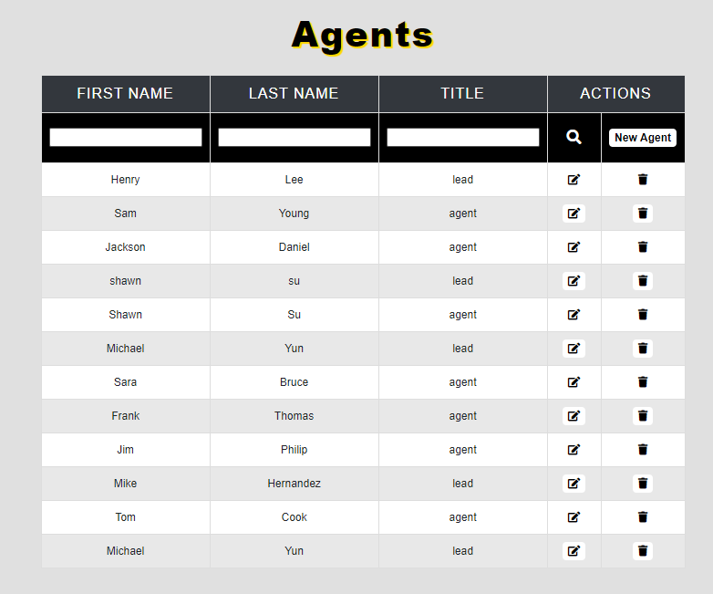

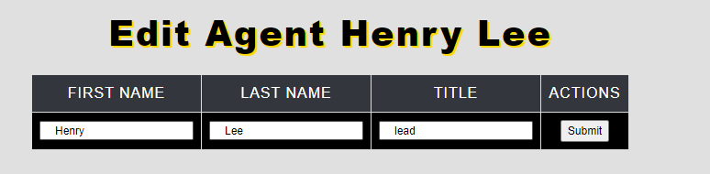

### **Kevin Tao Report**

**Create Scripts:**

CREATE TABLE [Heating_Unit] (

[Heating_Unit_ID] varchar(9) NOT NULL,

[Floor_Plan_ID] varchar(9),

[Heating_Unit_Type] varchar(9),

[Heating_Unit_Age] varchar(9),

CONSTRAINT [PK_Heating_Unit] PRIMARY KEY ([Heating_Unit_ID])

);

CREATE TABLE [Air_Conditioning_Unit] (

[ACU_ID] varchar(9) NOT NULL,

[Floor_Plan_ID] varchar(9),

[ACU_Type] varchar(9),

[ACU_Age] varchar(9),

CONSTRAINT [PK_Air_Conditioning_Unit] PRIMARY KEY ([ACU_ID])

);

CREATE TABLE [Property_Remodel] (

[Remodel_ID] varchar(9) NOT NULL,

[Property_ID] varchar(9),

[Date_of_Remodel] date,

CONSTRAINT [PK_Property_Remodel] PRIMARY KEY ([Remodel_ID])

);

CREATE TABLE [Paycheck] (

[Paycheck_ID] varchar(9) NOT NULL,

[Agent_ID] varchar(9),

[Paycheck_Amount] smallmoney,

[Date_of_Payment] date,

[Month_of_Services] varchar(9),

CONSTRAINT [PK_Paycheck] PRIMARY KEY ([Paycheck_ID])

);

CREATE TABLE [Pet] (

[Pet_ID] varchar(9) NOT NULL,

[Questionnaire_ID] varchar(9),

[Pet_Name] varchar(35),

[Pet_Species] varchar(35),

CONSTRAINT [PK_Pet] PRIMARY KEY ([Pet_ID])

);

CREATE TABLE [Special_Feature] (

[Special_Feature_ID] varchar(9) NOT NULL,

[Questionnaire_ID] varchar(9),

[Circumstance] bit,

[Description] varchar(200),

CONSTRAINT [PK_Special_Feature] PRIMARY KEY ([Special_Feature_ID])

);

**Data Created:**

**Client:**

|  |  |  |  |  |
| --- | --- | --- | --- | --- |
| Client_ID | Client_First_Name | Client_Last_Name | Client_Status_ID | Client_Type |
| 54d9d7ad-9e8c-46bf-a06e-e8b8f0af39c1 | Jamison | Cerutti | 7fc8c87c-5ad9-496c-991d-682c053ac686 | Renting |
| 0bdbdec3-56ca-4f8a-b12c-08e50d1d2568 | Tamra | Provencal | 9e084ced-27a5-49aa-9054-dc20239ba009 | Investing |
| 988d169a-4948-4acb-80b9-958d98c7734f | Clement | Quebedeaux | b0e608d8-4fdd-4b44-ae03-b8209ac117d7 | Renting |
| 50fb8c91-75a5-4737-9011-20c2d4a220b0 | Myrle | Hartman | 9553f186-1ff7-4a5b-9aae-73165eca4e78 | Renting |
| b82d8c6f-e7a0-4047-871d-fada593eea7d | Olive | Bertin | 4e9323df-8039-4503-b05e-1ec1d1f9532b | Buying |
| a7cbe0c6-978a-4ec9-88de-b72b1d4a67ec | Carlo | Jenkins | 4aa7c5d2-4c48-47c5-9d82-a925845d8438 | Renting |
| caf505e9-dd1b-4c2e-8223-22ed37374a8a | Yasuko | Gault | 53c72e52-f00a-49d2-a311-2f767da6b495 | Renting |
| 808d03a4-cb57-4758-aa19-3eb554730364 | Dean | Breitenbach | c9b73a36-e0cf-4b42-ab68-c19bcb0080e0 | Renting |
| 1025d8c7-1849-4e00-950e-7995ad0ba63c | Andreas | King | a16773c5-f41d-426f-89fb-1f0c879419a3 | Renting |
| 2077cc83-5c50-4fde-831b-8a989f2a7f1c | Velia | Finger | f64debc9-f680-4e73-a6e4-474235cb3b51 | Selling |
| 677d9ef7-c96b-43cb-a631-c82ccc7a1409 | Asa | Bronk | ed2312a7-aee2-4d84-b1c7-9409de9406c0 | Renting |
| 1171429a-5133-4833-8685-8f0c2b5511d6 | Abdul | Cowden | e8fc074d-93df-4ef4-87c7-5e323eecf228 | Renting |
| 9149a82d-e1ea-417f-a968-e276dd23c82b | Carina | Caldwell | 22698723-5845-4d0f-860d-070200c56fa3 | Renting |
| 9cfde100-94d1-4c0e-aa14-f19cfccc6352 | Miki | Hommel | f4e2e6f6-65ab-4151-b069-ac797ce4d358 | Renting |
| 41f1dd0c-2fab-4638-8db4-21c61e12e7a5 | Mirna | Ruf | f07f4b26-61fe-456c-8e28-65c8e294c7a3 | Renting |
| 02118fa7-3577-4d75-93dd-39667c8063e1 | Hunter | Tetrault | 8142464e-c7fa-44c5-bd17-7c0f437e998b | Investing |
| 69ad0aa8-4ae5-4cd9-b6f8-a757fa35940b | Aleta | Harrell | 7fc8c87c-5ad9-496c-991d-682c053ac686 | Renting |
| 0aab4be1-fccc-4a5a-9ece-24d265bfd1d1 | Eva | Mariotti | 9e084ced-27a5-49aa-9054-dc20239ba009 | Renting |
| 2b43adec-0945-4cab-a6f8-66bb870a28e3 | Manny | Koop | b0e608d8-4fdd-4b44-ae03-b8209ac117d7 | Renting |
| edb65795-f5c2-4ff2-b5ed-f839e8cd3b1b | Tawanna | Pettie | 9553f186-1ff7-4a5b-9aae-73165eca4e78 | Renting |
| a9987947-ae36-47e5-8d1f-057c674610b1 | Luise | Bonham | 4e9323df-8039-4503-b05e-1ec1d1f9532b | Buying |
| 3e6317fe-fdaa-4484-9a63-961a0915517d | Veola | Hosford | 4aa7c5d2-4c48-47c5-9d82-a925845d8438 | Renting |
| f30f746f-360d-4fc6-aedc-f9b6984df608 | Bernadette | Brault | 53c72e52-f00a-49d2-a311-2f767da6b495 | Renting |
| 43d69947-27b5-4b7e-8fe4-80f3efb11dee | Kam | Alger | c9b73a36-e0cf-4b42-ab68-c19bcb0080e0 | Renting |
| d25e3fa6-3d7a-41d5-a952-39f643d3462c | Hilda | Lawing | a16773c5-f41d-426f-89fb-1f0c879419a3 | Renting |
| 20c12303-2bef-473a-9403-3533ad19952c | Elaine | Farish | f64debc9-f680-4e73-a6e4-474235cb3b51 | Buying |
| b9aff15b-dd52-4f0e-bd3b-19b7a8dcef41 | Emmett | Mattews | ed2312a7-aee2-4d84-b1c7-9409de9406c0 | Renting |
| bbdc5e3e-4457-4e9e-bd3f-a9000eb6e22f | Deana | Wrinkle | e8fc074d-93df-4ef4-87c7-5e323eecf228 | Selling |
| 42b31a71-6d1f-4d86-a23d-849bb9aaaf09 | Ozella | Orduna | 22698723-5845-4d0f-860d-070200c56fa3 | Buying |
| 6a416c04-f522-4c2e-afe1-319ac5eaef7b | Natividad | Hardnett | f4e2e6f6-65ab-4151-b069-ac797ce4d358 | Renting |
| ce6827d9-db73-4189-88a8-33558dca6184 | Lorita | Buchan | f07f4b26-61fe-456c-8e28-65c8e294c7a3 | Renting |
| 11c8d918-69df-49aa-ba04-8eb5d0dcb9b7 | Cathie | Bowerman | 8142464e-c7fa-44c5-bd17-7c0f437e998b | Renting |
| 83728fc5-6eeb-4852-b621-81bcd19488b4 | Margorie | Sanon | 7fc8c87c-5ad9-496c-991d-682c053ac686 | Renting |
| cd869cd8-4be5-4bb1-ae5b-1d64a174f334 | Darwin | Gassaway | 9e084ced-27a5-49aa-9054-dc20239ba009 | Renting |
| 40cbb9a7-3214-4448-91f1-80208edd0856 | Rosena | Zaccaria | b0e608d8-4fdd-4b44-ae03-b8209ac117d7 | Selling |
| 0c1f8e8d-35d1-435a-b876-deb393fa79e1 | Maxwell | Swenson | 9553f186-1ff7-4a5b-9aae-73165eca4e78 | Buying |
| dfbb7ca3-7f36-4290-a3bd-c2c2e24739e7 | Sherell | Messing | 4e9323df-8039-4503-b05e-1ec1d1f9532b | Renting |
| a1f839bc-4ca8-462a-b64e-795b8c902960 | Omar | Sitton | 4aa7c5d2-4c48-47c5-9d82-a925845d8438 | Renting |
| 9fbb9f6d-f4c3-4a22-a555-813eff044cf8 | Neely | Cohen | 53c72e52-f00a-49d2-a311-2f767da6b495 | Renting |
| f5440876-d0e7-4f43-bb6a-db55d8ec7fc2 | Booker | Jumper | c9b73a36-e0cf-4b42-ab68-c19bcb0080e0 | Renting |
| 0e888a84-cfb9-4518-9d79-f37e63d16afc | Jenine | Topp | a16773c5-f41d-426f-89fb-1f0c879419a3 | Renting |
| d92df75b-dec6-4039-83bb-0771dd31a562 | Christine | Riffel | f64debc9-f680-4e73-a6e4-474235cb3b51 | Buying |
| d6388788-991b-4133-b766-7c0129e3b761 | Luther | Czarnecki | ed2312a7-aee2-4d84-b1c7-9409de9406c0 | Renting |
| 4a426f64-69d3-4de7-83e6-923f02e3ebb7 | Erik | Baer | e8fc074d-93df-4ef4-87c7-5e323eecf228 | Renting |
| 7fffd96b-2152-45b0-b9f4-ae217bebc05f | Alethea | Shattles | 22698723-5845-4d0f-860d-070200c56fa3 | Selling |
| 21509754-4f81-4542-9fe2-802a1bf3d9dd | Juana | Lewin | f4e2e6f6-65ab-4151-b069-ac797ce4d358 | Renting |
| 3cca14e1-71ed-47f5-8a61-f51c7ebf90fe | Goldie | Tuff | f07f4b26-61fe-456c-8e28-65c8e294c7a3 | Renting |
| 2603545e-e149-4340-aa7d-9ac61a2a2682 | Jenette | Nigro | 8142464e-c7fa-44c5-bd17-7c0f437e998b | Investing |
| 1d33265f-4fe4-48ea-b396-646414f851a2 | Hildegard | Abboud | 7fc8c87c-5ad9-496c-991d-682c053ac686 | Renting |
| 14b5dcfe-b948-4398-9fb5-05e8877e8ff0 | Mickey | Tinnin | 9e084ced-27a5-49aa-9054-dc20239ba009 | Buying |
| da8b7ae4-2ef5-4f0a-a969-f767e34dc8d1 | Taylor | Gilstrap | b0e608d8-4fdd-4b44-ae03-b8209ac117d7 | Renting |
| 605715e8-f558-4f88-a224-557abf28f9a1 | Roseanna | Miyamoto | 9553f186-1ff7-4a5b-9aae-73165eca4e78 | Renting |
| c04dc3de-9503-4297-b098-48a97b3a5e09 | Elias | Schmuck | 4e9323df-8039-4503-b05e-1ec1d1f9532b | Renting |
| 8e67399e-3615-4a97-a9c2-856c55277b98 | Elina | Lin | 4aa7c5d2-4c48-47c5-9d82-a925845d8438 | Selling |
| 0e43c12e-41cd-455c-964c-63edd30380a4 | Kristel | Gauna | 53c72e52-f00a-49d2-a311-2f767da6b495 | Renting |
| fcf36ae6-8661-43d9-a997-7077fc0fca3d | Efren | Mcfate | c9b73a36-e0cf-4b42-ab68-c19bcb0080e0 | Renting |
| 909549c9-ef1e-445b-8db7-146b73391e31 | Lucila | Hales | a16773c5-f41d-426f-89fb-1f0c879419a3 | Renting |
| f8eff727-4a7e-47aa-9fde-20901ea1604f | Christie | Ramage | f64debc9-f680-4e73-a6e4-474235cb3b51 | Renting |
| b83bdc33-8fdf-4954-a235-bac5fee7a6b5 | Jina | Crabb | ed2312a7-aee2-4d84-b1c7-9409de9406c0 | Renting |
| a33fc5a0-7cde-4274-96d9-01fac3e12175 | Yee | Phan | e8fc074d-93df-4ef4-87c7-5e323eecf228 | Renting |
| e8239fb8-0e82-4fce-b085-51408f97557c | Michale | Bushong | 22698723-5845-4d0f-860d-070200c56fa3 | Buying |
| f193a301-7af4-447b-928e-3756c410f667 | Suzy | Derosier | f4e2e6f6-65ab-4151-b069-ac797ce4d358 | Renting |
| f616a248-fa76-4261-879e-eade7d6eeee7 | Marketta | Kaya | f07f4b26-61fe-456c-8e28-65c8e294c7a3 | Renting |
| 0981ec61-a0c6-4b81-84d7-3eca32821a87 | Jacqualine | Wittmer | 8142464e-c7fa-44c5-bd17-7c0f437e998b | Renting |
| 819e6aea-785c-4b7d-b809-d6457a2f7266 | Caitlyn | Holdeman | 7fc8c87c-5ad9-496c-991d-682c053ac686 | Renting |
| a0877ca6-cf58-4d60-bc00-52f765d54611 | Derick | Brockman | 9e084ced-27a5-49aa-9054-dc20239ba009 | Renting |
| ad2a718b-e008-4677-8172-b9457642fc35 | Reba | Prada | b0e608d8-4fdd-4b44-ae03-b8209ac117d7 | Renting |
| 1a0528ad-d129-4165-ac7e-626a34d6b2ad | Yang | Harford | 9553f186-1ff7-4a5b-9aae-73165eca4e78 | Renting |
| be5f05b3-b46d-4aca-9e85-66d6d348cbcf | Louis | Kester | 4e9323df-8039-4503-b05e-1ec1d1f9532b | Renting |
| 235cfca7-8966-4cbd-ac81-28f60ff9664f | Ted | Poplawski | 4aa7c5d2-4c48-47c5-9d82-a925845d8438 | Renting |
| 6f52d8f0-d1cd-440d-b7d5-5a7805716fe7 | Tonia | Oliverio | 53c72e52-f00a-49d2-a311-2f767da6b495 | Renting |
| 8a67629e-923e-4e0a-9792-dd2454d41ed8 | Aleen | Calles | c9b73a36-e0cf-4b42-ab68-c19bcb0080e0 | Investing |
| f74ebc5a-d5d6-4daa-976f-5779aec36511 | Herta | Matney | a16773c5-f41d-426f-89fb-1f0c879419a3 | Buying |
| 0897cb47-3cd6-46b8-a088-5509136dc968 | Mason | Clute | f64debc9-f680-4e73-a6e4-474235cb3b51 | Renting |
| c9f3767f-80d8-43f1-8cb4-1a9068c1d772 | Zella | Denson | ed2312a7-aee2-4d84-b1c7-9409de9406c0 | Renting |
| 876aa173-05ac-42b5-abc3-617d21e1cd5b | Deja | Snelling | e8fc074d-93df-4ef4-87c7-5e323eecf228 | Renting |
| 42d7aca9-9cb4-41fa-bd71-a47d88b837ad | Rachael | Washburn | 22698723-5845-4d0f-860d-070200c56fa3 | Renting |
| 48610f9e-72c4-4d9f-b0b5-a0585b7c39a5 | Donte | Coss | f4e2e6f6-65ab-4151-b069-ac797ce4d358 | Buying |
| 0526fe8c-6c2d-46a1-b76d-680f7266f704 | Chester | Nease | f07f4b26-61fe-456c-8e28-65c8e294c7a3 | Renting |
| 78d779ec-ef11-4cdf-a287-f136c6f442d5 | Rayford | Ritter | 8142464e-c7fa-44c5-bd17-7c0f437e998b | Renting |
| 60608797-5f2d-48bd-ab07-25b443c20c50 | Bertram | Killinger | 7fc8c87c-5ad9-496c-991d-682c053ac686 | Renting |
| 78ac60c7-0f7b-40fd-adde-ba57b0dd49c5 | Wilma | Winfree | 9e084ced-27a5-49aa-9054-dc20239ba009 | Renting |
| 84a8de29-33b0-40a1-9801-44bd8530d641 | Tena | Amante | b0e608d8-4fdd-4b44-ae03-b8209ac117d7 | Buying |
| 7a3fe432-a382-4723-bdd0-9859d6f7cbdb | Johnna | Walton | 9553f186-1ff7-4a5b-9aae-73165eca4e78 | Renting |
| aa030136-c45d-406b-927a-597abb5f80ad | Faith | Izzi | 4e9323df-8039-4503-b05e-1ec1d1f9532b | Renting |
| 9137fceb-e3e7-4c5d-a114-b35b6fc7f897 | Tora | Headlee | 4aa7c5d2-4c48-47c5-9d82-a925845d8438 | Buying |
| aa8f8d6f-58d0-4a8d-8ef4-e72f769d9263 | Conchita | Mcswain | 53c72e52-f00a-49d2-a311-2f767da6b495 | Renting |
| 2fbef80f-238e-41e6-b1b4-e886906751ba | Patrina | Hagar | c9b73a36-e0cf-4b42-ab68-c19bcb0080e0 | Renting |
| 75081343-5475-4e46-bafa-3800c54df9ec | Emely | Parkinson | a16773c5-f41d-426f-89fb-1f0c879419a3 | Selling |
| 8f8fa936-a67c-4d51-9eb5-94e1698004cb | Armand | Tash | f64debc9-f680-4e73-a6e4-474235cb3b51 | Renting |
| 15a9727b-db76-4999-8282-87f23cf73b4f | Madeline | Fugitt | ed2312a7-aee2-4d84-b1c7-9409de9406c0 | Renting |
| 01900905-34f6-4ff6-a738-af07199b07d0 | Kurt | Anaya | e8fc074d-93df-4ef4-87c7-5e323eecf228 | Renting |
| 30bb6c76-0ab6-49a9-ba3d-ef2b63805d3c | Elisha | Schill | 22698723-5845-4d0f-860d-070200c56fa3 | Renting |
| b2e2e617-840b-4fc3-9e64-a4fe8badbd8d | Meryl | Pinter | f4e2e6f6-65ab-4151-b069-ac797ce4d358 | Renting |
| e4eacdb6-86e1-4af1-9fb1-5453e4147186 | Leeanne | Degen | f07f4b26-61fe-456c-8e28-65c8e294c7a3 | Buying |
| 06e1f3f3-8beb-422d-94ae-824bfc8bfe09 | Nevaeh | Maxham | 8142464e-c7fa-44c5-bd17-7c0f437e998b | Investing |
| 6271384d-1ca7-420f-86fe-5650f7bf5834 | Marcelo | Dieckman | 7fc8c87c-5ad9-496c-991d-682c053ac686 | Renting |
| 71d5e891-39bc-4ede-aa45-f740c8693102 | Gilberte | Nitta | 9e084ced-27a5-49aa-9054-dc20239ba009 | Renting |
| ec8399e7-7117-41d4-9b79-9528bde80569 | Wallace | Albritton | b0e608d8-4fdd-4b44-ae03-b8209ac117d7 | Selling |
| 1ee34776-4265-4438-8d06-cac7c0ce3998 | Roseanne | Bequette | 9553f186-1ff7-4a5b-9aae-73165eca4e78 | Renting |

**Open House Session:**

|  |  |  |
| --- | --- | --- |
| Open_House_ID | Date_Of_Open_House | Property_ID |
| abea5853-687d-4540-9859-888ccdfa24cf | 10/19/2020 | 2b1d6af0-fe91-4076-925c-75e7850f117c |
| b8c44afe-ef39-4eee-84bc-b1dad8538d67 | 10/20/2020 | 921fa8a2-b393-405b-adc4-6e44be5fb443 |
| c0d75b87-66a1-4fe0-9d28-55dc73798033 | 10/22/2020 | 3e822e76-cb65-4104-b717-508166cbb4aa |
| b9245bd8-e398-49ac-a6ba-f656d32037b2 | 10/26/2020 | 62dee43e-6a3b-448a-89d4-f1826b7df338 |
| cbd47ad0-a783-4d08-90be-85d0ccb97b9e | 10/27/2020 | 310364a3-b7f2-49bb-85eb-30792138d1a7 |
| 75ed96a1-30b7-44dc-9163-fffa45cb45ef | 10/29/2020 | 0b63829c-d020-4e1c-aa1d-7cac26d550d4 |
| 03fb3faf-e1cc-4612-9ea5-96eace2aaa45 | 11/2/2020 | e8c00a64-4d46-49f0-8830-f13907012e74 |
| 93873304-8f94-49dd-943b-d61995adaec2 | 11/4/2020 | 0dbbb9f2-79a8-4b4f-9ad2-148b277e9712 |
| 616bdf59-70b0-40fd-b189-8a9f3b59c4e7 | 11/5/2020 | aeb3cc93-1d4e-447e-bcf1-7f5e6141af59 |
| c7fb58bd-9064-4f22-9553-4a31091e562f | 11/9/2020 | 50ed0059-2158-42a5-9a2f-7c7365417531 |
| bbc71c8b-be48-4f6f-93fa-1e727b117b93 | 11/10/2020 | 10670c9e-424e-4812-b5a0-8940c0f5524b |
| f59b0134-ce1f-48af-9433-77494ab926ad | 11/12/2020 | 6f164735-681c-4beb-8d45-8acea3d8919c |
| 2e4ff88d-a436-48cd-b761-b853dfd05e27 | 11/16/2020 | 66c0d5e9-2580-43f1-babb-f6a7a808cde1 |
| a2126d18-1054-41a5-a6c4-448ea3becfd3 | 11/18/2020 | 8ba51990-6d2f-488e-8f9b-29a97dcddfba |
| 4e2f3f9a-3c22-4d72-a401-cca408964171 | 11/19/2020 | 975452f4-aab1-4bc9-bf12-1e491cbe2a01 |
| c304f156-2608-4998-b6a6-3eab42df6e97 | 11/23/2020 | 5f5656b5-2c99-4cc9-b49b-39ef35f84e0b |
| c5b906c9-3bc7-4fc4-8212-b24f9bdb0636 | 11/25/2020 | 09e2ae90-5e0a-4020-afda-cc5dc60e4f80 |
| 80110595-d34c-43d6-88e4-16e0a35b93ab | 11/26/2020 | ee34b790-540a-478e-8b97-f8ef46285e26 |

**School District Preference:**

|  |  |  |
| --- | --- | --- |
| School_District_ID | Questionnaire_ID | School_District |
| d8a32c6e-e729-427d-8ae9-0561b6581e16 | 3020c8a9-4a72-4d9f-a658-7a0c16782d6a | Feris School District |
| 6656ddef-d7f7-428b-9fb4-7be088f6378e | 744f03d1-289d-42d9-be47-1c2f5839e256 | Allen School District |
| e1a2efc6-d090-4501-98d5-638a556fb8af | 93e808b1-6a80-446a-8d74-853147b4c3be | Lovejoy School District |
| e5dbf2e8-d903-41b0-9b6f-1db205fd1897 | 9bde8a59-d0c1-40ba-8477-5695f89e934e | Kennedy School District |
| d1961eaa-28cb-4c8c-8d1f-12d31e1fdbbf | 44b59481-6b41-444f-a78a-08241c459884 | Alpine School District |
| 143d0b83-31cd-4633-9ff3-c4d5e20f053f | f534dbca-ae97-4ff9-b906-7ac0fe35089a | Rocksprings School District |
| 726112a1-437f-4d2f-8c5b-d5f71d4c129f | 4b68fc58-1afc-4371-9957-6389574d8211 | Rivercrest School District |
| 61988603-0f95-420c-81af-1a4a6aeeb601 | f880e2c8-099e-4f11-bc1b-7f776f506bc5 | Zephyr School District |
| e9b5e8c9-6b16-487b-9b70-fce3a819bb95 | ab89e19e-2db5-4b2b-be27-fb53f6eb041a | La villa School District |
| c84899be-2266-418f-8847-cdedba4e8e64 | 9236fd17-4eaa-483d-9fd9-598b11d9e294 | Sands School District |
| f2eca087-83c7-4656-bbee-7ef9c9d32bed | 795c1056-7cc2-431a-8ff0-8b107bfc08be | Sidney School District |
| 9a236705-183d-4eb4-8da0-95f88c972b1e | 13108d11-3b5d-4445-a8ff-09ea5d59577b | Princeton School District |
| cd87429e-837b-4779-b7f1-0cd9019e6f0d | 25756a58-5b7f-4517-9ea8-44142b62f20f | Alpine School District |
| 9a463d7b-d31c-439e-8175-f24dceea3843 | ceb443b6-378c-4ffc-acf7-faeffbd5f30f | Lovejoy School District |
| da91f1b6-5122-41a8-b706-e553d78242e2 | 6353a70e-9319-4197-b5b0-626b09bb9416 | Ruby School District |
| cc305359-234a-472e-8aed-b004b68f572f | 744f03d1-289d-42d9-be47-1c2f5839e256 | Bay City School District |
| b6abcb42-4e50-4b2f-9050-9a60666f5883 | 93e808b1-6a80-446a-8d74-853147b4c3be | Feris School District |
| 9102130b-ce9c-4093-a1e8-bbd55c1f5b8b | 9bde8a59-d0c1-40ba-8477-5695f89e934e | Holland School District |

**SQL Queries:**

**SQL Query Code 1:**

SELECT

Client.Client_First_Name,

Client.Client_Last_Name,

Property.Street_Address,

Property.City,

Contract_Status.Contract_Status,

Contract_Type.Contract_Type

FROM Contract

INNER JOIN

Client ON Contract.Client_ID = Client.Client_ID

INNER JOIN

Property ON Contract.Property_ID = Property.Property_ID

INNER JOIN

Contract_Type ON Contract.Contract_Type_ID = Contract_Type.Contract_Type_ID

INNER JOIN

Contract_Status ON Contract.Contract_Status_ID = Contract_Status.Contract_Status_ID

WHERE (Contract.Contract_Status_ID = 'a770ac25-a1f4-4573-ac95-00ecd6e2925e' OR Contract.Contract_Status_ID = '9a45f8da-29b4-45b4-a453-ace41714d37d')

AND (Contract.Contract_Type_ID = '1c4c6766-79f0-4c64-aeaa-185b19fede2b')

**SQL Query Code 2:**

SELECT

Client.Client_First_Name,

Client.Client_Last_Name,

Property.Street_Address,

Property.City,

Contract_Status.Contract_Status,

Contract_Type.Contract_Type

FROM Contract

INNER JOIN

Client ON Contract.Client_ID = Client.Client_ID

INNER JOIN

Property ON Contract.Property_ID = Property.Property_ID

INNER JOIN

Contract_Type ON Contract.Contract_Type_ID = Contract_Type.Contract_Type_ID

INNER JOIN

Contract_Status ON Contract.Contract_Status_ID = Contract_Status.Contract_Status_ID

WHERE (Contract.Contract_Status_ID = 'a770ac25-a1f4-4573-ac95-00ecd6e2925e' OR Contract.Contract_Status_ID = '9a45f8da-29b4-45b4-a453-ace41714d37d')

AND (Contract.Contract_Type_ID = 'bc156f2a-897d-41b6-8fc9-34e126caba07')

**SQL Query Code 3:**

SELECT

Client.Client_First_Name,

Client.Client_Last_Name,

Client_Email.Client_Email,

Client_Phone_Number.Client_Phone_Number,

Appointment.Appointment_Date,

Appointment.Appointment_Time,

Appointment.Appointment_Topic,

Appointment.Appointment_Summary,

Agent.Agent_First_Name,

Agent.Agent_Last_Name

FROM Client

INNER JOIN

Client_Email ON Client.Client_ID = Client_Email.Client_ID

INNER JOIN

Client_Phone_Number ON Client.Client_ID = Client_Phone_Number.Client_ID

INNER JOIN

Appointment ON Client.Client_ID = Appointment.Client_ID

INNER JOIN

Agent ON Appointment.Agent_ID = Agent.Agent_ID

**SQL Query Code 4:**

SELECT

Property.Street_Address,

Property.City,

Property_Style.Style,

Floor_Plan.Floor_Number,

Heating_Unit.Heating_Unit_Type,

Heating_Unit.Heating_Unit_Age

FROM Property

INNER JOIN

Property_Style ON Property.Property_Style_ID = Property_Style.Property_Style_ID

INNER JOIN

Floor_Plan ON Property.Property_ID = Floor_Plan.Property_ID

INNER JOIN

Heating_Unit ON Floor_Plan.Floor_Plan_ID = Heating_Unit.Floor_Plan_ID

**SQL Update Scripts:**

**Insert Script 1**

INSERT INTO Broker_Company

(Broker_Company_ID, Broker_Company)

VALUES (NEWID(), 'Evergreen Realty')

**Report/Query Results:**

**Before:**

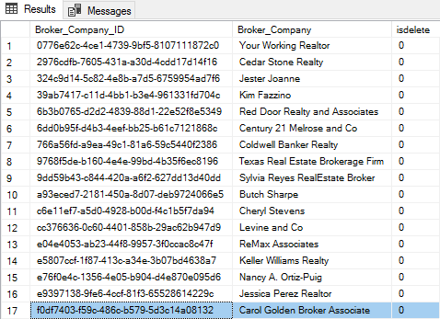

**After:**

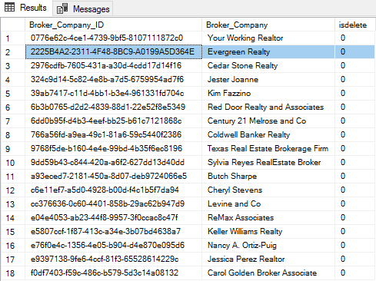

**Insert Script 2**

INSERT INTO Broker_Company

(Broker_Company_ID, Broker_Company)

VALUES (NEWID(), 'Windenbloom Realty')

**Report/Query Results:**

**Before:**



**After:**

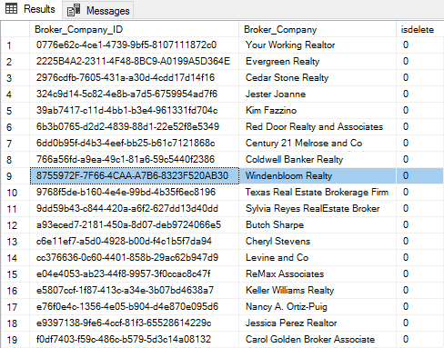

**Update Script 1**

UPDATE [Client_Email]

SET Client_Email.Client_Email = 'KristelGauna@gmail.com'

WHERE Client_Email.Client_Email_ID = '0c9ad874-efed-4126-bbfd-0f52e35f01da'

**Report/Query Results:**

**Before:**

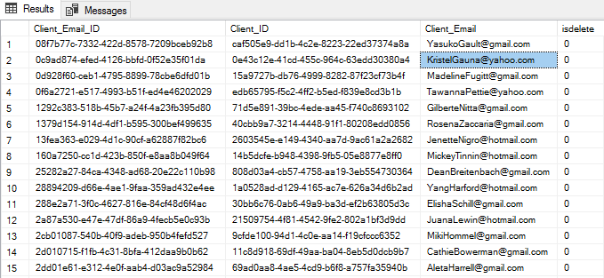

**After:**

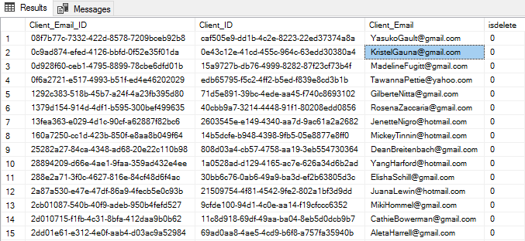

**Update Script 2**

UPDATE [Client_Email]

SET Client_Email.Client_Email = 'HildaLawing@gmail.com'

WHERE Client_Email.Client_Email_ID = '3f0be427-05d0-4c9b-8152-a14a6e4d2f53'

**Report/Query Results:**

**Before:**

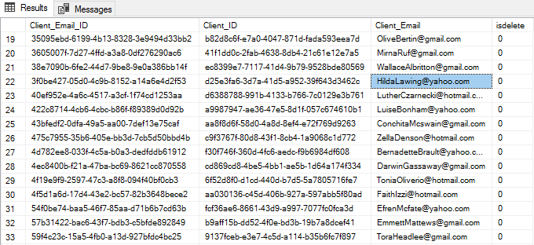

**After:**

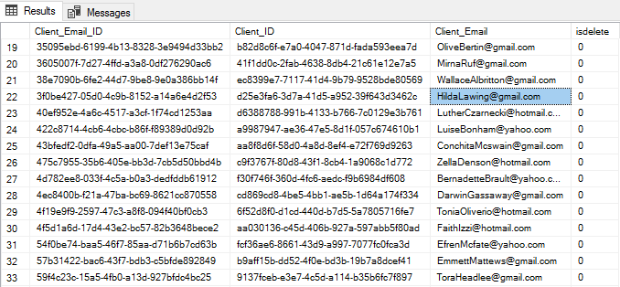

**Delete Script 1**

UPDATE Appliance

SET isdelete = '1'

WHERE Appliance_ID = 'd136dfac-0f24-11eb-adc1-0242ac120002'

**Report/Query Results:**

**Before:**

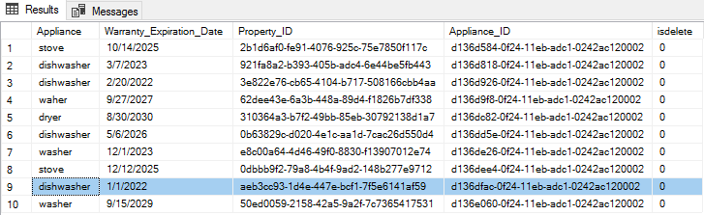

**After:**

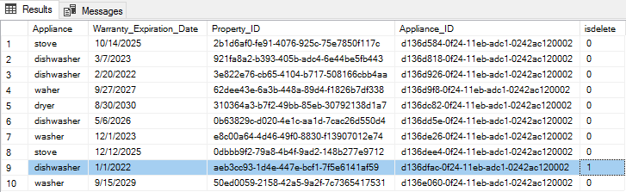

**Delete Script 2**

UPDATE Appliance

SET isdelete = '1'

WHERE Appliance_ID = 'd136d926-0f24-11eb-adc1-0242ac120002'

**Report/Query Results:**

**Before:**

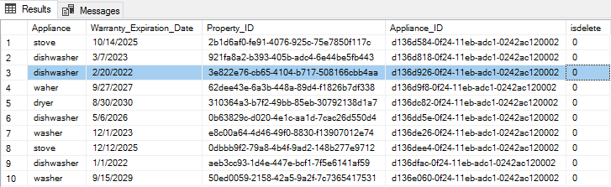

**After:**

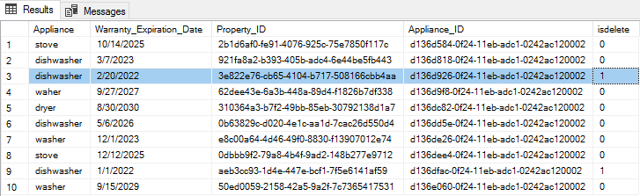

**SQL Queries Report:**

**Report Name:** Clients Buying Property

**Report Description:** These clients are interested in buying properties and only active or pending contracts are shown.

**Business Purpose:** The processes vary greatly depending on what needs the client has. This report will help agents identify the clients which are purchasing properties and aid the agents in preparing any necessary legal documents as well as contacting the right entities involved in the buying process.

**SQL CODE:**

SELECT

Client.Client_First_Name,

Client.Client_Last_Name,

Property.Street_Address,

Property.City,

Contract_Status.Contract_Status,

Contract_Type.Contract_Type

FROM Contract

INNER JOIN

Client ON Contract.Client_ID = Client.Client_ID

INNER JOIN

Property ON Contract.Property_ID = Property.Property_ID

INNER JOIN

Contract_Type ON Contract.Contract_Type_ID = Contract_Type.Contract_Type_ID

INNER JOIN

Contract_Status ON Contract.Contract_Status_ID = Contract_Status.Contract_Status_ID

WHERE (Contract.Contract_Status_ID = 'a770ac25-a1f4-4573-ac95-00ecd6e2925e' OR Contract.Contract_Status_ID = '9a45f8da-29b4-45b4-a453-ace41714d37d')

AND (Contract.Contract_Type_ID = '1c4c6766-79f0-4c64-aeaa-185b19fede2b')

**Report/Query Results:**

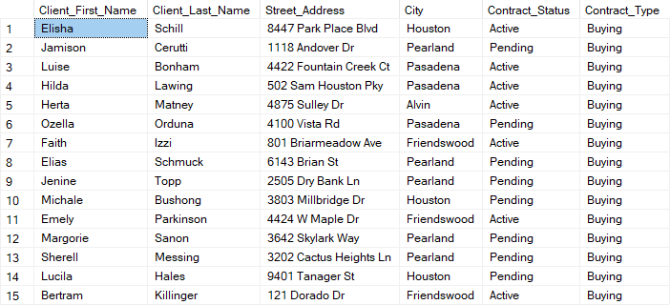

**Contract Table**

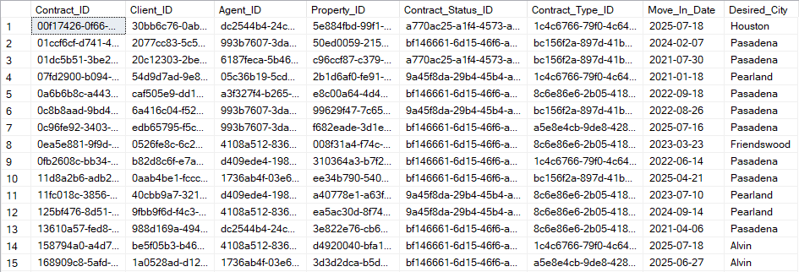

**Client Table**

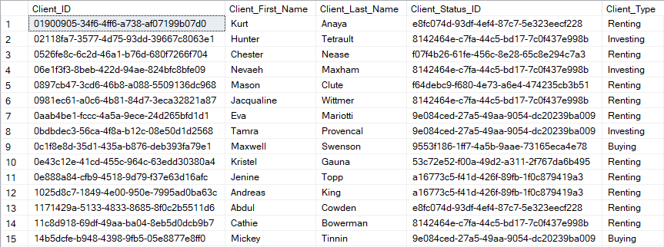

**Property Table**

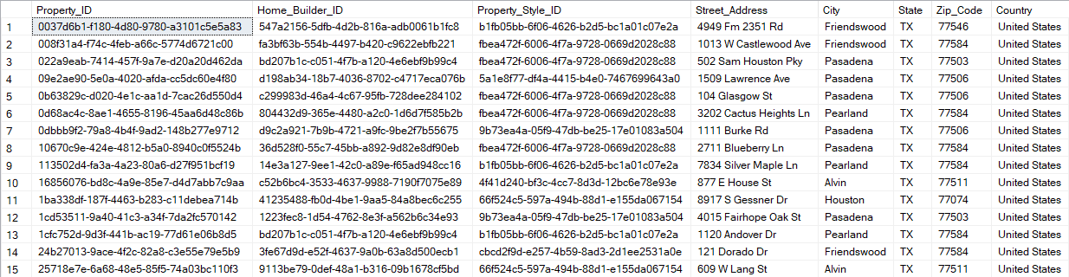

**Contract Status Table**

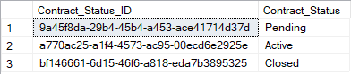

**Contract Type Table**

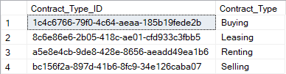

**Report Name:** Clients Selling Property

**Report Description:** These clients are interested in selling properties and only active or pending contracts are shown.

**Business Purpose:** The processes vary greatly depending on what needs the client has. This report will help agents identify the clients which are selling properties and aid the agents in preparing any necessary legal documents as well as contacting the right entities involved in the selling process.

**SQL CODE:**

SELECT

Client.Client_First_Name,

Client.Client_Last_Name,

Property.Street_Address,

Property.City,

Contract_Status.Contract_Status,

Contract_Type.Contract_Type

FROM Contract

INNER JOIN

Client ON Contract.Client_ID = Client.Client_ID

INNER JOIN

Property ON Contract.Property_ID = Property.Property_ID

INNER JOIN

Contract_Type ON Contract.Contract_Type_ID = Contract_Type.Contract_Type_ID

INNER JOIN

Contract_Status ON Contract.Contract_Status_ID = Contract_Status.Contract_Status_ID

WHERE (Contract.Contract_Status_ID = 'a770ac25-a1f4-4573-ac95-00ecd6e2925e' OR Contract.Contract_Status_ID = '9a45f8da-29b4-45b4-a453-ace41714d37d')

AND (Contract.Contract_Type_ID = 'bc156f2a-897d-41b6-8fc9-34e126caba07')

**Report/Query Results:**

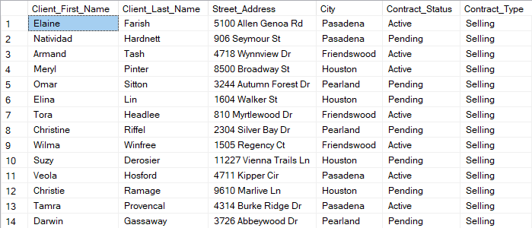

**Contract Table**



**Client Table**



**Property Table**



**Contract Status Table**



**Contract Type Table**



**Report Name:** Client Appointments

**Report Description:** These are all the clients that have an appointment along with their contact details.

**Business Purpose:** The report gives the most important information regarding appointments which are: the parties involved (client and attending agent) as well as the appointment time and what the appointment is about.

**SQL CODE:**

SELECT

Client.Client_First_Name,

Client.Client_Last_Name,

Client_Email.Client_Email,

Client_Phone_Number.Client_Phone_Number,

Appointment.Appointment_Date,

Appointment.Appointment_Time,

Appointment.Appointment_Topic,

Appointment.Appointment_Summary,

Agent.Agent_First_Name,

Agent.Agent_Last_Name

FROM Client

INNER JOIN

Client_Email ON Client.Client_ID = Client_Email.Client_ID

INNER JOIN

Client_Phone_Number ON Client.Client_ID = Client_Phone_Number.Client_ID

INNER JOIN

Appointment ON Client.Client_ID = Appointment.Client_ID

INNER JOIN

Agent ON Appointment.Agent_ID = Agent.Agent_ID

**Report/Query Results:**

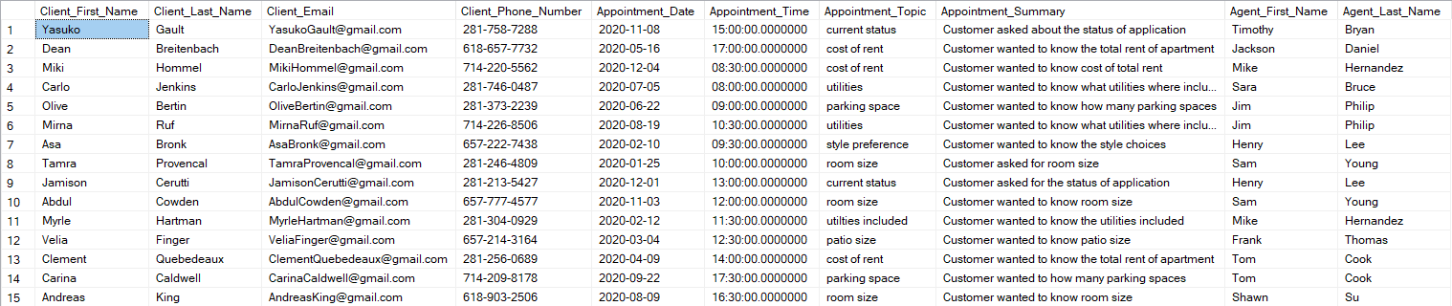

**Client Table**



**Client Email Table**

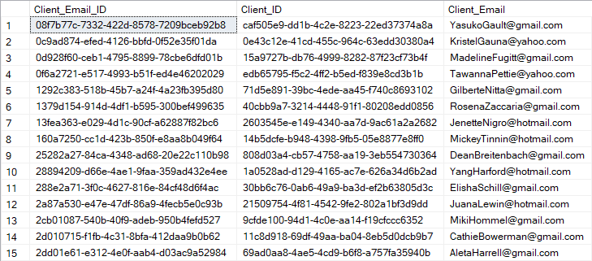

**Client Phone Number Table**

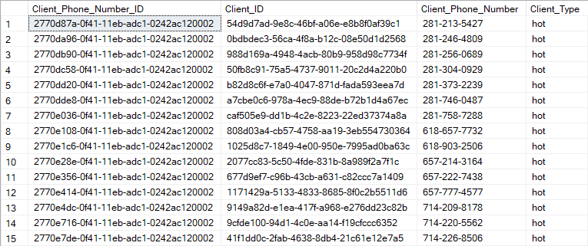

**Appointment Table**

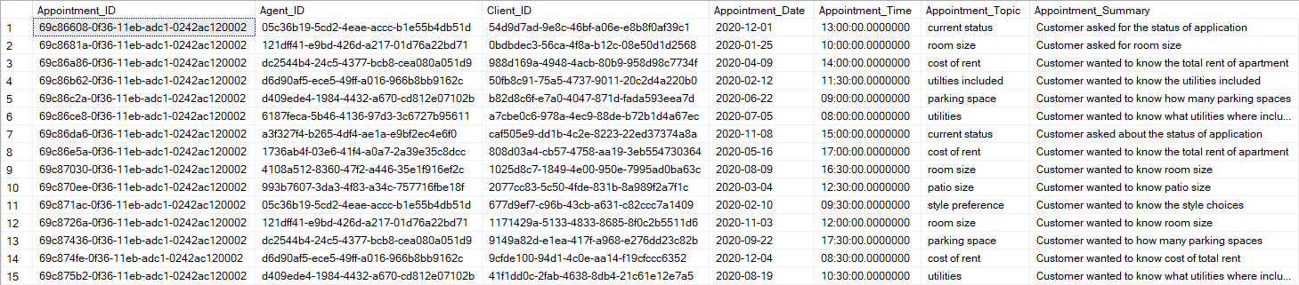

**Report Name:** Properties With Heating Unit

**Report Description:** The location and the number of floors of a property along with heating unit details (age and type).

**Business Purpose:** This gives information to clients that are interesting in properties that have a heating unit. The details of the property and heating unit will aid the client in choosing the right kind of property that they like.

**SQL CODE:**

SELECT

Property.Street_Address,

Property.City,

Property_Style.Style,

Floor_Plan.Floor_Number,

Heating_Unit.Heating_Unit_Type,

Heating_Unit.[Heating_Unit_Age_(Years)]

FROM Property

INNER JOIN

Property_Style ON Property.Property_Style_ID = Property_Style.Property_Style_ID

INNER JOIN

Floor_Plan ON Property.Property_ID = Floor_Plan.Property_ID

INNER JOIN

Heating_Unit ON Floor_Plan.Floor_Plan_ID = Heating_Unit.Floor_Plan_ID

**Report/Query Results:**

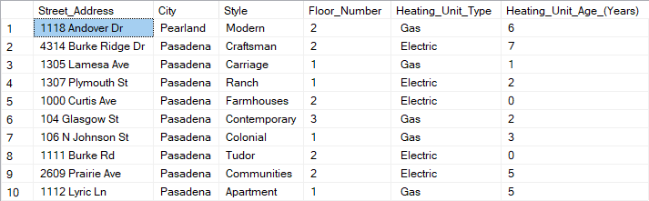

**Property Table**



**Property Style Table**

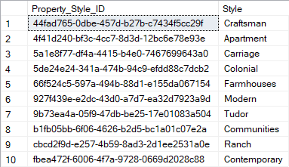

**Floor Plan Table**

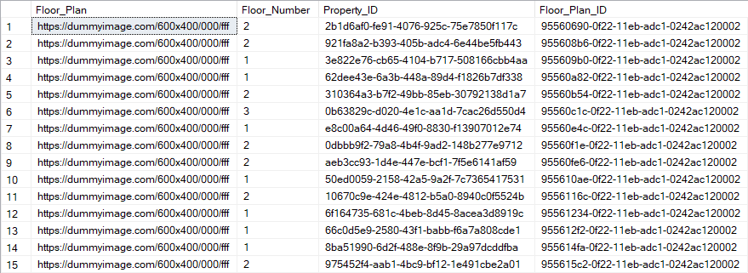

**Heating Unit Table**

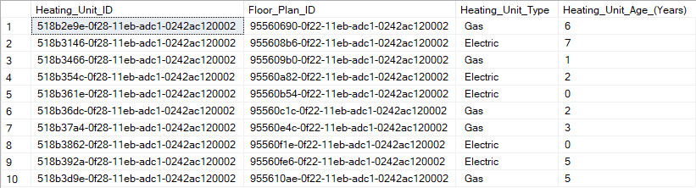

**GUI Printout and Description:**

GUI: Agent Phone Numbers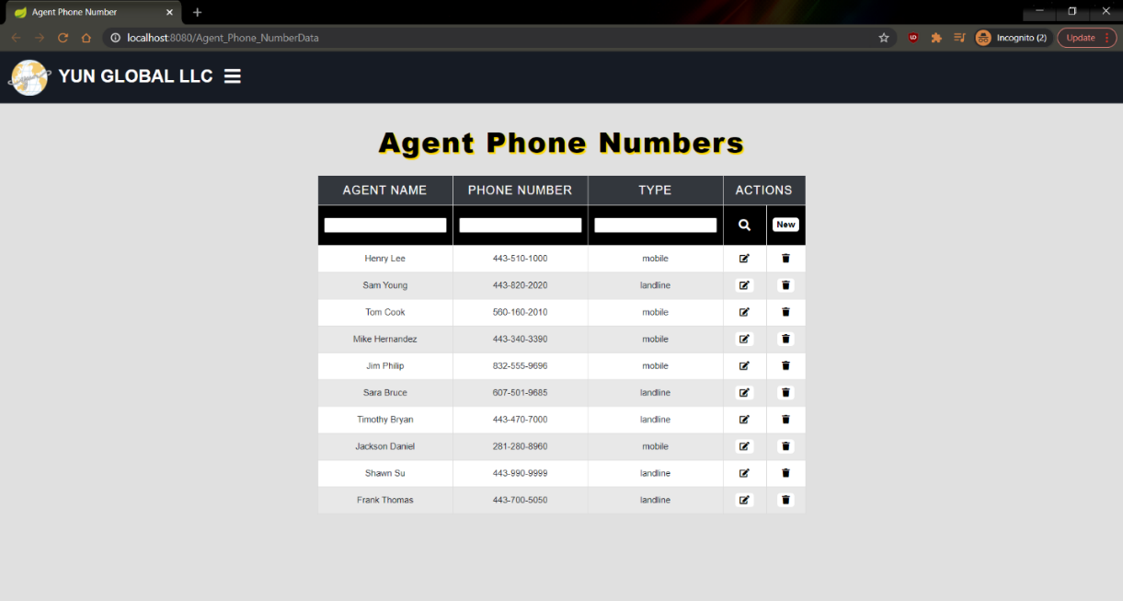

In the above image, once the user selects the agent phone number table, they are able to view all agent phone numbers and a number of options are available to the user which includes: searching by agent name/phone number/type of number, editing agent name/phone number/type of number, creating a new agent phone number for an agent, and deleting the phone number data for an agent.

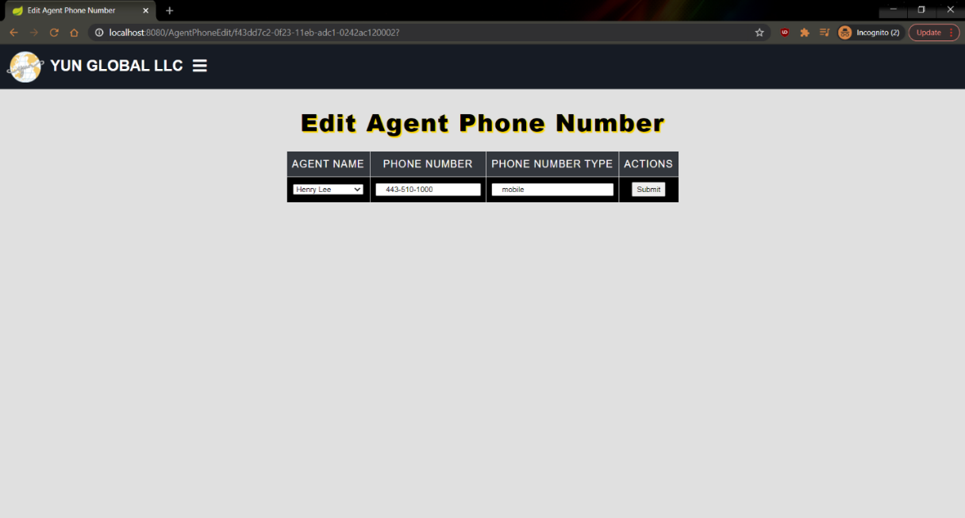

In the above image, after the user chooses to edit an agent phone number, this is what displays. They are able to edit the agent name, phone number, and phone number type and after they are done, they click the submit button.

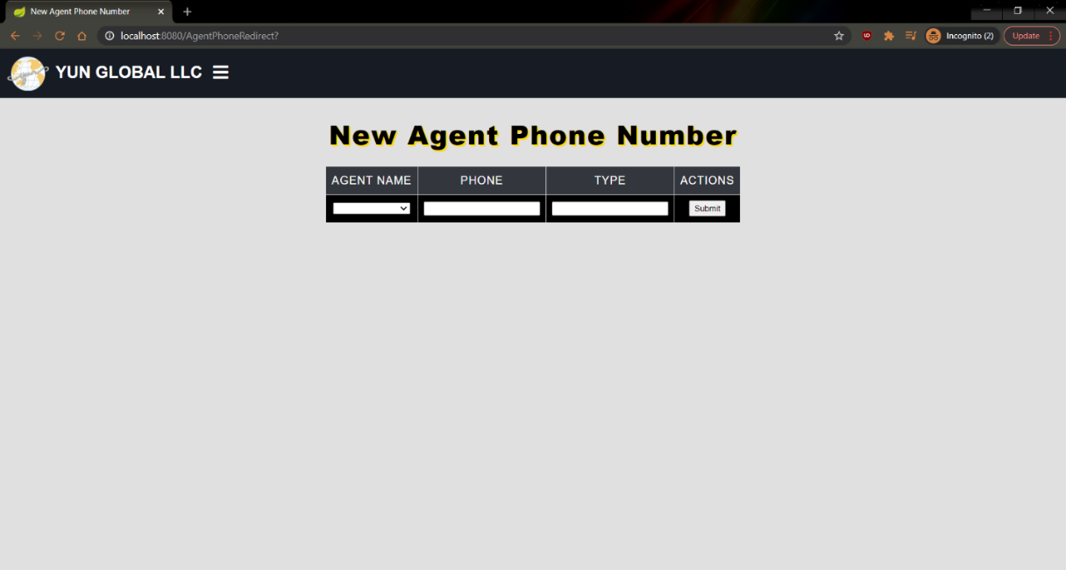

In the above image, after the user chooses to create a new agent phone number, this is what displays. They are able to add an agent name, phone number, and phone number type and after they are done, they click the submit button.

GUI: Appointments

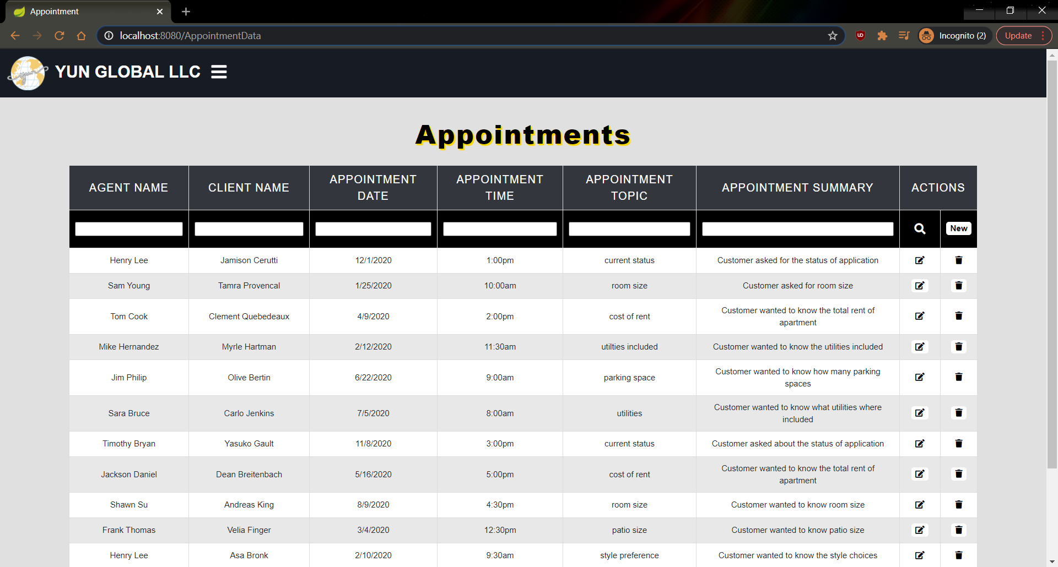

In the above image, once the user selects the appointments table, they are able to view all appointments and a number of options are available to the user which includes: searching by agent name/client name/appointment date/appointment time/appointment topic/appointment summary, editing agent name/client name/appointment date/appointment time/appointment topic/appointment summary, creating a new appointment for a client, and deleting the appointment for a client.

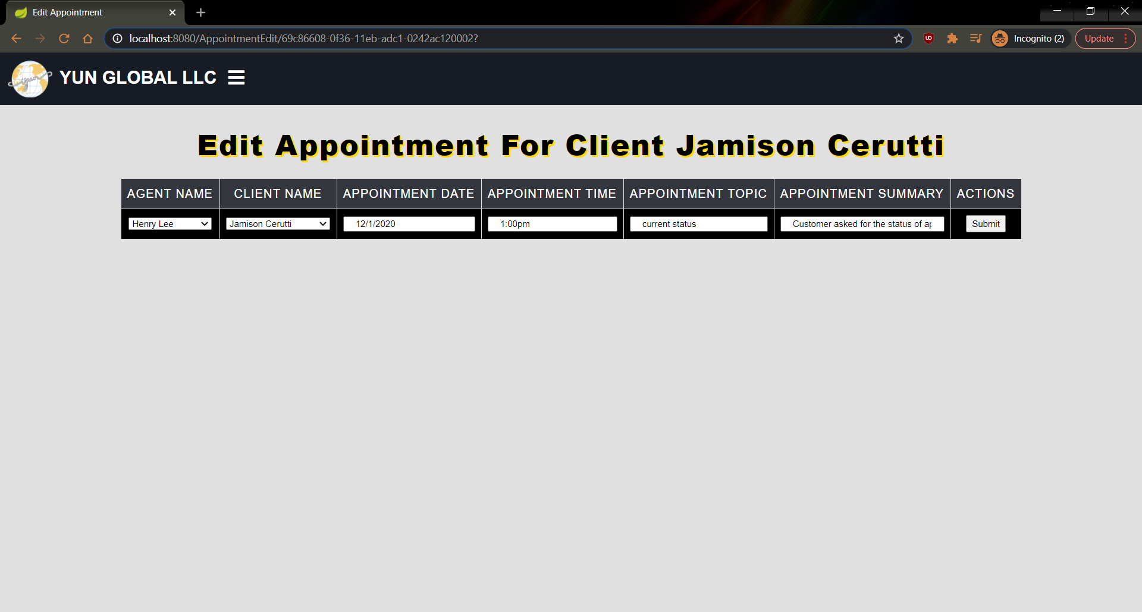

In the above image, after the user chooses to edit an open house session, this is what displays. They are able to edit the agent name/client name/appointment date/appointment time/appointment topic/appointment summary and after they are done, they click the submit button.

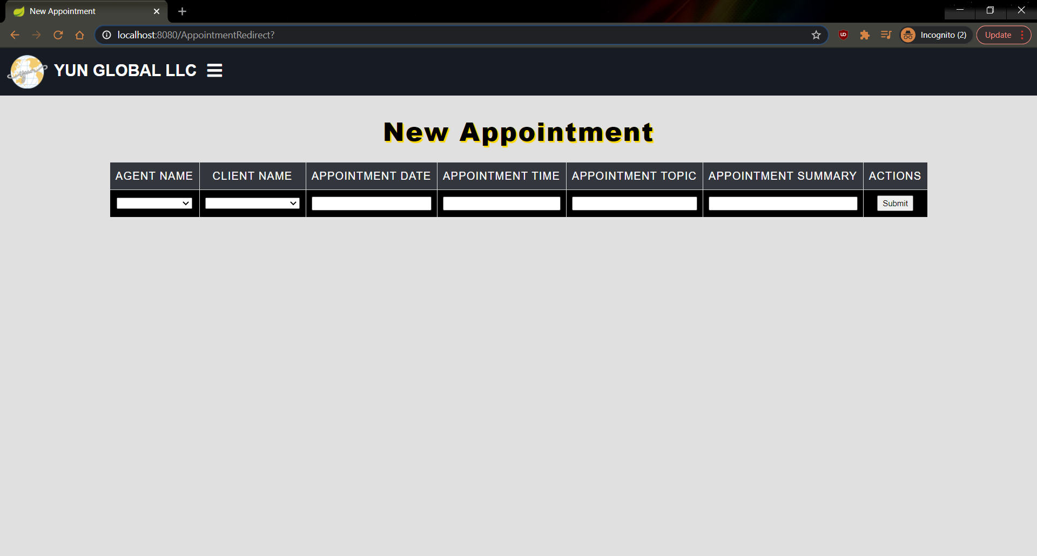

In the above image, after the user chooses to create a new appointment, this is what displays. They are able to add an agent name/client name/appointment date/appointment time/appointment topic/appointment summary and after they are done, they click the submit button.

GUI: Open House Sessions

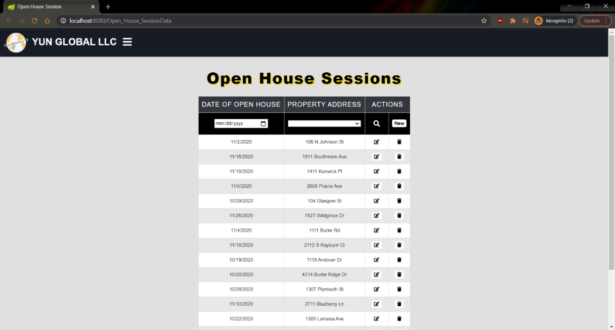

In the above image, once the user selects the open house sessions table, they are able to view all open house sessions and a number of options are available to the user which includes: searching by date of open house/property address, editing date of open house/property address, creating a new open house session for a property, and deleting the open house session for a property.

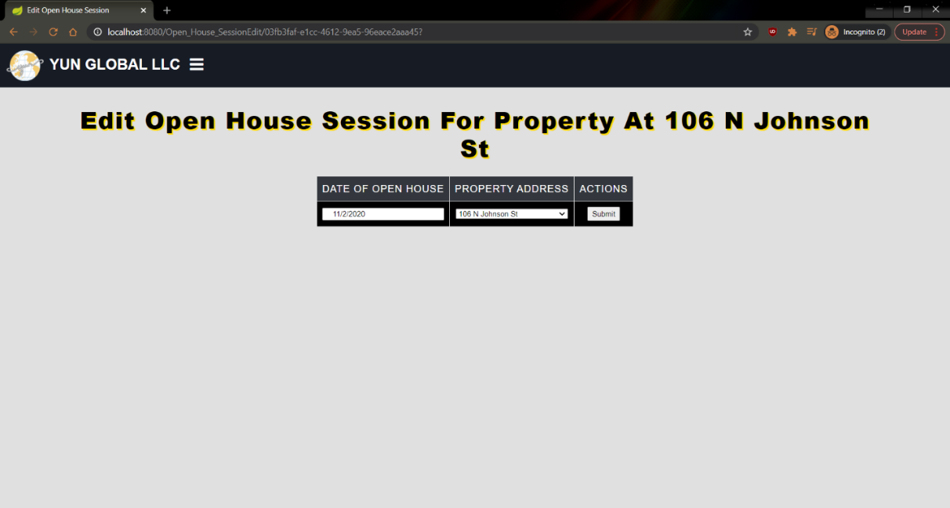

In the above image, after the user chooses to edit an open house session, this is what displays. They are able to edit the date of open house and the property address and after they are done, they click the submit button.

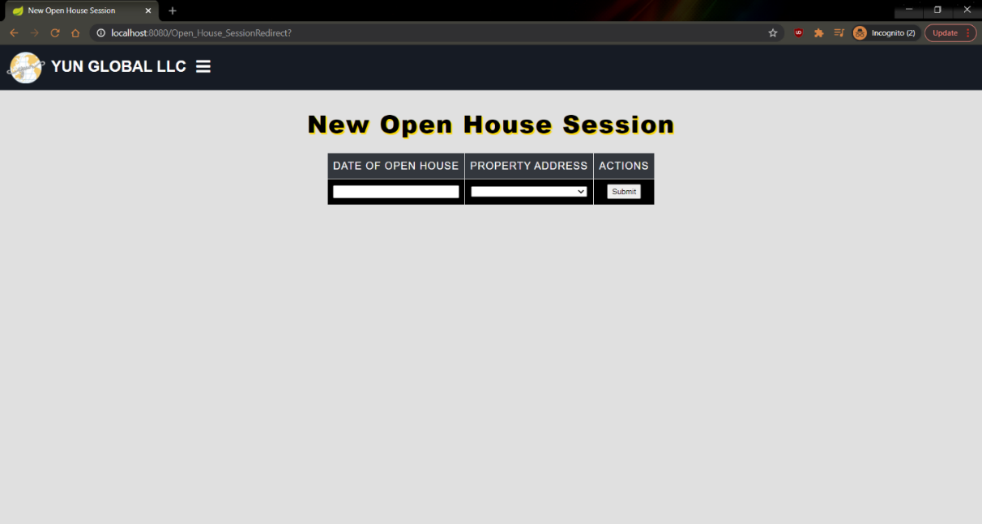

In the above image, after the user chooses to create a new open house session, this is what displays. They are able to add a date for the open house and a property address and after they are done, they click the submit button.

### **Kayla Harris Report**

## Create Scripts

CREATE TABLE [Nearby_Recreation] (

[Recreation_ID] varchar(9) NOT NULL,

[Flyer_ID] varchar(9),

[Recreation] varchar(35),

[Distance_From_Property] varchar(50),

[Address] varchar(35),

CONSTRAINT [PK_Nearby_Recreation] PRIMARY KEY ([Recreation_ID]),

);

CREATE TABLE [Title_Owner] (

[Title_Owner_ID] varchar(9) NOT NULL,

[Property_ID] varchar(9),

[Title_Owner] varchar(150),

CONSTRAINT [PK_Title_Owner] PRIMARY KEY ([Title_Owner_ID]),

);

CREATE TABLE [Top_Feature] (

[Top_Feature_ID] varchar(9) NOT NULL,

[Property_ID] varchar(9),

[Top_Feature] varchar(100),

CONSTRAINT [PK_Top_Feature] PRIMARY KEY ([Top_Feature_ID]),

);

## Data Created

**Commission Payment**

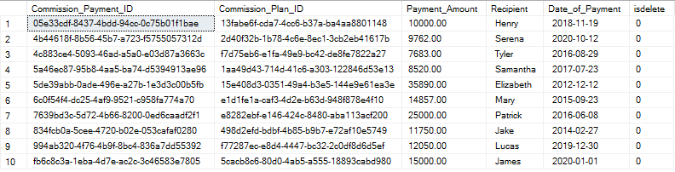

**Home Appraisal**

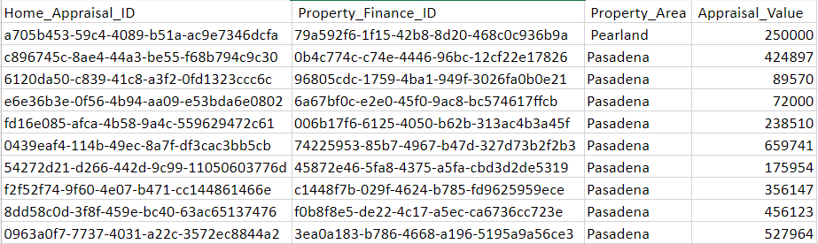

**Property Finance**

|  |  |  |  |  |
| --- | --- | --- | --- | --- |
| **Property_FInance_ID** | **Property_Tax** | **Property_ID** | **Total_Price_Estimate** | **Monthly_Price** |
| 006b17f6-6125-4050-b62b-313ac4b3a45f | 2000.00 | 310364a3-b7f2-49bb-85eb-30792138d1a7 | 250000.00 | 950.00 |
| 0365ab33-c1bd-4a11-86aa-4079b8e2cb2c | 1600.00 | f5706d82-8974-4c8a-8db7-9370de155bec | 987321.00 | 745.00 |
| 03d81551-139d-4214-946f-ba379046b4ee | 1000.00 | c95a284a-30d1-4e5b-a89d-b21e006b111b | 789456.00 | 563.00 |
| 03e97d38-9e8e-4a82-97d4-a47ae5382763 | 2000.00 | d4920040-bfa1-46d0-9b3e-bbb928ed03a3 | 439486.00 | 756.00 |
| 0554d685-2543-4c9a-9da3-ed667378be6a | 1800.00 | c51bc5b1-49bc-4e79-aa04-0e354d851ddb | 99999.00 | 99.00 |
| 09137d78-598f-47e2-afe7-c2694bf5d3ac | 2000.00 | a8d81a56-5142-4228-98a3-34f4e26f9b41 | 678941.00 | 204.00 |
| 0b0f88d1-6d31-4e3f-8485-46c0b90ccdcc | 1800.00 | 5c605f71-b1a3-45f3-832d-5c6630d81d55 | 456123.00 | 456.00 |
| 0b4c774c-c74e-4446-96bc-12cf22e17826 | 2500.00 | 921fa8a2-b393-405b-adc4-6e44be5fb443 | 205000.00 | 680.00 |
| 0e71d1e1-07d5-4959-a1b7-6948bdbba071 | 3000.00 | 4cc6320c-caf5-4fa6-8e11-312f092dec7c | 796311.00 | 75.00 |
| 18ecc342-ce94-4ccf-b302-1830010fc91c | 6000.00 | 41d92682-a384-4319-9381-0b2a289f405a | 987654.00 | 159.00 |
| 1bc094c5-156c-4664-955d-583444f6a35d | 1800.00 | cbb66f74-ee8f-4291-80d8-7952cef3ff94 | 75620.00 | 452.00 |
| 223731db-746f-4c9d-865d-d2fb021bcb40 | 2000.00 | 8b130e10-a9e5-4863-93ed-277fe82a7696 | 98765.00 | 537.00 |
| 25d24b91-d2e5-40af-9317-b443f62921c4 | 2000.00 | 36227da0-59ef-465e-8a32-43e6755a505e | 123456.00 | 987.00 |
| 276657aa-3f15-49d5-bf24-d1081fd42889 | 2000.00 | 3635ef0e-6cda-46fc-bd62-78656def31a6 | 975075.00 | 750.00 |
| 29e76a08-56e9-4e1c-a450-b3a763c8a673 | 6000.00 | 3bf8d3d0-8bb8-4ce4-840a-be959be1ae45 | 510000.00 | 300.00 |
| 2e3421bb-9c9d-4346-8c4c-eb095aee0e5f | 2000.00 | 616ba815-c2a7-47d8-b33c-d24f22ab2fca | 364956.00 | 631.00 |
| 2f500095-9ab4-4ef5-b0b6-c333fb7d6748 | 6000.00 | 32fc3d2e-fb82-4d15-973f-e1d2acc52a7c | 153486.00 | 153.00 |
| 316999f5-64e4-4fe9-84da-222fb03755a0 | 2000.00 | d1bb6fb7-4a9e-4fae-9268-ad8715d270f9 | 987456.00 | 357.00 |
| 33660735-8013-4ecd-ae6e-8cf2d663f84c | 2000.00 | 1cfc752d-9d3f-441b-ac19-77d61e06b8d5 | 94568.00 | 156.00 |
| 39d808b2-1b5a-4985-8f8f-959c8bb86847 | 1900.00 | 741834a3-fdf3-40db-bd38-628bc038606c | 86000.00 | 350.00 |
| 3ea0a183-b786-4668-a196-5195a9a56ce3 | 2100.00 | 50ed0059-2158-42a5-9a2f-7c7365417531 | 678215.00 | 552.00 |
| 3f38f828-b5b4-4b46-99b2-876aacf60915 | 1800.00 | 5f5656b5-2c99-4cc9-b49b-39ef35f84e0b | 512345.00 | 514.00 |
| 3f81d033-4104-4d93-a9c6-83dfa2d16212 | 1800.00 | 10670c9e-424e-4812-b5a0-8940c0f5524b | 321654.00 | 945.00 |
| 45872e46-5fa8-4375-a5fa-cbd3d2de5319 | 1600.00 | e8c00a64-4d46-49f0-8830-f13907012e74 | 450987.00 | 300.00 |
| 490a646d-491b-4859-ad6f-d4a7ad7895a1 | 2300.00 | c264fc18-e241-44df-907e-8d133a61a6b3 | 246851.00 | 678.00 |
| 49a62ad8-641c-436b-9bf7-be3eb35f9958 | 2000.00 | 63110407-7a88-4a9f-af92-1dc9f460bc2f | 687954.00 | 468.00 |
| 4b2fbef2-027c-4931-9510-d667d248f017 | 2300.00 | 5357fdc2-28e1-46e7-984a-71d5a4f931c8 | 480950.00 | 245.00 |
| 4c8e0d4f-a128-4ad7-bfc8-c92bb416766c | 1900.00 | 3bdb4744-0bc8-483c-9aca-5e13e9516bfc | 250000.00 | 650.00 |
| 50bad4a7-fe7f-4a3a-813d-dc90003feb08 | 2100.00 | 0d68ac4c-8ae1-4655-8196-45aa6d48c86b | 840500.00 | 405.00 |
| 5324912d-5dd4-43c7-bfa5-7d6abde3d721 | 3000.00 | 25718e7e-6a68-48e5-85f5-74a03bc110f3 | 452785.00 | 245.00 |
| 565dba6c-ea47-40cd-a388-ff817a78daed | 1800.00 | 7b5129f9-ccae-4eaf-9390-048ce0b11e44 | 486597.00 | 597.00 |
| 574812d8-24e1-454e-8220-1928eb9d9d3d | 2000.00 | d64e4f85-86bc-44ad-9aab-29622fe3aa53 | 2156348.00 | 2000.00 |
| 5be0e02f-d635-483a-b009-978e28697cbb | 1600.00 | fbee546b-1f02-433c-9f25-04f98b5fb06c | 345547.00 | 324.00 |
| 5c7e2cf7-2e98-4262-b230-664a68519e23 | 1900.00 | 4d3a1425-9c28-4cff-9d23-af9ce2918104 | 199675.00 | 254.00 |
| 5c8dc4a2-06e8-445f-b3e3-771e3256ae83 | 2100.00 | 8bae6861-2c78-4418-afff-f051c880d327 | 754214.00 | 351.00 |
| 5dcfa00e-65ea-4b2a-90bd-13cd0c0eae4f | 2300.00 | e6fd7023-32b3-4397-9b99-3f14393c6478 | 267960.00 | 547.00 |
| 5e3678a3-028c-4265-ab5a-6c1b2c017138 | 1800.00 | cb4a3d27-79b4-45c4-964a-7da08297246a | 654987.00 | 153.00 |
| 5eb0ab15-66c8-4771-b8c4-520b531b37ba | 1800.00 | a7c8c067-3e80-4871-9f3d-5b64e888b04d | 321456.00 | 156.00 |
| 5fb7ed77-7e0e-425b-b7b9-4cce79692bfc | 1600.00 | 72aaf3ee-d2fa-4d3c-bb3d-f83b46391690 | 658321.00 | 654.00 |
| 605bc1d8-b8ae-4f44-b974-81502d279645 | 2000.00 | ee34b790-540a-478e-8b97-f8ef46285e26 | 167321.00 | 987.00 |
| 61e9d160-63b1-4173-a2f6-c17350cc15f1 | 1900.00 | b631ec30-6479-40ea-9690-ef4d4658b2c1 | 800600.00 | 605.00 |
| 644baa2f-6bc7-4c56-bcc5-dc9e226e7300 | 1600.00 | 2f883387-1b68-4c10-9272-7925ec99a2a4 | 254789.00 | 512.00 |
| 6a67bf0c-e2e0-45f0-9ac8-bc574617ffcb | 3000.00 | 62dee43e-6a3b-448a-89d4-f1826b7df338 | 175200.00 | 500.00 |
| 6e65adab-d81b-4c98-83e2-225d5aab8edb | 1800.00 | 45360f67-a623-4410-a5f1-c0b2daa9f83a | 486597.00 | 354.00 |
| 724b47e2-0870-4758-b2df-803e1e859795 | 2000.00 | b4ac0a66-10c0-4acd-adca-0d036edfe064 | 987654.00 | 642.00 |
| 74225953-85b7-4967-b47d-327d73b2f2b3 | 1900.00 | 0b63829c-d020-4e1c-aa1d-7cac26d550d4 | 350500.00 | 650.00 |
| 79a592f6-1f15-42b8-8d20-468c0c936b9a | 2000.00 | 2b1d6af0-fe91-4076-925c-75e7850f117c | 105250.00 | 1050.00 |
| 7ba86f41-be75-4d6e-8018-8a1d12bfb51f | 999.00 | 0037d6b1-f180-4d80-9780-a3101c5e5a83 | 999.00 | 999.00 |
| 7d083aea-e18b-46a1-8fe3-16696810f917 | 2100.00 | 8ba51990-6d2f-488e-8f9b-29a97dcddfba | 75000.00 | 913.00 |
| 80bb74d6-d265-4456-872a-0ee948187be0 | 2100.00 | ec62a02f-71f5-4b78-b05e-257178426a95 | 159951.00 | 150.00 |
| 80ccbbfe-ff05-4f41-b8cb-7b65082614e6 | 2300.00 | 24b27013-9ace-4f2c-82a8-c3e55e79e5b9 | 78050.00 | 364.00 |
| 8551313b-c823-46ae-a171-f1d6332aa150 | 2000.00 | 591531b1-4b08-4084-996e-7d4e33ce242f | 345789.00 | 504.00 |
| 8614c760-44f1-473a-8224-c7996f8cd8e1 | 1900.00 | 5a0fff10-6f49-424f-9403-6e02170573e2 | 78945.00 | 456.00 |
| 8f279c4c-b54a-4803-a9f8-287d19bfa067 | 2000.00 | 3490005e-f48e-42f6-bee4-d114528f6a67 | 479230.00 | 453.00 |
| 91dce28a-caac-45b9-94d2-0b82c0103522 | 2300.00 | e815939c-0675-488f-9d51-c8909472bfd5 | 87500.00 | 251.00 |
| 96805cdc-1759-4ba1-949f-3026fa0b0e21 | 1800.00 | 3e822e76-cb65-4104-b717-508166cbb4aa | 125800.00 | 800.00 |
| 970e8826-3998-44ba-bcd2-a1bacc0bde27 | 2100.00 | c96ccf87-c379-4184-986c-48bd9b1bc49b | 769841.00 | 457.00 |
| 988e9f80-0088-4549-8e71-decfe6323b28 | 2100.00 | 5d087201-9225-4f53-9c3a-124b9aabdc38 | 357159.00 | 654.00 |
| 9f620c3b-2b4a-4fb3-a4cb-59a74d2d52be | 2000.00 | 875dd1f0-a212-4ef9-946e-3d0b80b415b8 | 486351.00 | 764.00 |
| a4acb5f0-d619-4796-a7e3-be4830e3901c | 2000.00 | 113502d4-fa3a-4a23-80a6-d27f951bcf19 | 97500.00 | 250.00 |
| a9344fb1-b38a-4b19-a277-abb7e57404ac | 2000.00 | 008f31a4-f74c-4feb-a66c-5774d6721c00 | 65000.00 | 60.00 |
| a97a4f20-583f-4594-8832-8614af5aebf2 | 2000.00 | 66c0d5e9-2580-43f1-babb-f6a7a808cde1 | 963852.00 | 478.00 |
| aa25c048-a3dc-4f5c-a205-6063654848b0 | 1800.00 | 99629f47-7c65-4e00-9e3a-364414124a83 | 456789.00 | 645.00 |
| aa392adb-00bb-419f-9a63-7498f183869a | 2000.00 | 6b13a2ce-fcd4-4a6a-8ecf-6a267a796535 | 987321.00 | 321.00 |
| ab86d7c3-1bdd-4cc8-bdba-7e23b9d9a0a6 | 2000.00 | a40778e1-a63f-4a6b-b6a2-0df8bb634cf8 | 147852.00 | 156.00 |
| b0008225-cb68-41ec-af01-11175c4fc958 | 2300.00 | ea5ac30d-8f74-4cef-854a-7c8a9ba6fb39 | 309800.00 | 800.00 |
| b076a9c0-caf2-4f3d-9429-04fdbe9415a2 | 1000.00 | 3d3d2dca-b5d8-4667-9587-cfba8af4473d | 357489.00 | 468.00 |
| b76719ca-8126-4996-b387-1ecbe0fab61d | 1800.00 | aee65602-ff97-46c9-adaa-a14366a6f106 | 355888.00 | 214.00 |
| b8e71533-8e1e-4656-86af-d7510708b35c | 2100.00 | 2f027aff-6fc3-4bb1-8be8-47ffb8313d07 | 687145.00 | 679.00 |
| c1448f7b-029f-4624-b785-fd9625959ece | 1800.00 | 0dbbb9f2-79a8-4b4f-9ad2-148b277e9712 | 687321.00 | 250.00 |
| c352e01d-1621-44c4-9a58-6b083516b0c7 | 2100.00 | 975452f4-aab1-4bc9-bf12-1e491cbe2a01 | 870540.00 | 845.00 |
| c3dfe352-7393-4463-94ec-65bd2b7bace8 | 6000.00 | 785ff909-f010-4705-8c74-71a48c6f8a48 | 357984.00 | 210.00 |
| c413b01c-6faa-47ff-b3b8-87f3d7612af5 | 1800.00 | 1ba338df-187f-4463-b283-c11debea714b | 300000.00 | 600.00 |
| c493438a-9edf-4110-8f4e-5e73410b442d | 2100.00 | e5081a79-226e-48f8-8db0-4895b2514c8c | 98999.00 | 768.00 |
| c5709fa1-f296-4a26-8364-818fa4a0fe31 | 2100.00 | 0037d6b1-f180-4d80-9780-a3101c5e5a83 | 344955.00 | 246.00 |
| c7440045-737a-4945-9e01-a0511a58a60a | 2000.00 | f639ed99-c6f6-4de6-a4ae-979db7034699 | 597520.00 | 60.00 |
| c8365a92-e320-4719-a757-06d7b2cc79e3 | 2100.00 | 1cd53511-9a40-41c3-a34f-7da2fc570142 | 697843.00 | 784.00 |
| cc77f181-ed9b-4f64-be83-86b869e9cac4 | 1800.00 | 438cc7e7-e0d2-4e00-847d-ad3d7671b507 | 77500.00 | 250.00 |
| ce7c9d9c-c5e5-43f7-9ef6-26fb53db54b1 | 2000.00 | 16856076-bd8c-4a9e-85e7-d4d7abb7c9aa | 789654.00 | 489.00 |
| d1a264df-ba6c-4faa-bd48-96adecd2bb67 | 1800.00 | cacdd116-0d35-4a44-b95d-b3337ef1b737 | 74521.00 | 21.00 |
| d59dff7a-d152-4cad-913e-bf7eba78783b | 1800.00 | d0c25909-4cfe-4d2c-82a1-4d17502a7e36 | 256210.00 | 265.00 |
| d791b49d-c45d-493c-a4ab-69d613b10e55 | 2000.00 | d9afc1cf-901c-4bc4-9cc5-654f8a0b21cb | 786510.00 | 247.00 |
| d9af9247-c345-42ea-a9ad-9381bfd2d7c0 | 3000.00 | b0520743-12f6-4796-aa70-a975d9887d2a | 357159.00 | 657.00 |
| dc392d48-1fe9-4ea4-b147-d58acb2b6a74 | 1900.00 | 09e2ae90-5e0a-4020-afda-cc5dc60e4f80 | 874321.00 | 412.00 |
| dc89eac9-8e43-4de1-8e35-25c82f0dab4e | 3000.00 | 7688039c-7119-4168-a73c-60db37862163 | 854210.00 | 210.00 |
| dcbdc753-4ea6-494c-8ee3-135f2d531f28 | 1900.00 | 807ee124-208e-406c-b7b7-228911e13b73 | 85200.00 | 230.00 |
| dcf08eda-f54a-4b1a-91d1-d645d6087f54 | 1900.00 | bc3e19aa-e665-4828-b68c-07550da498bd | 75412.00 | 879.00 |
| def9a9d0-c164-49b0-8407-848b72344b8b | 1600.00 | 6f164735-681c-4beb-8d45-8acea3d8919c | 789456.00 | 654.00 |
| df9e5869-bfb2-4e0e-8365-ca5f8867fd0f | 1900.00 | 654ad4e9-8a81-4a84-b0f6-bd0992da12b5 | 475155.00 | 274.00 |
| e15f3c95-4b2b-42d7-8e87-1d4d425aef17 | 2200.00 | 85433e8c-b157-46e9-b013-ca25f1119cfd | 156489.00 | 746.00 |
| e4dba4d5-e15a-4dc1-b8dd-123f311101b2 | 1600.00 | 7d73d4c3-47fb-4c62-9144-64dab859ea6d | 350000.00 | 175.00 |
| e665f5bf-7245-40d5-893b-eba2bc4bc4b3 | 1600.00 | f682eade-3d1e-4b18-b199-4f63c9cf1da7 | 89561.00 | 874.00 |
| e80c9ece-c867-4bab-bc72-cbadb030b569 | 2100.00 | 28d61998-864f-4cb5-8af7-342ca8dc63cf | 597865.00 | 354.00 |
| ed5e58f0-35cf-4adb-9122-d0d371da13df | 1900.00 | f676801d-61f5-4165-b495-4f2dc3ab7bda | 741853.00 | 321.00 |
| eef7a7e7-a814-42f5-8d73-41aec8eff2de | 2300.00 | 6c3837b9-a100-465b-99c3-f6d69df6f12c | 745530.00 | 310.00 |
| f0b8f8e5-de22-4c17-a5ec-ca6736cc723e | 2100.00 | aeb3cc93-1d4e-447e-bcf1-7f5e6141af59 | 357489.00 | 725.00 |
| f1207a84-014d-4c0d-86d8-82902162be5c | 1800.00 | f491d809-59fb-4aea-bf69-773845170f37 | 205104.00 | 109.00 |
| f2d638bc-4b89-4195-a1ab-54852f368a59 | 1000.00 | 5e884fbd-99f1-4fe7-ac3d-815946eb5364 | 1000000.00 | 1000.00 |
| f4b4d0a4-86a6-4fa4-b7cc-3d3dcb5d15c1 | 2100.00 | 28ce26ef-0812-4982-af67-21fd4c85dfb2 | 122549.00 | 125.00 |
| f984d2d2-5a4a-446e-8727-f82c2ebb322f | 1800.00 | 022a9eab-7414-457f-9a7e-d20a20d462da | 109504.00 | 789.00 |
| fc1d11e9-9c84-480b-bfe9-8cdf38c403ed | 2000.00 | db8f1f4c-9962-4ec3-9bf2-4e133f0e8d77 | 357951.00 | 159.00 |

**Seller Disclosure Form**

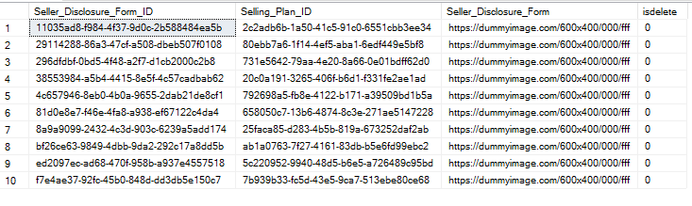

## SQL Queries

**Report 1: 2 Story Properties**

**Report Description:** Selects homes that are listed as 2-strory properties.

**Business Purpose:** Mr. Yun would use this type of report to narrow down the properties that exclusively have a second floor. This will help simplify the process for clients

**SQL Code:**

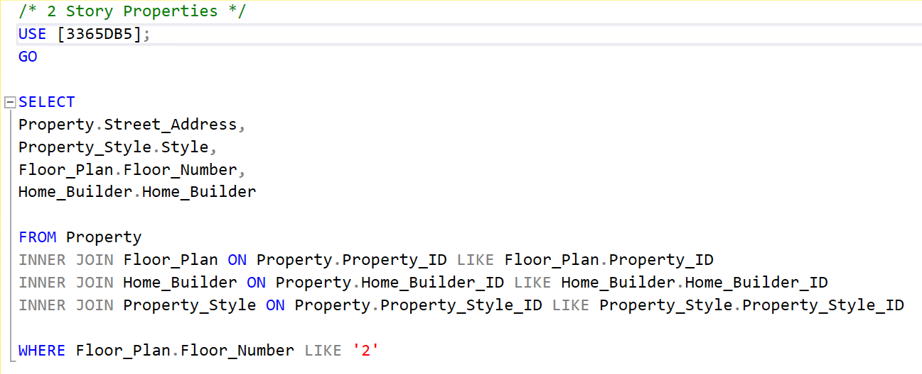

**Query Results:**

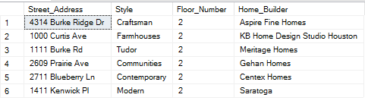

**Report Name: Properties in Alvin**

**Report Description:** Selects properties that are located in Alvin, Texas.

**Business Purpose:** This report can be used by Mr. Yun and his agents to locate properties in Alvin. The report also displays the style, price, and home builder of the property.

**SQL Code:**

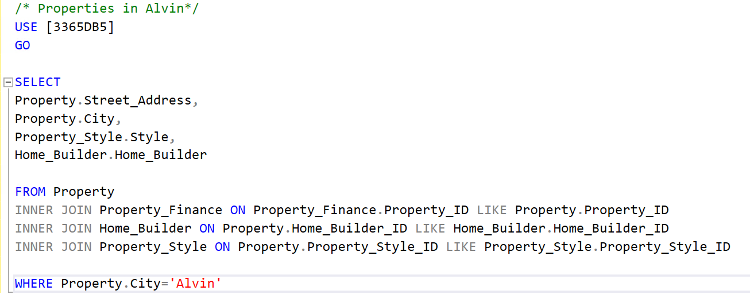

**Query Results:**

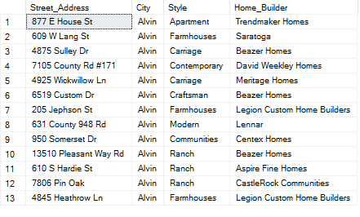

**Report Name: Properties $500,000 or Less**

**Report Description:** Clients looking for a home less than or equal to $500,000.

**Business Purpose:** This query can assist Mr. Yun and his agents in narrowing down properties listed at a value of $500,000 or less. This is beneficial for clients who may have a specific price range.

**SQL Code:**

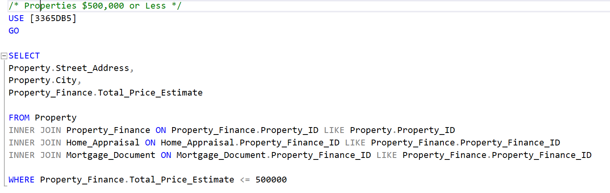

**Query Results:**

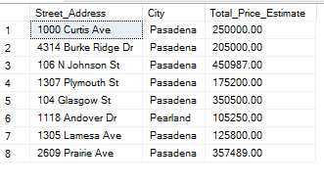

**Report 4: Tudor Properties in Pasadena**

**Report Description:** Display Tudor properties in a city.

**Business Purpose:** This query allows agents to see which of these properties are Tudor style properties. The query is narrowed down to display which of these properties is located in Pasadena, Texas.

**SQL Code:**

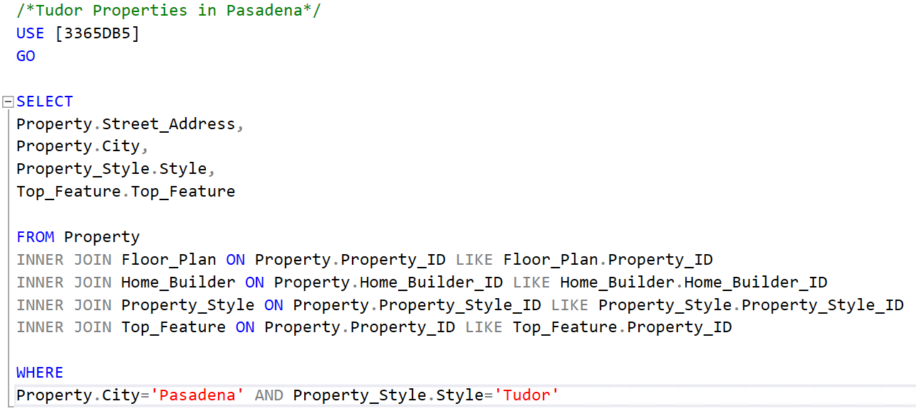

**Query Results:**

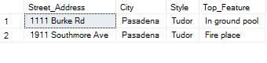

## SQL Update Queries: Insert, Update, Delete

**Insert Script 1: HOA Email**

INSERT into HOA_Email (HOA_Email_ID, HOA_ID, HOA_Email)

VALUES (NEWID(), 'fd155060-929a-4bea-81df-1e303aa0f921', 'ForestTree@hoa1.com')

**Before**

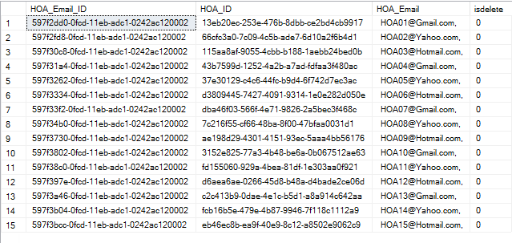

**After**

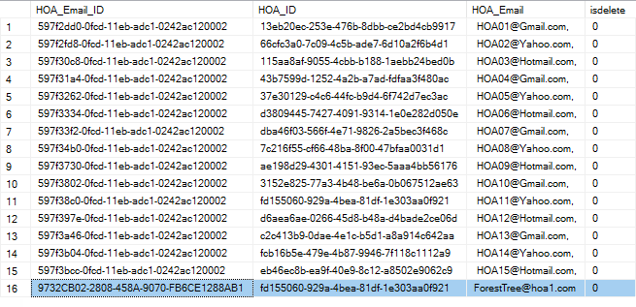

**Insert Script 2: Nearby Businesses**

INSERT into [Nearby_Businesses] (Nearby_Businesses_ID, Flyer_ID, Business, Distance_From_Property, Address)

VALUES (NEWID(), 'f64bcaab-ecdd-4a48-89ee-598fa06dc1ff', 'Minute Maid Park', '5 miles', '501 Crawford Street, Houston, TX 77002')

**Before**

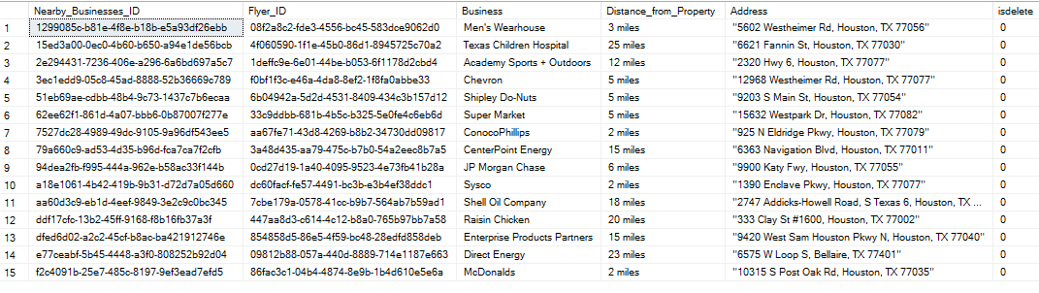

**After**

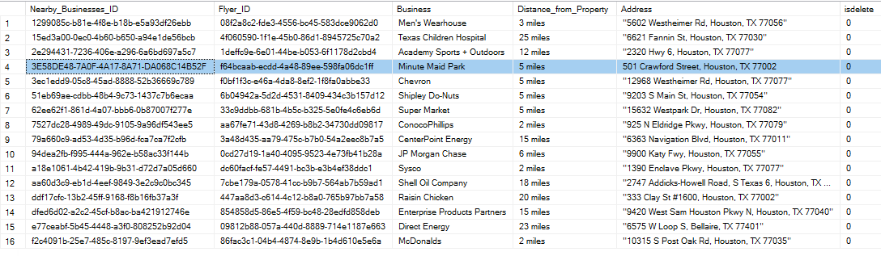

**Update Script 1: HOA Email**

UPDATE [HOA_EMAIL]

SET HOA_EMAIL.HOA_EMAIL = 'HOA-10@outlook.com'

WHERE HOA_EMAIL_ID = '597f3802-0fcd-11eb-adc1-0242ac120002'

**Before**



**After**

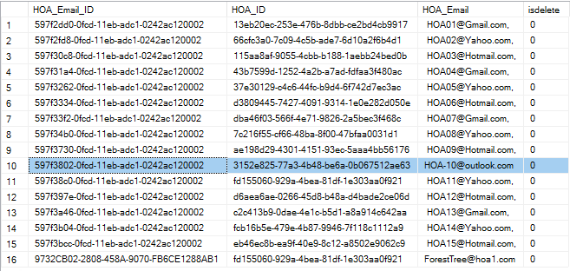

**Update Script 2: Nearby Businesses**

UPDATE [Nearby_Businesses]

SET Address = '737 North Eldridge Pkwy Houston, TX 77079'

WHERE Address = '"10315 S Post Oak Rd, Houston, TX 77035"'

**Before**



**After**

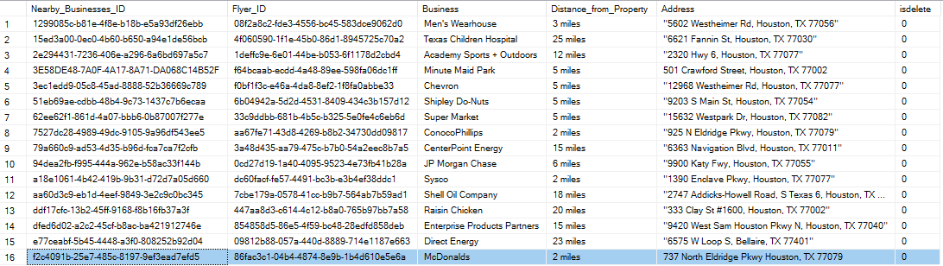

**Delete Script 1: HOA Email**

UPDATE HOA_EMAIL

SET isdelete = '1'

WHERE HOA_EMAIL.HOA_Email_ID = '597f3730-0fcd-11eb-adc1-0242ac120002'

**Before**



**After**

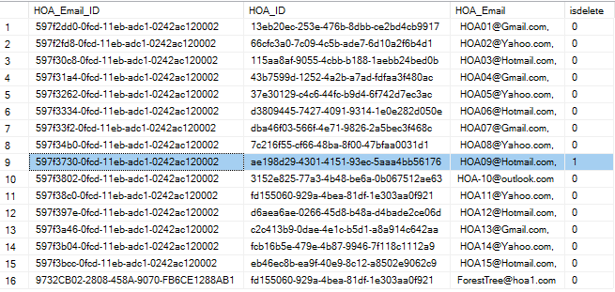

**Delete Script 2: Nearby Businesses**

UPDATE Nearby_Businesses

SET isdelete = '1'

WHERE Nearby_Businesses.Nearby_Businesses_ID = 'ddf17cfc-13b2-45ff-9168-f8b16fb37a3f'

**Before**



**After**

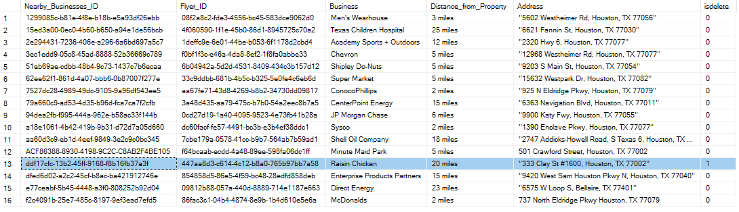

# GUI Screenshots

**Garage GUI**

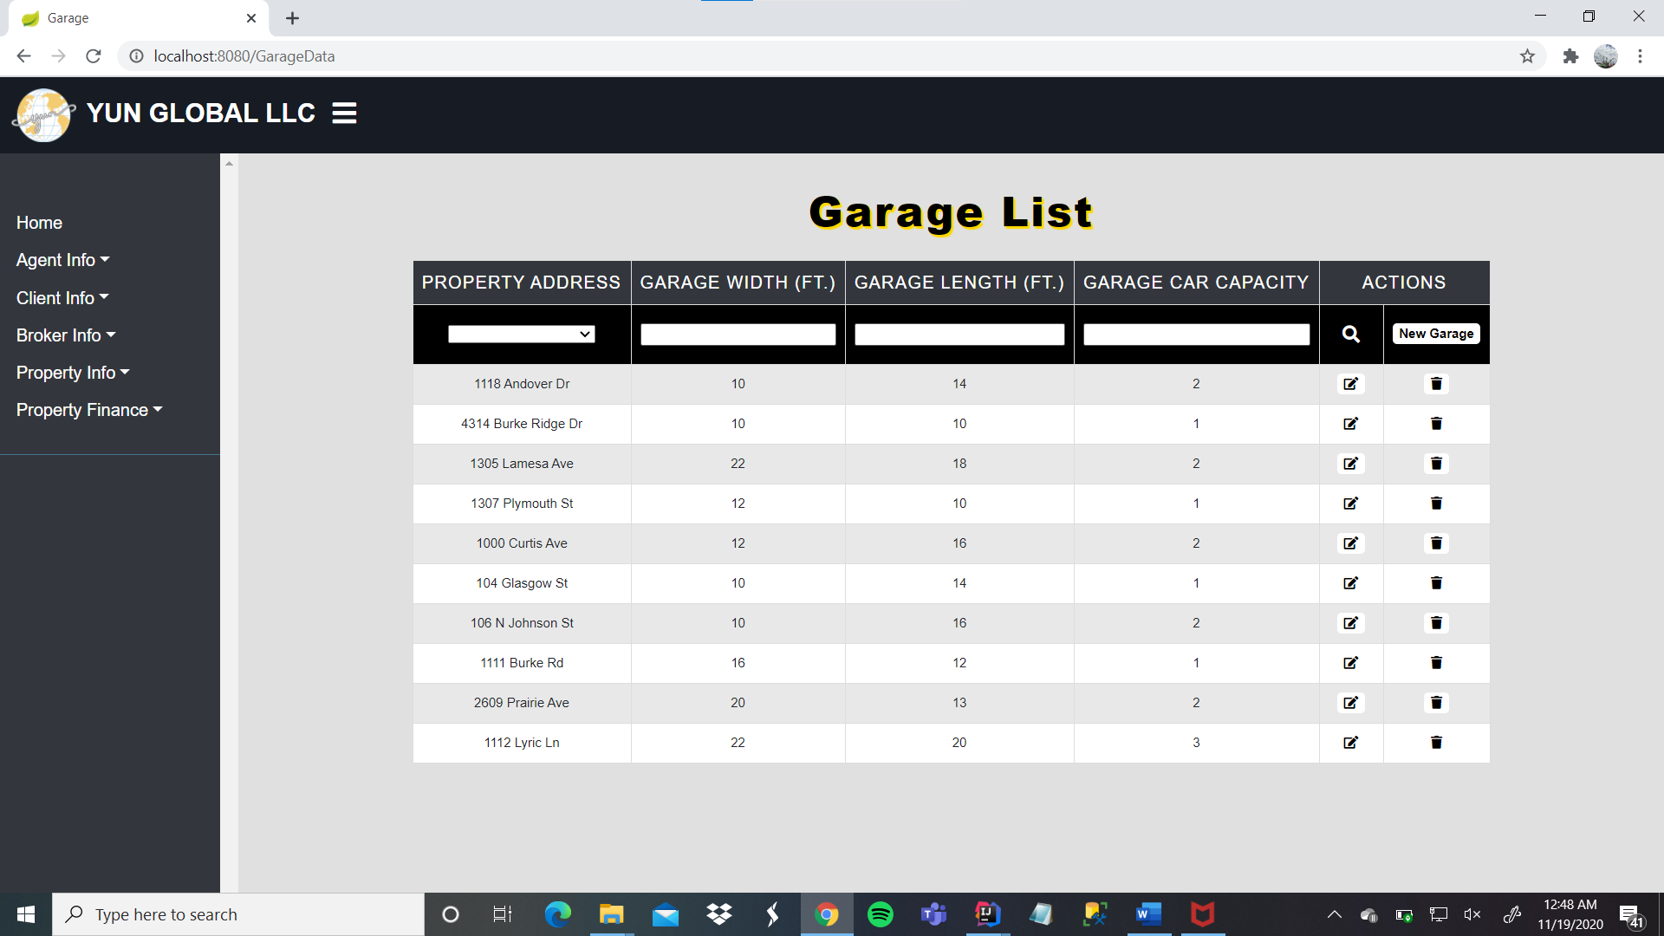

**Edit Garage**

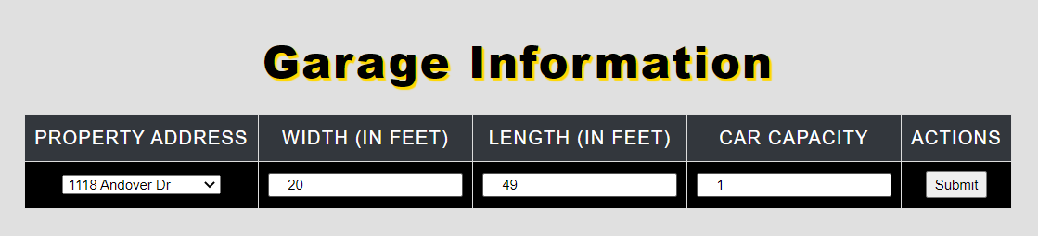

**New Garage**

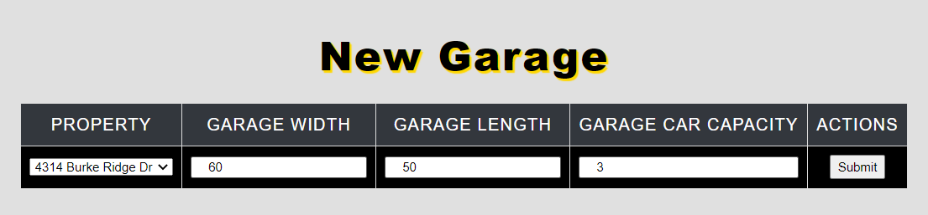

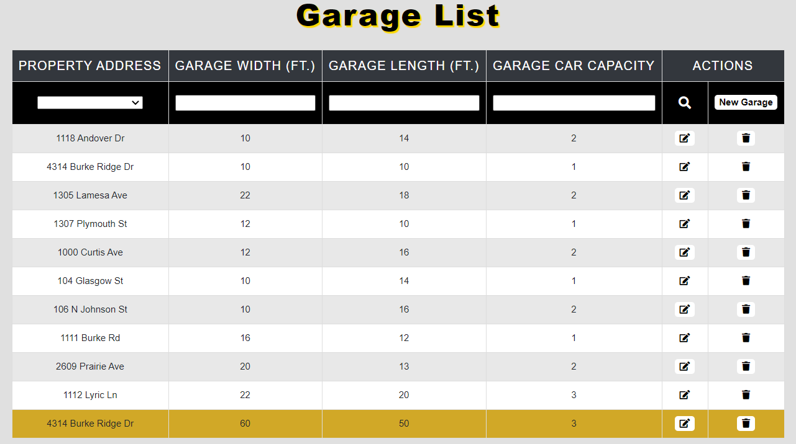

**Homeowner Association**

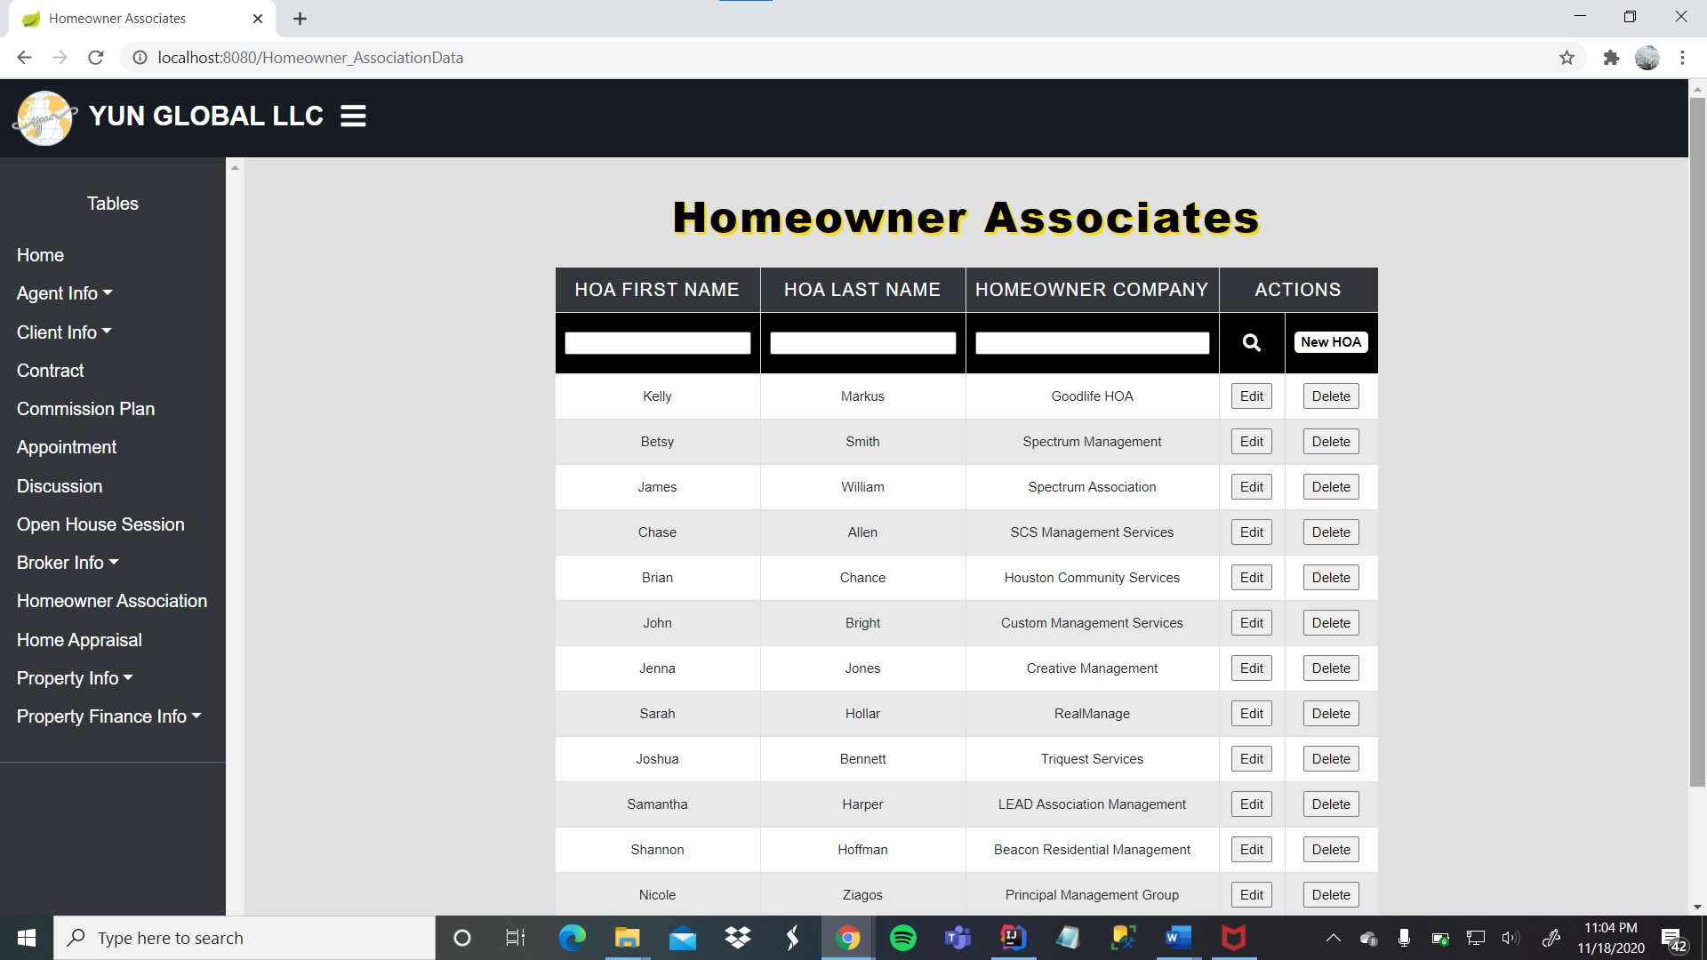

**Edit Homeowner Association**

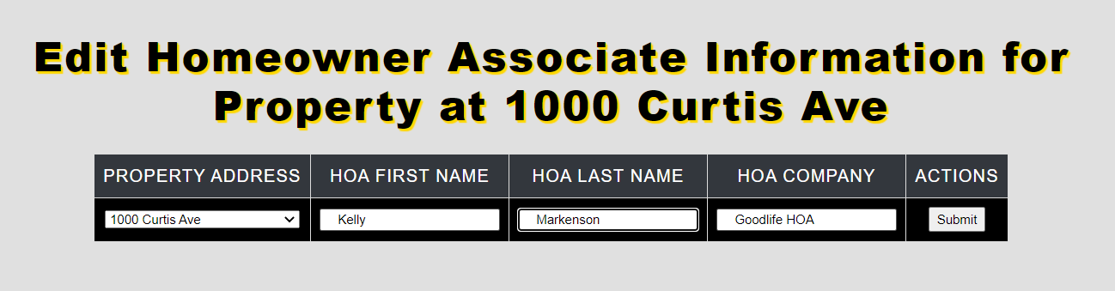

**New Homeowner Association**

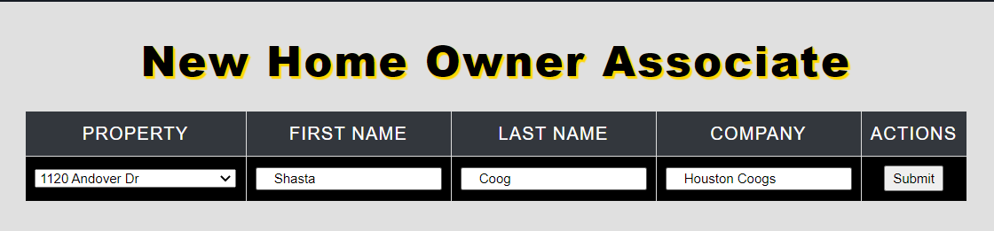

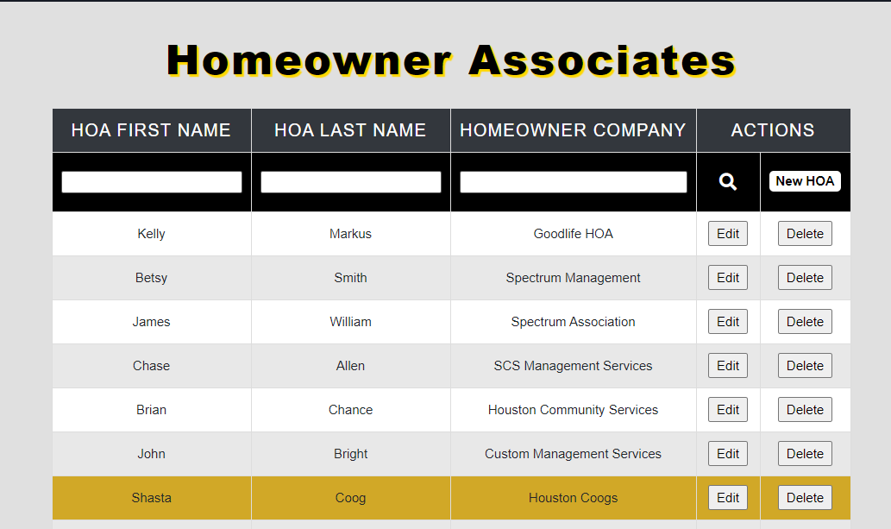

**Paycheck**

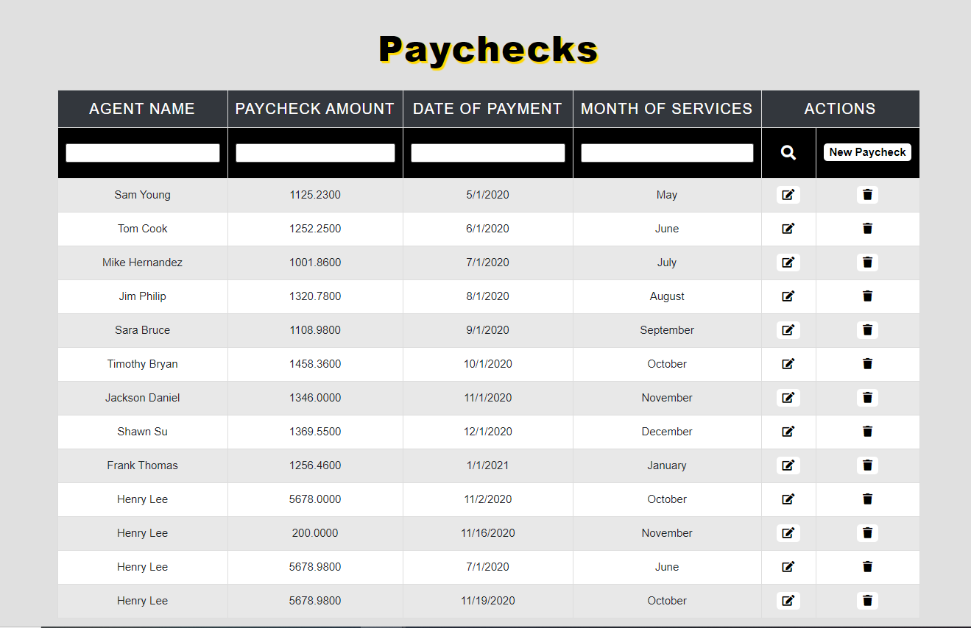

**Edit Paycheck**

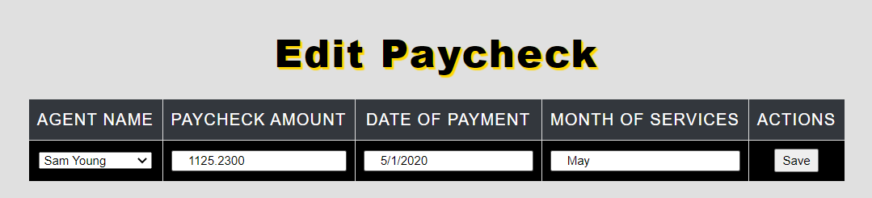

**New Paycheck**

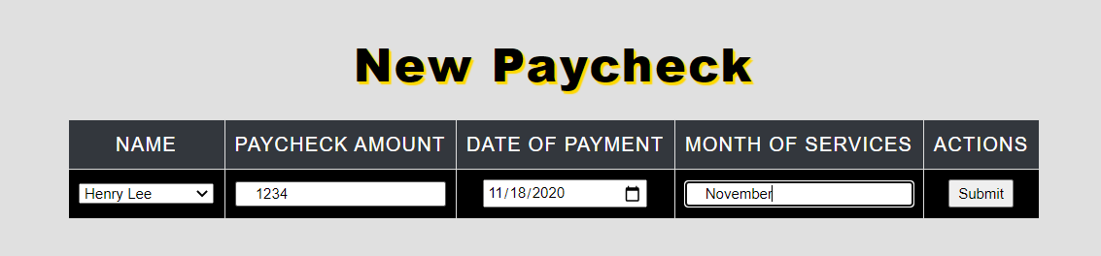

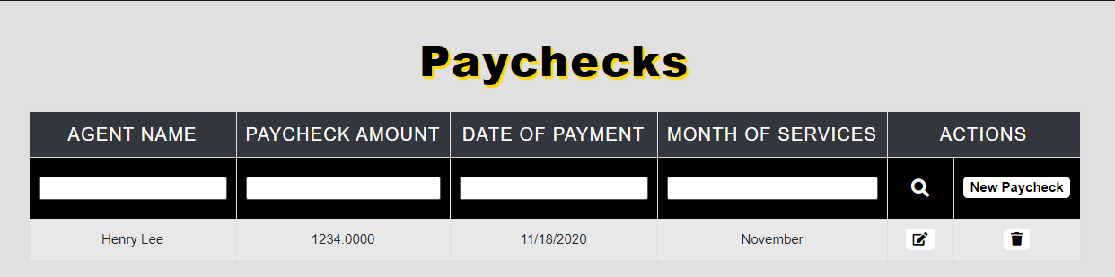

### **Muhammad Tahir Report**

**Create Script:**

**CREATE TABLE [Bathroom] (**

**[Bathroom_ID] varchar(36) NOT NULL,**

**[Bathtub_Width] int NOT NULL,**

**[Bathtub_Length] int NOT NULL,**

**[Bathroom_Width] int NOT NULL,**

**[Bathroom_Length] int NOT NULL,**

**[Floor_Plan_ID] varchar(36) NOT NULL FOREIGN KEY REFERENCES Floor_Plan(Floor_Plan_ID),**

**CONSTRAINT [PK_Bathroom] PRIMARY KEY ([Bathroom_ID]),**

**CREATE TABLE [Garage] (**

**[Garage_ID] varchar(36) NOT NULL,**

**[Garage_Width] int NOT NULL,**

**[Garage_Length] int NOT NULL,**

**[Garage_Car_Capacity] int NOT NULL,**

**[Floor_Plan_ID] varchar(36) NOT NULL FOREIGN KEY REFERENCES Floor_Plan(Floor_Plan_ID),**

**CONSTRAINT [PK_Garage] PRIMARY KEY ([Garage_ID]),**

**);**

**CREATE TABLE [Open_House_Session] (**

**[Open_House_ID] varchar(36) NOT NULL,**

**[Date_Of_Open_House] varchar(36) NOT NULL,**

**[Property_ID] varchar(36) NOT NULL FOREIGN KEY REFERENCES Property(Property_ID),**

**CONSTRAINT [PK_Open_House_Session] PRIMARY KEY ([Open_House_ID]),**

**);**

**CREATE TABLE[School_District_Preference] (**

**[School_District_ID] varchar(36) NOT NULL,**

**[Questionnaire_ID] varchar(36) NOT NULL FOREIGN KEY REFERENCES Questionnaire(Questionnaire_ID),**

**[School_District] varchar(100) NOT NULL,**

**CONSTRAINT [PK_School_District_Preference] PRIMARY KEY ([School_District_ID]),**

**);**

**CREATE TABLE[Broker_Email](**

**[Broker_Email_ID] varchar(36) NOT NULL,**

**[Broker_ID] varchar(36) NOT NULL FOREIGN KEY REFERENCES Broker(Broker_ID),**

**[Broker_Email] nvarchar(255) NOT NULL,**

**CONSTRAINT [PK_Broker_Email] PRIMARY KEY ([Broker_Email_ID]),**

**);**

**CREATE TABLE[Broker_Phone_Number](**

**[Broker_Phone_Number_ID] varchar(36) NOT NULL,**

**[Broker_ID] varchar(36) NOT NULL FOREIGN KEY REFERENCES Broker(Broker_ID),**

**[Broker_Phone_Number] varchar(15) NOT NULL,**

**[Broker_Phone_Type] varchar(9) NOT NULL,**

**CONSTRAINT [PK_Broker_Phone_Number] PRIMARY KEY ([Broker_Phone_Number_ID]),**

**);**

**Data Created:**

* **Agent**

|  |  |  |  |
| --- | --- | --- | --- |
| **Agent_ID** | **Agent_First_Name** | **Agent_Last_Name** | **Title** |
| 05c36b19-5cd2-4eae-accc-b1e55b4db51d | Henry | Lee | lead |
| 121dff41-e9bd-426d-a217-01d76a22bd71 | Sam | Young | agent |
| dc2544b4-24c5-4377-bcb8-cea080a051d9 | Tom | Cook | agent |
| d6d90af5-ece5-49ff-a016-966b8bb9162c | Mike | Hernandez | lead |
| d409ede4-1984-4432-a670-cd812e07102b | Jim | Philip | agent |
| 6187feca-5b46-4136-97d3-3c6727b95611 | Sara | Bruce | agent |
| a3f327f4-b265-4df4-ae1a-e9bf2ec4e6f0 | Timothy | Bryan | agent |
| 1736ab4f-03e6-41f4-a0a7-2a39e35c8dcc | Jackson | Daniel | agent |
| 4108a512-8360-47f2-a446-35e1f916ef2c | Shawn | Su | agent |
| 993b7607-3da3-4f83-a34c-757716fbe18f | Frank | Thomas | agent |

**Agent Email:**

|  |  |  |
| --- | --- | --- |
| **Agent_Email_ID** | **Agent_ID** | **Agent_Email** |
| a80750d6-0f23-11eb-adc1-0242ac120002 | 05c36b19-5cd2-4eae-accc-b1e55b4db51d | henrylee11@yahoo.com |
| a807536a-0f23-11eb-adc1-0242ac120002 | 121dff41-e9bd-426d-a217-01d76a22bd71 | samyoung2000@hotmail.com |
| a8075464-0f23-11eb-adc1-0242ac120002 | dc2544b4-24c5-4377-bcb8-cea080a051d9 | tomcook@gmail.com |
| a8075536-0f23-11eb-adc1-0242ac120002 | d6d90af5-ece5-49ff-a016-966b8bb9162c | mikehern99@hotmail.com |
| a8075612-0f23-11eb-adc1-0242ac120002 | d409ede4-1984-4432-a670-cd812e07102b | philip_j@yahoo.com |
| a80756da-0f23-11eb-adc1-0242ac120002 | 6187feca-5b46-4136-97d3-3c6727b95611 | sara_bruce2020@outlook.com |
| a80757ac-0f23-11eb-adc1-0242ac120002 | a3f327f4-b265-4df4-ae1a-e9bf2ec4e6f0 | timb55@gmail.com |
| a807586a-0f23-11eb-adc1-0242ac120002 | 1736ab4f-03e6-41f4-a0a7-2a39e35c8dcc | j_Daniel1101@hotmail.com |
| a8075b6c-0f23-11eb-adc1-0242ac120002 | 4108a512-8360-47f2-a446-35e1f916ef2c | shawn1100-a@hotmail.com |
| a8075c52-0f23-11eb-adc1-0242ac120002 | 993b7607-3da3-4f83-a34c-757716fbe18f | frank_t001@gmail.com |

**Agent Phone Number:**

|  |  |  |  |
| --- | --- | --- | --- |
| **Agent_Phone_Number_ID** | **Agent_ID** | **Agent_Phone_Number** | **Agent_Phone_Type** |
| f43dd7c2-0f23-11eb-adc1-0242ac120002 | 05c36b19-5cd2-4eae-accc-b1e55b4db51d | 443-510-1000 | mobile |
| f43dda38-0f23-11eb-adc1-0242ac120002 | 121dff41-e9bd-426d-a217-01d76a22bd71 | 443-820-2020 | landline |
| f43ddb3c-0f23-11eb-adc1-0242ac120002 | dc2544b4-24c5-4377-bcb8-cea080a051d9 | 560-160-2010 | mobile |
| f43ddc0e-0f23-11eb-adc1-0242ac120002 | d6d90af5-ece5-49ff-a016-966b8bb9162c | 443-340-3390 | mobile |
| f43dded4-0f23-11eb-adc1-0242ac120002 | d409ede4-1984-4432-a670-cd812e07102b | 832-555-9696 | mobile |
| f43ddf9c-0f23-11eb-adc1-0242ac120002 | 6187feca-5b46-4136-97d3-3c6727b95611 | 607-501-9685 | landline |
| f43de064-0f23-11eb-adc1-0242ac120002 | a3f327f4-b265-4df4-ae1a-e9bf2ec4e6f0 | 443-470-7000 | landline |
| f43de12c-0f23-11eb-adc1-0242ac120002 | 1736ab4f-03e6-41f4-a0a7-2a39e35c8dcc | 281-280-8960 | mobile |
| f43de1f4-0f23-11eb-adc1-0242ac120002 | 4108a512-8360-47f2-a446-35e1f916ef2c | 443-990-9999 | landline |
| f43de2bc-0f23-11eb-adc1-0242ac120002 | 993b7607-3da3-4f83-a34c-757716fbe18f | 443-700-5050 | landline |

**Heating Unit:**

|  |  |  |  |
| --- | --- | --- | --- |
| **Heating_Unit_ID** | **Floor_Plan_ID** | **Heating_Unit_Type** | **Heating_Unit_Age** |
| 518b2e9e-0f28-11eb-adc1-0242ac120002 | 95560690-0f22-11eb-adc1-0242ac120002 | Gas | 6 |
| 518b3146-0f28-11eb-adc1-0242ac120002 | 955608b6-0f22-11eb-adc1-0242ac120002 | Electric | 7 |
| 518b3466-0f28-11eb-adc1-0242ac120002 | 955609b0-0f22-11eb-adc1-0242ac120002 | Gas | 1 |
| 518b354c-0f28-11eb-adc1-0242ac120002 | 95560a82-0f22-11eb-adc1-0242ac120002 | Electric | 2 |
| 518b361e-0f28-11eb-adc1-0242ac120002 | 95560b54-0f22-11eb-adc1-0242ac120002 | Electric | 0 |
| 518b36dc-0f28-11eb-adc1-0242ac120002 | 95560c1c-0f22-11eb-adc1-0242ac120002 | Gas | 2 |
| 518b37a4-0f28-11eb-adc1-0242ac120002 | 95560e4c-0f22-11eb-adc1-0242ac120002 | Gas | 3 |
| 518b3862-0f28-11eb-adc1-0242ac120002 | 95560f1e-0f22-11eb-adc1-0242ac120002 | Electric | 0 |
| 518b392a-0f28-11eb-adc1-0242ac120002 | 95560fe6-0f22-11eb-adc1-0242ac120002 | Electric | 5 |
| 518b3d9e-0f28-11eb-adc1-0242ac120002 | 955610ae-0f22-11eb-adc1-0242ac120002 | Gas | 5 |

**Air Conditioning Unit:**

|  |  |  |  |
| --- | --- | --- | --- |
| **ACU_ID** | **Floor_Plan_ID** | **ACU_Type** | **ACU_Age** |
| 4d751288-0f24-11eb-adc1-0242ac120002 | 95560690-0f22-11eb-adc1-0242ac120002 | Electric | 5 |
| 4d7514ae-0f24-11eb-adc1-0242ac120002 | 955608b6-0f22-11eb-adc1-0242ac120002 | Window | 3 |
| 4d7515a8-0f24-11eb-adc1-0242ac120002 | 955609b0-0f22-11eb-adc1-0242ac120002 | Electric | 5 |
| 4d75167a-0f24-11eb-adc1-0242ac120002 | 95560a82-0f22-11eb-adc1-0242ac120002 | Electric | 0 |
| 4d751742-0f24-11eb-adc1-0242ac120002 | 95560b54-0f22-11eb-adc1-0242ac120002 | Electric | 1 |
| 4d751814-0f24-11eb-adc1-0242ac120002 | 95560c1c-0f22-11eb-adc1-0242ac120002 | Window | 6 |
| 4d7518d2-0f24-11eb-adc1-0242ac120002 | 95560e4c-0f22-11eb-adc1-0242ac120002 | Window | 10 |
| 4d751b52-0f24-11eb-adc1-0242ac120002 | 95560f1e-0f22-11eb-adc1-0242ac120002 | Electric | 16 |
| 4d751c2e-0f24-11eb-adc1-0242ac120002 | 95560fe6-0f22-11eb-adc1-0242ac120002 | Electric | 11 |
| 4d751cec-0f24-11eb-adc1-0242ac120002 | 955610ae-0f22-11eb-adc1-0242ac120002 | Electric | 0 |

**Appliance:**

|  |  |  |  |
| --- | --- | --- | --- |
| **Appliance** | **Warranty_Expiration_Date** | **Property_ID** | **Appliance_ID** |
| stove | 10/14/2025 | 2b1d6af0-fe91-4076-925c-75e7850f117c | d136d584-0f24-11eb-adc1-0242ac120002 |
| dishwasher | 3/7/2023 | 921fa8a2-b393-405b-adc4-6e44be5fb443 | d136d818-0f24-11eb-adc1-0242ac120002 |
| dishwasher | 2/20/2022 | 3e822e76-cb65-4104-b717-508166cbb4aa | d136d926-0f24-11eb-adc1-0242ac120002 |
| waher | 9/27/2027 | 62dee43e-6a3b-448a-89d4-f1826b7df338 | d136d9f8-0f24-11eb-adc1-0242ac120002 |
| dryer | 8/30/2030 | 310364a3-b7f2-49bb-85eb-30792138d1a7 | d136dc82-0f24-11eb-adc1-0242ac120002 |
| dishwasher | 5/6/2026 | 0b63829c-d020-4e1c-aa1d-7cac26d550d4 | d136dd5e-0f24-11eb-adc1-0242ac120002 |
| washer | 12/1/2023 | e8c00a64-4d46-49f0-8830-f13907012e74 | d136de26-0f24-11eb-adc1-0242ac120002 |
| stove | 12/12/2025 | 0dbbb9f2-79a8-4b4f-9ad2-148b277e9712 | d136dee4-0f24-11eb-adc1-0242ac120002 |
| dishwasher | 1/1/2022 | aeb3cc93-1d4e-447e-bcf1-7f5e6141af59 | d136dfac-0f24-11eb-adc1-0242ac120002 |
| washer | 9/15/2029 | 50ed0059-2158-42a5-9a2f-7c7365417531 | d136e060-0f24-11eb-adc1-0242ac120002 |

**Bathroom:**

|  |  |  |  |  |  |
| --- | --- | --- | --- | --- | --- |
| **Bathroom_ID** | **Bathtub_Width** | **Bathtub_Length** | **Bathroom_Width** | **Bathroom_Length** | **Floor_Plan_ID** |
| 42b49fcc-74ed-4dc0-aab8-6250f0f92f61 | 9 | 3 | 96 | 72 | 95560690-0f22-11eb-adc1-0242ac120002 |
| 6f2be46f-8f02-4ae9-8d66-a581721f9326 | 9 | 7 | 70 | 90 | 955608b6-0f22-11eb-adc1-0242ac120002 |
| b16ba80b-1d7c-4226-be3f-f29a14c5ae28 | 9 | 4 | 88 | 74 | 955609b0-0f22-11eb-adc1-0242ac120002 |
| 7ee7d7e4-0798-4eb8-9422-44ae282ef89e | 5 | 5 | 50 | 80 | 95560a82-0f22-11eb-adc1-0242ac120002 |
| cc4e0f08-0744-47ae-b3f4-852c0559e2a8 | 2 | 11 | 60 | 30 | 95560b54-0f22-11eb-adc1-0242ac120002 |
| 36b39333-cc3b-4ace-9854-ced047d5e72c | 4 | 5 | 55 | 66 | 95560c1c-0f22-11eb-adc1-0242ac120002 |
| 597ad1c0-52b8-49ad-878f-468223ef5c25 | 9 | 6 | 52 | 40 | 95560e4c-0f22-11eb-adc1-0242ac120002 |
| 3aa032e6-216a-48a3-9548-e6b1ba153242 | 9 | 6 | 100 | 70 | 95560f1e-0f22-11eb-adc1-0242ac120002 |
| 5193f785-c985-4707-8f99-f922ed916273 | 2 | 7 | 66 | 44 | 95560fe6-0f22-11eb-adc1-0242ac120002 |
| d649eec4-6438-4c38-8fe2-66be94257091 | 8 | 3 | 75 | 65 | 955610ae-0f22-11eb-adc1-0242ac120002 |

**Garage:**

|  |  |  |  |  |
| --- | --- | --- | --- | --- |
| **Garage_ID** | **Garage_Width** | **Garage_Length** | **Garage_Car_Capacity** | **Floor_Plan_ID** |
| d28d7a34-0f27-11eb-adc1-0242ac120002 | 10 | 14 | 2 | 95560690-0f22-11eb-adc1-0242ac120002 |
| d28d7ca0-0f27-11eb-adc1-0242ac120002 | 10 | 10 | 1 | 955608b6-0f22-11eb-adc1-0242ac120002 |
| d28d7d9a-0f27-11eb-adc1-0242ac120002 | 22 | 18 | 2 | 955609b0-0f22-11eb-adc1-0242ac120002 |
| d28d7ff2-0f27-11eb-adc1-0242ac120002 | 12 | 10 | 1 | 95560a82-0f22-11eb-adc1-0242ac120002 |
| d28d80ce-0f27-11eb-adc1-0242ac120002 | 12 | 16 | 2 | 95560b54-0f22-11eb-adc1-0242ac120002 |
| d28d81a0-0f27-11eb-adc1-0242ac120002 | 10 | 14 | 1 | 95560c1c-0f22-11eb-adc1-0242ac120002 |
| d28d8268-0f27-11eb-adc1-0242ac120002 | 10 | 16 | 2 | 95560e4c-0f22-11eb-adc1-0242ac120002 |
| d28d8326-0f27-11eb-adc1-0242ac120002 | 16 | 12 | 1 | 95560f1e-0f22-11eb-adc1-0242ac120002 |
| d28d83e4-0f27-11eb-adc1-0242ac120002 | 20 | 13 | 2 | 95560fe6-0f22-11eb-adc1-0242ac120002 |
| d28d84ac-0f27-11eb-adc1-0242ac120002 | 22 | 20 | 3 | 955610ae-0f22-11eb-adc1-0242ac120002 |

**Broker Email:**

|  |  |  |
| --- | --- | --- |
| **Broker_Email_ID** | **Broker_ID** | **Broker_Email** |
| 41a56a18-0f27-11eb-adc1-0242ac120002 | 69c14391-7c17-4bf5-a1d8-59212aec3ae4 | property_101@yahoo.com |
| 41a56c7a-0f27-11eb-adc1-0242ac120002 | 124c5f9b-4dce-4257-b065-3918f9950756 | realestate101@gmail.com |
| 41a56db0-0f27-11eb-adc1-0242ac120002 | 61749a28-a6e2-4451-b474-f8e20cb6288a | property123@yahoo.com |
| 41a56e8c-0f27-11eb-adc1-0242ac120002 | bc3f9fff-57db-4226-bca4-277474e297ee | global_real_estate@gmail.com |
| 41a56f5e-0f27-11eb-adc1-0242ac120002 | f6f91b03-b816-44ae-89fa-b64b0108a48b | property_broker@yahoo.com |
| 41a57026-0f27-11eb-adc1-0242ac120002 | 64e01149-3fc8-4af4-ac63-bf9273305729 | jim_properties@gmail.com |
| 41a570e4-0f27-11eb-adc1-0242ac120002 | ef16af70-df16-455b-9d03-2d9c81cb6f68 | best_realestate561@yahoo.com |
| 41a5735a-0f27-11eb-adc1-0242ac120002 | 816c09c4-a046-4834-9d4c-a765dd493631 | michelle_realty@hotmail.com |
| 41a5742c-0f27-11eb-adc1-0242ac120002 | 3c2dc7ce-a507-4bc4-a75a-6fad4e5a7075 | austin_realestate@austinreality.com |
| 41a574ea-0f27-11eb-adc1-0242ac120002 | 6c044e21-5ab3-4077-b7c9-31bd2e1c4695 | justinproperty@justinreality.com |

**Broker Phone Number:**

|  |  |  |  |
| --- | --- | --- | --- |
| **Broker_Phone_Number_ID** | **Broker_ID** | **Broker_Phone_Number** | **Broker_Phone_Type** |
| b12b5960-0f27-11eb-adc1-0242ac120002 | 69c14391-7c17-4bf5-a1d8-59212aec3ae4 | 281-150-9590 | landline |
| b12b5d5c-0f27-11eb-adc1-0242ac120002 | 124c5f9b-4dce-4257-b065-3918f9950756 | 281-333-9591 | mobile |
| b12b5e6a-0f27-11eb-adc1-0242ac120002 | 61749a28-a6e2-4451-b474-f8e20cb6288a | 281-320-9592 | mobile |
| b12b5f3c-0f27-11eb-adc1-0242ac120002 | bc3f9fff-57db-4226-bca4-277474e297ee | 832-150-9593 | landline |
| b12b6004-0f27-11eb-adc1-0242ac120002 | f6f91b03-b816-44ae-89fa-b64b0108a48b | 289-915-9137 | mobile |
| b12b60c2-0f27-11eb-adc1-0242ac120002 | 64e01149-3fc8-4af4-ac63-bf9273305729 | 281-222-9595 | landline |
| b12b618a-0f27-11eb-adc1-0242ac120002 | ef16af70-df16-455b-9d03-2d9c81cb6f68 | 281-363-9596 | mobile |
| b12b6248-0f27-11eb-adc1-0242ac120002 | 816c09c4-a046-4834-9d4c-a765dd493631 | 281-998-9597 | mobile |
| b12b6310-0f27-11eb-adc1-0242ac120002 | 3c2dc7ce-a507-4bc4-a75a-6fad4e5a7075 | 281-111-9598 | landline |
| b12b6658-0f27-11eb-adc1-0242ac120002 | 6c044e21-5ab3-4077-b7c9-31bd2e1c4695 | 281-000-9599 | mobile |

**SQL Queries:**

**SQL Query Code 1:**

SELECT

Property.Street_Address,

Property.City,

Property.Zip_Code,

Floor_Plan.Floor_Number,

Outdoor.Sprinkler_System,

Garage.Garage_Car_Capacity

FROM Floor_Plan

INNER JOIN Garage ON Garage.Floor_Plan_ID LIKE Floor_plan.Floor_Plan_ID

INNER JOIN Property ON Property.Property_ID LIKE Floor_Plan.Property_ID

INNER JOIN Outdoor ON Outdoor.Floor_Plan_ID LIKE Floor_plan.Floor_Plan_ID

AND Garage.Garage_Car_Capacity LIKE '2'

**SQL Query Code 2:**

SELECT

Floor_Plan.Floor_Number,

Property_Style.Style,

Top_Feature.Top_Feature,

Property.Street_Address,

Property.City,

Property.Zip_Code

FROM Property

INNER JOIN Property_Style ON Property_Style.Property_Style_ID LIKE Property.Property_Style_ID

INNER JOIN Top_Feature ON Top_Feature.Property_ID LIKE Property.Property_ID

INNER JOIN Floor_Plan ON Floor_Plan.Property_ID LIKE Property.Property_ID

AND Property.City LIKE 'Pasadena'

**SQL Query Code 3:**

SELECT

Property.Street_Address,

Property.City,

Property.Zip_Code,

Floor_Plan.Floor_Number,

Heating_Unit.Heating_Unit_Type,

Heating_Unit.[Heating_Unit_Age],

Room.Room_Type

FROM Floor_Plan

INNER JOIN Property ON Property.Property_ID LIKE Floor_Plan.Property_ID

INNER JOIN Room ON Room.Floor_Plan_ID LIKE Floor_Plan.Floor_Plan_ID

INNER JOIN Heating_Unit ON Heating_Unit.Floor_Plan_ID LIKE Floor_Plan.Floor_Plan_ID

AND Heating_Unit.Heating_Unit_Type LIKE 'Gas'

**SQL Query Code 4:**

SELECT

Property.Street_Address,

Property.City,

Property.Zip_Code,

Floor_Plan.Floor_Number,

Air_Conditioning_Unit.ACU_Type,

Air_Conditioning_Unit.[ACU_Age],

Room.Room_Type

FROM Floor_Plan

INNER JOIN Property ON Property.Property_ID LIKE Floor_Plan.Property_ID

INNER JOIN Room ON Room.Floor_Plan_ID LIKE Floor_Plan.Floor_Plan_ID

INNER JOIN Air_Conditioning_Unit ON Air_Conditioning_Unit.Floor_Plan_ID LIKE Floor_Plan.Floor_Plan_ID

AND Air_Conditioning_Unit.[ACU_Age] < '10'

**SQL Update script:**

**Member: Muhammad Tahir**

**Insert Script # 1**

INSERT into Garage(Garage_ID, [Garage_Width], [Garage_Length], Garage_Car_Capacity, Floor_Plan_ID)

VALUES (NEWID(), '40', '30', '3', '95560690-0f22-11eb-adc1-0242ac120002');

**Report/Query Results:**

**Before:**

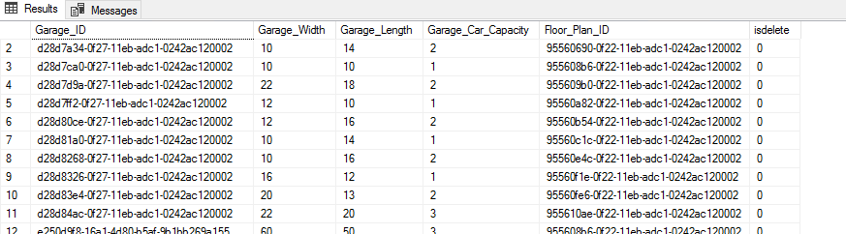

**After:**

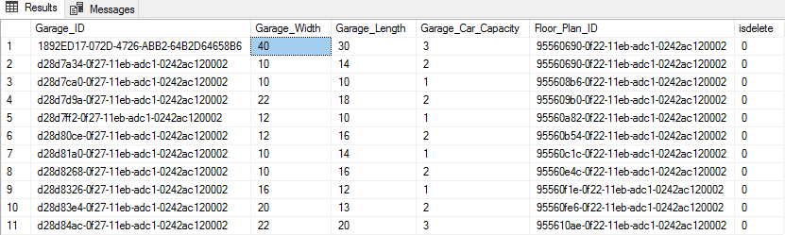

**Insert Script # 2**

INSERT into Broker_Email(Broker_Email_ID,Broker_ID,Broker_Email)

VALUES (NEWID(), '69c14391-7c17-4bf5-a1d8-59212aec3ae4','realestate_george@property111.com');

**Report/Query Results:**

**Before:** 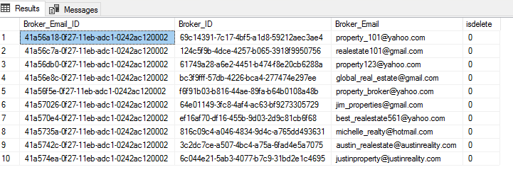

**After:** 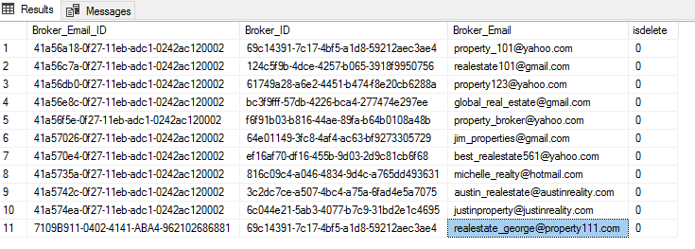

**Update Script # 1**

UPDATE[Garage]

SET Garage.Garage_Car_Capacity='5'

WHERE Garage.Garage_ID='1892ED17-072D-4726-ABB2-64B2D64658B6'

**Report/Query Results:**

**Before:** 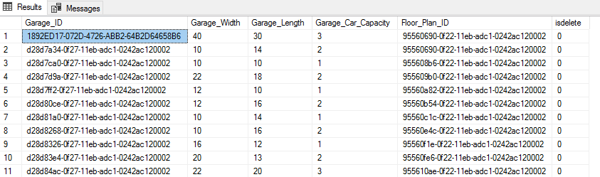

**After:** 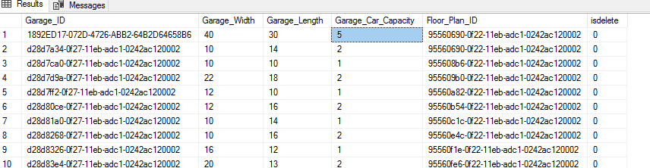

**Update Script # 2**

UPDATE[Broker_Email]

SET Broker_Email.Broker_Email='globalproperties@realestate.com'

WHERE Broker_Email_ID='41a56a18-0f27-11eb-adc1-0242ac120002'

**Report/Query Results:**

**Before:** 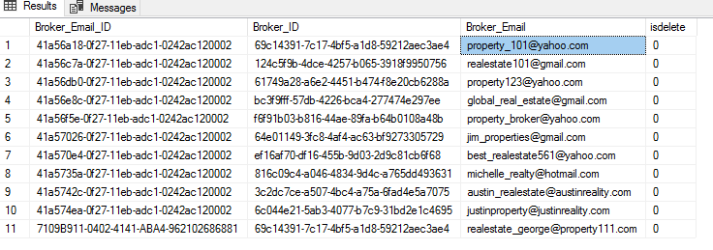

**After:**

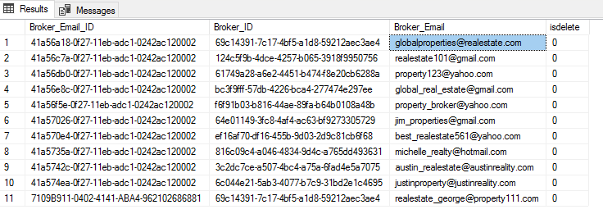

**Delete Script # 1**

UPDATE[Garage]

SET isdelete='1'

WHERE Garage.Garage_Car_Capacity='5'

**Report/Query Results:**

**Before:** 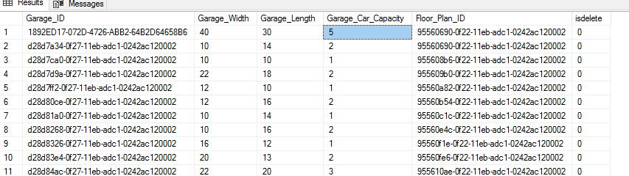

**After:**

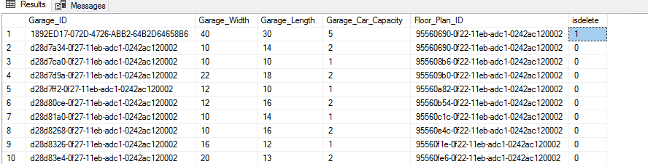

**Delete Script # 2**

UPDATE[Broker_Email]

SET isdelete='1'

WHERE Broker_Email.Broker_Email='globalproperties@realestate.com'

**Report/Query Results:**

**Before:** 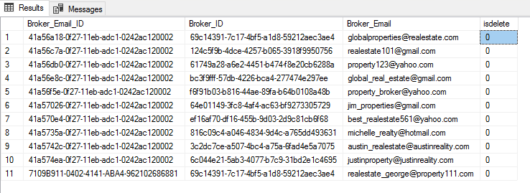

**After:** 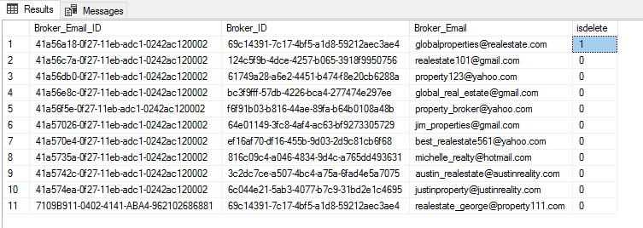

**SQL Queries Report:**

**Section: Muhammad Tahir**

**1. Report Name:** Number of Car Garage in a Property

**Report Description:** These Clients are interested in buying properties with specific number of car garage, which in this case is properties with two car garages.

**Business Purpose:** This Report will help Mr. Yun, the business owner and his agents to find specific properties according to client needs with two car garages. The report will also provide useful information regarding property such as complete street address with city and zip code, number of floors in the property and if Sprinkler system is installed in the property or not.

**SQL Code:**

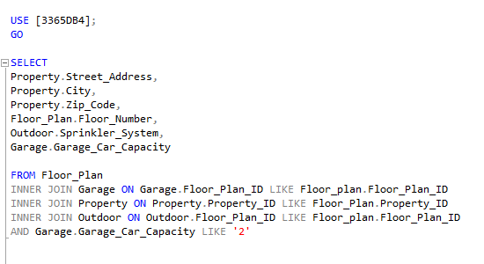

**Report/ Query Result**:

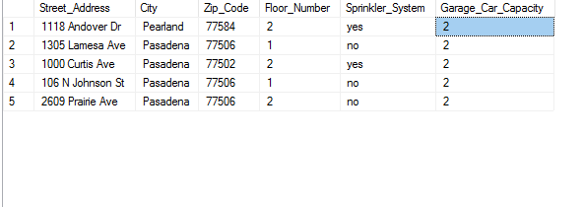

**Data List:**

1. **Property Table with Street Address, City and Zip Code:**

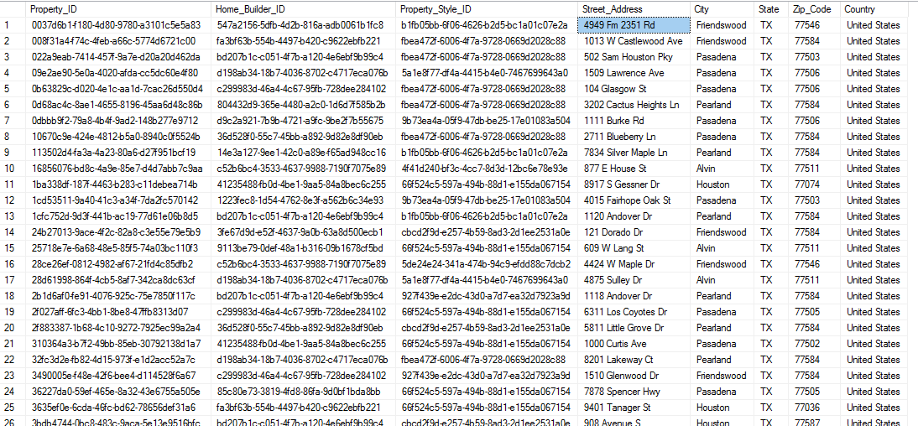

1. **Floor Plan Table:**

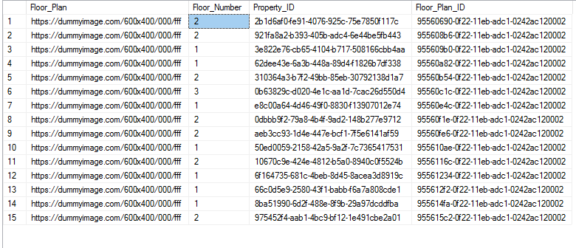

**Outdoor Table:**

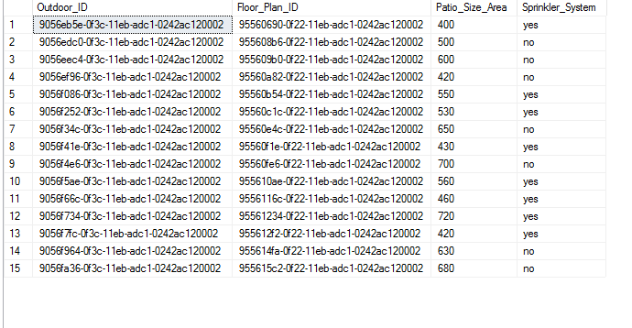

**Garage Table:**

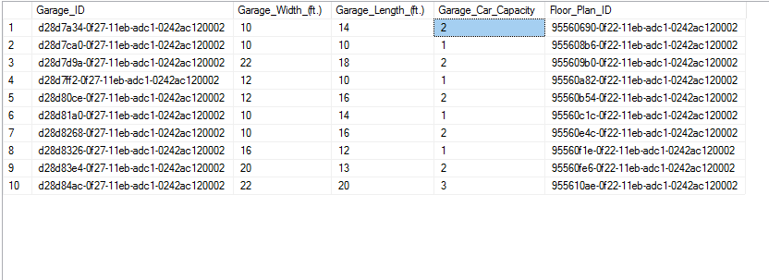

**2. Report name:** Property City Preference

**Report Description:** These Clients are interested in buying property in Specific City, which in this case is Pasadena.

**Business Purpose:** This Report will help Mr. Yun, the business owner and his agents to search the properties for clients according to their preferred city. The report will also provide useful information regarding property, such as Complete Property street address, Its top features, Property Style and number of floors in the property.

**SQL Code:**

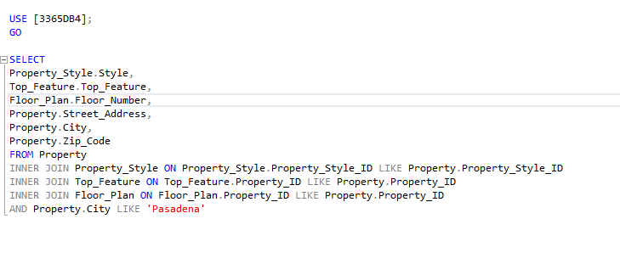

**Report/ Query Result**:

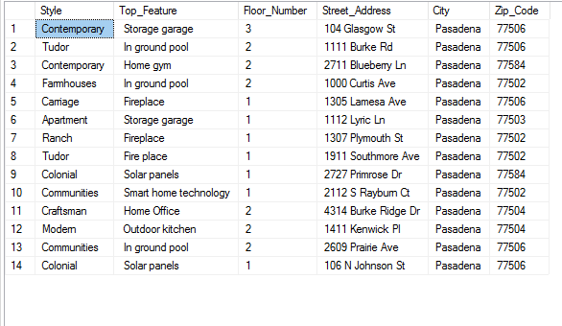

**Data List:**

1. **Property Table with Street Address, City and Zip Code:**



1. **Floor Plan Table:**



1. **Property Style Table:**

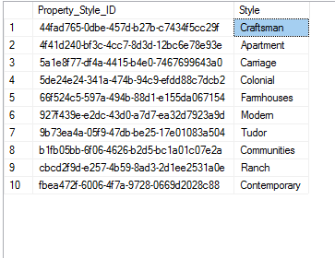

1. **Top Features Table:**

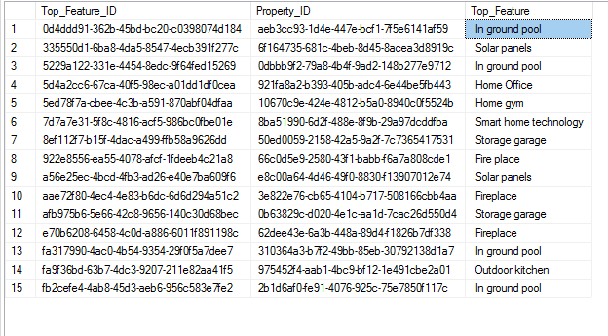

**3. Report Name:** Heating Unit Preference

**Report Description:** These Clients are interested in buying properties with specific type of Heating Unit installed, which in this case is Gas.

**Business Purpose:** This Report will help Mr. Yun, the business owner and his agents to sort specific properties according to client needs with Gas Heating Unit type. The report will also provide useful information regarding property, such as complete street address with city and zip code, number of floors in the property, Heating Unit Age and Number of rooms in the property.

**SQL Code:**

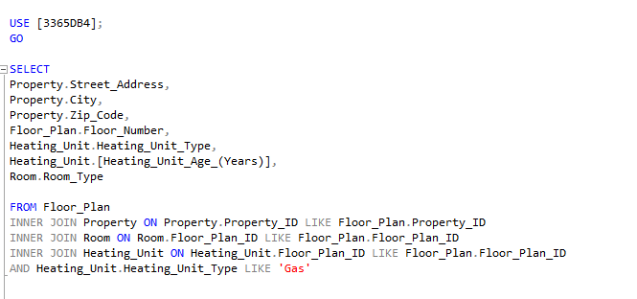

**Report/ Query Result**:

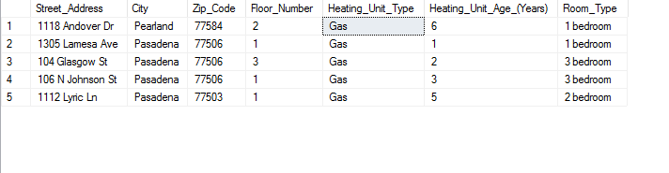

**Data List:**

1. **Property Table with Street Address, City and Zip Code**



1. **Floor Plan Table:**



1. **Heating Unit Table**

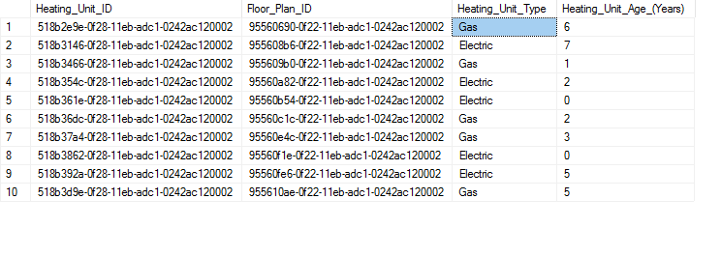

**4. Report Name:** Air Conditioning Unit Age

**Report Description:** These Clients are interested in buying properties with Air Conditioning unit of a Specific Age, which in this case is less than ten years old.

**Business Purpose:** This Report will help Mr. Yun, the business owner and his agents to find specific properties according to client needs with Air Conditioning unit of less 10 years old. The report will also provide information useful information regarding property such as complete street address with city and zip code, number of floors in the property, type of Air conditioning Unit and Number of rooms in the property.

**SQL Code:**

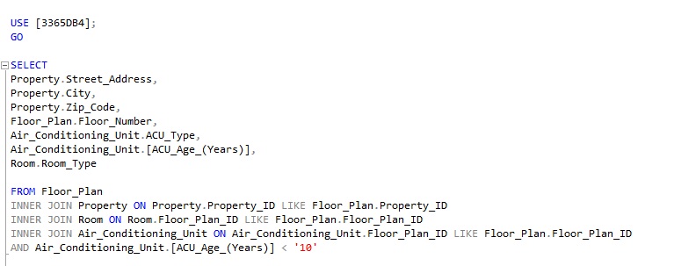

**Report/ Query Result**:

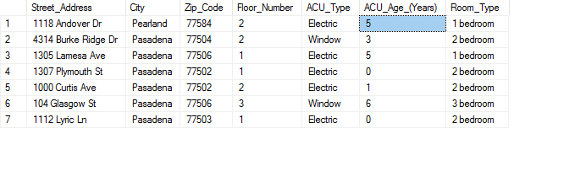

**Data List:**

1. **Property Table with Street Address, City and Zip Code:**



1. **Floor Plan Table**



1. **Air Conditioning Table**

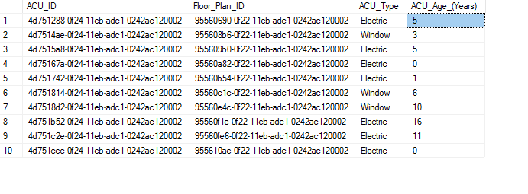

1. **Room Table**

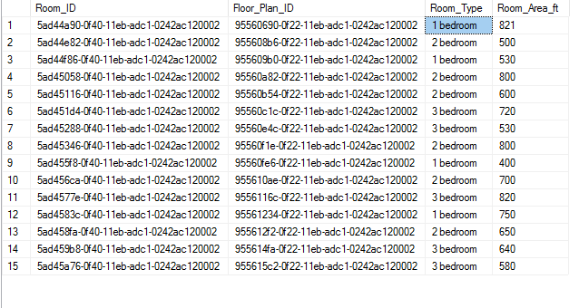

**Forms/GUI print out and description:**

**GUI 1: Client Email page view**

This is the page that users would see when they will go to client info tab and click on Client Email option. This page will provide them with a list of all the clients with their first and last names, their emails addresses and options to filter the client list by species client name and client email address.

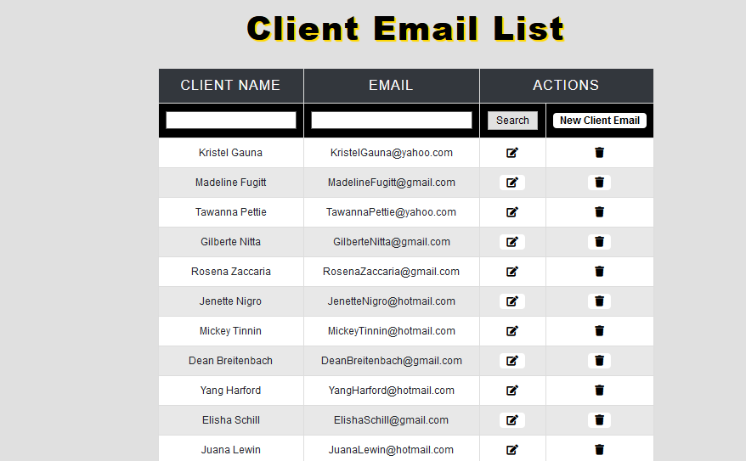

**Client Email Edit page:**

Right next to every client name and email field, there is an edit option which user can click to edit the Client email address. This page would allow user to select any client from drop down list and edit their email address.



**Add new Client Email:**

This page would allow user to select any client from drop down list and add a new email address from them.

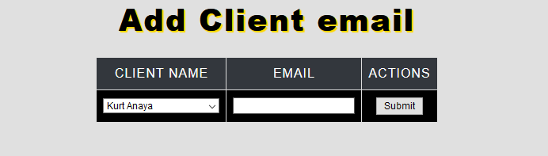

**Delete Client Email:**

On the right most side of every Client entry on client email page, users have an option to delete the client entry by clicking on trash can icon.

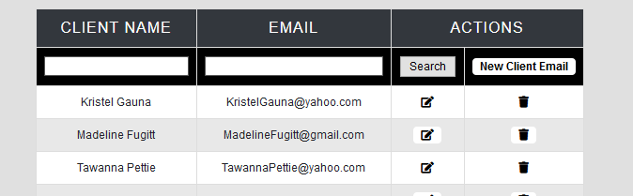

**GUI 2: Client Phone Number view:**

This is the page that users would see when they will go to client info tab and click on Client Phone Number option. In this view, users can view the client full name, their phone numbers and client types. This page also allows them to filter client by their names, phone numbers and types.

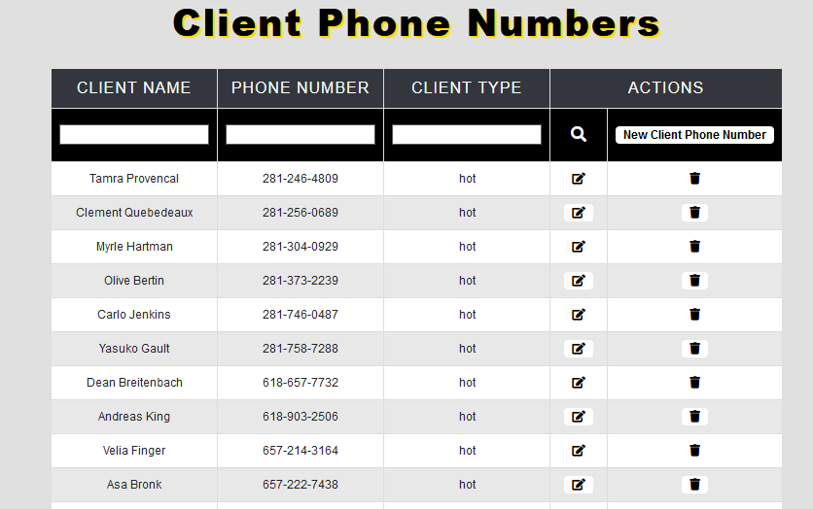

**Client Phone Number Edit:**

Right next to every field in client phone view, there is an edit option which user can click to edit the Client Phone number. The page would allow user to select any client from drop down list and edit their Phone number as well as the client type.

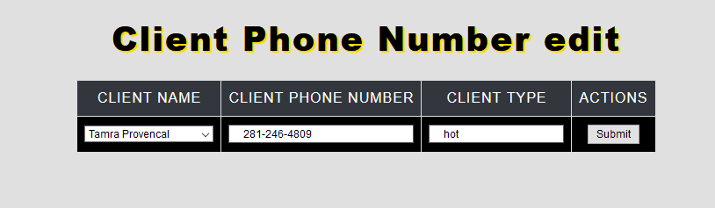

**Add new Client Phone Number:**

This page would allow user to select any client from drop down list and add a new Phone Number as well client type from them.

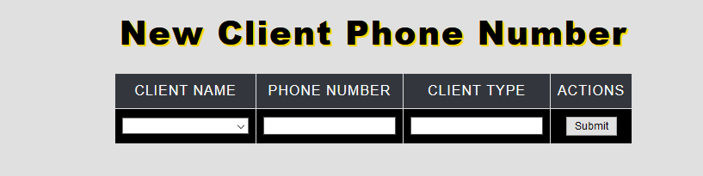

**Delete Client Phone Number:**

On the right most side of every Client entry on client Phone Number page, users have an option to delete the client entry by clicking on trash can icon.

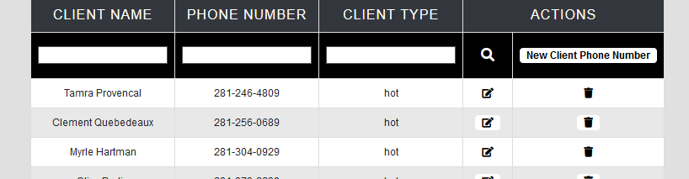

**GUI 3: Home Appraisal List View:**

This is the page that users would see when they will go to property tab and from navigation bar and click on Home Appraisal option. In this view, users can view the Property Street Address, Property are and Appraisal Value. This page also allows users to filter properties by property address, area and appraisal values.

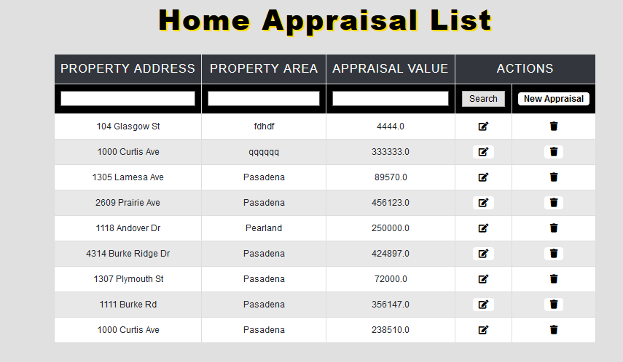

**Edit Home Appraisal:**

Right next to every field in Home appraisal view, there is an edit option which user can click to edit the Home appraisal values and property area. The page would allow users to select any property from drop down list and edit their area and appraisal value.

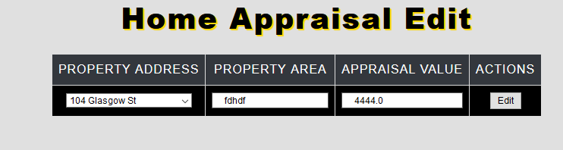

**New Appraisal:**

This page would allow user to select any property from drop down list and add a new Property area and new Appraisal value.

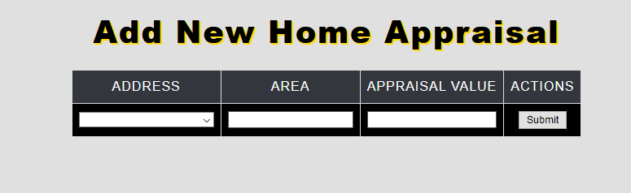

**Delete Home Appraisal:**

On the right most side of every Home appraisal entry on Home appraisal view, users have an option to delete the Home appraisal by clicking on trash can icon.

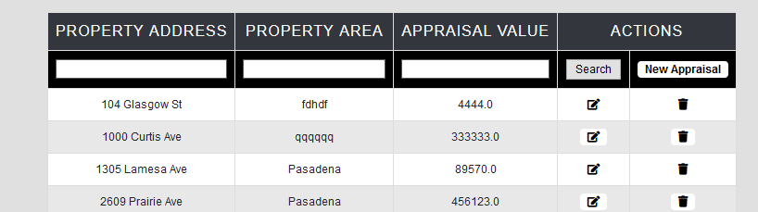

### **Robert Smith Report**

**Create Scripts:**

CREATE TABLE [Appliance](

[Appliance] varchar (20),

[Warranty_Expiration_Date] varchar (35),

[Property_ID] varchar(9),

[Appliance_ID] varchar (9) NOT NULL,

CONSTRAINT [PK_Appliance_ID] PRIMARY KEY ([Appliance_ID]),

);

CREATE TABLE [Property_Style](

[Style] varchar (35),

[Property_ID] varchar (9),

[Property_Style_ID] varchar (9) NOT NULL,

CONSTRAINT[PK_Property_Style_ID] PRIMARY KEY ([Property_Style_ID]),

);

CREATE TABLE [Floor_Plan](

[Floor_Plan] varbinary(max),

[Floor_Number] tinyint (4),

[Property_ID] varchar (9),

[Floor_Plan_ID] varchar (9) NOT NULL,

CONSTRAINT [PK_Floor_Plan_ID] PRIMARY KEY ([Floor_Plan_ID]),

);

CREATE TABLE [New_Home_Questionnaire](

[Style_Preference] varchar(255),

[Stairs_Prefernce] bit,

[Master_Bathroom] bit,

[Property_Size] nvarchar,

[Open_Floor_Plan] bit,

[Office/Study] bit,

[Formal_Dining_Room] bit,

[Patio_Or_Deck] bit,

[Sprinkler_System] bit,

[Garage] bit,

[Garage_Capacity] tinyint,

[Lot_Size_Preference] nvarchar,

[Questionnaire_ID] varchar(9) NOT NULL,

CONSTRAINT [PK_Questionnaire_ID] PRIMARY KEY ([Questionnaire_ID]),

);

CREATE TABLE [Financing_Questionnaire](

[Financing_Arranged] bit,

[Loan_Amount] money,

[Loan_Letter_Inssuance] bit,

[Enough_Funds_For_Earnest] bit,

[Preferred_Monthly_Range] nvarchar(20),

[Questionnaire_ID] varchar(9) NOT NULL,

CONSTRAINT[PK_Questionnaire_ID] PRIMARY KEY ([Questionnaire_ID]),

);

**SQL Queries:**

**SQL Query Code 1**

SELECT

Property.Style,

Property.Street_Address,

Property.City,

Top_Feature.Top_Feature,

Title_Owner.Title_Owner,

Property_Financing.Total_Price_Estimate

FROM Property

INNER JOIN Top_Feature ON Property.Property_ID=Top_Feature.Property_ID

INNER JOIN Title_Owner ON Property.Property_ID=Title_Owner.Property_ID

INNER JOIN Property_Financing ON Property.Property_ID=Property_Financing.Property_ID

WHERE

Top_Feature.Top_Feature = 'In ground pool'

**SQL Query Code 2**

SELECT

Property.Style,

Property.Street_Address,

Property.City,

Appliance.Appliance,

Title_Owner.Title_Owner,

Property_Financing.Monthly_Price_Estimate

FROM Property

INNER JOIN Appliance ON Property.Property_ID=Appliance.Property_ID

INNER JOIN Title_Owner ON Property.Property_ID=Title_Owner.Property_ID

INNER JOIN Property_Financing ON Property_ID=Property_Financing.Property_ID

WHERE

Appliance.Appliance = 'washer'

**SQL Query Code 3**

SELECT

Property.Style,

Property.Street_Address,

Property.City,

Property_Style.Style,

Floor_Plan.Floor_Number,

Property_Remodel.Date_of_Remodel

FROM Property

INNER JOIN Property_Style ON Property.Property_ID=Property_Style.Property_ID

INNER JOIN Floor_Plan ON Property.Property_ID=Floor_Plan.Property_ID

INNER JOIN Property_Remodel ON Property.Property_ID=Property_Remodel.Property_ID

WHERE

Floor_Plan.Floor_Plan = '1'

**SQL Query Code 4**

SELECT

Property.City,

Property.State,

Property.Zip_Code,

Property_Style.Style,

Floor_Plan.Floor_Number,

Open_House_Session.Date_of_Open_House

FROM Property

INNER JOIN Property_Style ON Property.Property_ID=Property_Style.Property_ID

INNER JOIN Floor_Plan ON Property.Property_ID=Property_Style.Property_ID

INNER JOIN Open_House_Session ON Property.Property_ID=Floor_Plan.Property_ID

WHERE

Property.Zip_Code = '77504'

**SQL  Insert Scripts:**

/*Insert script #1 */

INSERT into Floor_Plan(Floor_Plan,Floor_Number, Property_ID, Floor_Plan_ID)

VALUES ('https://dummyimage.com/600x400/000/fff', '2','438cc7e7-e0d2-4e00-847d-ad3d7671b507',NEWID())

/*Insert script #2 */

INSERT INTO Appliance(Appliance_ID,Property_ID,Appliance,Warranty_Expiration_Date)

VALUES (NEWID(), 'f5706d82-8974-4c8a-8db7-9370de155bec','stove','10/14/2025')

**SQL  Update Scripts:**

UPDATE[Floor_Plan]

SET Floor_Plan.Floor_Plan='https://dummyimage.com/600x400/000/000'

WHERE Floor_Plan.Property_ID = ‘6AC08E1F-E480-46DC-8A38-50E465423171’

UPDATE[Appliance]

SET Appliance.Warranty_Expiration_Date='10/20/2027'

WHERE Appliance.Appliance_ID = 'DF489DFE-D8F5-4DD4-A97F-AE4A5E1920F6'

**SQL  Soft Delete Scripts:**

UPDATE[Floor_Plan]

SET isdelete='1'

WHERE Floor_Plan.Floor_Plan_ID= '955615c2-0f22-11eb-adc1-0242ac120002'

UPDATE[Appliance]

SET isdelete='1'

WHERE Appliance.Appliance_ID='d136e060-0f24-11eb-adc1-0242ac120002'

**SQL Queries Report:**

**Report Name:**Properties in zip code 77504

**Report Description:**The clients are specifically looking for a property in the zip code area of 770504.

**Business Purpose:**The purpose of this report will help the real estate agent find properties in the zip code area of 77504. Not only will this report pick up the client requested zip code area, but it will also display the style of the home, number of floors, and the open house date that fall under the requested zip code.

**SQL Code:**

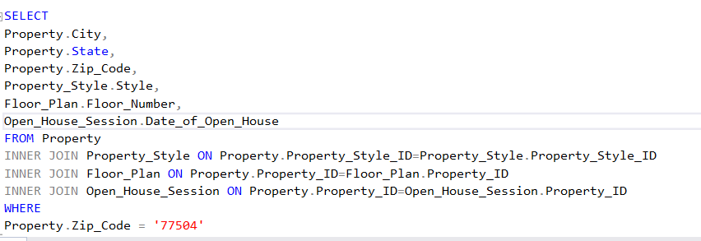

**Report/ Query Result:**

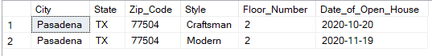

**Data List:**

1. **Property table with city, state, and zip code**

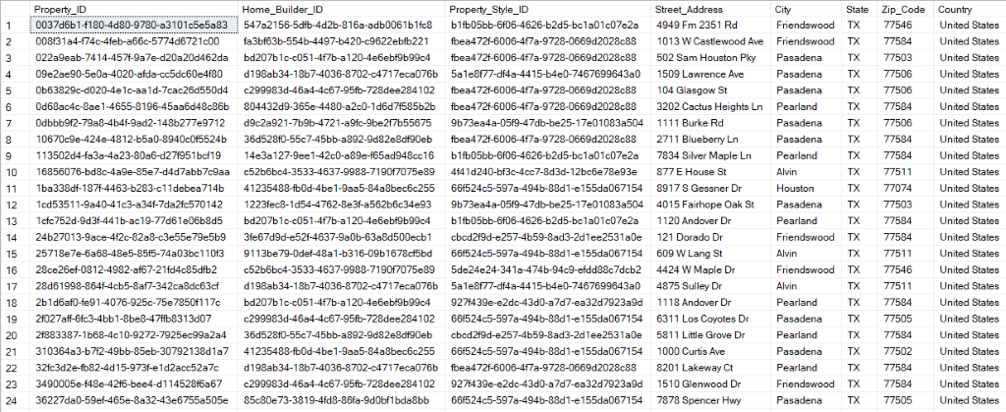

1. **Property Style table**

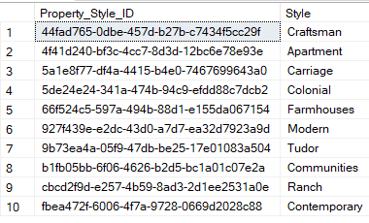

1. **Floor Plan Table**

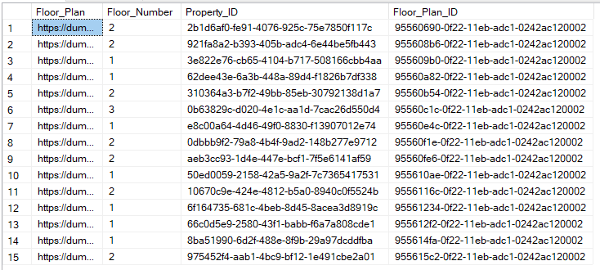

1. **Open House Session Table**

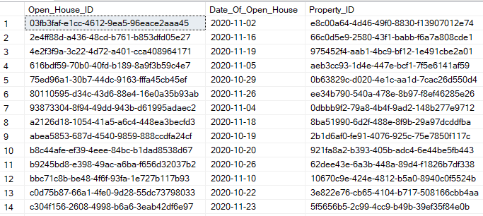

**Report Name:**Properties that include in ground swimming pool

**Report Description:**The clients a property with the request of must include a swimming pool

**Business Purpose:**This report shows real estate agent all properties that meet the condition of the client, in this case a swimming pool. The system will also pull other attributes of properties that have in ground swimming pool, such as the style, street address, city, Total price estimate and the title owner of the property.

**SQL Code:**

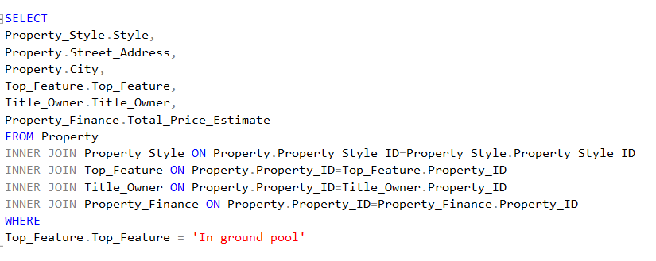

**Report/ Query Result:**

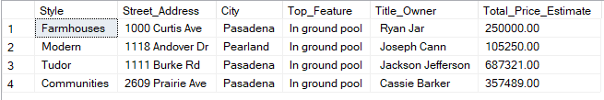

**Data List:**

1. **Property Style table**



1. **Property table with street address and city**



1. **Top Features Table**

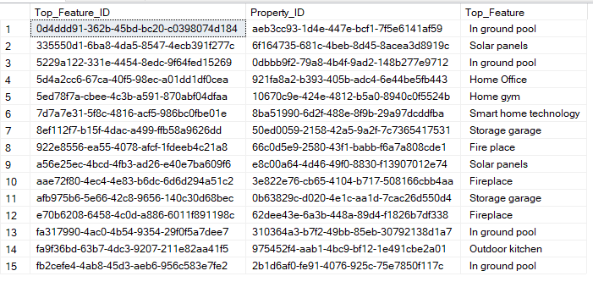

1. **Title Owner Table**

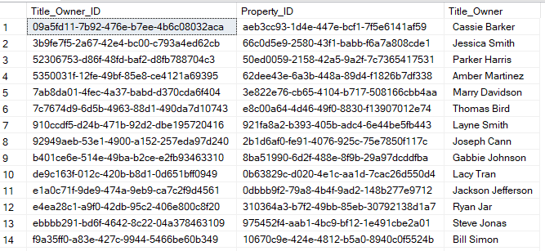

1. **Property Finance Table**

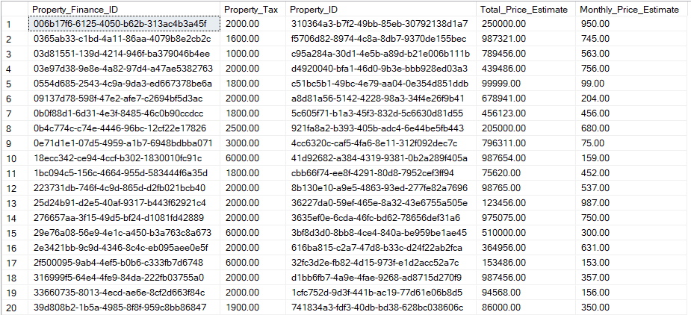

**Report Name:**Properties that include a washer

**Report Description:**The client is looking for a property that includes a washer

**Business Purpose:**The purpose of this report will help the real estate agent find properties that come with a washer. Not only will this system pick up the client request of a property that includes a washer, but is will also display the city and street address of the properties that include a washer as well as the title owner and the monthly price estimate of the property

**SQL Code:**

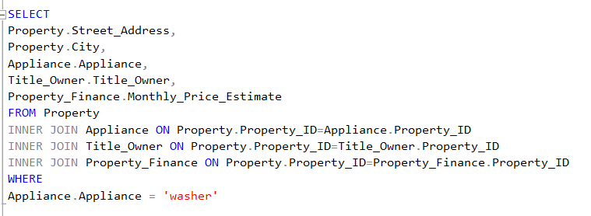

**Report/ Query Result:**

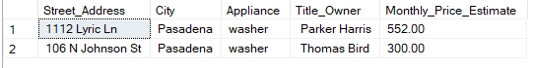

**Data List:**

1. **Property table with street address and city**



1. **Appliance table**

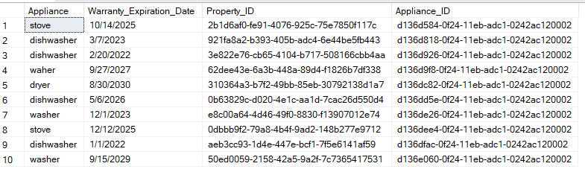

1. **Title Owner table**



1. **Property Finance**



**Report Name:**Properties with 1 story

**Report Description:**The client is looking for a property with only 1 story.

**Business Purpose:**The purpose of this report will help the real estate agent find properties the clients request of properties with only 1 story. Not only will the system pick up the client request but, it will display the property style, street address, city and the date remodeled of properties that are under the clients requests

**SQL Code:**

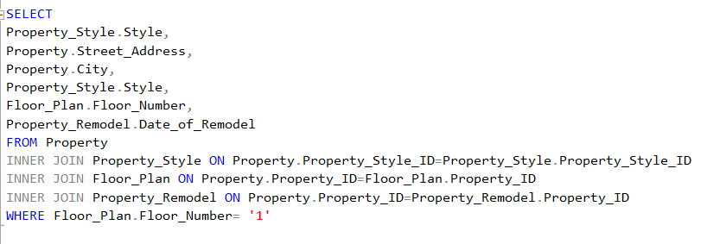

**Report/ Query Result:**

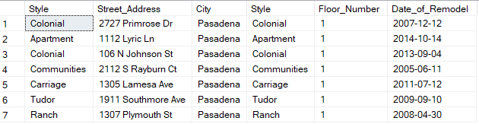

**Data list:**

1. **Property Style table**



1. **Property table with street address and city**



1. **Floor Plan table**



1. **Property Remodel table**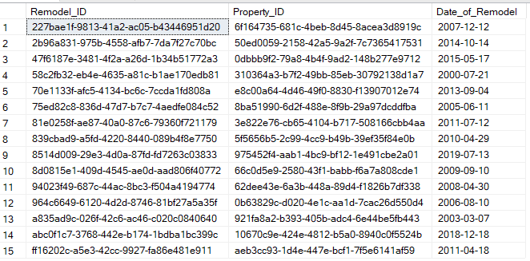

**Outdoor GUI Screenshots:**

1. **Outdoor New Before:**

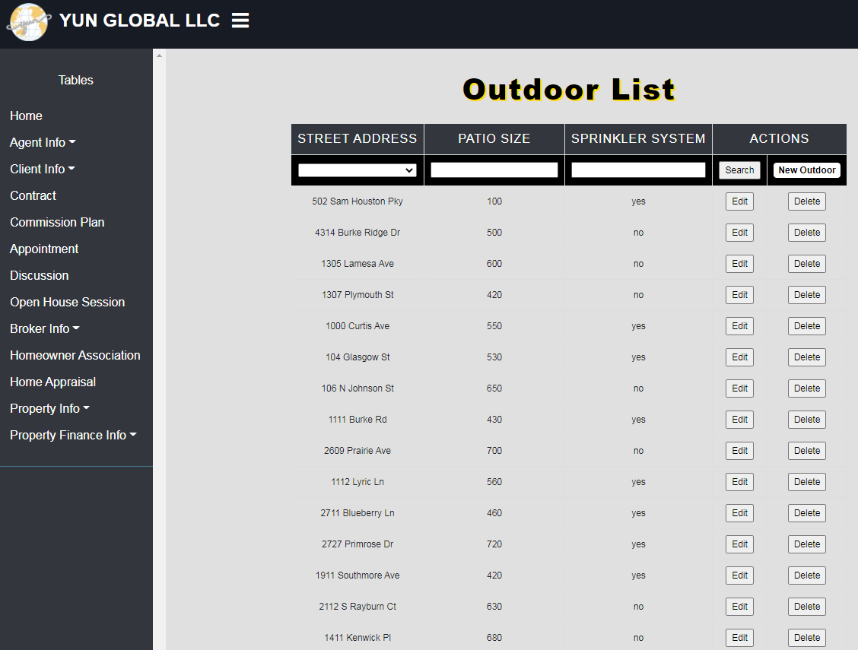

1. **Outdoor New After:**

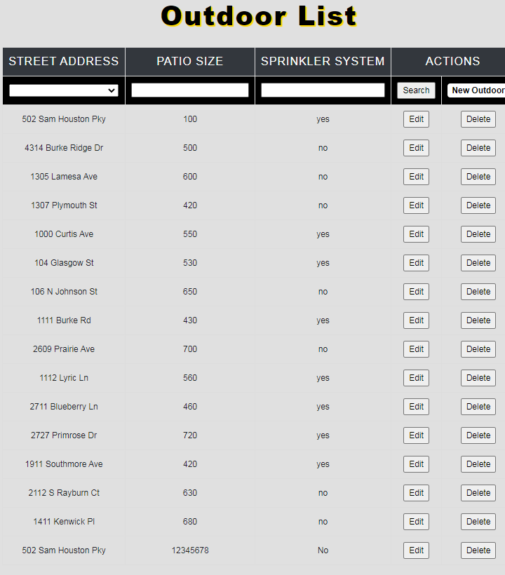

1. **Outdoor Edit Before:**

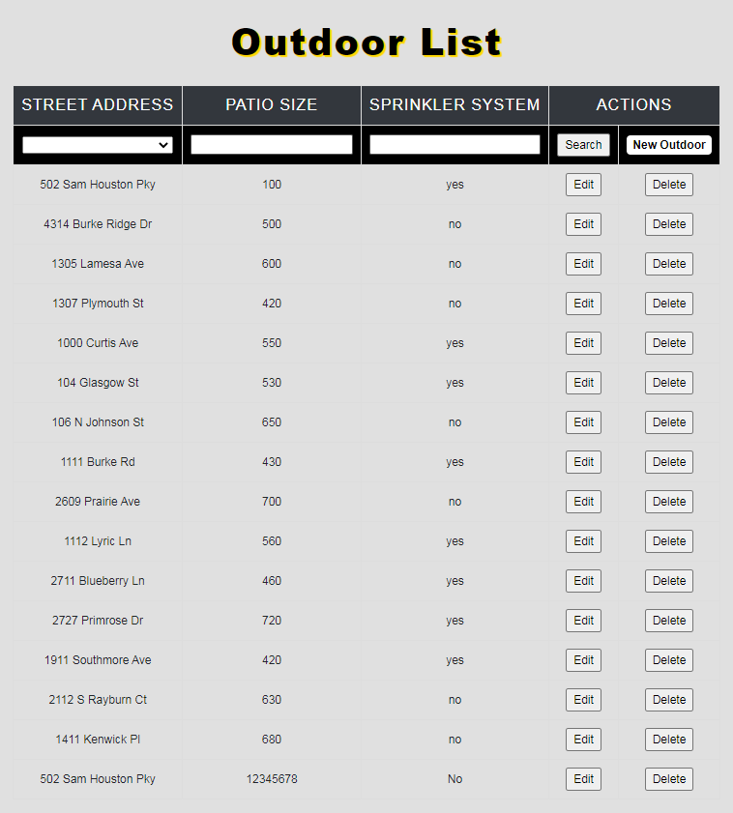

1. **Outdoor Edit After:**

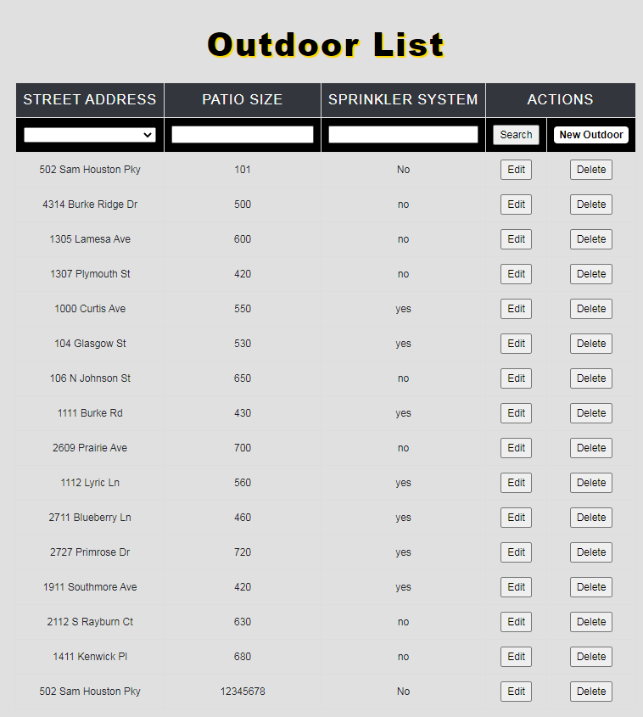

1. **Outdoor Delete Before:**

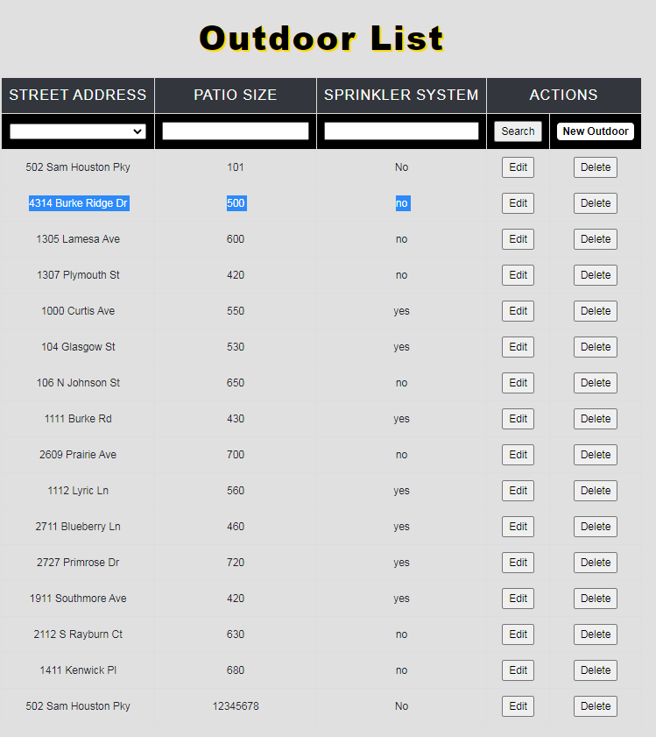

**Property Remodel GUI Screenshots:**

1. **Property Remodel Date New Before:**

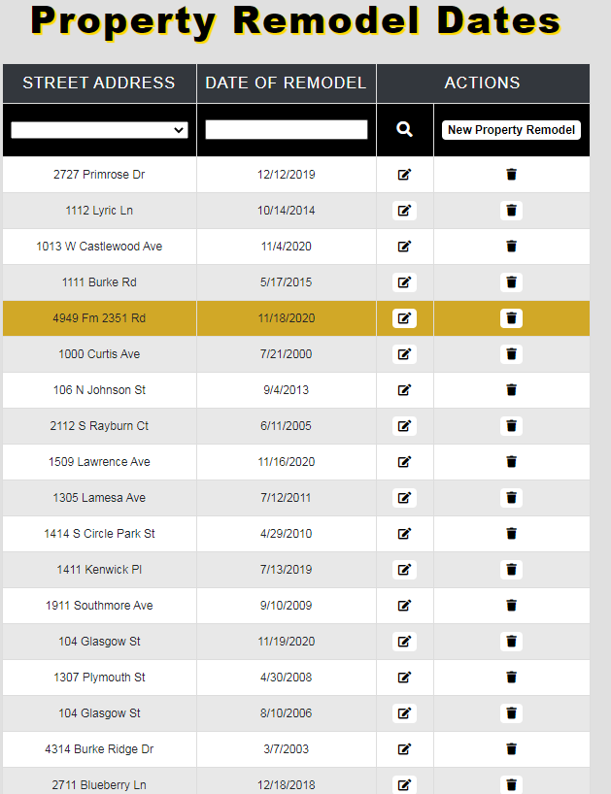

1. **Property Remodel Date New After:**

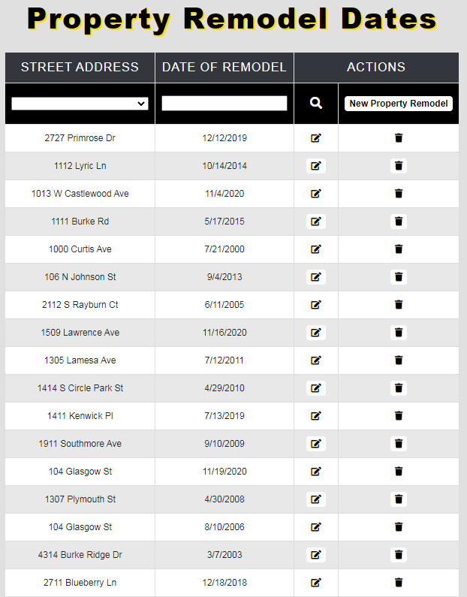

1. **Property Remodel Date Edit Before:**

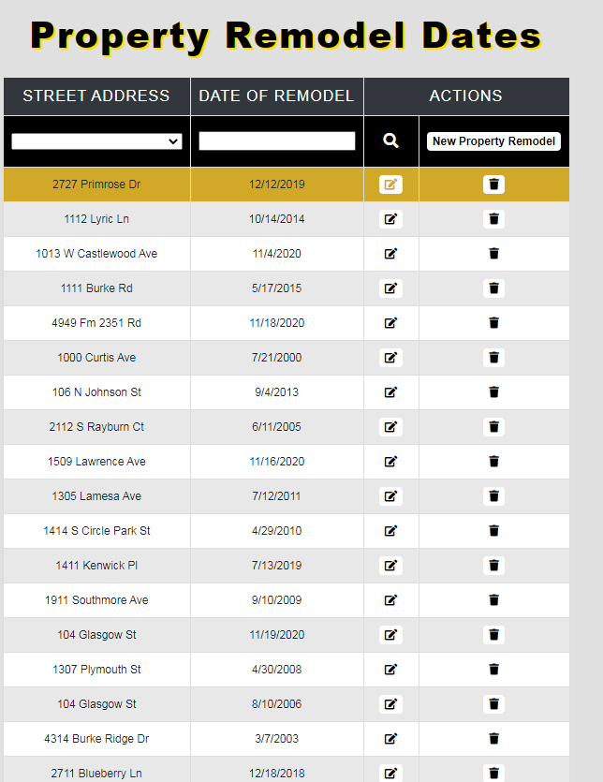

1. **Property Remodel Date Edit After:**

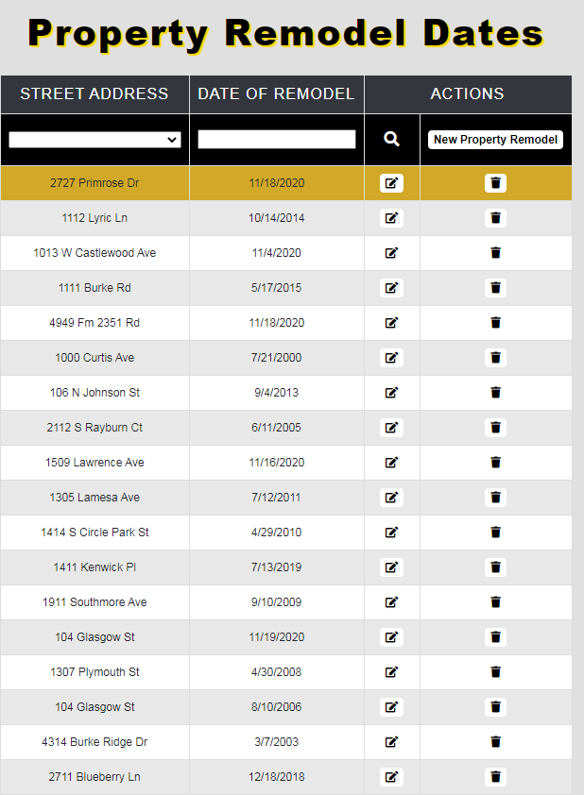

1. **Property Remodel Delete Before:**

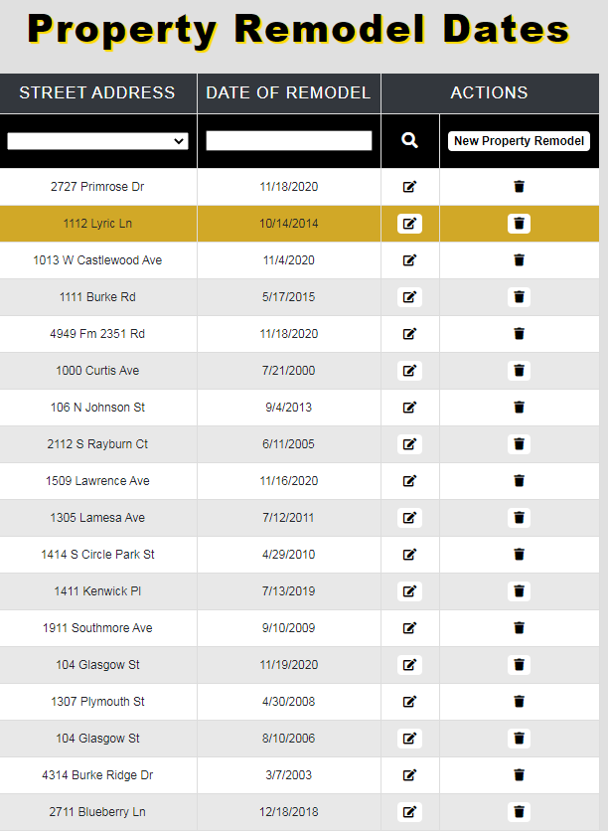

1. **Property Remodel Date Delete After:**

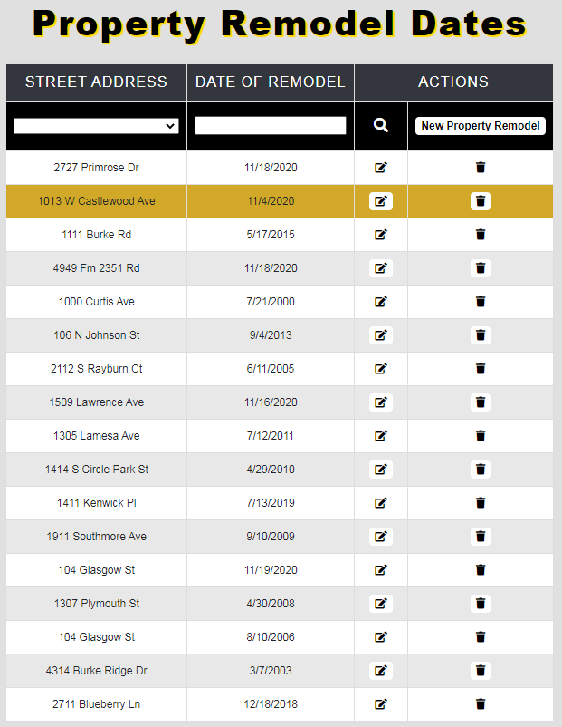

**Room GUI Screenshots:**

1. **Room New Before:**

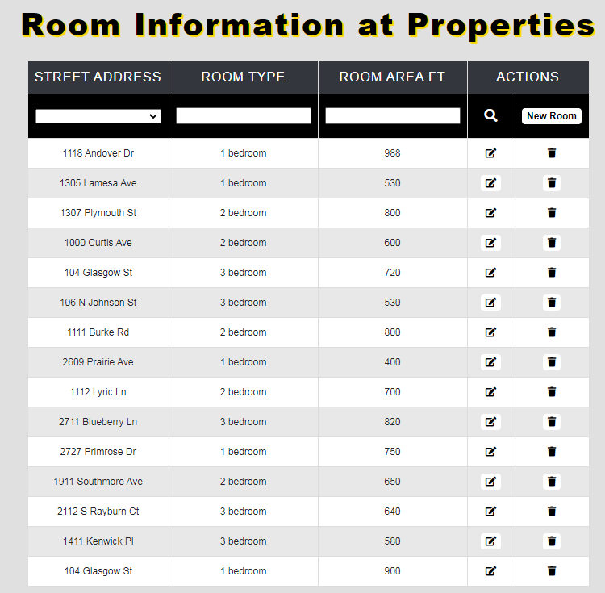

1. **Room New After:**

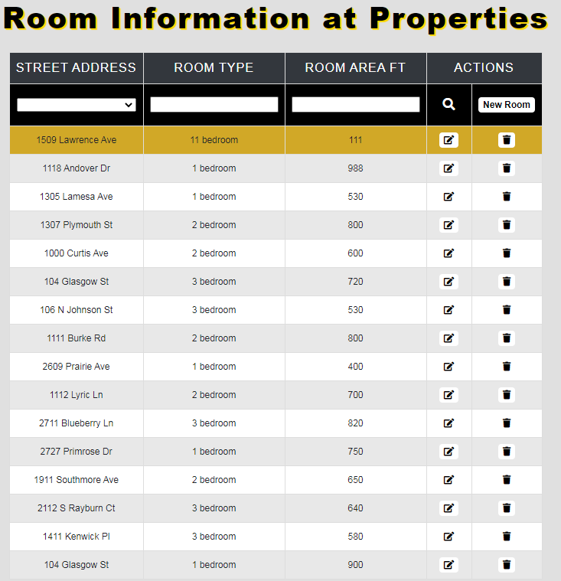

1. **Room Edit Before:**

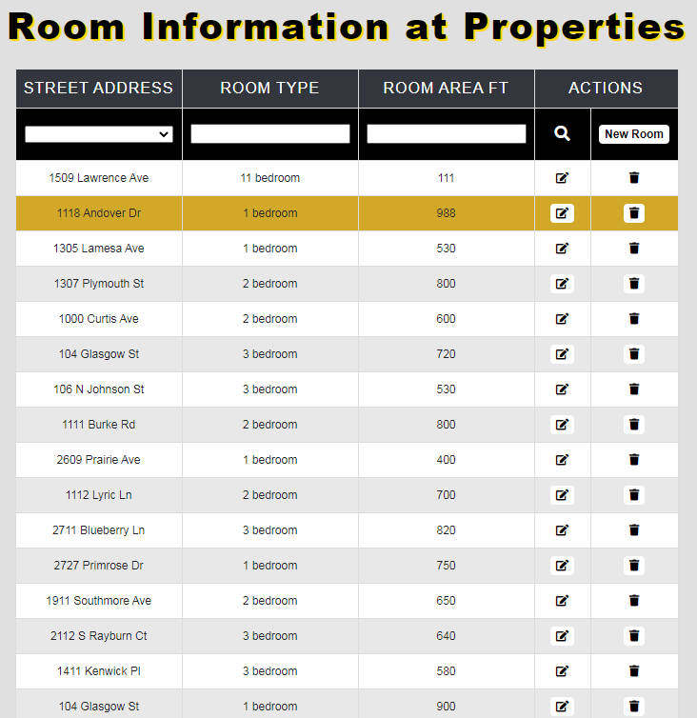

1. **Room Edit After:**

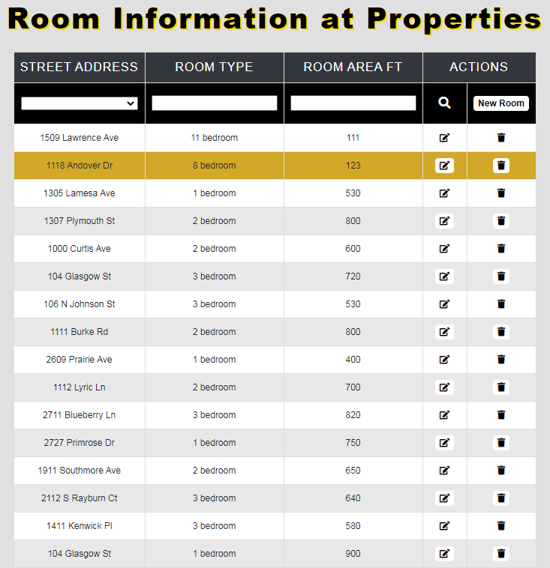

1. **Room Delete Before:**

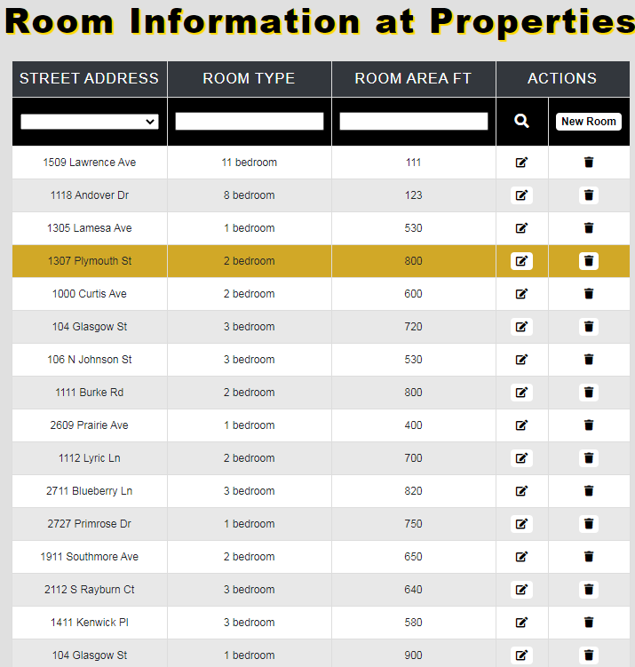

1. **Room Delete After:**

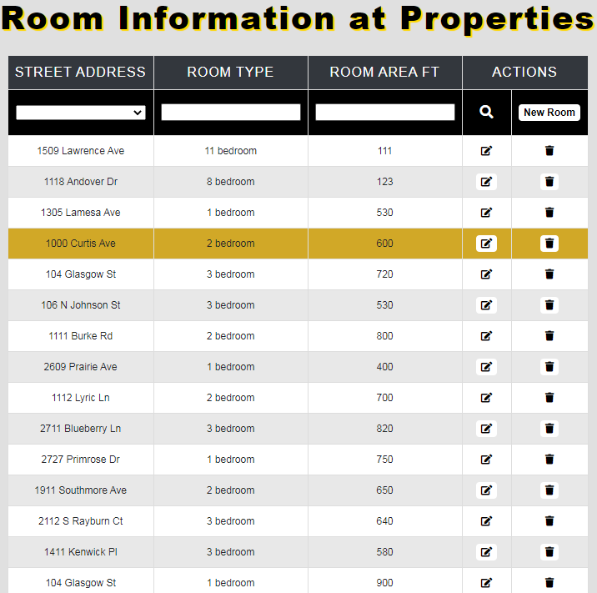

### **Sunny Sembhi Report**

**Create Scripts:**

CREATE TABLE [HOA_Phone_Number] (

[HOA_Phone_Number_ID] varchar(9) NOT NULL,

[HOA_ID] int,

CONSTRAINT [PK_HOA_Phone_Number]  
 PRIMARY KEY ([HOA_Phone_Number_ID]),

);

CREATE TABLE [Discussion] (

[Discussion_ID] int NOT NULL,

[Agent_ID] int,

[Client_ID] int,

[Discussion_Medium] varchar(255),

[Discussion_Time] int,

[Discussion_Topic] varchar(255),

[Discussion_Summary] varchar(255),

CONSTRAINT [PK_Discussion] PRIMARY KEY ([Discussion_ID]),

);

CREATE TABLE [Client_Selling_Plan] (

[Selling_Plan_ID] varchar(9) NOT NULL,

[Contract_ID] int,

[Listing_Price] int,

[Lowest_Price] int,

[Ideal_Price] int,

[Overall_Commission_%] int,

[Agent_Commission_%] int,

[Ideal_Timeframe] varchar(9),

CONSTRAINT [PK_Client_Selling_Plan] PRIMARY KEY ([Selling_Plan_ID]),

);

CREATE TABLE [dbo].[Property_Flyer](

[Flyer_Id] varchar(9) NOT NULL,

[Property_Id] varchar(9) NOT NULL,

[Flyer] nvarchar(255),

CONSTRAINT [PK_Flyer_Id] PRIMARY KEY ([Flyer_ID]),

);

CREATE TABLE [dbo].[Nearby_Businesses](

[Nearby_Businesses_Id] varchar(9) NOT NULL,

[Flyer_Id] varchar(9) NOT NULL,

[Business] nvarchar(255),

[Distance_from_Property] varchar(255),

[Address] nvarchar(255),

CONSTRAINT [PK_Nearby_Businesses_Id] PRIMARY KEY ([Nearby_Businesses_Id])

);

CREATE TABLE [dbo].[Nearby_School_District](

[School_District_Id] varchar(9) NOT NULL,

[Flyer_Id] varchar(9),

[School_District] nvarchar(255),

CONSTRAINT [PK_School_District_Id] PRIMARY KEY ([School_District_Id]),

);

**Data Created:**

**Client Email:**

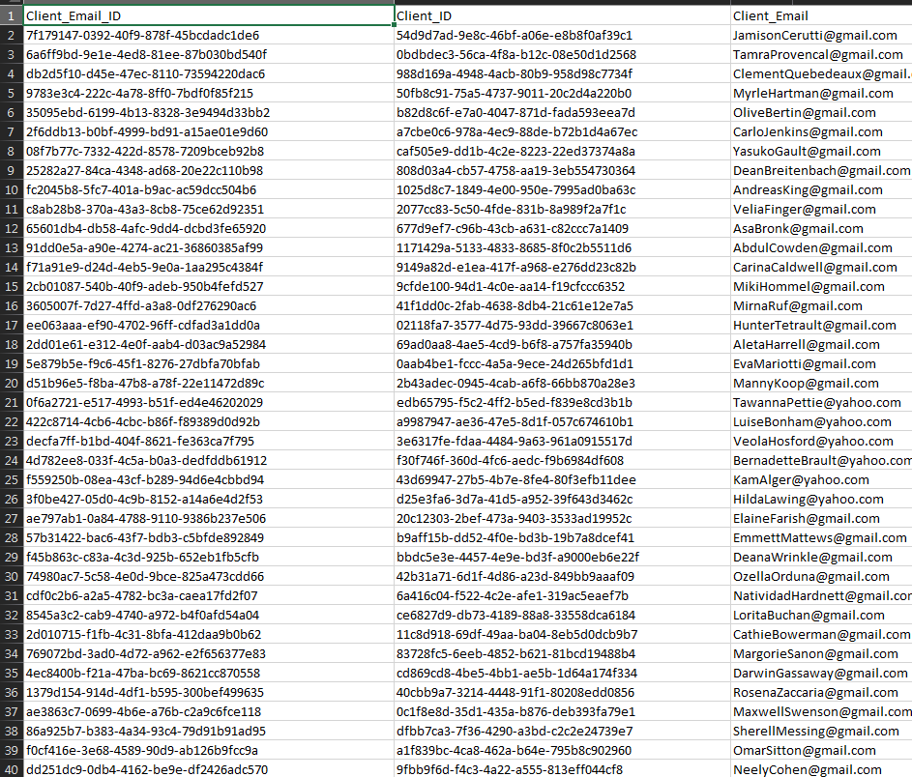

**Client Email(cont.)**

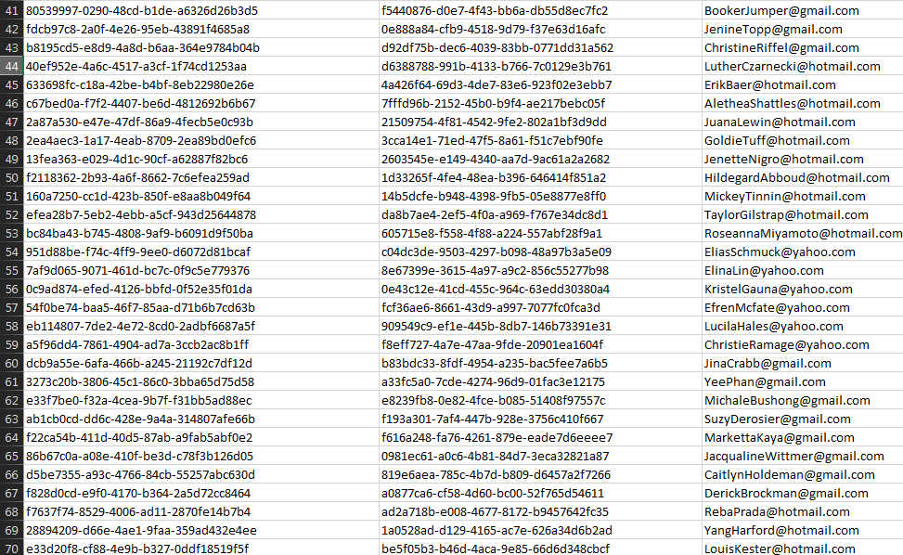

**Client Email(cont.)**

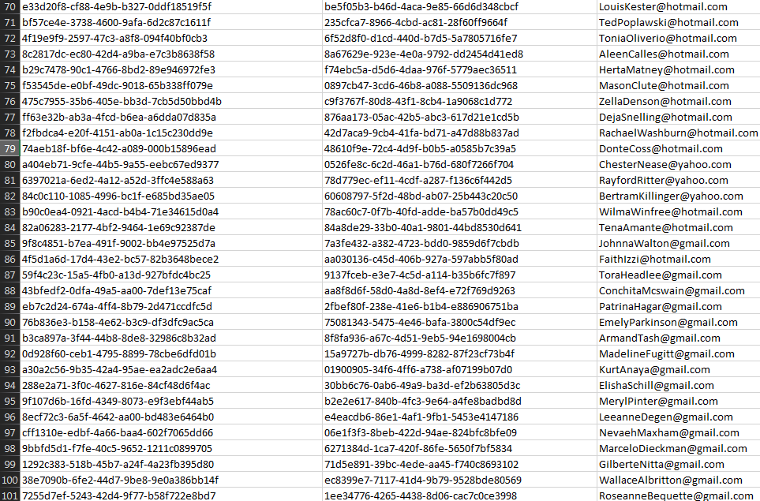

**Client Phone Number:**

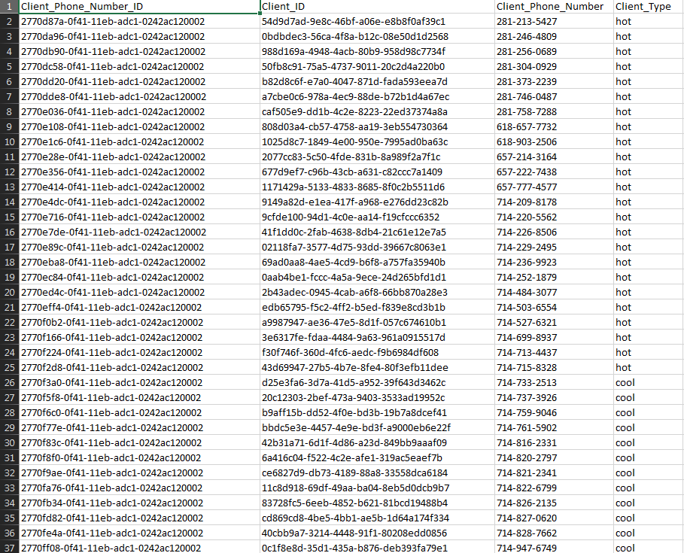

**Client Phone Number: (cont.)**

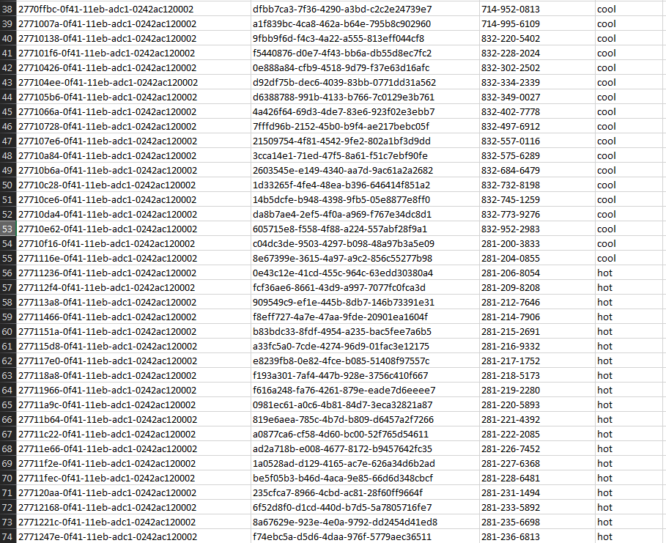

**Client Phone Number: (cont.)**

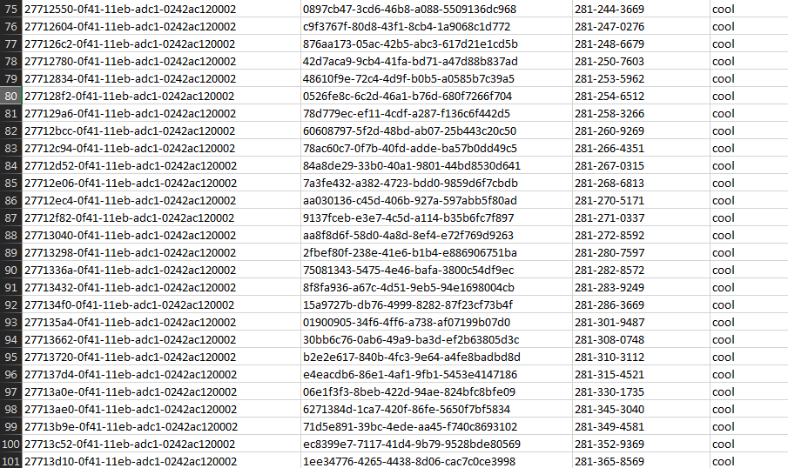

**Client Status:**

|  |  |
| --- | --- |
| Client_Status_ID | Client_Status |
| 7fc8c87c-5ad9-496c-991d-682c053ac686 | Uninterested |
| 9e084ced-27a5-49aa-9054-dc20239ba009 | Bought Property |
| b0e608d8-4fdd-4b44-ae03-b8209ac117d7 | Low Financial Status |
| 9553f186-1ff7-4a5b-9aae-73165eca4e78 | Interested in Selling |
| 4e9323df-8039-4503-b05e-1ec1d1f9532b | Interested in Buying |
| 4aa7c5d2-4c48-47c5-9d82-a925845d8438 | Using a Loan |
| 53c72e52-f00a-49d2-a311-2f767da6b495 | In Need of a Loan |
| c9b73a36-e0cf-4b42-ab68-c19bcb0080e0 | Employment Verified |
| a16773c5-f41d-426f-89fb-1f0c879419a3 | Background Information Required |
| f64debc9-f680-4e73-a6e4-474235cb3b51 | Background Information Acquired |
| ed2312a7-aee2-4d84-b1c7-9409de9406c0 | Proof of Employment Needed |
| e8fc074d-93df-4ef4-87c7-5e323eecf228 | Active |
| 22698723-5845-4d0f-860d-070200c56fa3 | Inactive |
| f4e2e6f6-65ab-4151-b069-ac797ce4d358 | Closed |
| f07f4b26-61fe-456c-8e28-65c8e294c7a3 | Under Contract |
| 8142464e-c7fa-44c5-bd17-7c0f437e998b | Pending |

**Commission Plan:**

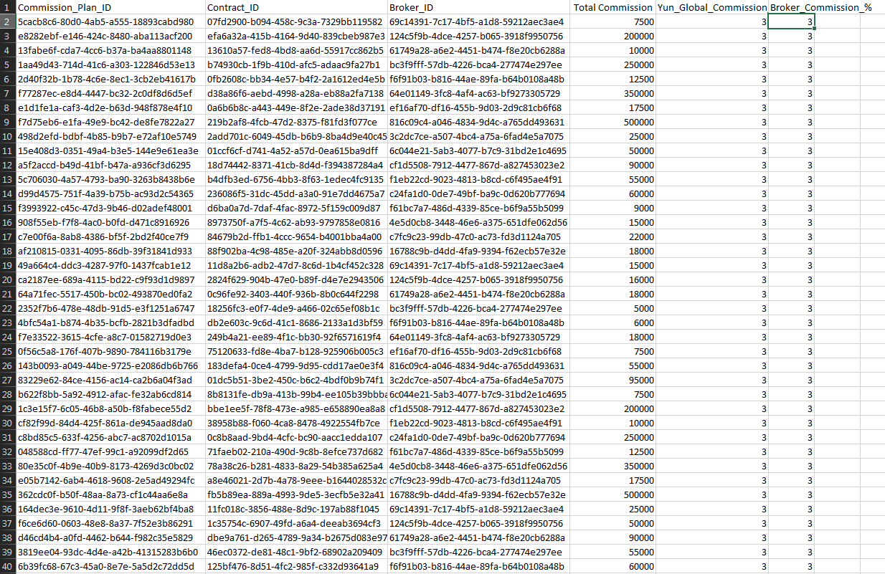

**Commission Plan: (cont.)**

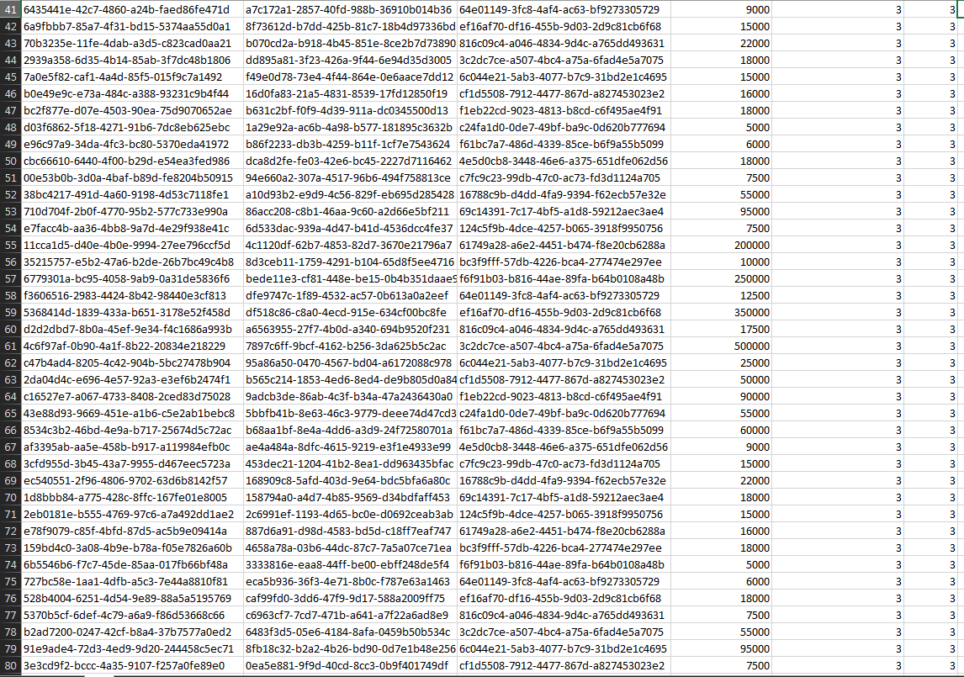

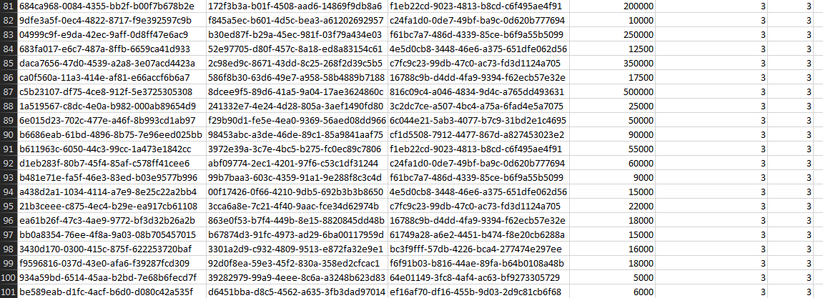

**Discussion:**

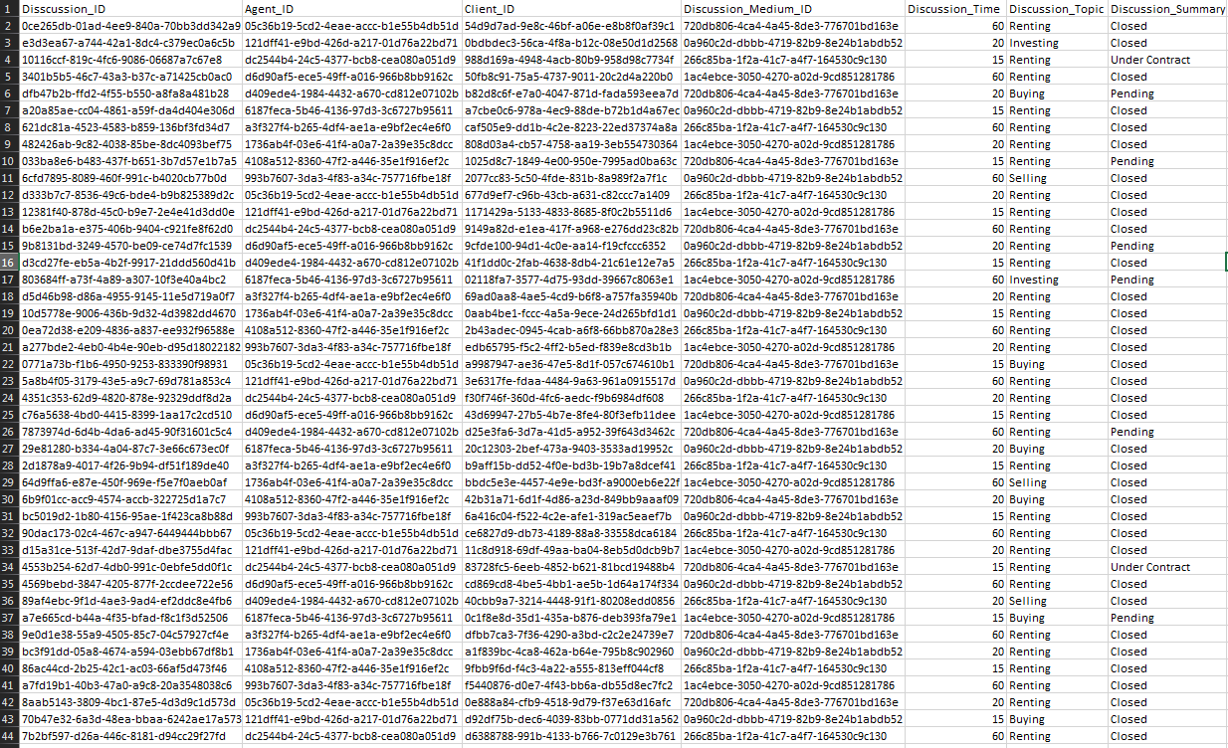

**Discussion: (cont.)**

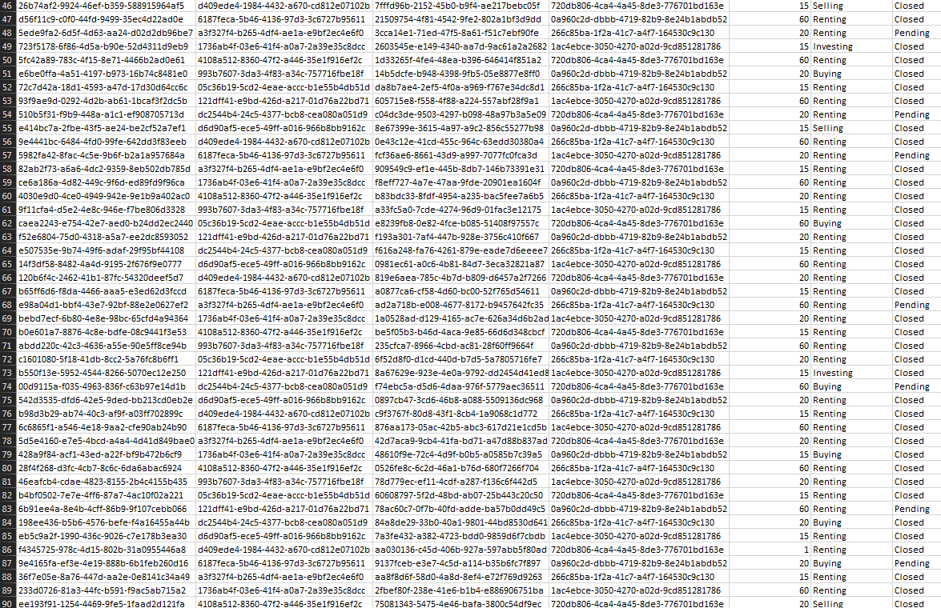

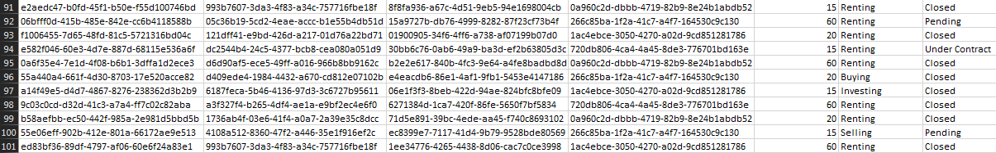

**HOA Phone Number:**

|  |  |  |  |
| --- | --- | --- | --- |
| HOA_Phone_Number_ID | HOA_ID | HOA_Phone_Number | HOA_Phone_Type |
| a0a10255-fa60-4be1-bba8-d8430af751ce | e89fc8e8-0f79-11eb-adc1-0242ac120002 | 214-200-5917 | Cell Phone |
| cb5448b5-fc39-48c3-bb8b-4572d34c60ca | e89fcb86-0f79-11eb-adc1-0242ac120002 | 214-204-8783 | Home Phone |
| deba1151-28b6-4078-96b5-b7282f08a4bb | e89fcc8a-0f79-11eb-adc1-0242ac120002 | 214-205-7391 | Office Phone |
| 6b689574-0729-44d4-b419-3cbcc2458dfe | e89fcd5c-0f79-11eb-adc1-0242ac120002 | 214-206-2155 | Cell Phone |
| d8c80158-7afc-49ac-b354-687959b0d351 | e89fce24-0f79-11eb-adc1-0242ac120002 | 214-207-1719 | Home Phone |
| 6d48a68a-227b-49f6-a61e-a2c7f15eda58 | e89fcef6-0f79-11eb-adc1-0242ac120002 | 214-209-8095 | Office Phone |
| 14d1eaa2-c9cf-4a61-86b8-bcdfca3cdea1 | e89fd072-0f79-11eb-adc1-0242ac120002 | 214-210-7786 | Cell Phone |
| 25bad8a6-1855-4f57-9790-602566f6cf9e | e89fd310-0f79-11eb-adc1-0242ac120002 | 214-216-8793 | Home Phone |
| 89618aa3-1d2c-4fbc-bf70-04cf34ef541b | e89fd3e2-0f79-11eb-adc1-0242ac120002 | 214-217-7015 | Office Phone |
| e7fe3f90-3d56-4b59-b197-1154536078de | e89fd4a0-0f79-11eb-adc1-0242ac120002 | 214-219-7094 | Cell Phone |
| 65daaa14-bec4-4ec0-88b8-5c2aaa1d0630 | e89fd568-0f79-11eb-adc1-0242ac120002 | 214-220-3866 | Home Phone |
| 029f1a30-520d-4f66-a0f3-a36dbdf72a94 | e89fd626-0f79-11eb-adc1-0242ac120002 | 214-221-9221 | Office Phone |
| 68f2d167-6f7e-4e57-b8ba-bcf829d66d26 | e89fd6e4-0f79-11eb-adc1-0242ac120002 | 214-224-0308 | Office Phone |
| a2fb0a62-ecf5-444e-819b-567c6b3c8d23 | e89fd7a2-0f79-11eb-adc1-0242ac120002 | 214-229-4031 | Cell Phone |
| a00989bb-2e2a-4212-a23e-265334e68277 | e89fd9b4-0f79-11eb-adc1-0242ac120002 | 214-231-8186 | Home Phone |

**Nearby Business:**

|  |  |  |  |  |
| --- | --- | --- | --- | --- |
| Business_ID | Flyer_ID | Business | Distance_from_Property | Address |
| 62ee62f1-861d-4a07-bbb6-0b87007f277e | 33c9ddbb-681b-4b5c-b325-5e0fe4c6eb6d | Super Market | 5 miles | 15632 Westpark Dr, Houston, TX 77082 |
| a18e1061-4b42-419b-9b31-d72d7a05d660 | dc60facf-fe57-4491-bc3b-e3b4ef38ddc1 | Sysco | 2 miles | 1390 Enclave Pkwy, Houston, TX 77077 |
| 7527dc28-4989-49dc-9105-9a96df543ee5 | aa67fe71-43d8-4269-b8b2-34730dd09817 | ConocoPhillips | 2 miles | 925 N Eldridge Pkwy, Houston, TX 77079 |
| dfed6d02-a2c2-45cf-b8ac-ba421912746e | 854858d5-86e5-4f59-bc48-28edfd858deb | Enterprise Products Partners | 15 miles | 9420 West Sam Houston Pkwy N, Houston, TX 77040 |
| ddf17cfc-13b2-45ff-9168-f8b16fb37a3f | 447aa8d3-c614-4c12-b8a0-765b97bb7a58 | Raisin Chicken | 20 miles | 333 Clay St #1600, Houston, TX 77002 |
| 79a660c9-ad53-4d35-b96d-fca7ca7f2cfb | 3a48d435-aa79-475c-b7b0-54a2eec8b7a5 | CenterPoint Energy | 15 miles | 6363 Navigation Blvd, Houston, TX 77011 |
| 2e294431-7236-406e-a296-6a6bd697a5c7 | 1deffc9e-6e01-44be-b053-6f1178d2cbd4 | Academy Sports + Outdoors | 12 miles | 2320 Hwy 6, Houston, TX 77077 |
| 94dea2fb-f995-444a-962e-b58ac33f144b | 0cd27d19-1a40-4095-9523-4e73fb41b28a | JP Morgan Chase | 6 miles | 9900 Katy Fwy, Houston, TX 77055 |
| 3ec1edd9-05c8-45ad-8888-52b36669c789 | f0bf1f3c-e46a-4da8-8ef2-1f8fa0abbe33 | Chevron | 5 miles | 12968 Westheimer Rd, Houston, TX 77077 |
| 1299085c-b81e-4f8e-b18b-e5a93df26ebb | 08f2a8c2-fde3-4556-bc45-583dce9062d0 | Men's Wearhouse | 3 miles | 5602 Westheimer Rd, Houston, TX 77056 |
| aa60d3c9-eb1d-4eef-9849-3e2c9c0bc345 | 7cbe179a-0578-41cc-b9b7-564ab7b59ad1 | Shell Oil Company | 18 miles | 2747 Addicks-Howell Road, S Texas 6, Houston, TX 77082 |
| 15ed3a00-0ec0-4b60-b650-a94e1de56bcb | 4f060590-1f1e-45b0-86d1-8945725c70a2 | Texas Children Hospital | 25 miles | 6621 Fannin St, Houston, TX 77030 |
| 51eb69ae-cdbb-48b4-9c73-1437c7b6ecaa | 6b04942a-5d2d-4531-8409-434c3b157d12 | Shipley Do-Nuts | 5 miles | 9203 S Main St, Houston, TX 77054 |
| f2c4091b-25e7-485c-8197-9ef3ead7efd5 | 86fac3c1-04b4-4874-8e9b-1b4d610e5e6a | McDonalds | 2 miles | 10315 S Post Oak Rd, Houston, TX 77035 |
| e77ceabf-5b45-4448-a3f0-808252b92d04 | 09812b88-057a-440d-8889-714e1187e663 | Direct Energy | 23 miles | 6575 W Loop S, Bellaire, TX 77401 |

**Nearby School District:**

|  |  |  |
| --- | --- | --- |
| School_District_ID | School_District | Flyer_ID |
| 9c971f11-fbac-4155-b3aa-44a52b078549 | Feris School District | 73d93288-a216-4887-8b5d-6d916ac25b58 |
| f1219d01-8a7c-4b5b-93c9-ca75b32d7b5e | Allen School District | 13c7f157-4be7-47c3-b640-a4b0b6426767 |
| e5c5912b-6a6a-4e56-abdc-bfdf3392610f | Lovejoy School District | e51057fe-255b-431f-b3bf-c610035bd9a9 |
| 3b8ba519-0424-47bc-a4fd-f2e69096b1d7 | Kennedy School District | da631579-7b92-4b91-824b-a8d5a6cfd275 |
| 38214038-a9aa-4df1-96d1-71e2516fe0ce | Alpine School District | 0410fe0e-f344-4d6f-9959-f6db5a0e9e3a |
| 0b9bfb19-b9f5-46b4-87ce-9ece466811f8 | Rocksprings School District | 041c00ff-8a44-4e67-a949-85347eccc6b0 |
| 54b7bd96-9076-4606-9a31-3d945fff377d | Rivercrest School District | 4ffe6e72-4efe-4ceb-826a-9b840b2a887c |
| 95108657-65aa-42ec-a868-25263767972a | Zephyr School District | b6c11884-6e06-4d91-8498-a70e11cb5e7a |
| 3f2edc9b-369e-4e46-8d23-3bb3d89464a0 | La villa School District | 354b8540-9e02-4362-9556-4ec8fbe8e9a0 |
| ee23b25d-2739-4053-b497-e274d9470857 | Sands School District | a40061db-dde7-400f-acdd-5a3c367dc84b |
| 767f4786-c267-4804-9ff3-b1fdbb5ad9c7 | Sidney School District | 4610f446-a389-4c77-a7d7-b0449f361f59 |
| 62e95f0e-ba20-42ee-baad-196d34deadae | Princeton School District | 1c76fc3f-e56e-4c0c-9559-cc3722c14e74 |
| 16f3f32a-ae79-497b-b976-bfb4f62056b0 | Alpine School District | 56b57614-c8c9-46fc-bf12-ce73cb6466ad |
| 8d358554-2195-4893-a249-a3d9e7c01d35 | Ruby School District | b755488c-612b-438e-9e51-422372590e1b |
| 0aad0563-cd66-4e05-8465-d5a4d1030ebe | Bay City School District | 7a8eeac9-730d-4f5d-aa28-5c9da8c7ca95 |
| 82cdfb70-f396-45b4-befd-0a5f274fa73a | Holland School District | c2eb3960-546f-4cce-97e7-fd0b34f20010 |

**Property Flyer:**

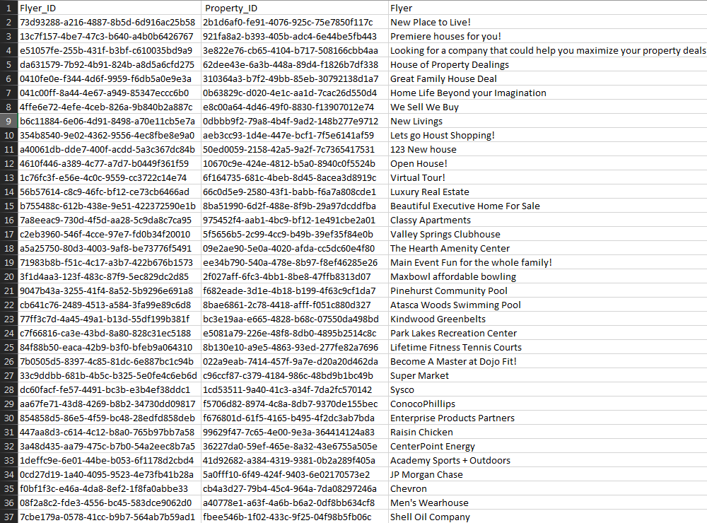

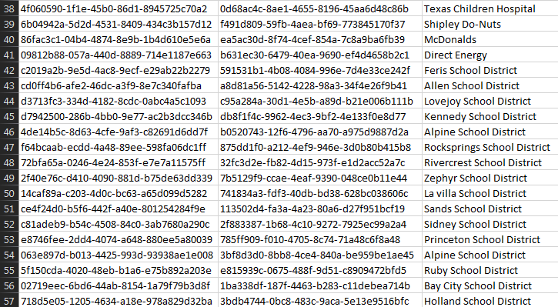

**Section: Sharanjit Sembhi**

**Report Name:** Walking Distance from Recreation Area

**Report Description:** These Recreation Areas are less than 5 miles away

**Business Purpose:** Client wants to add a morning walking routine to his or her trip to the recreation areas near property.

**SQL CODE 1:**

SELECT

Property.Street_Address,

Property.City,

Property_Style.Style AS 'Property Styele',

Nearby_Recreation.Distance_From_Property AS 'Recreation Distance From Property'

FROM Property

INNER JOIN Property_Flyer ON Property.Property_ID=Property_Flyer.Property_ID

INNER JOIN Nearby_Recreation ON Property_Flyer.Flyer_ID=Nearby_Recreation.Flyer_ID

INNER JOIN Property_Style ON Property_Style.Property_Style_ID=Property.Property_Style_ID

WHERE Nearby_Recreation.Distance_from_Property <'5'

**Report/Query Results:**

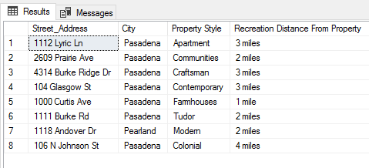

**Property Table: Displaying 34/100**

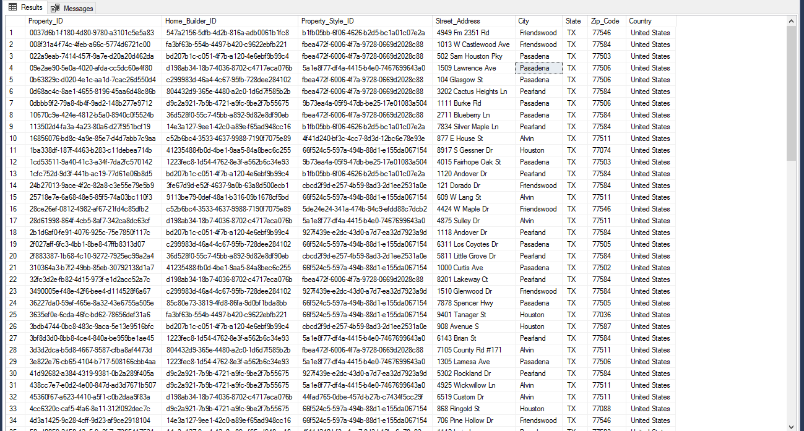

**Property Style Table:**

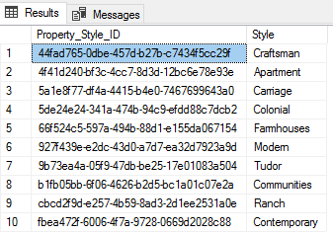

**Nearby Recreation Table:**

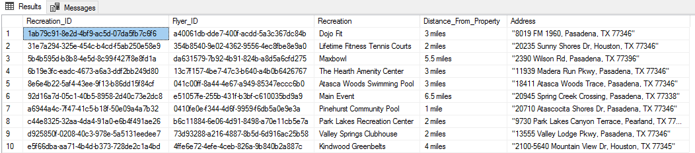

**Property Flyer Table: Displaying 30/56**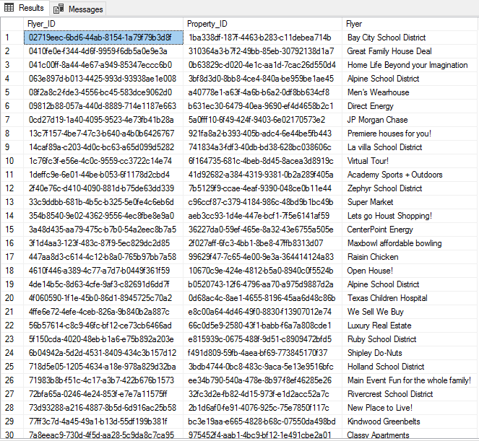

**Report Description:** These properties have low utility costs

**Business Purpose:** Client wants a property with low utility costs

**SQL CODE 2:**

SELECT

Property.Street_Address,

Property.City,

Property_Style.Style AS 'Property Style',

Property_Finance.Monthly_Price_Estimate AS 'Monthly Price Estimate',

Utility_Bill.Cost_Of_Utility AS 'Cost of Utility'

FROM Property

INNER JOIN Property_Finance ON Property.Property_ID=Property_Finance.Property_ID

INNER JOIN Utility_Bill ON Property_Finance.Property_Finance_ID=Utility_Bill.Property_Finance_ID

INNER JOIN Property_Style ON Property_Style.Property_Style_ID=Property.Property_Style_ID

WHERE Utility_Bill.Cost_Of_Utility <'60'

**Report/Query Results:**

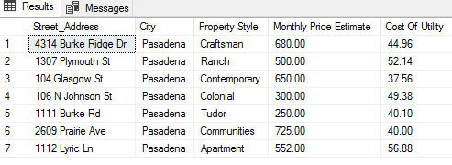

**Property Table:**



**Property Style Table:**



**Property Finance Table:**

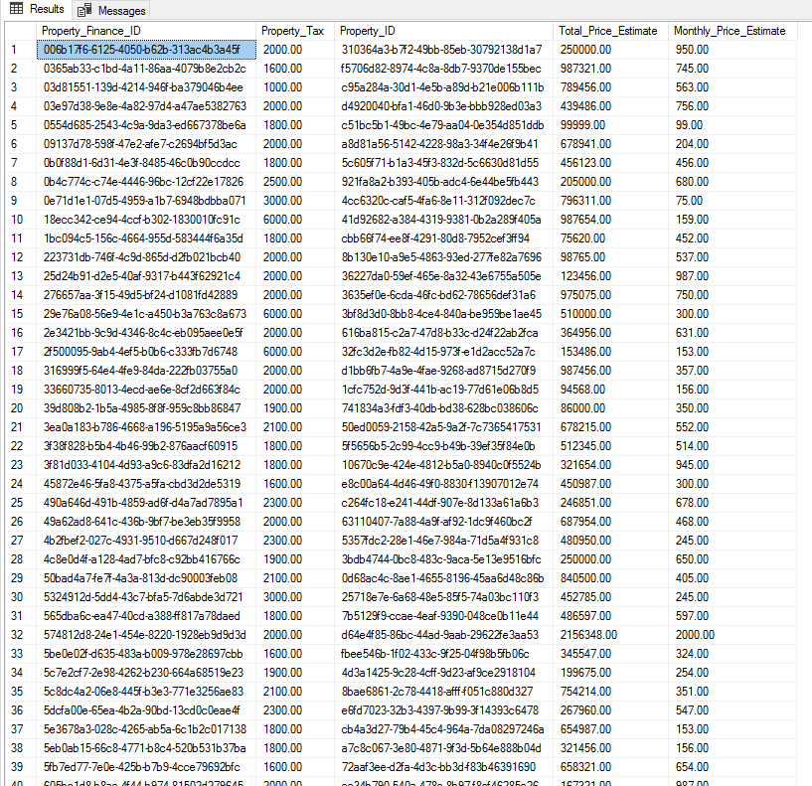

**Utility Bill Table:** 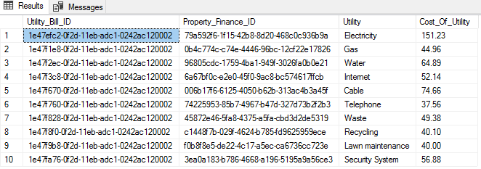

**Report Name:** Sugarland Client

**Report Description:** Client who wants a property in Sugarland

**Business Purpose:** Purpose is to meet help the agent sort information about Clients based on their preferred location in this case Sugarland.

**SQL CODE 3:**

SELECT

Client.Client_First_Name AS 'Client First Name',

Client.Client_Last_Name AS 'Client Last Name',

Client_Phone_Number.Client_Phone_Number,

Questionnaire.Preferred_Location AS 'Preferred Location',

Client_Email.Client_Email

FROM Client

INNER JOIN Client_Email ON Client.Client_ID=Client_Email.Client_ID

INNER JOIN Questionnaire ON Questionnaire.Client_ID=Client.Client_ID

INNER JOIN Client_Phone_Number ON Client.Client_ID=Client_Phone_Number.Client_ID

WHERE Questionnaire.Preferred_Location ='Sugarland'

**Report/Query Results:**

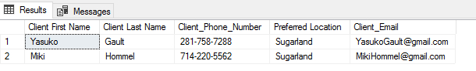 **Client Table: Display 39/100**

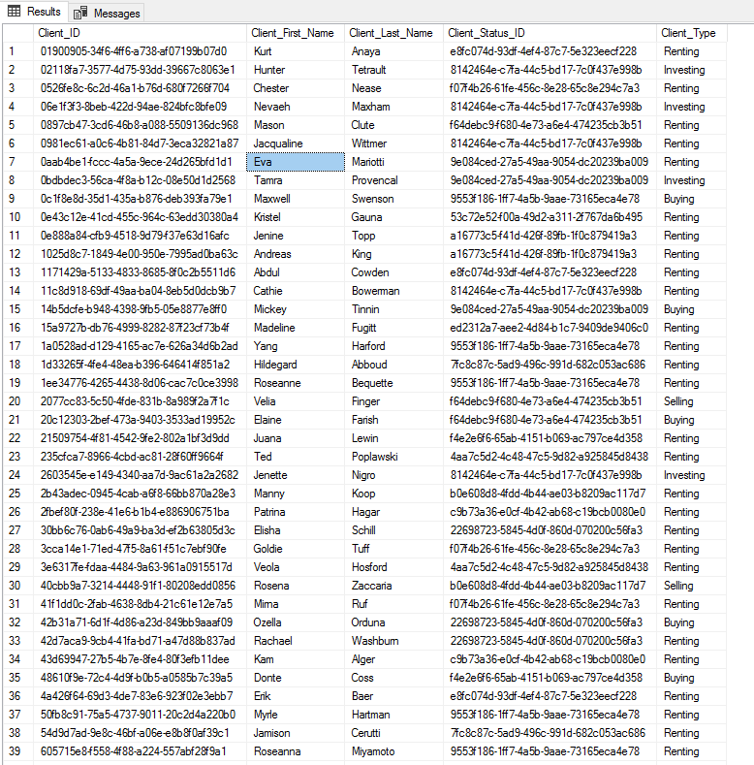

**Questionnaire Table:**

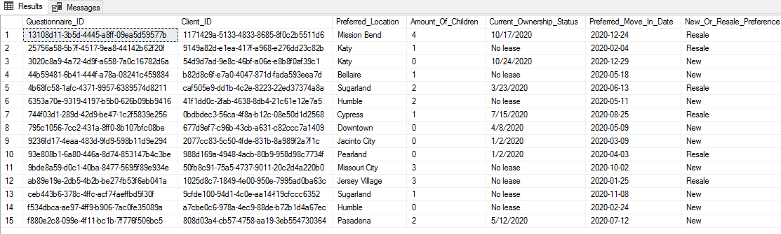

**Client Email Table: Display 30/100**

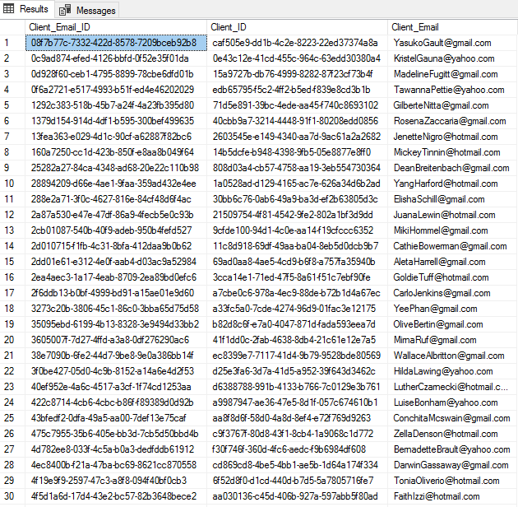

**Client Phone Number Table**: **Displaying 33/100**

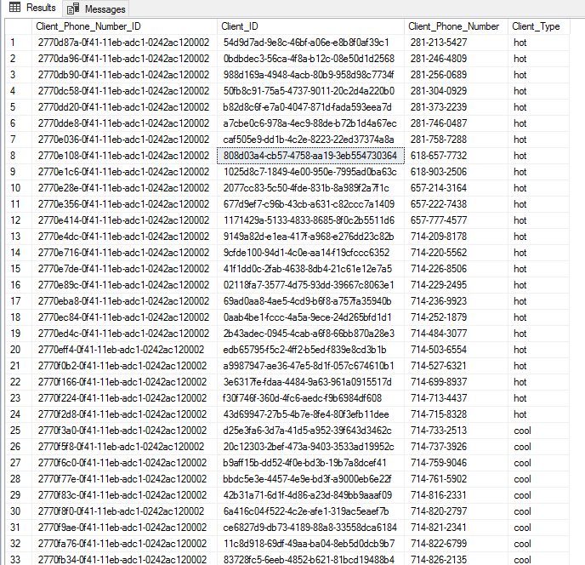

**Report Name:** Nearby McDonalds

**Report Description:** Client who wants a property near his/her favorite fast food restaurant

**Business Purpose:** Purpose is to meet help the agent find his/her client’s property that has their favorite fast food location.

**SQL CODE 4:**

SELECT

Property.Street_Address,

Property.City AS ' Property City',

Property_Style.Style AS 'Property Style',

Nearby_Businesses.Business AS 'Nearby Businesses',

Nearby_Businesses.Distance_from_Property AS 'Distance From Property'

FROM Property

INNER JOIN Property_Flyer ON Property.Property_ID=Property_Flyer.Property_ID

INNER JOIN Nearby_Businesses ON Property_Flyer.Flyer_ID=Nearby_Businesses.Flyer_ID

INNER JOIN Property_Style ON Property_Style.Property_Style_ID=Property.Property_Style_ID

WHERE Nearby_Businesses.Business = 'McDonalds'

**Result/SQL Query:**

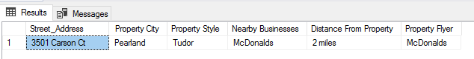

**Property Flyer Table: Display 30/56**

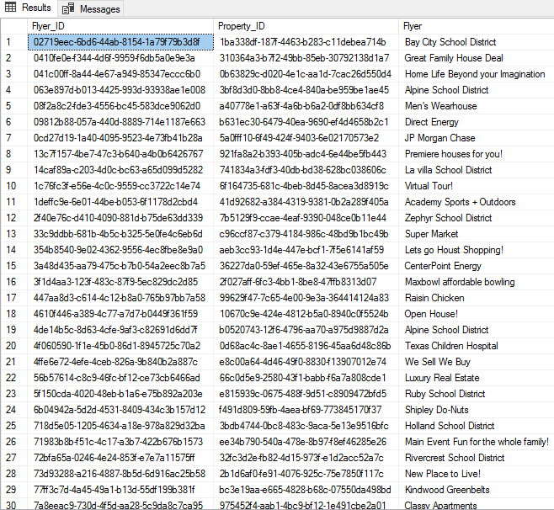

**Property Table: Display 34/100**



**Property Style Table:**



**Nearby Businesses Table:**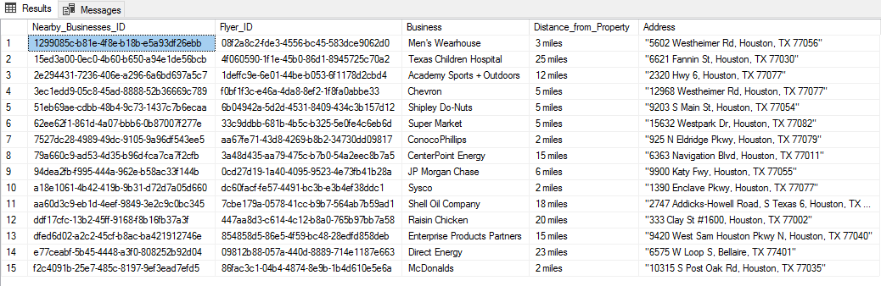

**Member: Sharanjit Sembhi**

**Insert Script # 1**

INSERT INTO Property_Flyer(Flyer_ID,Property_ID,Flyer)

VALUES(NEWID(),'fbee546b-1f02-433c-9f25-04f98b5fb06c','We dont make it until you order it')

**Report/Query Results:**

**Before:**

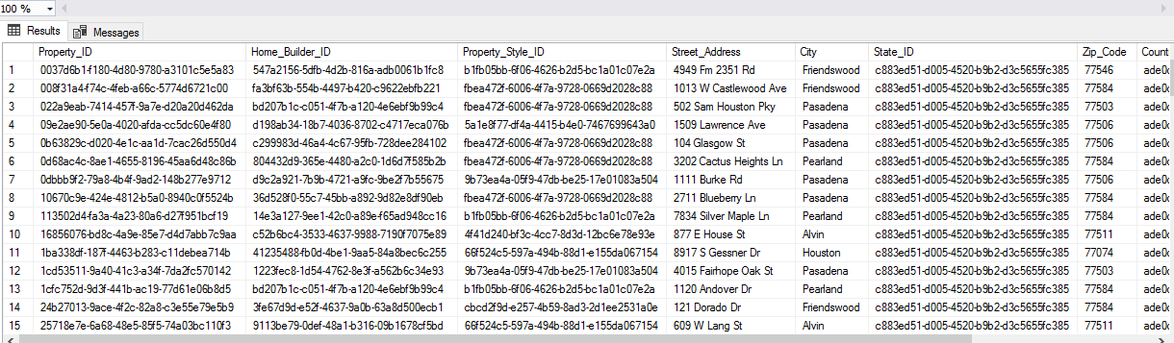

**After:**

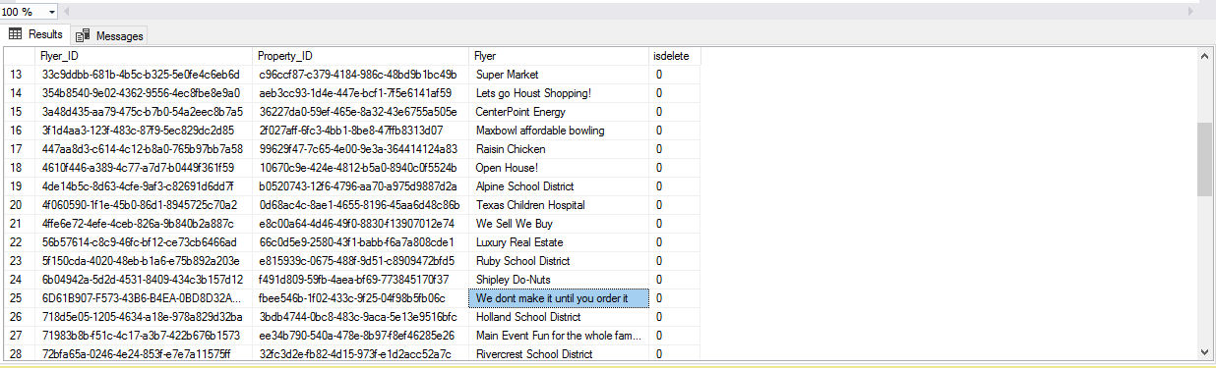

**Insert Script # 2**

INSERT into Nearby_Businesses(Nearby_Businesses_ID,Flyer_ID,Business,Distance_from_Property,Address)

VALUES(NEWID(),'6D61B907-F573-43B6-B4EA-0BD8D32ADBC3','Jack_In_The_Box','8 miles','25105 Market Pl Dr, Katy, TX 77494')

**Report/Query Results:**

**Before:**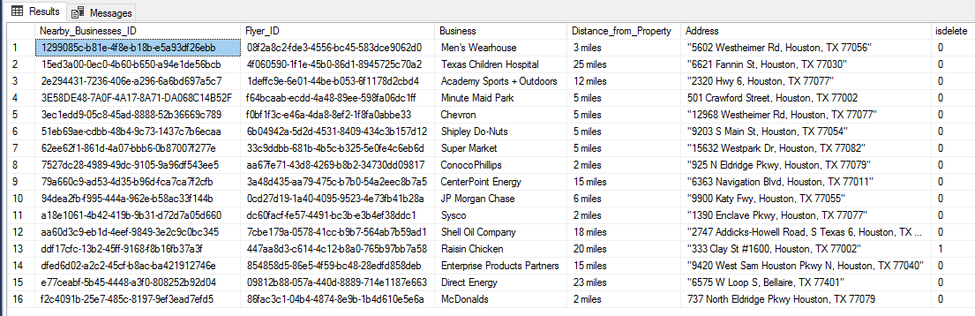

**After:**

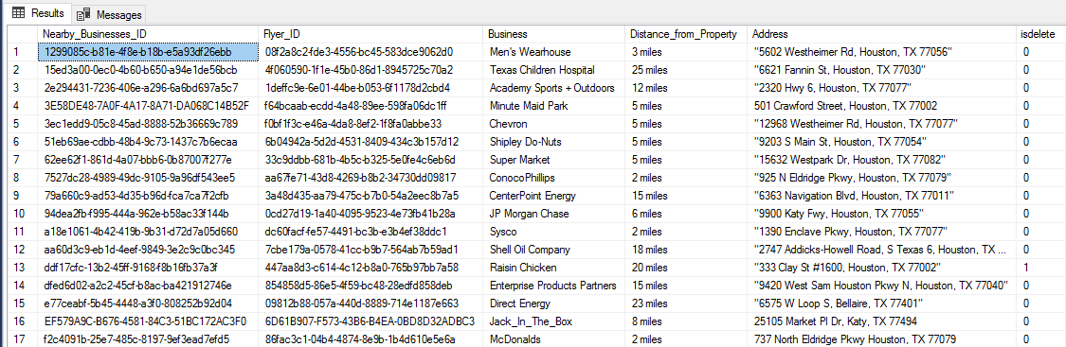

**Update Script # 1**

UPDATE [Property_Flyer]

SET Property_Flyer.Flyer = 'We Don’t Make It Until You Order It’

WHERE Property_Flyer.Flyer_ID=' 6D61B907-F573-43B6-B4EA-0BD8D32ADBC3

**Report/Query Results:**

**Before:**



**After:**

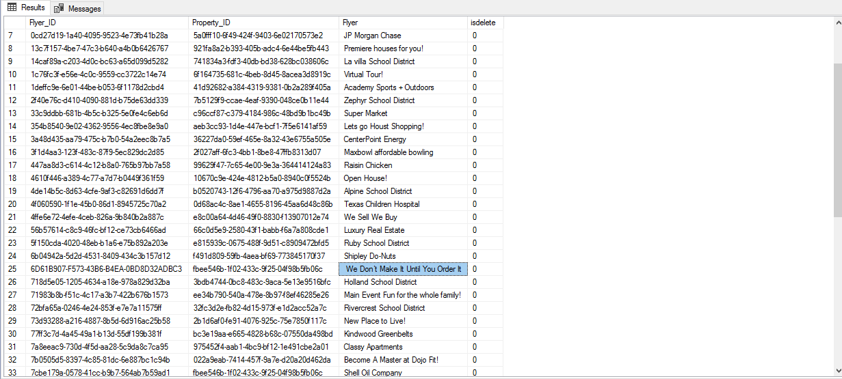

**Update Script # 2**

UPDATE [Nearby_Businesses]

SET Distance_from_Property ='12 miles'

WHERE Nearby_Businesses.Nearby_Businesses_ID='62ee62f1-861d-4a07-bbb6-0b87007f277e'

**Report/Query Results:**

**Before:**

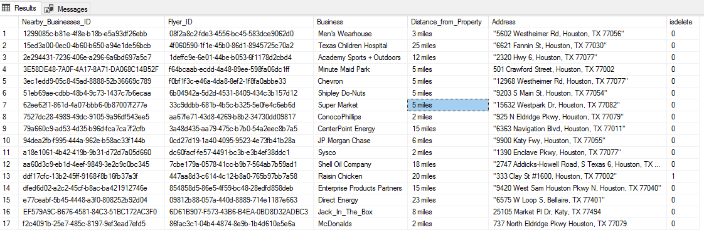

**After:**

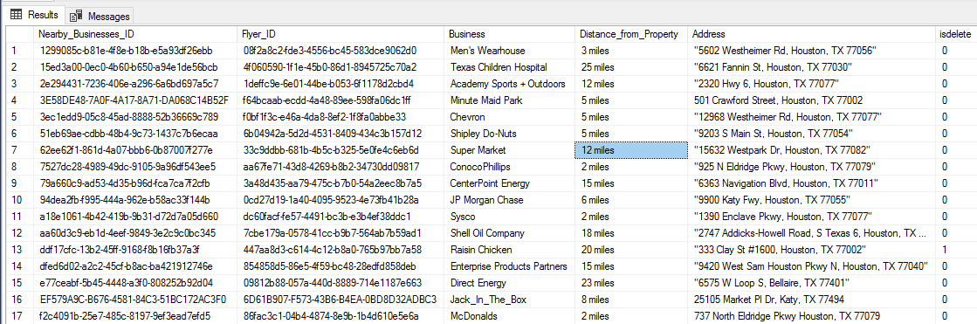

**Delete Script # 1**

UPDATE [Property_Flyer]

SET isdelete = '1'

WHERE Property_Flyer.Flyer=' We Don’t Make It Until You Order It '

**Report/Query Results:**

**Before:**

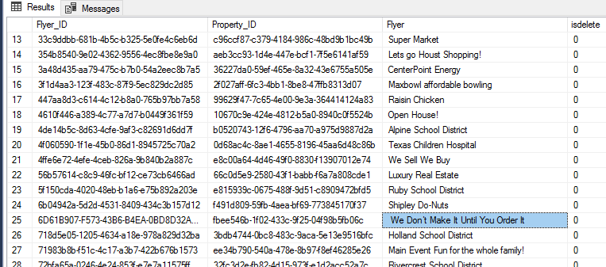

**After:**

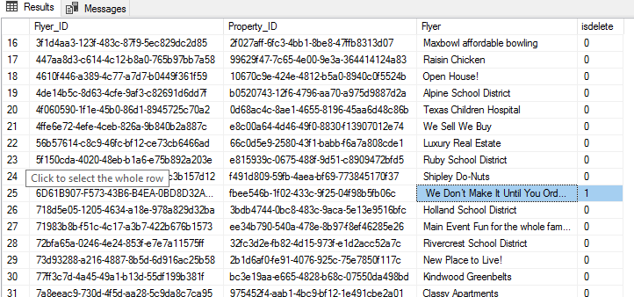

**Delete Script # 2**

UPDATE [Property_Flyer]

SET isdelete = '1'

WHERE Property_Flyer.Flyer='We dont make it until you order it'

**Report/Query Results:**

**Before:**

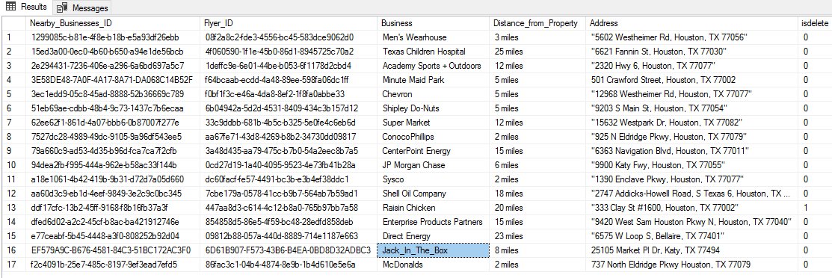

**After:**

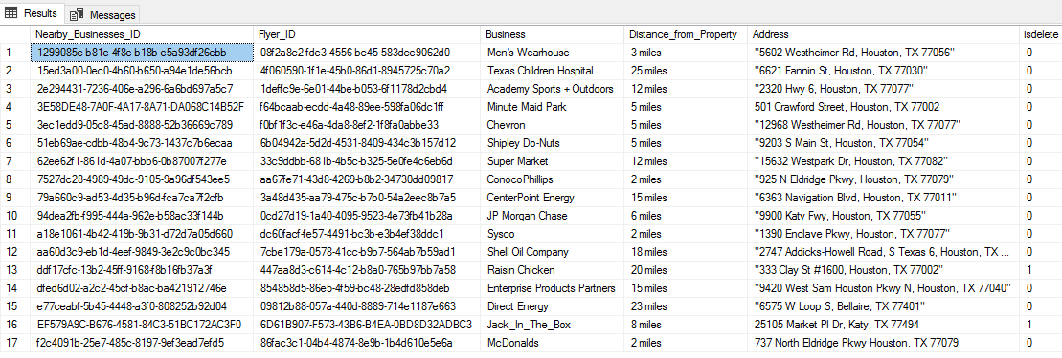

**GUI Forms:**

**1. Air Conditioning Unit**

**Before New**

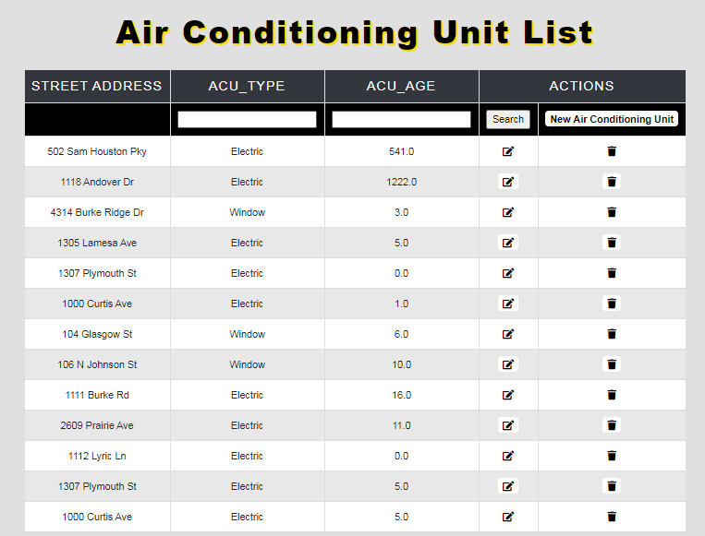

**GUI Forms**

1. **Air Conditioning Unit**
   1. **Filter**
   2. **Before and After New**
   3. **Before and After Edit**
   4. **Before and After Delete**

**Filter**

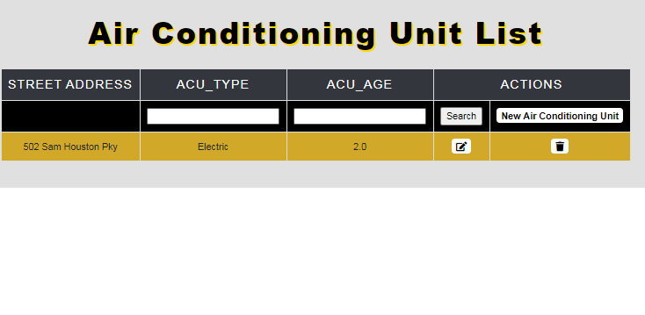

**Before New**



**After New**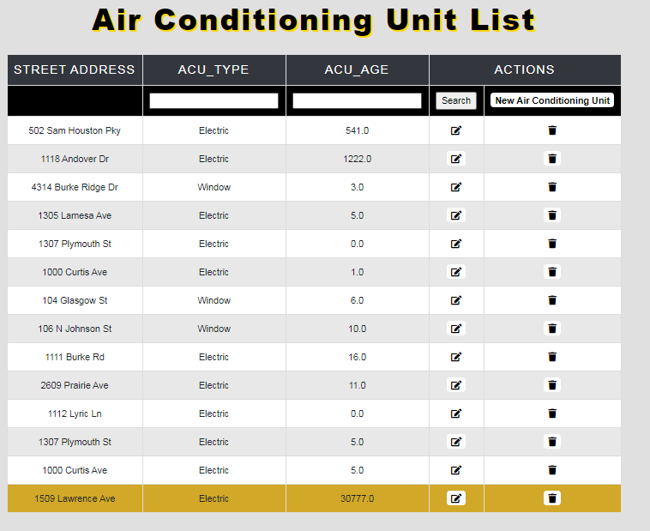

**Before Edit**

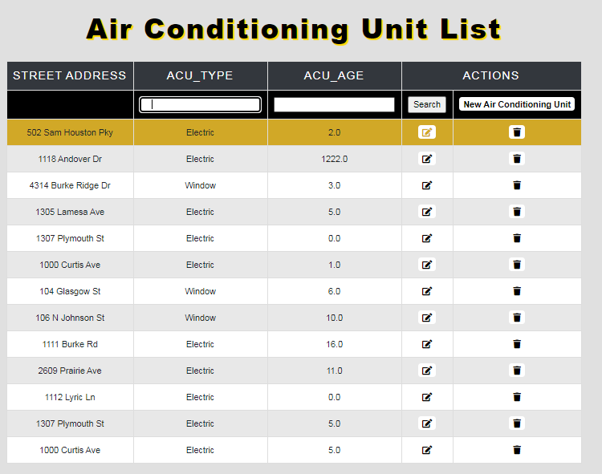

**After Edit**

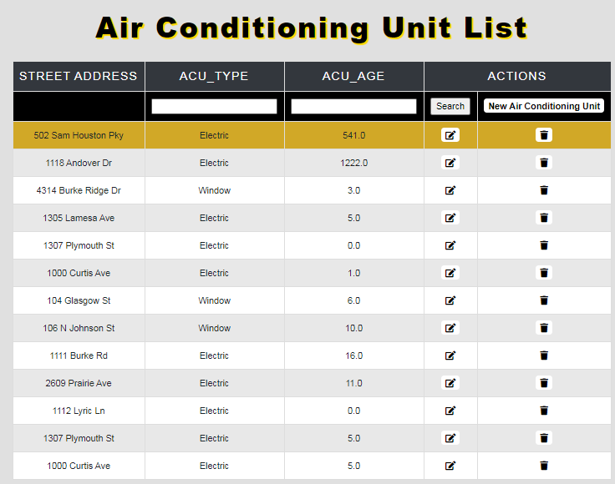

**Before Delete**

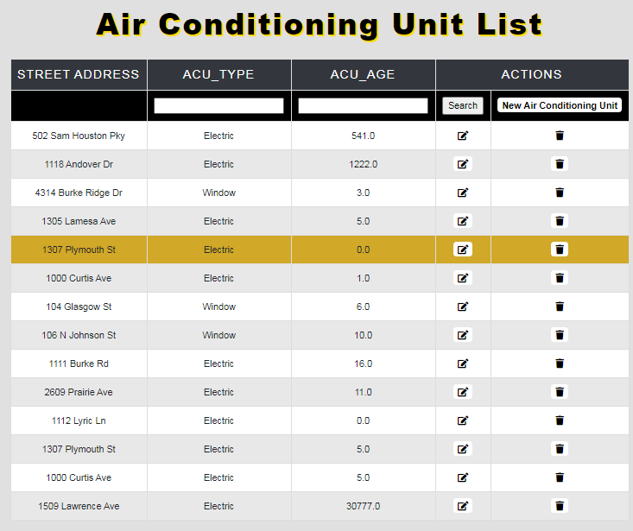

**After Delete** 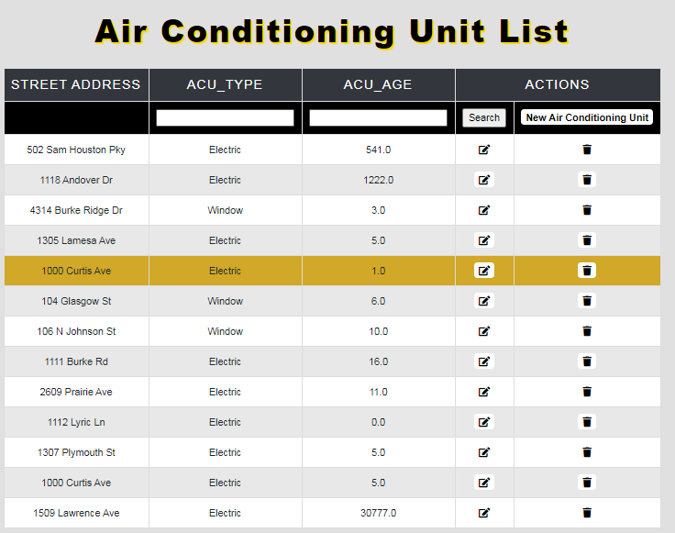

**GUI Forms(cont.)**

1. **Bathroom**
   1. **Filter**
   2. **Before and After New**
   3. **Before and After Edit**
   4. **Before and After Delete**

**Filter**

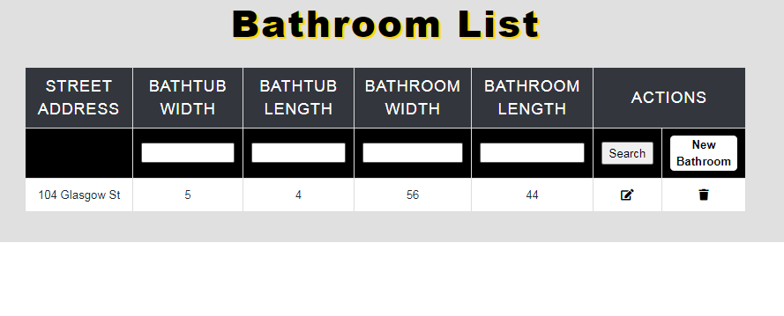

**Before New**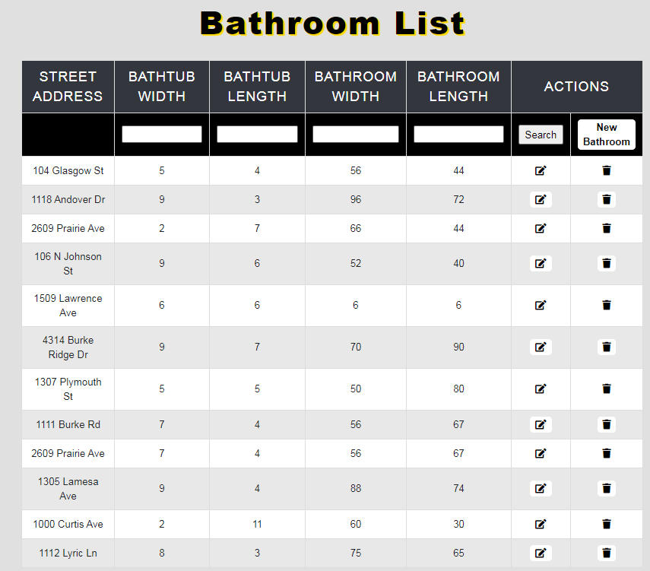

**After New**

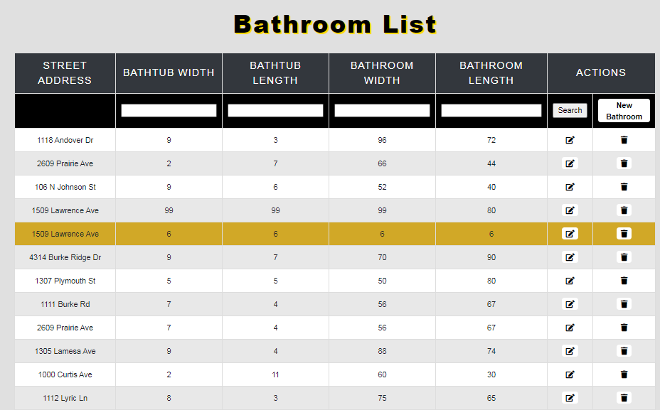

**Before Edit**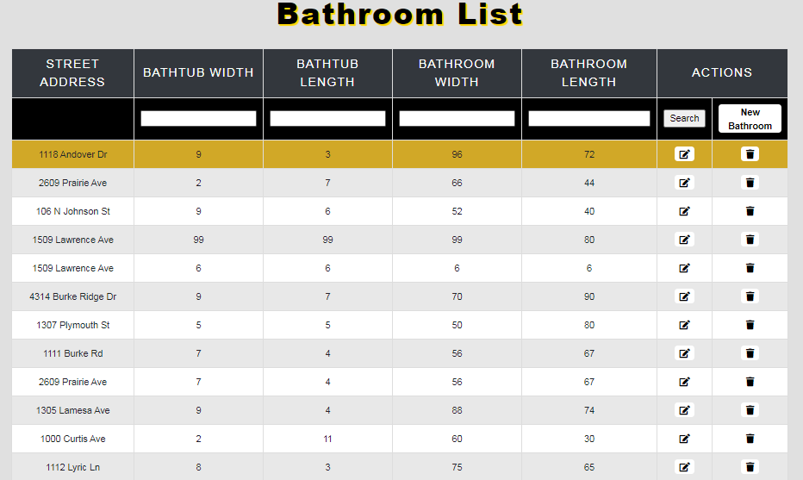

**After Edit**

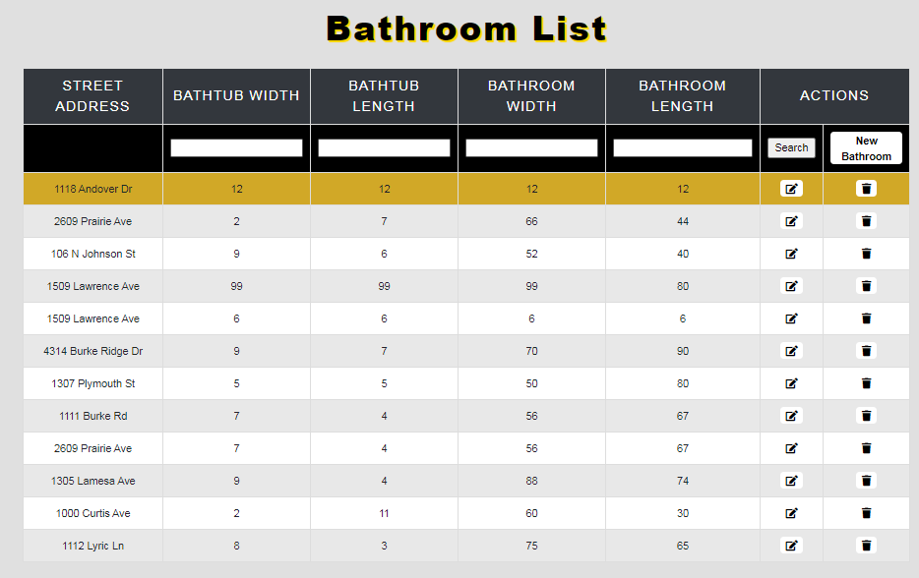

**Before Delete**

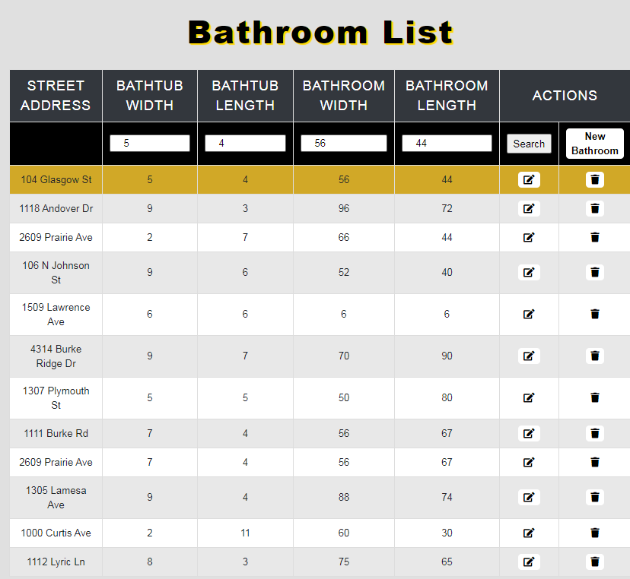

**After Delete**

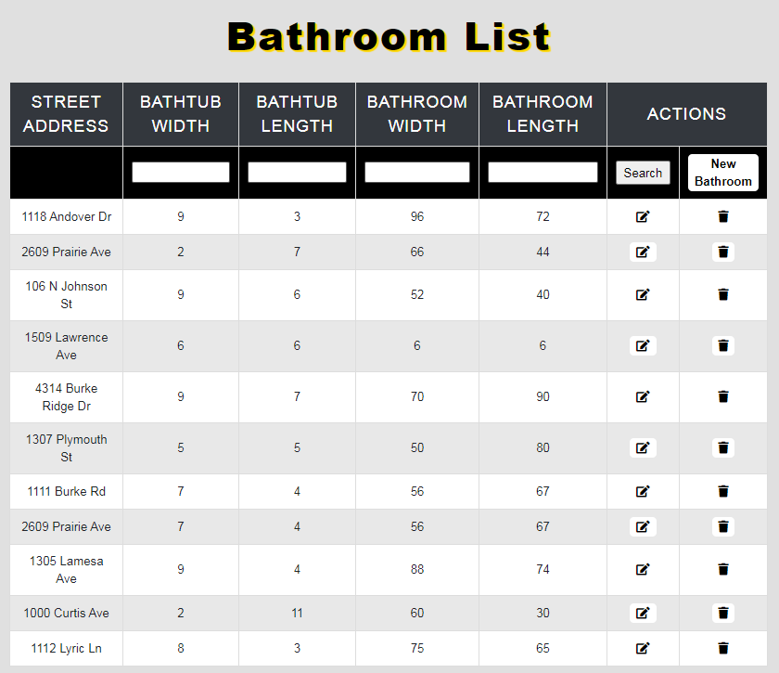

**GUI Forms(cont.)**

1. **Heating Unit**
   1. **Filter**
   2. **Before and After New**
   3. **Before and After Edit**
   4. **Before and After Delete**

**Filter**

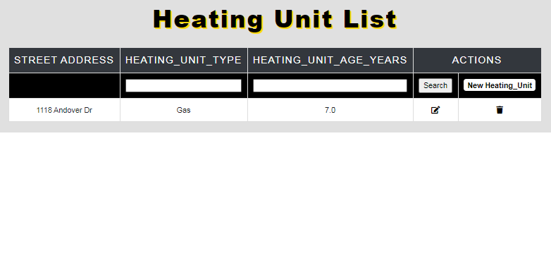

**Before New**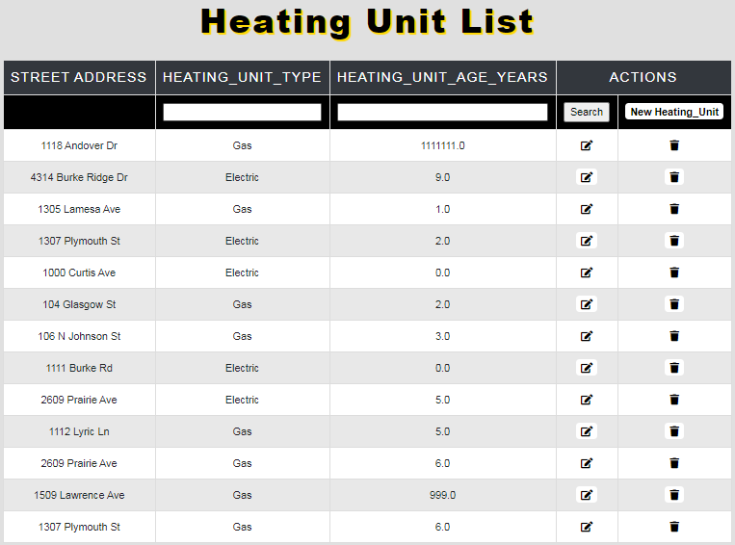

**After New**

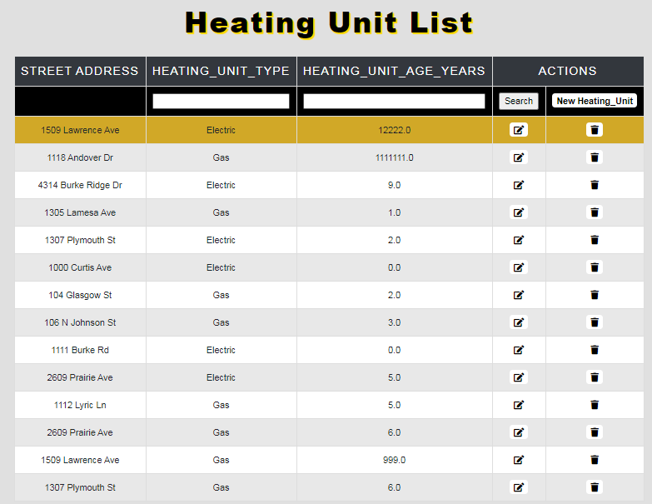

**Before Edit**

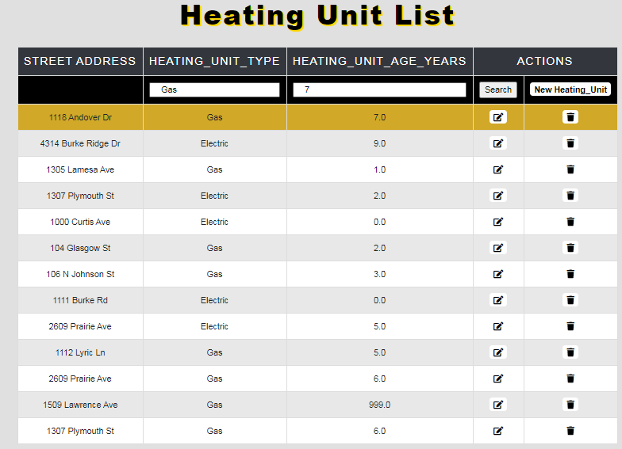

**After Edit**

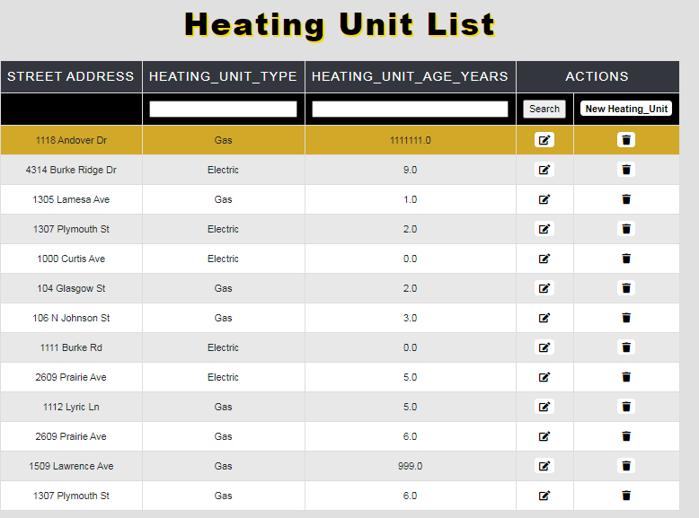

**Before Delete**

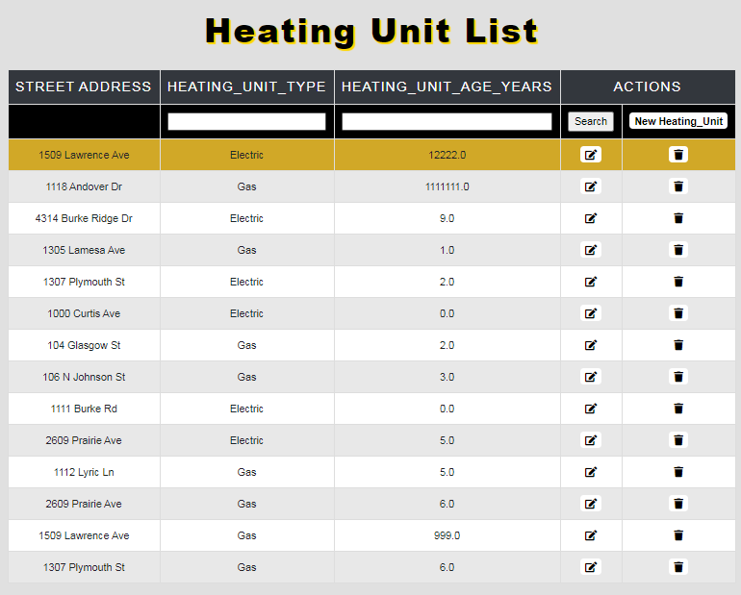

**After Delete**

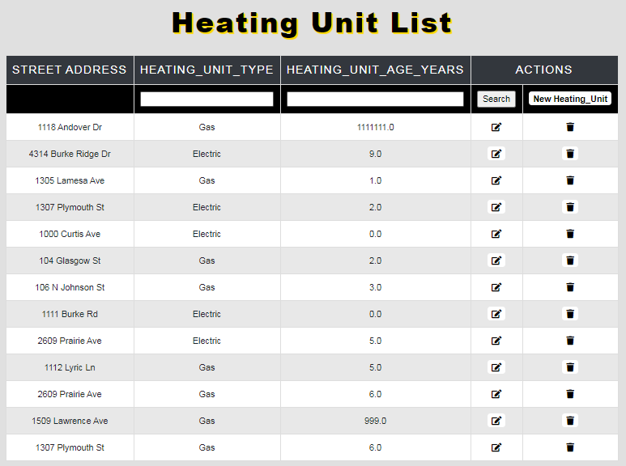

### **Julia Byrne Report**

**Create Script:**

**CREATE TABLE [Property_Survey] (**

**[Property_Survey_ID] varchar(36) NOT NULL,**

**[Property_ID] varchar(36) NOT NULL FOREIGN KEY REFERENCES Property(Property_ID),**

**[Survey_Document] varchar(max) NOT NULL,**

**CONSTRAINT [PK_Property_Survey] PRIMARY KEY ([Property_Survey_ID]),**

**);**

**CREATE TABLE [Homeowner_Associate] (**

**[HOA_ID] varchar(36) NOT NULL,**

**[Property_ID] varchar(36) NOT NULL FOREIGN KEY REFERENCES Property(Property_ID),**

**[HOA_First_Name] varchar(35) NOT NULL,**

**[HOA_Last_Name] varchar(35) NOT NULL,**

**[HOA_Company] varchar(100) NOT NULL,**

**CONSTRAINT [PK_Homeowner_Associate] PRIMARY KEY ([HOA_ID]),**

**);**

**CREATE TABLE [Property_Finance] (**

**[Property_Finance_ID] varchar(36) NOT NULL,**

**[Property_Tax] money NOT NULL,**

**[Property_ID] varchar(36) NOT NULL FOREIGN KEY REFERENCES Property(Property_ID),**

**[Total_Price_Estimate] money NOT NULL,**

**[Monthly_Price_Estimate] money NOT NULL,**

**CONSTRAINT [PK_Property_Finance] PRIMARY KEY ([Property_Finance_ID]),**

**);**

**CREATE TABLE [Agent] (**

**[Agent_ID] varchar(36) NOT NULL,**

**[Agent_First_Name] varchar(35) NOT NULL,**

**[Agent_Last_Name] varchar(35) NOT NULL,**

**[Title] varchar(100) NOT NULL,**

**CONSTRAINT [PK_Agent] PRIMARY KEY ([Agent_ID])**

**);**

**CREATE TABLE [Home_Inspection_Company] (**

**[Home_Inspection_Company_ID] varchar(36) NOT NULL,**

**[Property_ID] varchar(36) NOT NULL FOREIGN KEY REFERENCES Property(Property_ID),**

**[Company_Name] varchar(200) NOT NULL,**

**[Phone_Number] varchar(15) NOT NULL,**

**[Email] nvarchar(255) NOT NULL,**

**CONSTRAINT [PK_Home_Inspection_Company] PRIMARY KEY ([Home_Inspection_Company_ID])**

**);**

**CREATE TABLE [Property_Inspection] (**

**[Property_Inspection_ID] varchar(36) NOT NULL,**

**[Property_ID] varchar(36) NOT NULL FOREIGN KEY REFERENCES Property(Property_ID),**

**[Home_Inspection_Company_ID] varchar(36) NOT NULL FOREIGN KEY REFERENCES Home_Inspection_Company(Home_Inspection_Company_ID),**

**[Home_Inspection_PDF] varchar(max) NOT NULL,**

**CONSTRAINT [PK_Property_Inspection] PRIMARY KEY ([Property_Inspection_ID])**

**);**

**Data Create:**

**Home Inspection Company:**



**Homeowner Associate:**



**Discussion Medium:**

|  |  |
| --- | --- |
| **Discussion_Medium_ID** | **Discussion_Medium** |
| **720db806-4ca4-4a45-8de3-776701bd163e** | **Phone** |
| **0a960c2d-dbbb-4719-82b9-8e24b1abdb52** | **Email** |
| **266c85ba-1f2a-41c7-a4f7-164530c9c130** | **Text** |
| **1ac4ebce-3050-4270-a02d-9cd851281786** | **In-Person** |

**Broker Company:**

|  |  |
| --- | --- |
| **Broker_Company_ID** | **Broker_Company** |
| **766a56fd-a9ea-49c1-81a6-59c5440f2386** | **Coldwell Banker Realty** |
| **9dd59b43-c844-420a-a6f2-627dd13d40dd** | **Sylvia Reyes RealEstate Broker** |
| **e9397138-9fe6-4ccf-81f3-65528614229c** | **Jessica Perez Realtor** |
| **6b3b0765-d2d2-4839-88d1-22e52f8e5349** | **Red Door Realty and Associates** |
| **f0df7403-f59c-486c-b579-5d3c14a08132** | **Carol Golden Broker Associate** |
| **9768f5de-b160-4e4e-99bd-4b35f6ec8196** | **Texas Real Estate Brokerage Firm** |
| **a93eced7-2181-450a-8d07-deb9724066e5** | **Butch Sharpe** |
| **6dd0b95f-d4b3-4eef-bb25-b61c7121868c** | **Century 21 Melrose and Co** |
| **e04e4053-ab23-44f8-9957-3f0ccac8c47f** | **ReMax Associates** |
| **e76f0e4c-1356-4e05-b904-d4e870e095d6** | **Nancy A. Ortiz-Puig** |
| **e5807ccf-1f87-413c-a34e-3b07bd4638a7** | **Keller Williams Realty** |
| **0776e62c-4ce1-4739-9bf5-8107111872c0** | **Your Working Realtor** |
| **c6e11ef7-a5d0-4928-b00d-f4c1b5f7da94** | **Cheryl Stevens** |
| **39ab7417-c11d-4bb1-b3e4-961331fd704c** | **Kim Fazzino** |
| **2976cdfb-7605-431a-a30d-4cdd17d14f16** | **Cedar Stone Realty** |
| **cc376636-0c60-4401-858b-29ac62b947d9** | **Levine and Co** |
| **324c9d14-5c82-4e8b-a7d5-6759954ad7f6** | **Jester Joanne** |

**Broker:**

|  |  |  |
| --- | --- | --- |
| **Broker_ID** | **Broker_Company_ID** | **Broker_Name** |
| **69c14391-7c17-4bf5-a1d8-59212aec3ae4** | **766a56fd-a9ea-49c1-81a6-59c5440f2386** | **Jonathan Franklin** |
| **124c5f9b-4dce-4257-b065-3918f9950756** | **9dd59b43-c844-420a-a6f2-627dd13d40dd** | **Sylvia Reyes** |
| **61749a28-a6e2-4451-b474-f8e20cb6288a** | **e9397138-9fe6-4ccf-81f3-65528614229c** | **Jessica Perez** |
| **bc3f9fff-57db-4226-bca4-277474e297ee** | **6b3b0765-d2d2-4839-88d1-22e52f8e5349** | **Sandra Dunn** |
| **f6f91b03-b816-44ae-89fa-b64b0108a48b** | **f0df7403-f59c-486c-b579-5d3c14a08132** | **Carol Golden** |
| **64e01149-3fc8-4af4-ac63-bf9273305729** | **9768f5de-b160-4e4e-99bd-4b35f6ec8196** | **Megan Robertson** |
| **ef16af70-df16-455b-9d03-2d9c81cb6f68** | **a93eced7-2181-450a-8d07-deb9724066e5** | **Butch Sharpe** |
| **816c09c4-a046-4834-9d4c-a765dd493631** | **6dd0b95f-d4b3-4eef-bb25-b61c7121868c** | **Dave Melrose** |
| **3c2dc7ce-a507-4bc4-a75a-6fad4e5a7075** | **e04e4053-ab23-44f8-9957-3f0ccac8c47f** | **Ethan Parks** |
| **6c044e21-5ab3-4077-b7c9-31bd2e1c4695** | **e76f0e4c-1356-4e05-b904-d4e870e095d6** | **Nancy Ortiz** |
| **cf1d5508-7912-4477-867d-a827453023e2** | **e5807ccf-1f87-413c-a34e-3b07bd4638a7** | **Melissa Shine** |
| **f1eb22cd-9023-4813-b8cd-c6f495ae4f91** | **0776e62c-4ce1-4739-9bf5-8107111872c0** | **Rose Riggan** |
| **c24fa1d0-0de7-49bf-ba9c-0d620b777694** | **c6e11ef7-a5d0-4928-b00d-f4c1b5f7da94** | **Cheryl Stevans** |
| **f61bc7a7-486d-4339-85ce-b6f9a55b5099** | **39ab7417-c11d-4bb1-b3e4-961331fd704c** | **Kim Fazzino** |
| **4e5d0cb8-3448-46e6-a375-651dfe062d56** | **2976cdfb-7605-431a-a30d-4cdd17d14f16** | **Arthur Nichols** |
| **c7fc9c23-99db-47c0-ac73-fd3d1124a705** | **cc376636-0c60-4401-858b-29ac62b947d9** | **Ed Rilee** |
| **16788c9b-d4dd-4fa9-9394-f62ecb57e32e** | **324c9d14-5c82-4e8b-a7d5-6759954ad7f6** | **Jester Joanne** |

**Client Selling Plan:**



**Nearby Recreation:**



**SQL Queries:**

**SQL Query Code 1:**

SELECT

Agent.Agent_First_Name AS 'Agent First Name',

Agent.Agent_Last_Name AS 'Agent Last Name',

Agent_Email.Agent_Email AS 'Agent Email',

Agent_Phone_Number.Agent_Phone_Number AS 'Agent Phone Number',

Paycheck.Paycheck_Amount AS 'Paycheck Amount'

FROM AGENT

INNER JOIN Agent_Email ON Agent.Agent_ID = Agent_Email.Agent_ID

INNER JOIN Agent_Phone_Number ON Agent.Agent_ID = Agent_Phone_Number.Agent_ID

INNER JOIN Paycheck ON Agent.Agent_ID = Paycheck.Agent_ID

WHERE Paycheck.Paycheck_Amount > '1200'

**SQL Query Code 2:**

SELECT

Property.Street_Address AS 'Street Address',

Property.City AS 'City',

Property.Zip_Code AS 'Zip Code',

State.State_Name AS 'State',

Homeowner_Associate.HOA_First_Name AS 'HOA First Name',

Homeowner_Associate.HOA_Last_Name AS 'HOA Last Name',

HOA_Email.HOA_Email AS 'HOA Email'

FROM PROPERTY

INNER JOIN State ON State.State_ID = Property.State_ID

INNER JOIN Homeowner_Associate ON Homeowner_Associate.Property_ID = Property.Property_ID

INNER JOIN HOA_Email ON Homeowner_Associate.HOA_ID = HOA_Email.HOA_ID

WHERE HOA_First_Name IS NOT NULL

**SQL Query Code 3:**

SELECT

Client.Client_First_Name AS 'Client First Name',

Client.Client_Last_Name AS 'Client Last Name',

Agent.Agent_First_Name AS 'Agent First Name',

Agent.Agent_Last_Name AS 'Agent Last Name',

Contract.Desired_City AS 'Property Location',

Contract_Type.Contract_Type AS 'Type of Client'

FROM CONTRACT

INNER JOIN Client ON Contract.Client_ID = Client.Client_ID

INNER JOIN Agent ON COntract.Agent_ID = Agent.Agent_ID

INNER JOIN Contract_Type ON Contract.Contract_Type_ID = Contract_Type.Contract_Type_ID

WHERE Contract.Desired_City = 'Pearland' and Contract_Type.Contract_Type = 'Buying'

**SQL Query Code 4:**

SELECT

Property.Street_Address AS 'Street Address',

Property.City AS 'City',

State.State_Name AS 'State',

Property.Zip_Code AS 'Zip Code',

Property_Style.Style AS 'Home Style',

Property_Finance.Total_Price_Estimate AS 'Est Price of Home',

Room.Room_Type AS 'Number of Rooms'

FROM PROPERTY

INNER JOIN State ON State.State_ID = Property.State_ID

INNER JOIN Property_Style ON Property.Property_Style_ID = Property_Style.Property_Style_ID

INNER JOIN Property_Finance ON Property.Property_ID = Property_Finance.Property_ID

INNER JOIN Floor_Plan ON Property.Property_ID = Floor_Plan.Property_ID

INNER JOIN Room ON Floor_Plan.Floor_Plan_ID = Room.Floor_Plan_ID

WHERE Room.Room_Type = '3 Bedroom'

**SQL Update script:**

**Member: Julia Byrne**

**Insert Script # 1**

INSERT INTO Home_Inspection_Company(Home_Inspection_Company_ID, Property_ID, Company_Name, Phone_Number, Email)

VALUES (NEWID(), '36227da0-59ef-465e-8a32-43e6755a505e', 'Texas Homes Safe', '8884845757', 'TexasHomesSafe@THS.net')

**Report/Query Results:**

**Before:**

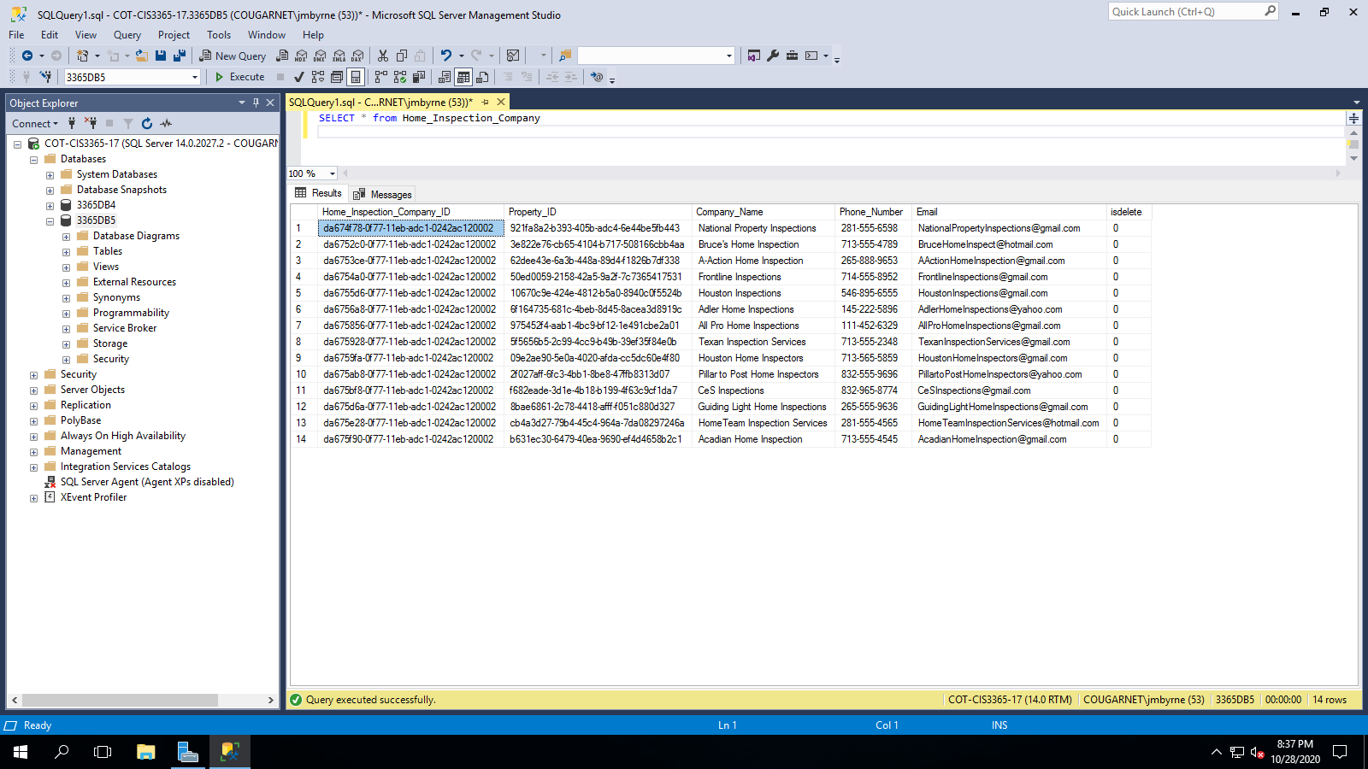

**After:**

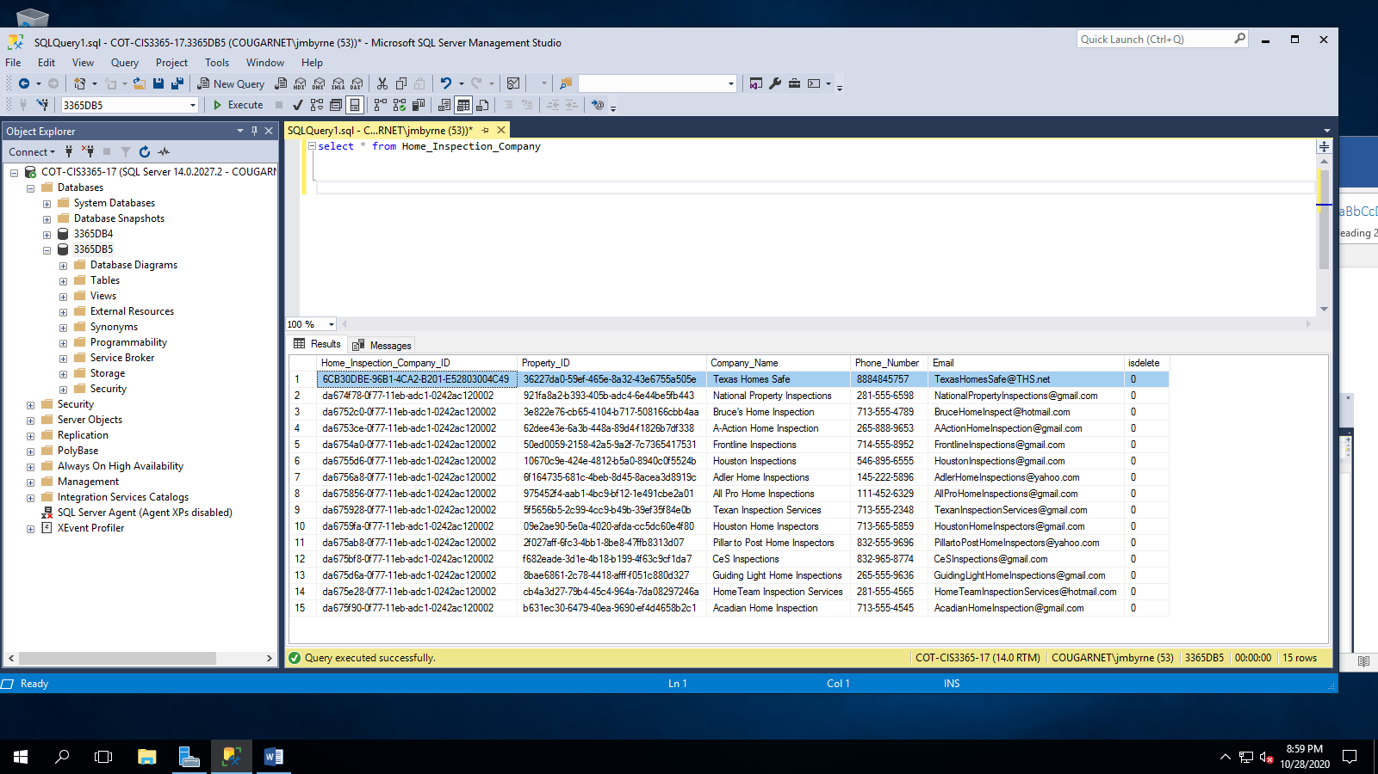

**Insert Script # 2**

INSERT INTO Utility_Bill(Utility_Bill_ID, Property_Finance_ID, Utility, Cost_Of_Utility)

VALUES (NEWID(), '8551313b-c823-46ae-a171-f1d6332aa150’, 'Electricity', '75.80')

**Report/Query Results:**

**Before:**

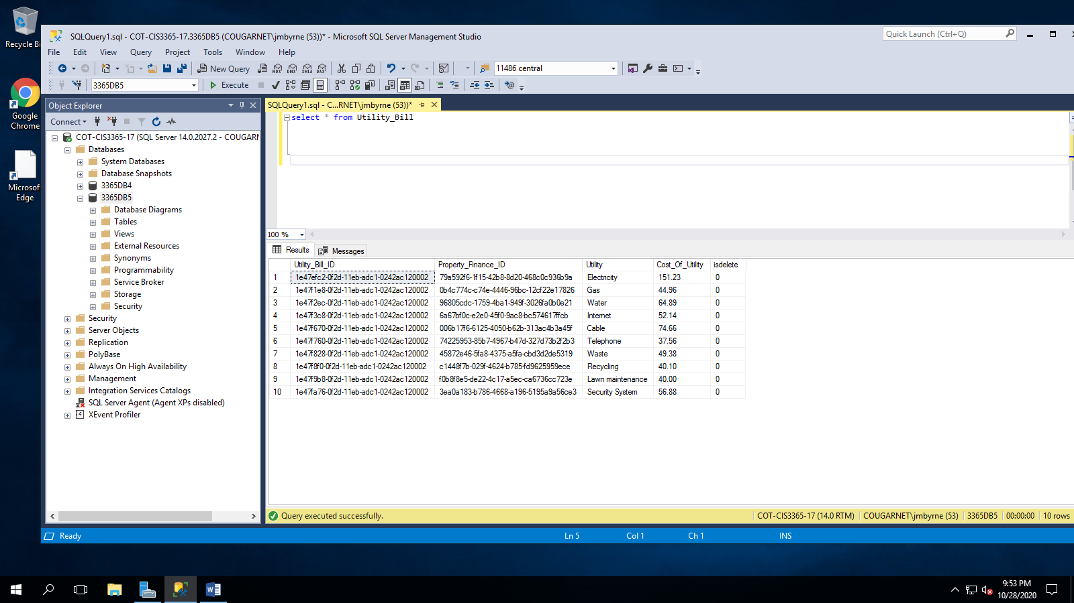

**After:**

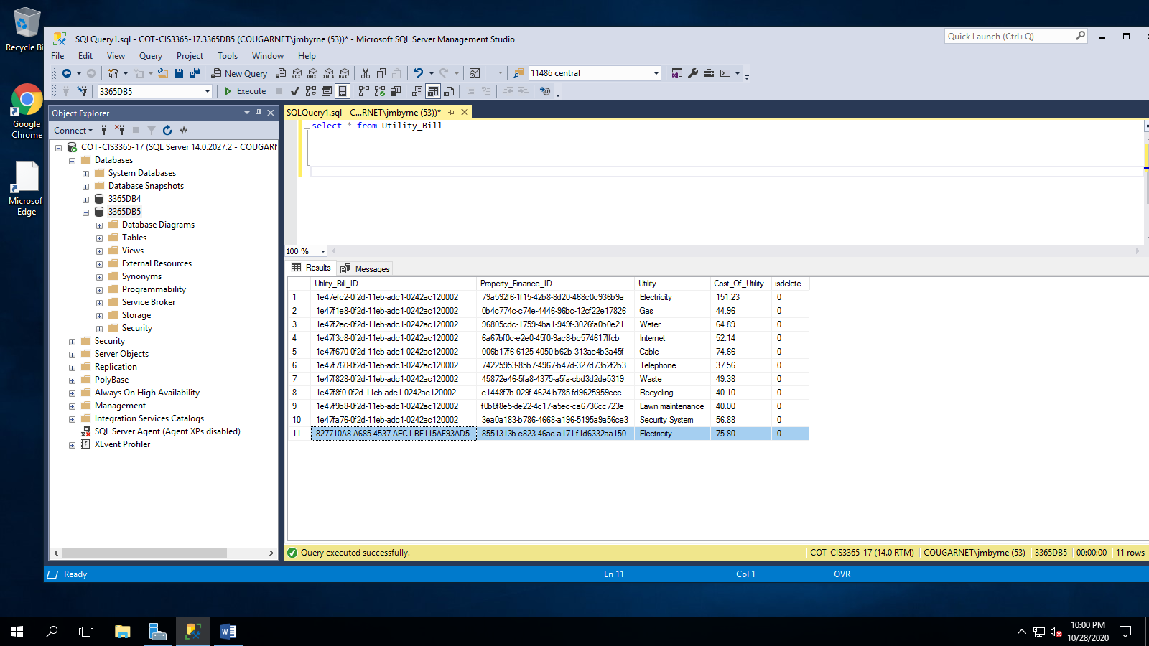

**Update Script # 1**

UPDATE [Paycheck]

SET Paycheck.Paycheck_Amount = '1456.29'

WHERE Paycheck.Paycheck_ID='0f59241c-0f29-11eb-adc1-0242ac120002'

**Report/Query Results:**

**Before:**

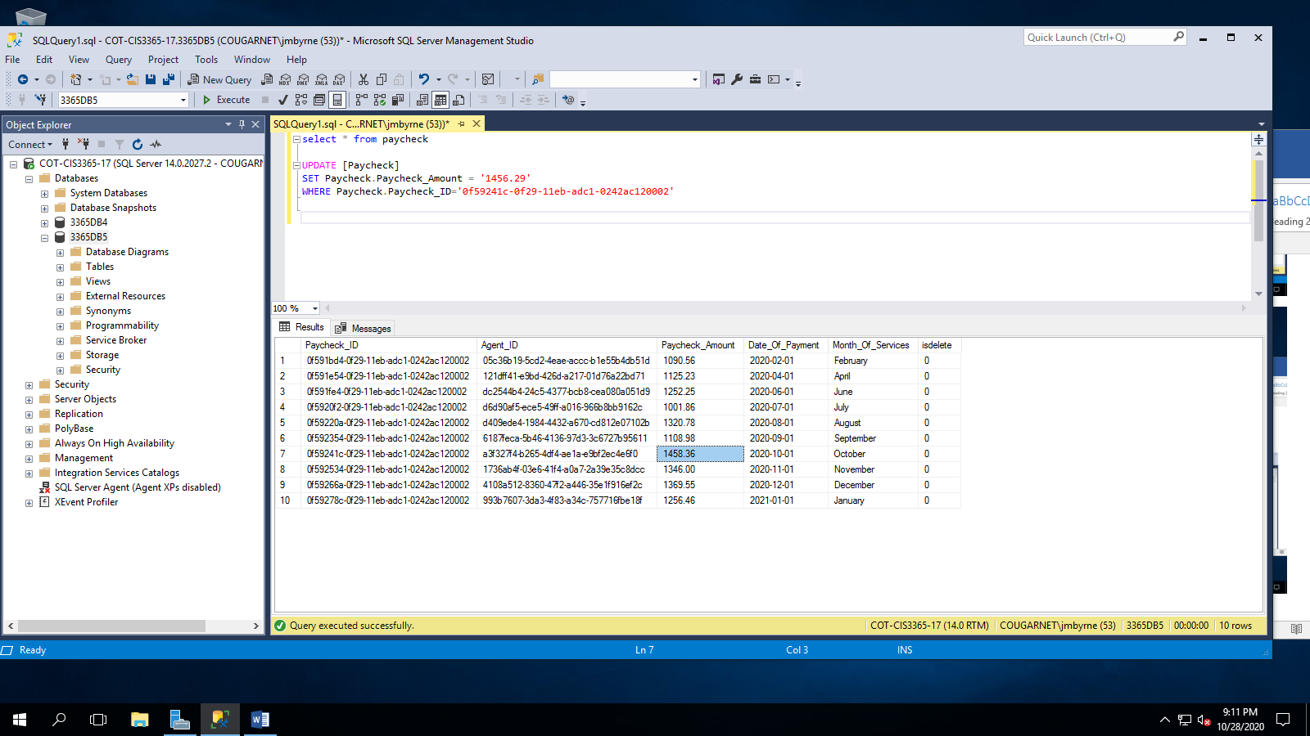

**After:**

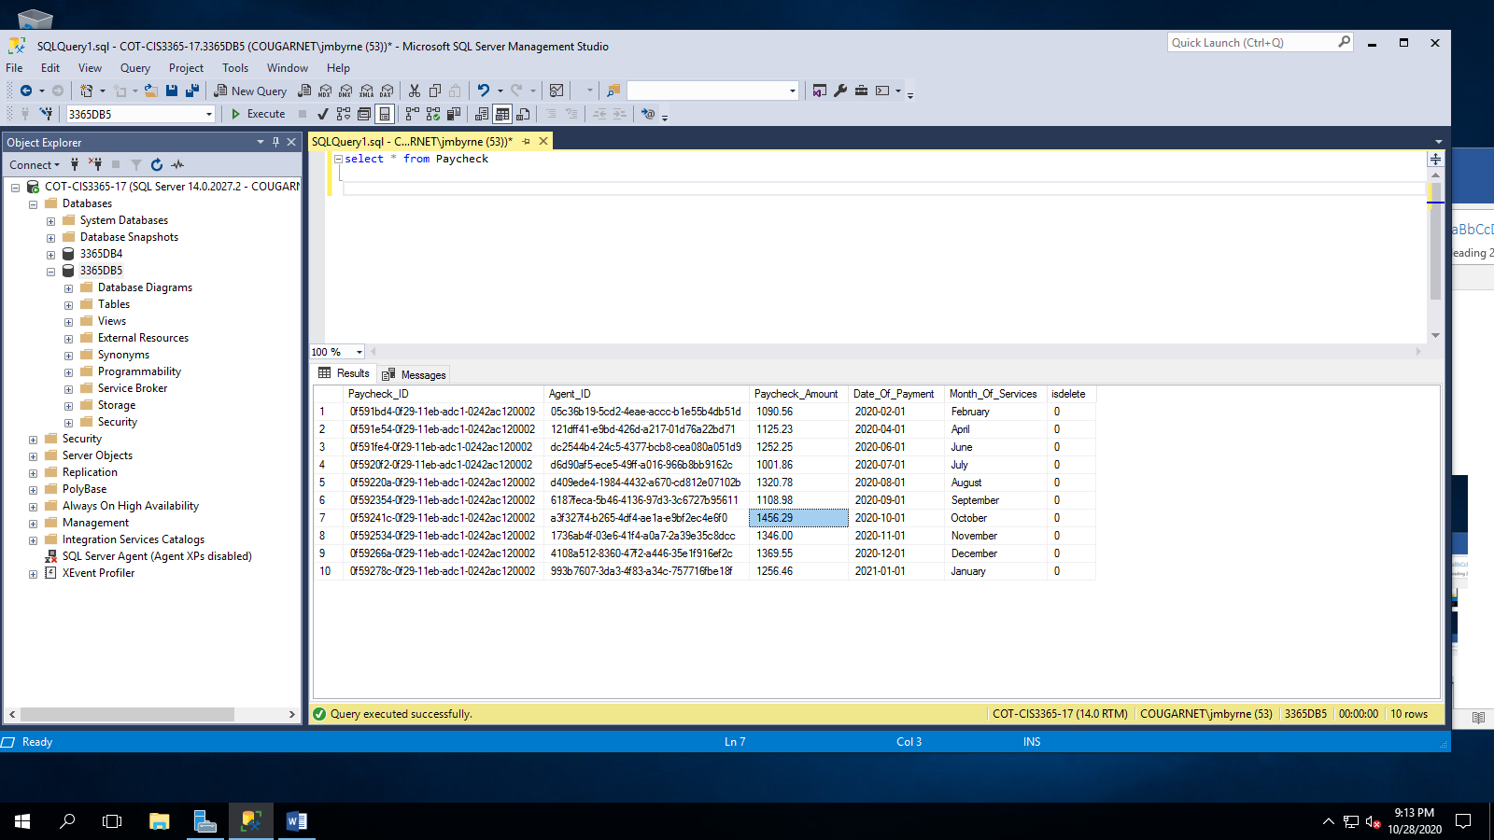

**Update Script # 2**

UPDATE [Utility_Bill]

SET Utility_Bill.Utility='Water'

WHERE Utility_Bill.Utility_Bill_ID='827710A8-A685-4537-AEC1-BF115AF93AD5'

**Report/Query Results:**

**Before:**

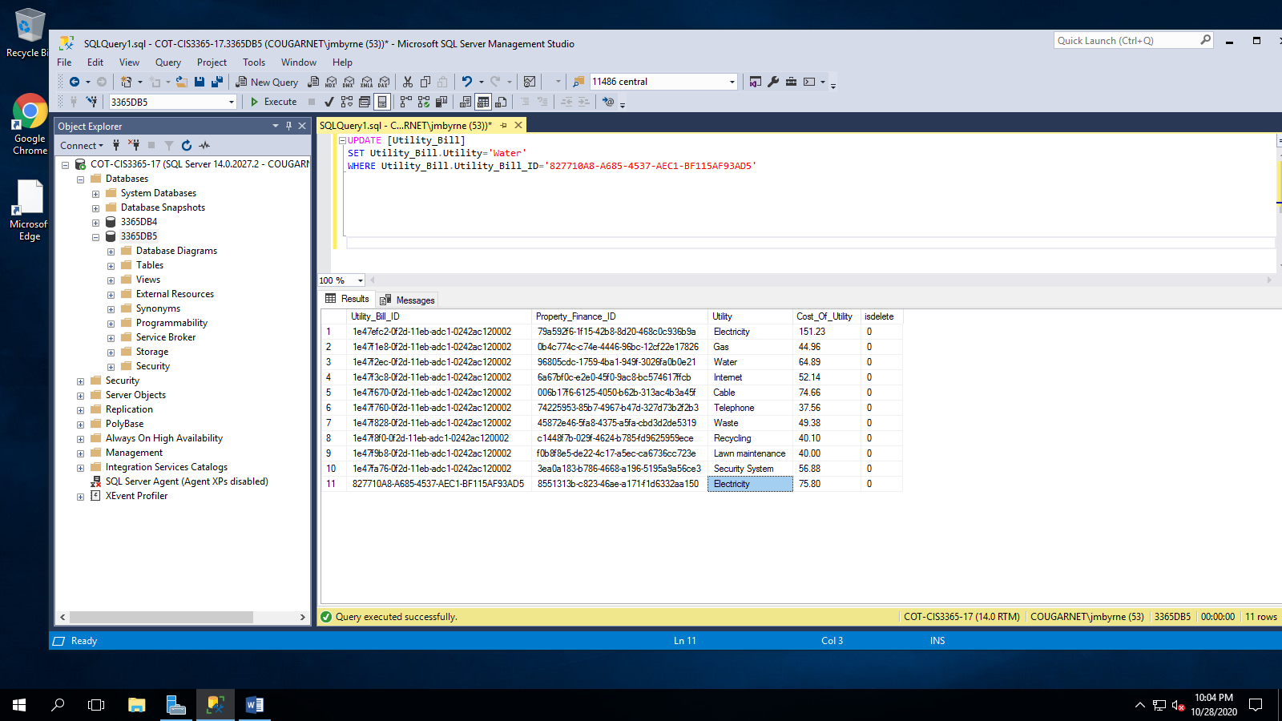

**After:**

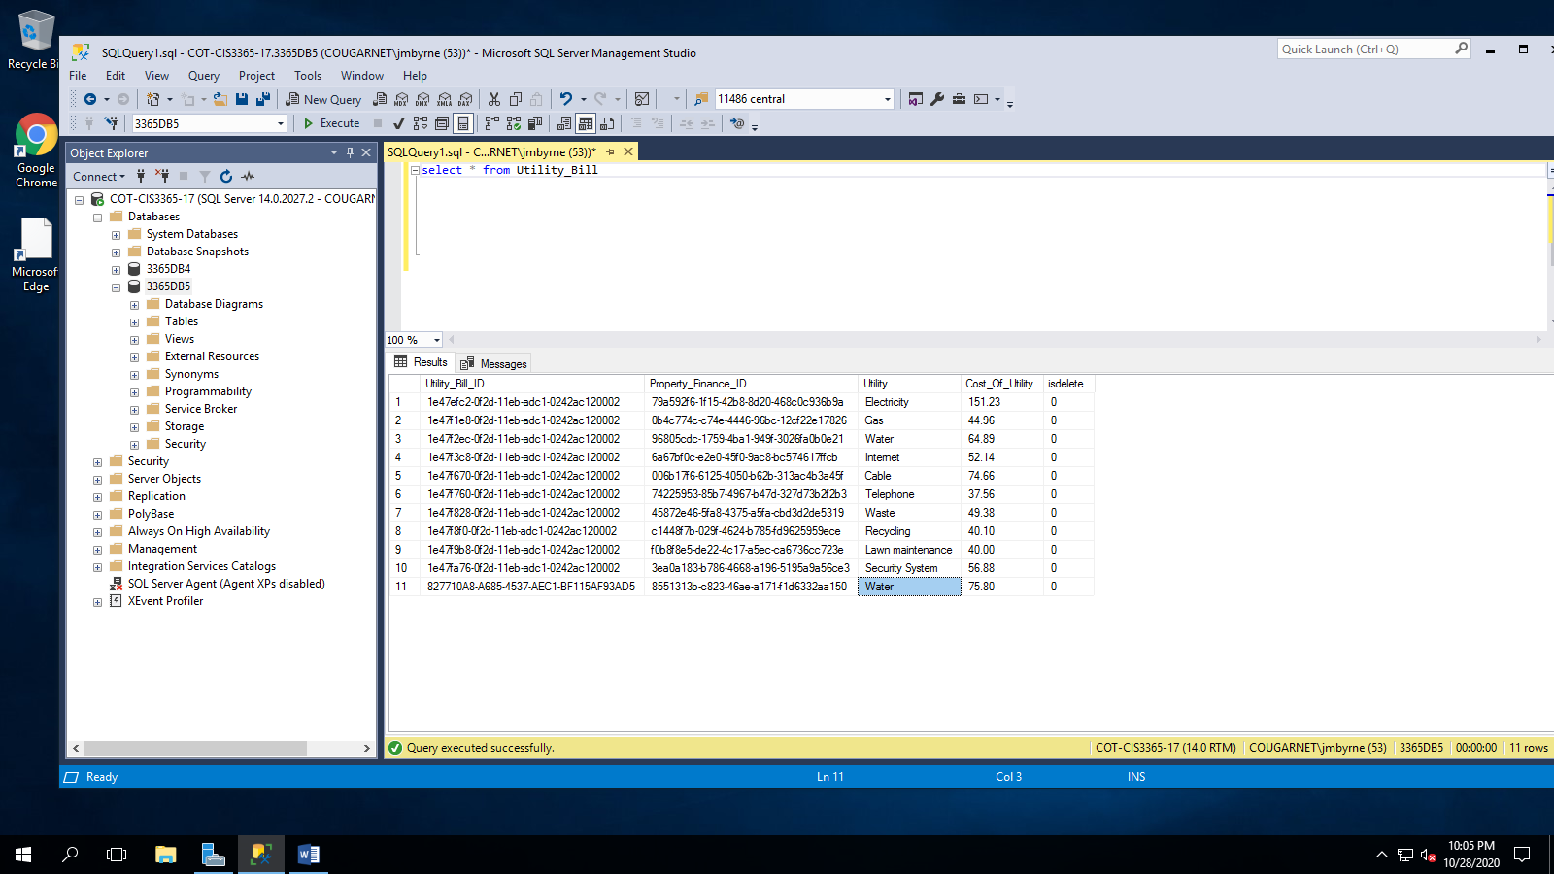

**Delete Script # 1**

UPDATE [Home_Inspection_Company]

SET isdelete = '1'

WHERE Home_Inspection_Company.Company_Name='Texas Homes Safe'

**Report/Query Results:**

**Before:**

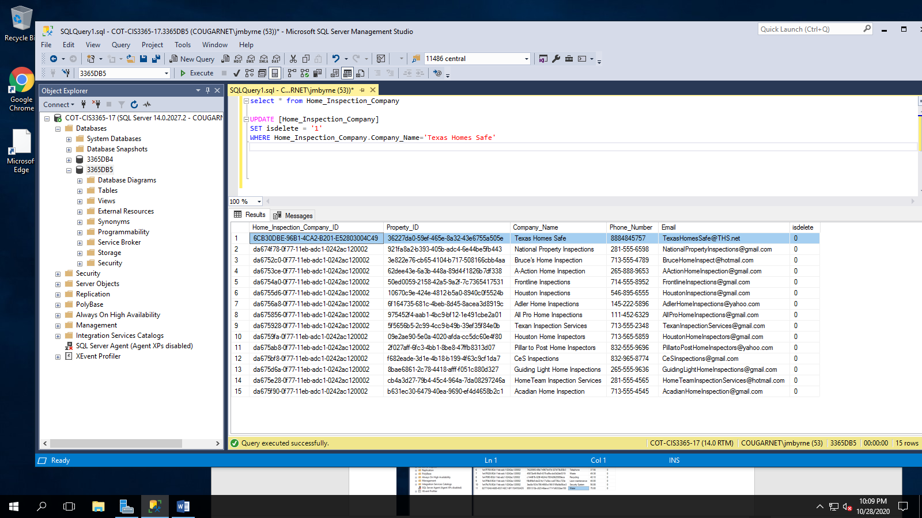

**After:**

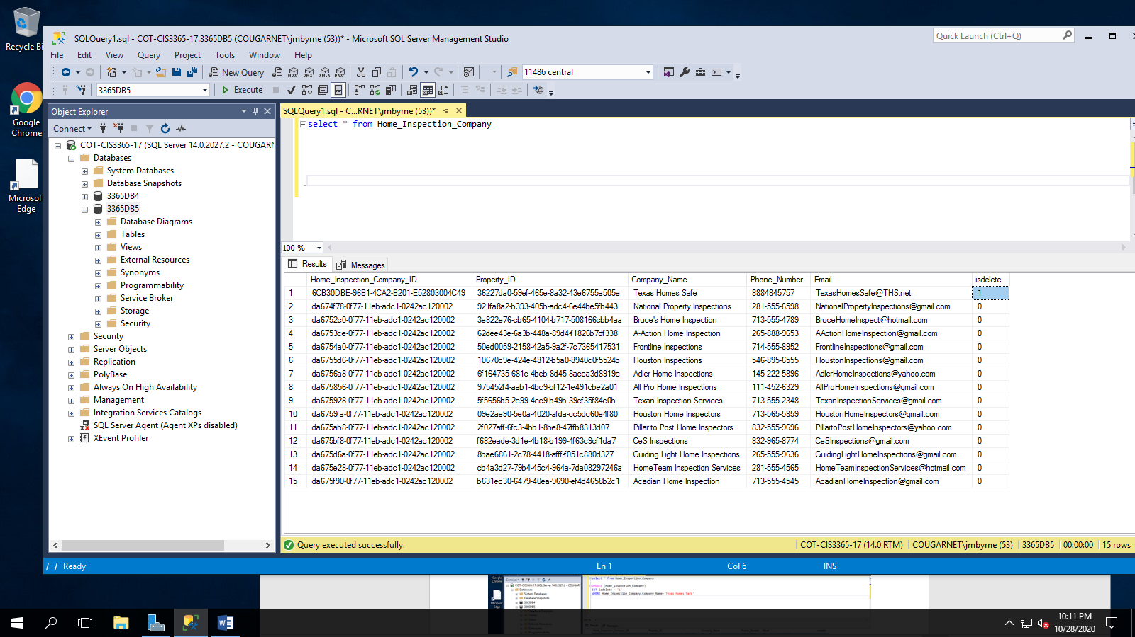

**Delete Script # 2**

UPDATE [Utility_Bill]

SET isdelete = '1'

WHERE Utility_Bill.Utility_Bill_ID='827710A8-A685-4537-AEC1-BF115AF93AD5'

**Report/Query Results:**

**Before:**

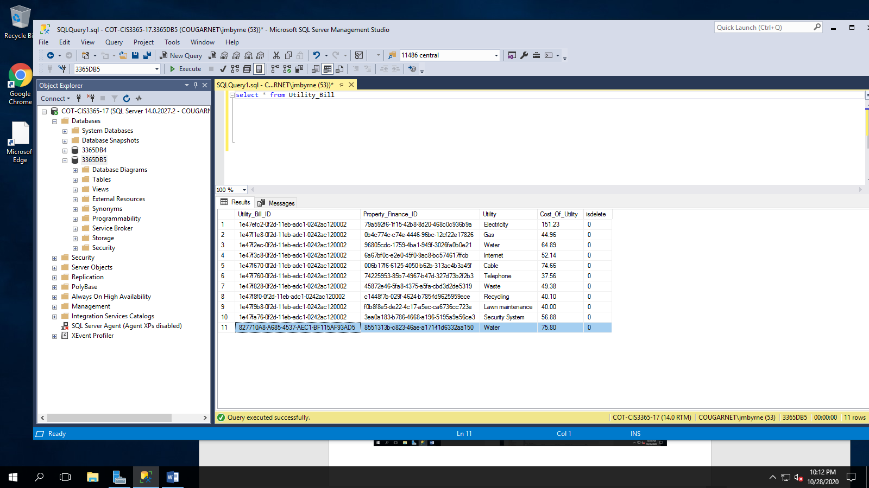

**After:**

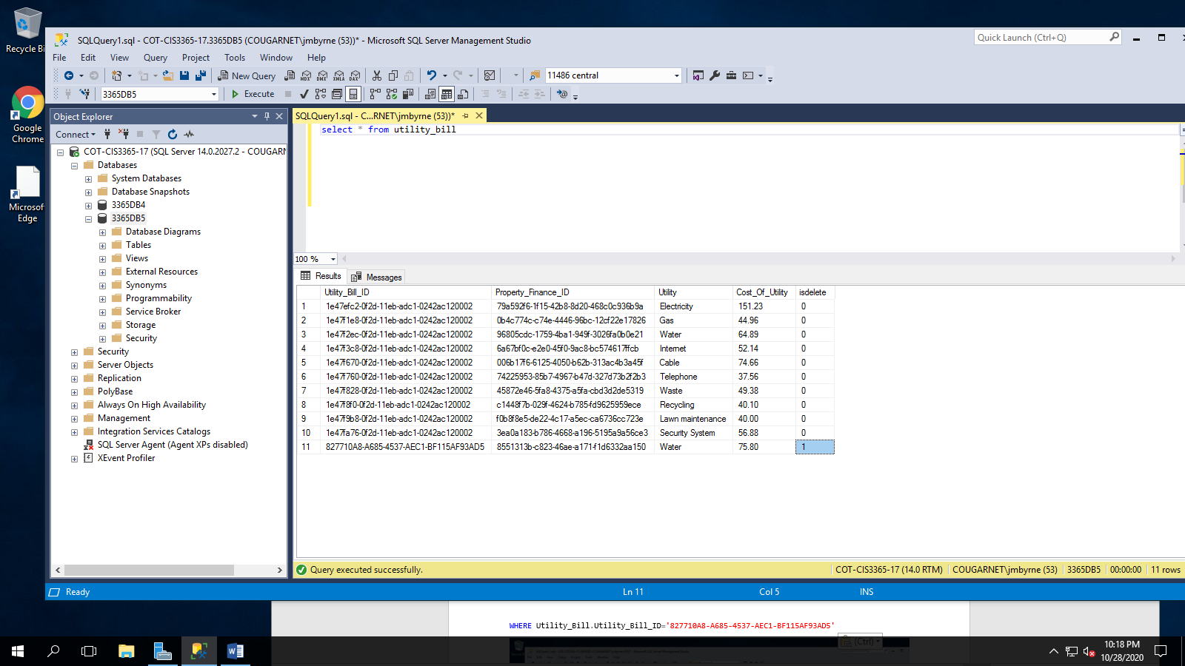

**SQL Queries Report:**

**Section: Julia Byrne**

**Report Name:** Agent Paycheck Filter

**Report Description:** These agents made more than $1200 per paycheck/home sale.

**Business Purpose:** Agents are paid based on how many sales they make and the price of the home that is sold. If Steven Yun can see who his top selling agents are by filtering their earnings from each sale.

**SQL CODE:**

SELECT

Agent.Agent_First_Name AS 'Agent First Name',

Agent.Agent_Last_Name AS 'Agent Last Name',

Agent_Email.Agent_Email AS 'Agent Email',

Agent_Phone_Number.Agent_Phone_Number AS 'Agent Phone Number',

Paycheck.Paycheck_Amount AS 'Paycheck Amount'

FROM AGENT

INNER JOIN Agent_Email ON Agent.Agent_ID = Agent_Email.Agent_ID

INNER JOIN Agent_Phone_Number ON Agent.Agent_ID = Agent_Phone_Number.Agent_ID

INNER JOIN Paycheck ON Agent.Agent_ID = Paycheck.Agent_ID

WHERE Paycheck.Paycheck_Amount > '1200'

**Report/Query Results:**

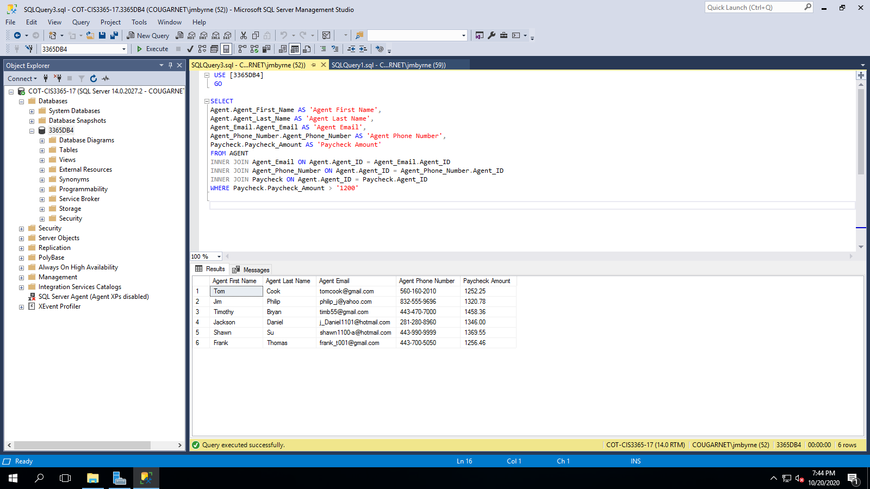

**Agent Table**

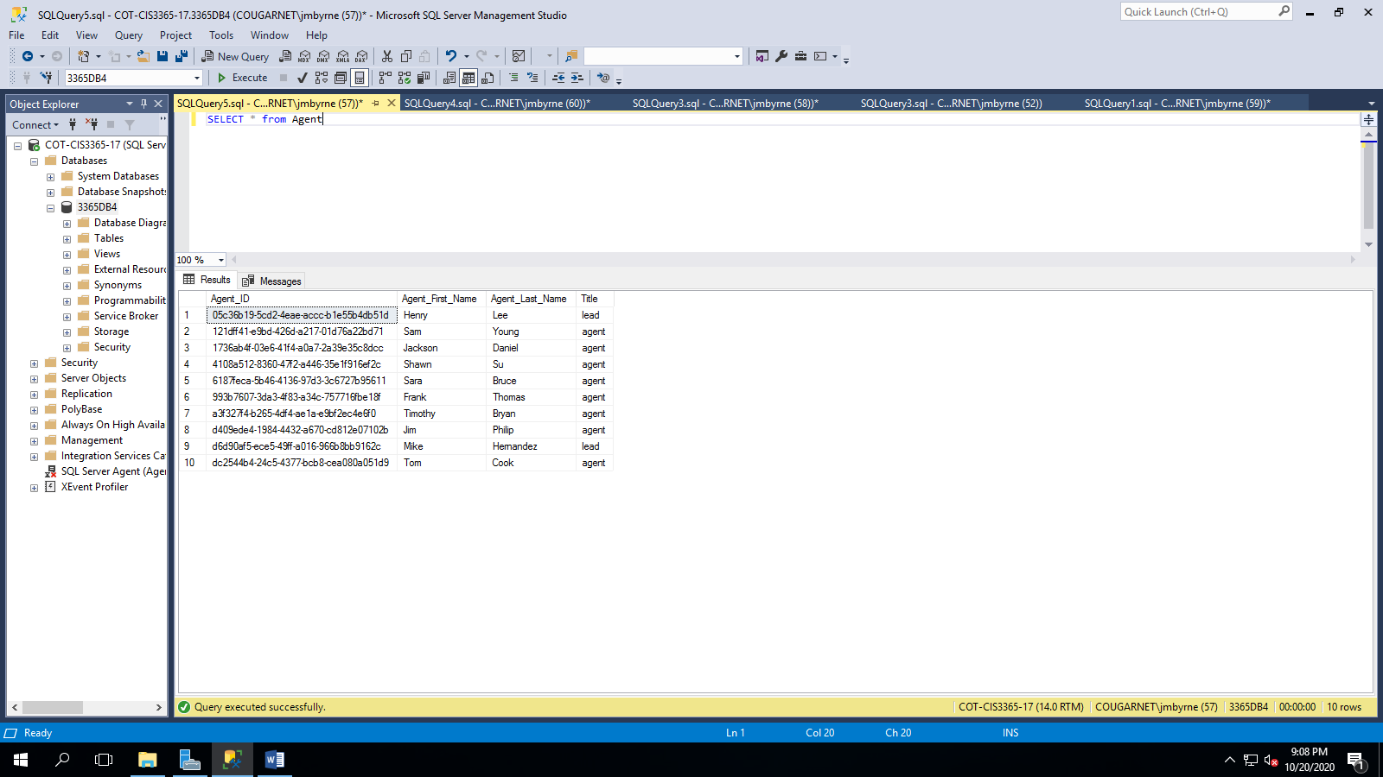

**Agent Email Table**

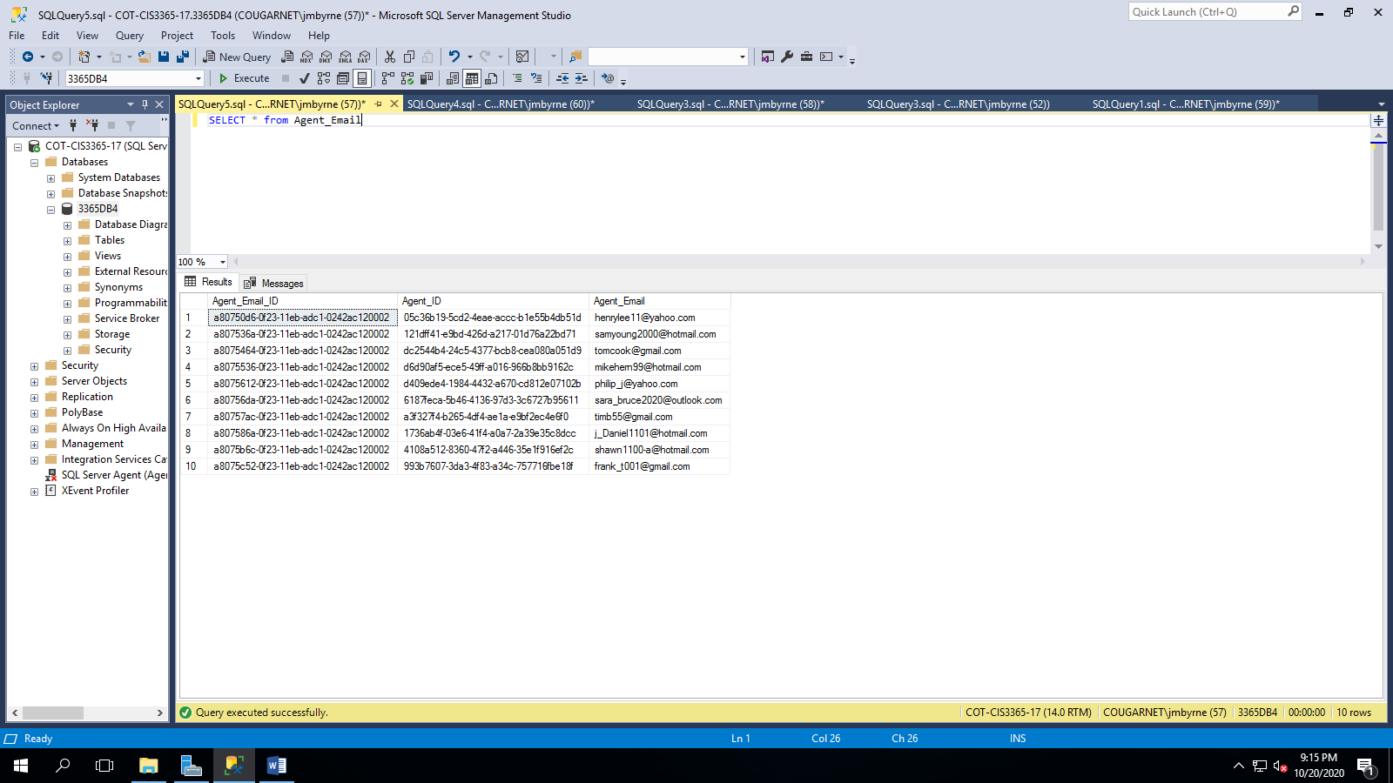

**Agent Phone Number Table**

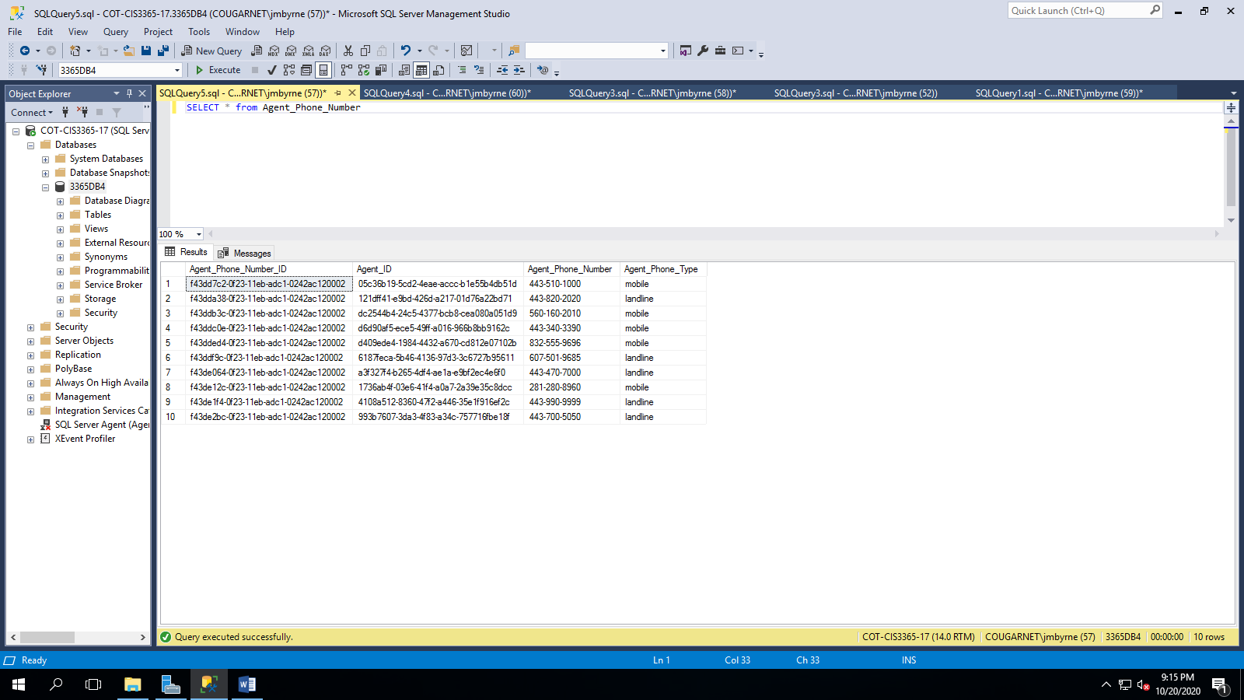

**Paycheck Table**

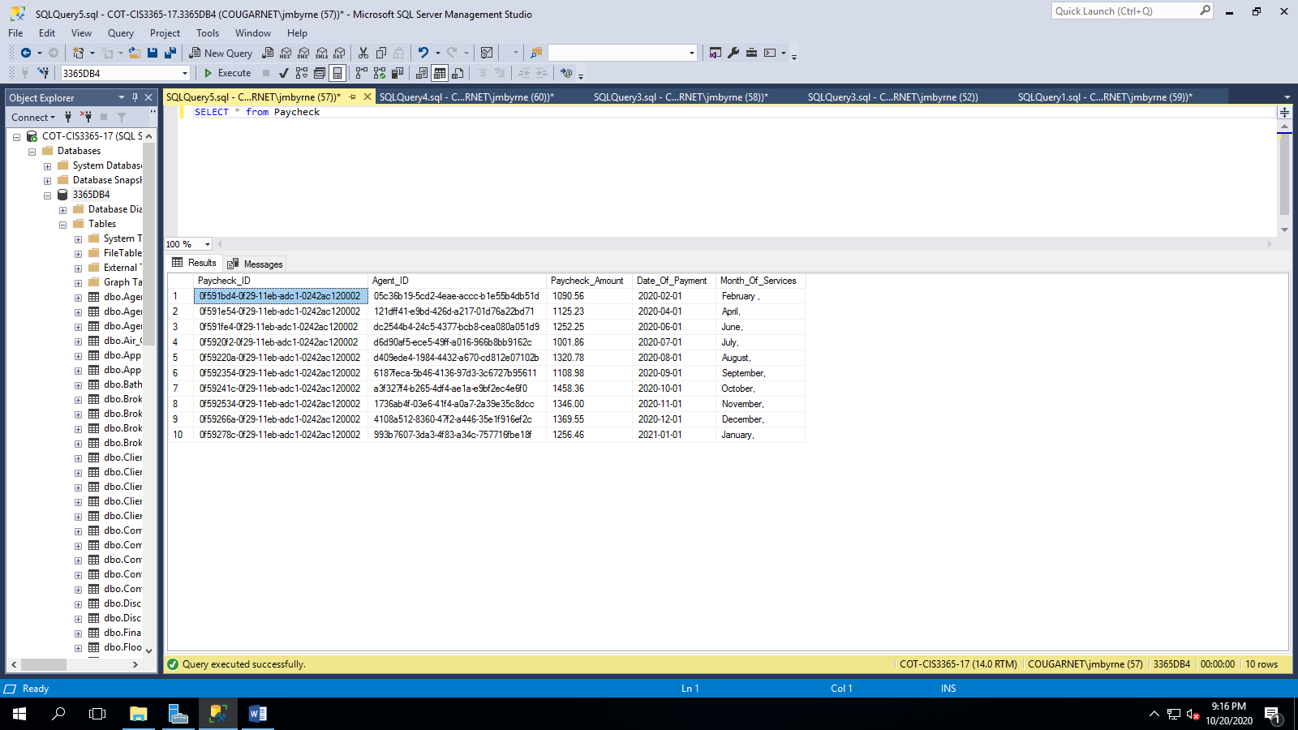

**Report Name:** Properties with an HOA

**Report Description:** Properties with an HOA and the HOA contact information will be displayed.

**Business Purpose:** Some clients may only be interested in properties with an HOA. This query will allow the agents to easily filter the properties that have an associated HOA member. The HOA contact is useful to the client to research the rules of the neighborhood before deciding on their purchase.

**SQL CODE:**

SELECT

Property.Street_Address AS 'Street Address',

Property.City AS 'City',

Property.Zip_Code AS 'Zip Code',

State.State_Name AS 'State',

Homeowner_Associate.HOA_First_Name AS 'HOA First Name',

Homeowner_Associate.HOA_Last_Name AS 'HOA Last Name',

HOA_Email.HOA_Email AS 'HOA Email'

FROM PROPERTY

INNER JOIN State ON State.State_ID = Property.State_ID

INNER JOIN Homeowner_Associate ON Homeowner_Associate.Property_ID = Property.Property_ID

INNER JOIN HOA_Email ON Homeowner_Associate.HOA_ID = HOA_Email.HOA_ID

WHERE HOA_First_Name IS NOT NULL

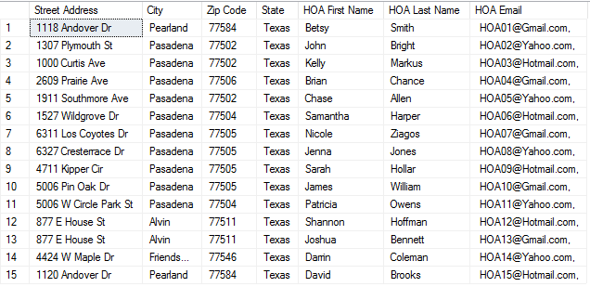**Report/Query Results:**

**Property Table**

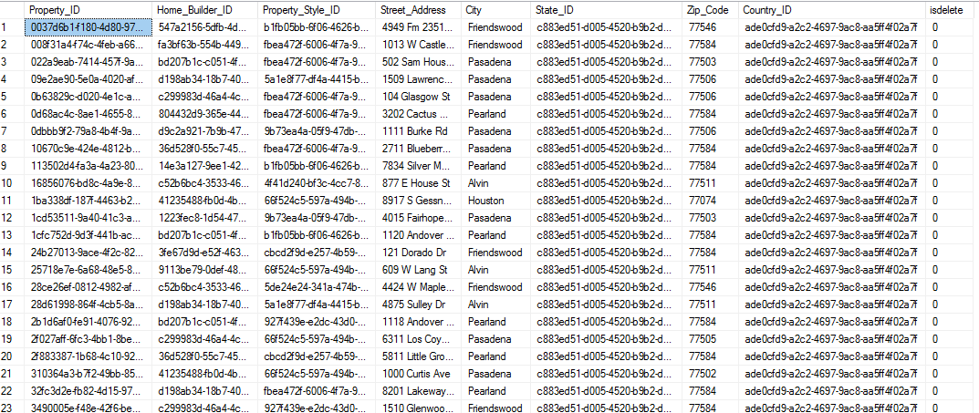

**Homeowner Associate Table**

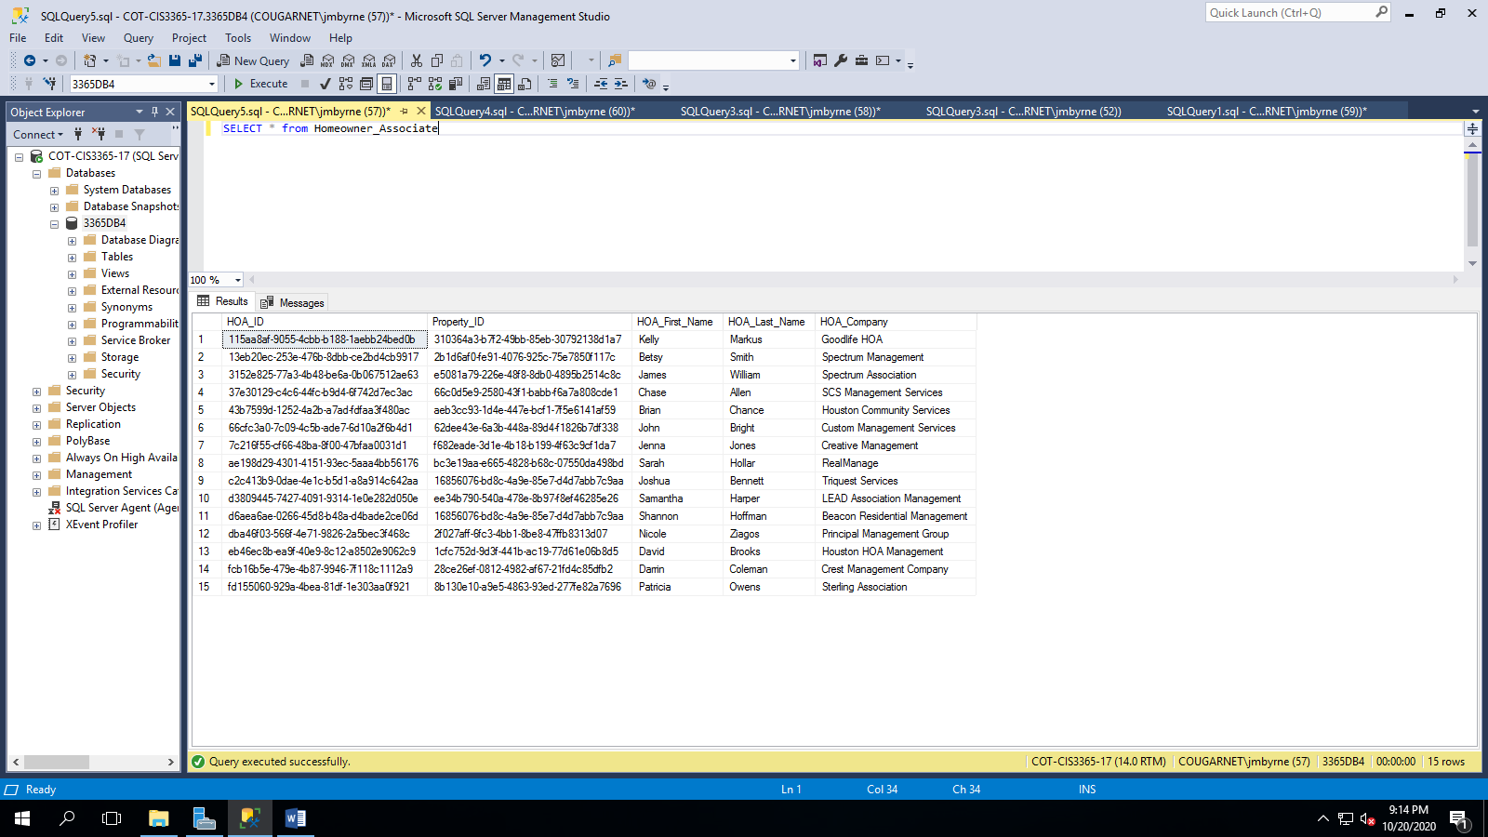

**HOA Email Table**

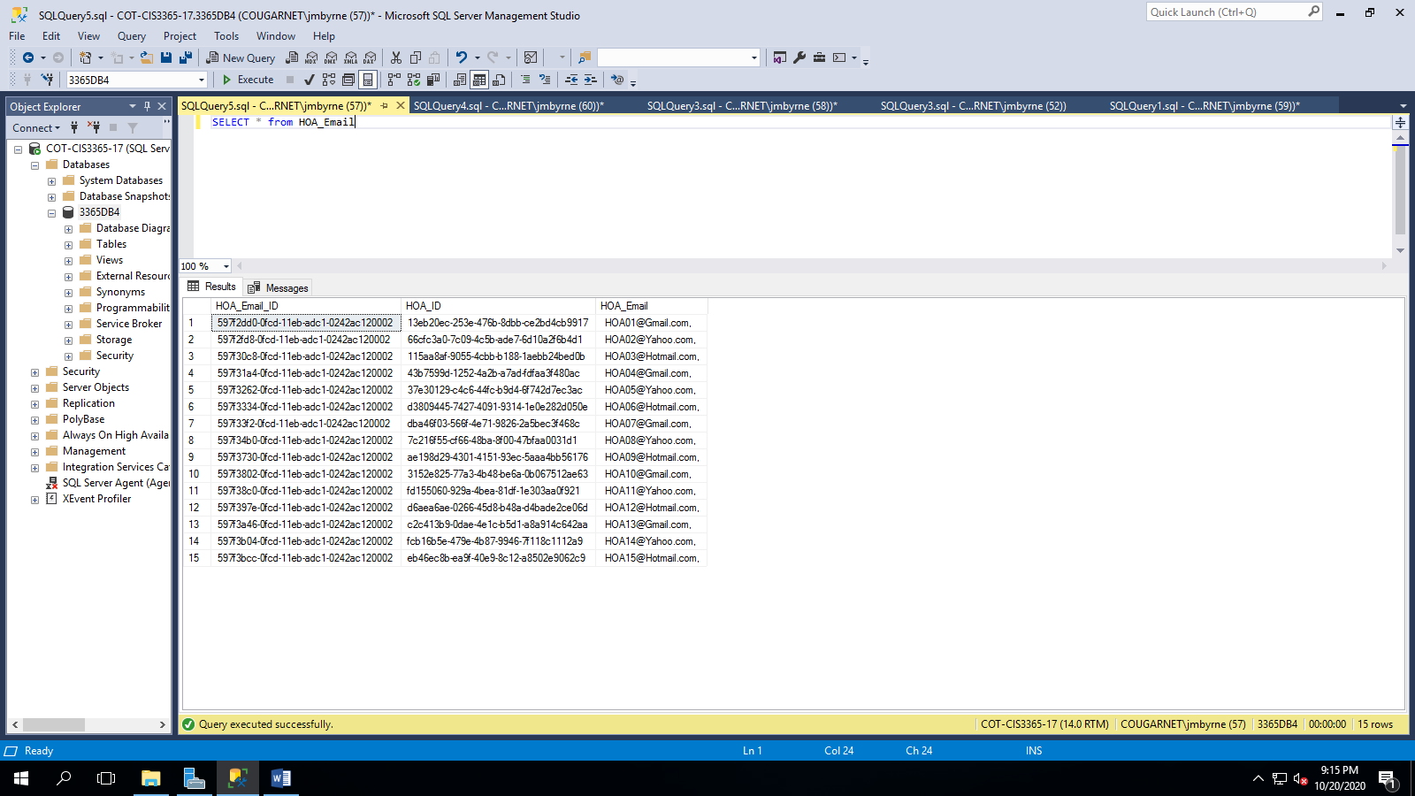

**State Table**

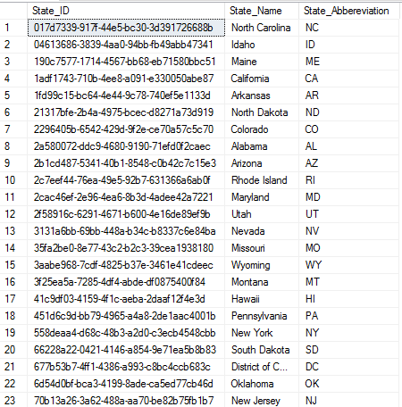

**Report Name:** Clients Buying Property in Pearland

**Report Description:** These are all the clients buying property in Pearland and who their agent is.

**Business Purpose:** When a new lead comes in for a client wanting to buy a property in Pearland, Steven Yun may want to give the lead to one of his agents already working in the Pearland area versus giving the lead to an agent that is less familiar with the current Pearland market.

**SQL CODE:**

SELECT

Client.Client_First_Name AS 'Client First Name',

Client.Client_Last_Name AS 'Client Last Name',

Agent.Agent_First_Name AS 'Agent First Name',

Agent.Agent_Last_Name AS 'Agent Last Name',

Contract.Desired_City AS 'Property Location',

Contract_Type.Contract_Type AS 'Type of Client'

FROM CONTRACT

INNER JOIN Client ON Contract.Client_ID = Client.Client_ID

INNER JOIN Agent ON COntract.Agent_ID = Agent.Agent_ID

INNER JOIN Contract_Type ON Contract.Contract_Type_ID = Contract_Type.Contract_Type_ID

WHERE Contract.Desired_City = 'Pearland' and Contract_Type.Contract_Type = 'Buying'

**Report/Query Results:**

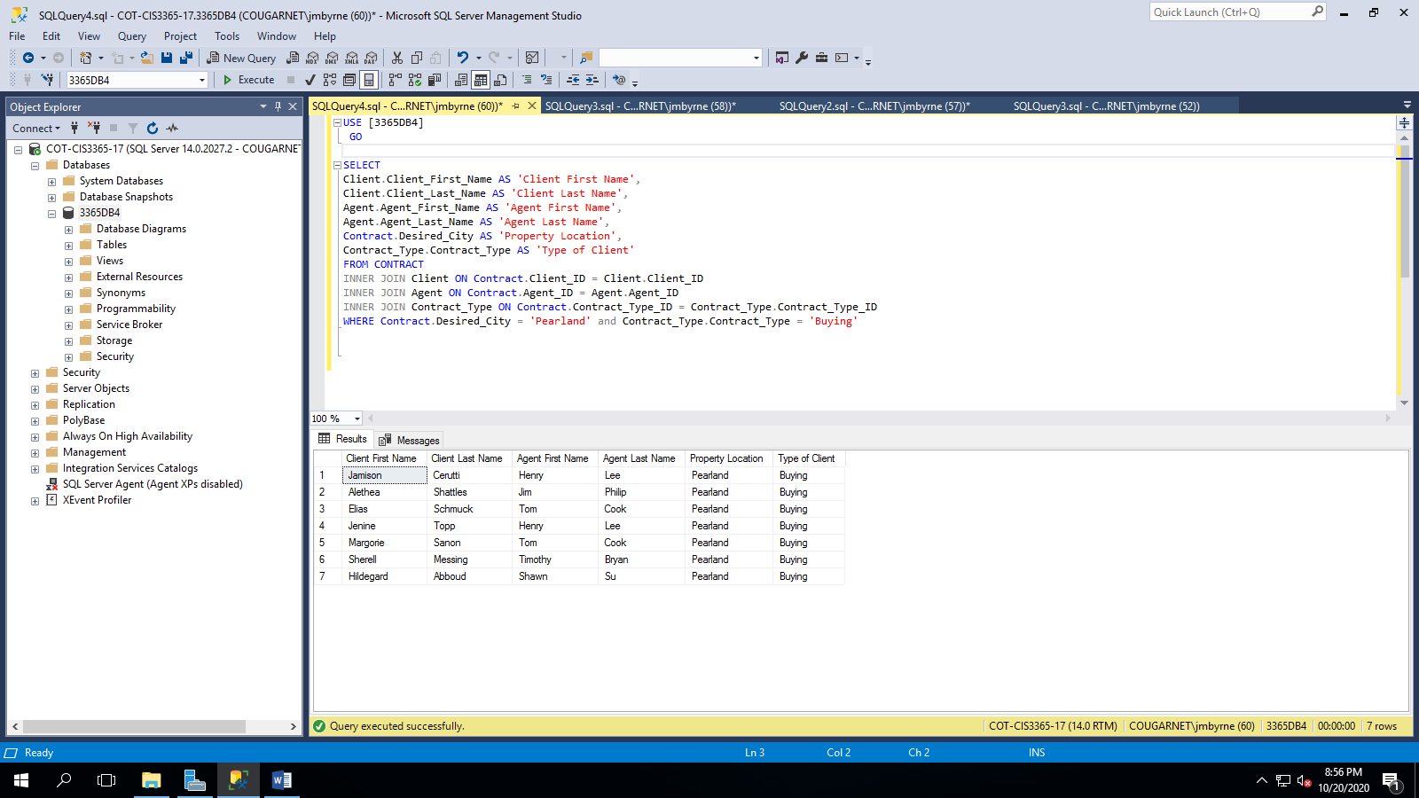

**Client Table**

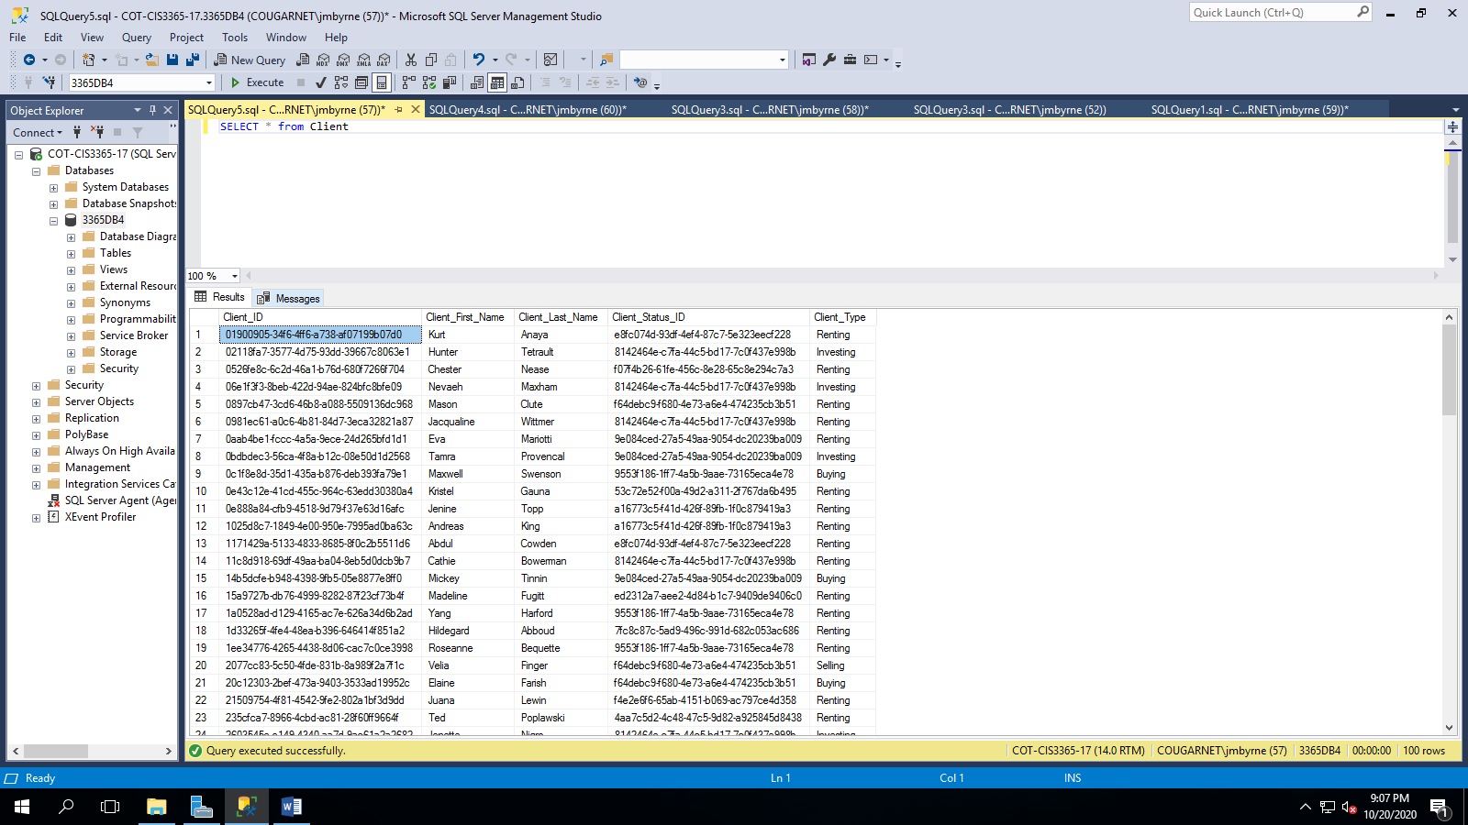

**Agent Table**



**Contract Table**

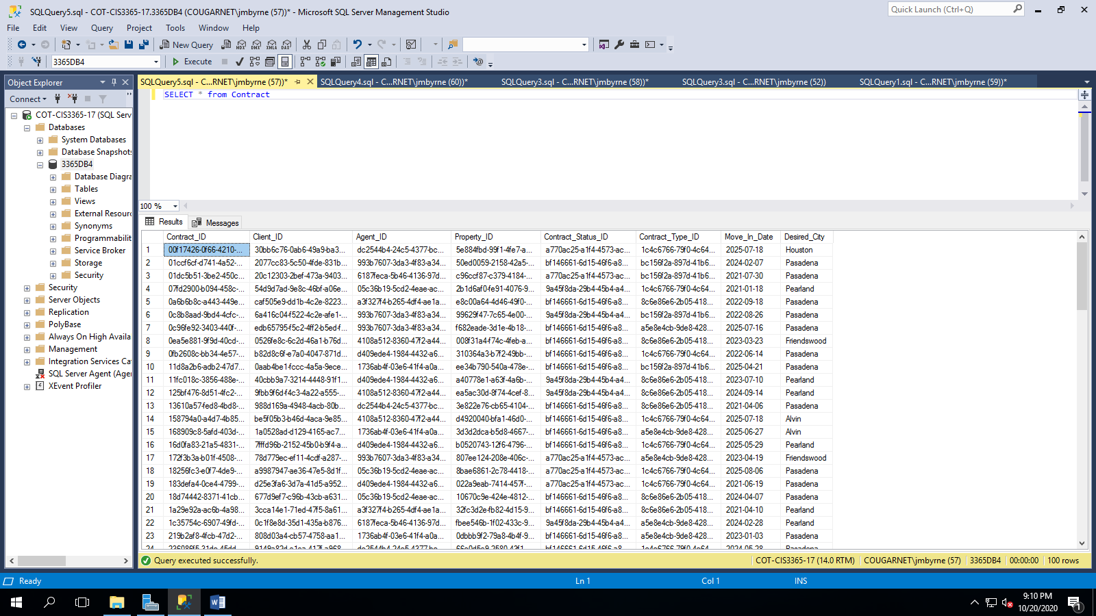

**Contract Type Table**

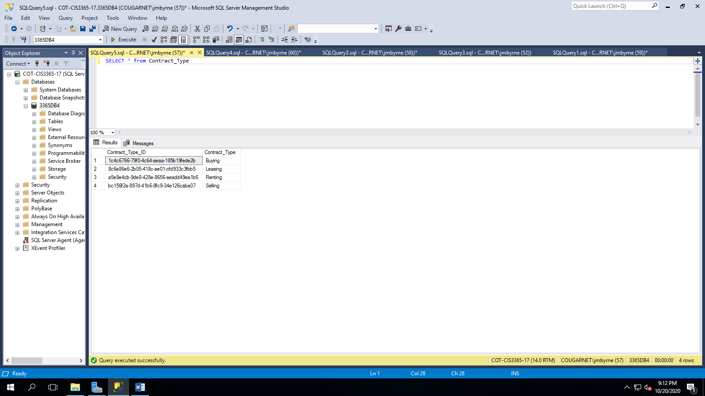

**Report Name:** Properties with 3 Bedrooms

**Report Description:** These are all of the properties that have 3 bedrooms along with the style and price of the property.

**Business Purpose:** An agent would use this when their client has a specific requirement of only wanting to see properties that have 3 bedrooms, while also wanting to know the home style and price of the home before deciding which homes to schedule viewings at.

**SQL CODE:**

SELECT

Property.Street_Address AS 'Street Address',

Property.City AS 'City',

State.State_Name AS 'State',

Property.Zip_Code AS 'Zip Code',

Property_Style.Style AS 'Home Style',

Property_Finance.Total_Price_Estimate AS 'Est Price of Home',

Room.Room_Type AS 'Number of Rooms'

FROM PROPERTY

INNER JOIN State ON State.State_ID = Property.State_ID

INNER JOIN Property_Style ON Property.Property_Style_ID = Property_Style.Property_Style_ID

INNER JOIN Property_Finance ON Property.Property_ID = Property_Finance.Property_ID

INNER JOIN Floor_Plan ON Property.Property_ID = Floor_Plan.Property_ID

INNER JOIN Room ON Floor_Plan.Floor_Plan_ID = Room.Floor_Plan_ID

WHERE Room.Room_Type = '3 Bedroom'

**Report/Query Results:**

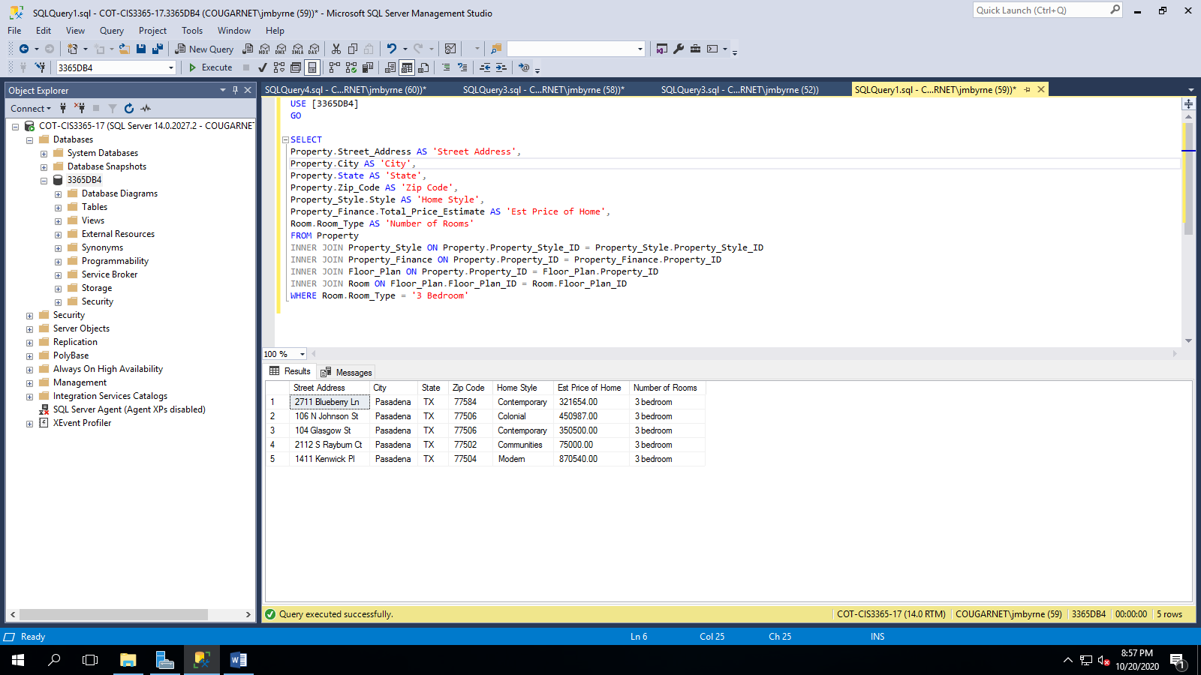

**Property Table**



**Property Style Table**

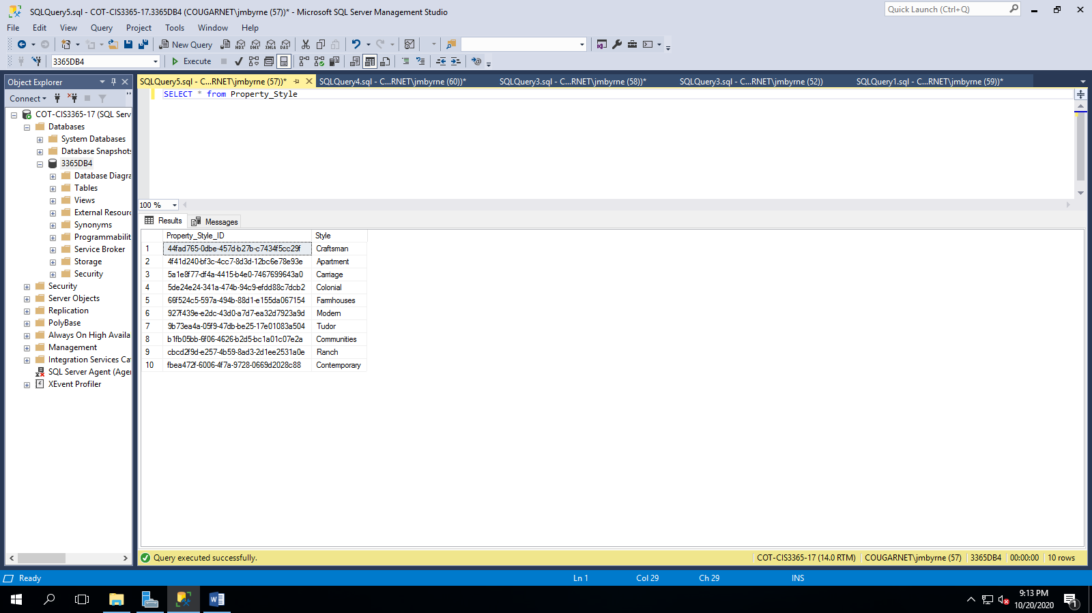

**Property Finance Table**

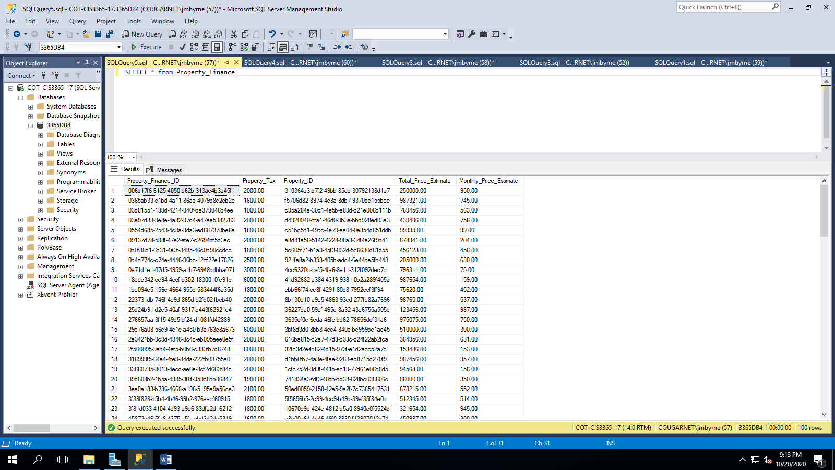

**Room Table**

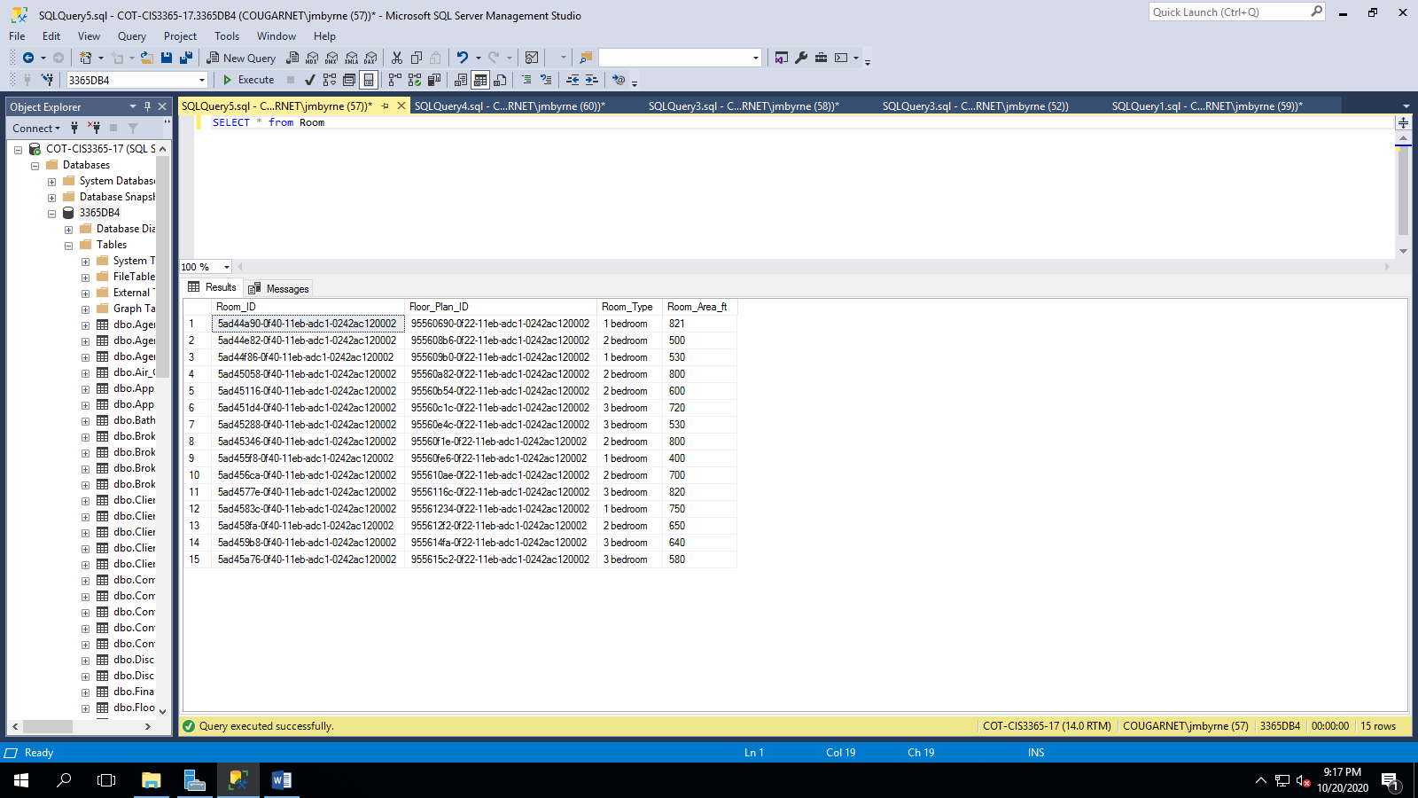

**State Table**



**GUI Printout and Description:**

**Commission Plan Data GUI**

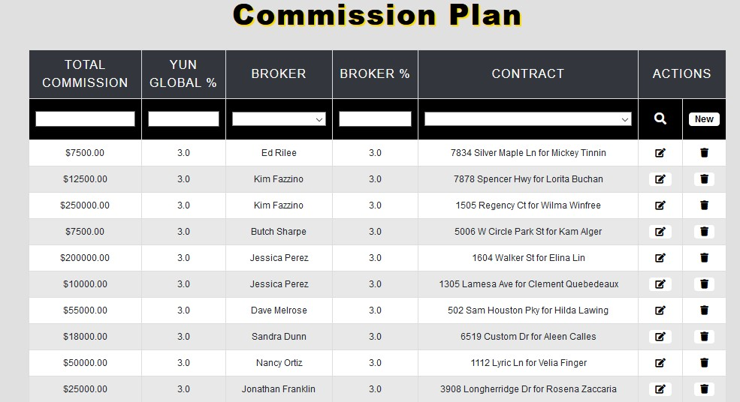

The user will get to this table by choosing it on the navigation bar, not shown in this printout, from the left side of the screen. The commission plan table keeps track of the percentage commission split between Yun Global and their broker. The user can filter by any of the above options. The user can navigate to the edit commission plan and add new commission plan from this table. The user may also soft delete an entry from this table.

**Add New Commission Plan GUI:**

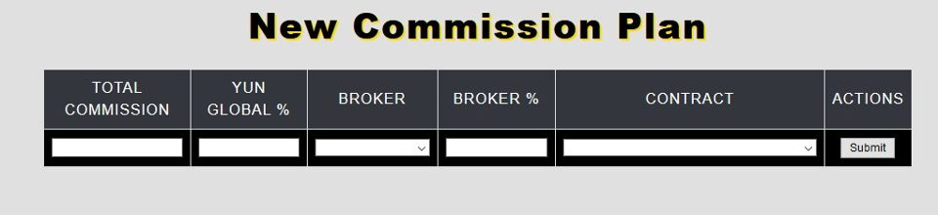

Once the user chooses “New”, they are redirected to this webpage where they will insert their information. By clicking submit they will be auto redirected back to the Commission Plan Data page.

**Edit Commission Plan GUI :**

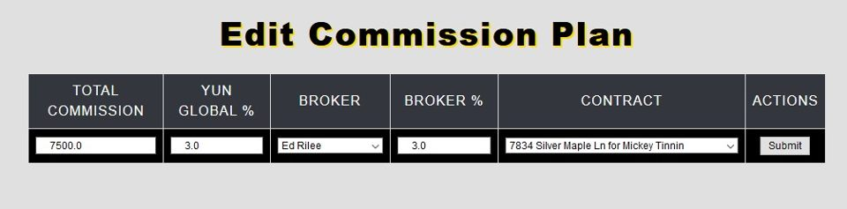

The user will be redirected to edit a specific commission plan after clicking the edit button located to the right side of the screen on the Commission Plan Data printout. All fields are editable and contract is a dropdown menu that specifies a contract of a client at a certain address.

**Contract Data GUI :**

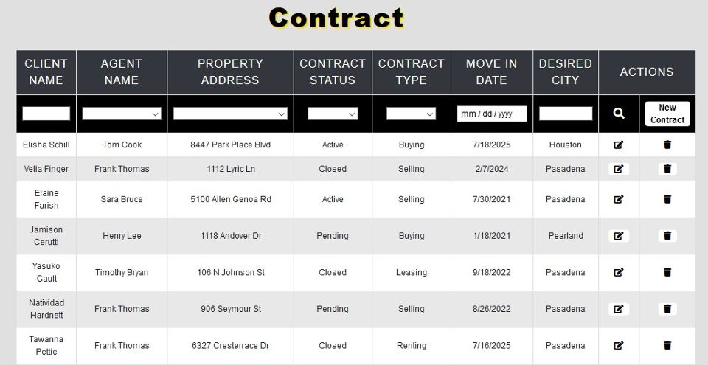

The table above displays all contracts at Yun Global. The user can filter the data using any column. Agent name, property address, contract status and contract type are dropdown menus. From this page, the user can soft delete or navigate to the edit contract or new contract pages using the buttons on the right side of the screen.

**Add New Contract GUI:**

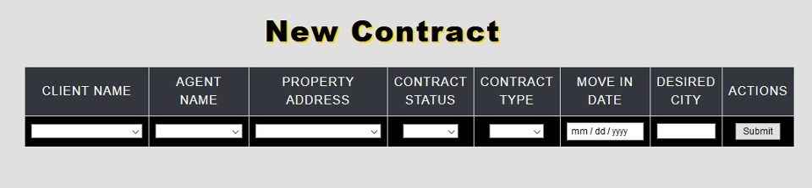

The above table allows the user to add a new contract into the system. Client name is a dropdown menu because the client must already have been added to the system to have a contract made under their name. The submit button will redirect the user back to the webpage with all contracts displayed.

**Edit Contract GUI:**

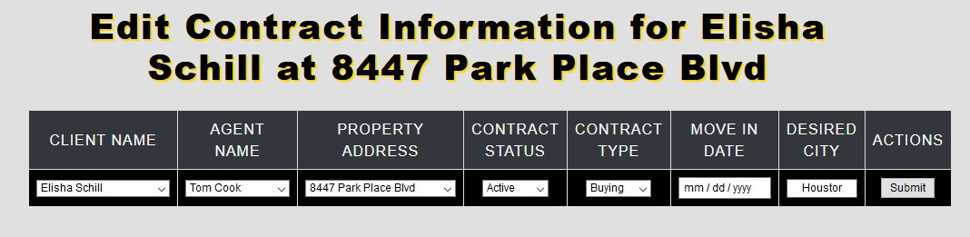

From the edit contract page, the user is able to make any necessary change to a previously created contract. The submit button will auto redirect the user back to the contracts webpage.

**Discussion Data GUI:**

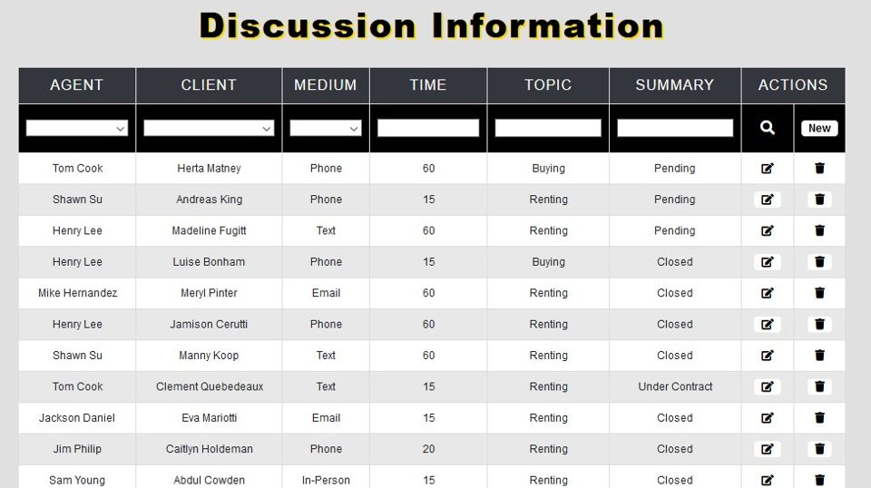

The discussions table above contains the most up to date contact info between an agent and client. This was a requirement from our client Yun Global. The client, agent, medium of communication, length of time the communication lasted, topics of conversation are held in this table. The topic and summary data can be as long or as short as needed. The edit, delete and new buttons are located on the right side of the table. The data can be filtered using any field.

**Add New Discussion GUI:**

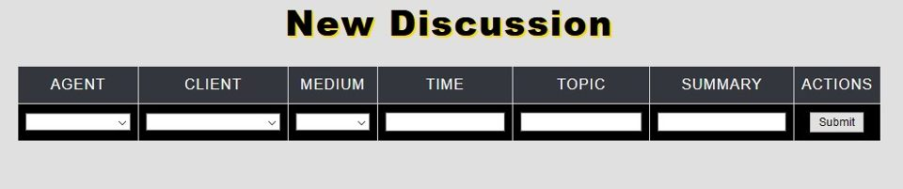

Above, a new discussion between client and agent can be entered into the discussion table. Agent and client fields are dropdowns to make sure that both parties have already been entered into the system. The submit button will redirect the user back to the main discussion table.

**Edit Discussion GUI:**

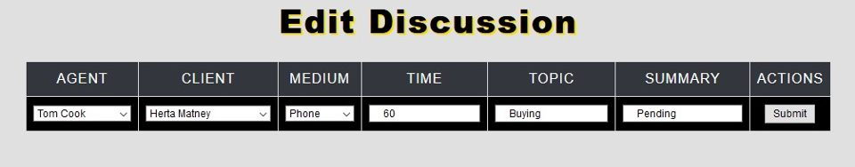

The edit discussion table allows the user to make changes to a conversation that has already been entered. Every field is able to be changed to leave room to edit mistakes that may have been made when initially entering the data. The submit button will automatically redirect the user to the discussion webpage.